260 West 91st street, SUITE #1A,
NEW YORK, NEW YORK 10024
T: (646) 780-1856
F: (646) 813-1497
EMAIL: rcrealtynyc@gmail.com
WEBSITE: WWW.RCREALTY.NYC

Generic
Short Sale
Package
Important Instructions: Read Before Proceeding

RC REALTY GROUP OF NEW YORK INC ·∙ Short Sale Package Instructions & Policies
Thank you for choosing RC REALTY GROUP OF NEW YORK INC to negotiate your short sale. The following are detailed instructions on completing and submitting a short sale file to our office. Please read these instructions carefully and be sure to completely execute all requirements so we may ensure the very best service for you.
- Please make sure that you are using the most current available lender package. Our packages are updated
frequently to reflect the most up to date requirements of the different lenders that we work with. If you are unsure if you have the most current package available, you may email rcrealty2@aol.com with your request and we will forward you the necessary documents in PDF attachment.
- Be sure to use the checklist that we have provided on the following page. It is designed to help you stay.
organized and ensure that you provide us with all necessary pieces of information required for a smooth, successful negotiation.
- You must have a valid offer on the subject property in question with a signed and dated purchase & sales.
contract in order to submit a file to us.
The day the purchase & sales contract is signed you should also have:
- detailed hardship letter
- financial statement
- any supporting documents requiring a date & signature.
(ALL SHOULD BE DATED SAME AS THE PURCHASE & SALES CONTRACT)
- 60 days of bank statements as well as 30 days of paystubs
- must be current to the day that the purchase & sales contract is signed.
IT IS IMPERATIVE THAT ALL DATED MATERIALS CORRESPOND AND MATCH THE DATE LISTED ON THE PURCHASE AND SALES CONTRACT!
i.e.- If the purchase contract is signed and dated for April 1st, the hardship letter, financial statement, and supporting documents must also be signed and dated April 1st. The 60 days of bank statements should be from February 1st to March 1st to April 1st and the 30 days of pay stubs should be from March 1st to April 1st.
- After collecting all necessary documentation, scan your file to PDF format and email to rcrealty2@aol.com as an attachment.
- Once your package has been received, we will review all documentation and notify you of a missing or inaccurate information.
- Your timelines in addressing any issues that are found will determine how long it will take us to be able to submit your file to the lender and begin our negotiations.
- WE WILL NOT SUBMIT YOUR FILE TO THE LENDER UNTIL WE RECEIVE ALL NECESSSARY DOCUMENTATION
- Once we have submitted your package to the lender, we will need update paystubs and bank.
statement from the seller on a MONTHLY BASIS. Be advised that ALL lenders require us too continually.
update all files on a monthly basis for the duration of our negotiations.

We ask that you understand that these instructions and policies have been put into place in order to help us better serve you as our value client. All information that we request is required by the lenders and our ultimate goal is to be proactive so that we may expedite every file as quickly as possible. If you have any questions or concerns, please contact us directly at 212-837-1835 or email us at rcrealty2@aol.com

!

Short Sale Check List
This packet needs to be completed and emailed to Submit@ rcrealty2@aol.com
* The Following Documentation Must Be I included To Determine Eligibility *

Financial Documents Should Include
For each borrower who is paid by an employer (W-2 wage earner):
- Copy of 2 years most recent federal tax return with all schedules and W-2 forms.
- Copy of 60 days most recent bank statements (include all pages even if blank)
- Copy of 60 days most recent pay stubs
For each borrower who is self-employed (1099 wage earner):
- Copy of 2 years most recent federal tax return with all schedules and 1099 forms.
- Copy of 60 days most recent bank statements (include all pages even if blank)
- Copy of their year-to-date profit/loss statement
For each borrower who has income such as Social Security, disability, death benefits, or pension:
- Copy of 2 years most recent federal tax return with all schedules and W-2 forms.
- Copy of 60 days most recent bank statements (include all pages even if blank)
- Copy of benefits statement or letter from the provider stating the amount, frequency and duration of the benefit.
For each borrower who has income such as public assistance, or unemployment:
- Copy of 2 years most recent federal tax return with all schedule and W-2 forms.
- Copy of 60 days most recent bank statements (include all pages even if blank)
- Copy of benefits statement or letter from the provider that states the amount, frequency, and duration of the benefit.

For each borrower who relies on alimony or child support as qualifying income:
- Copy of 2 years most recent federal tax return with all schedules and W-2 forms.
- Copy of 60 days most recent bank statements (include all pages even if blank)
- Copy of divorce decree, separation agreement or other written agreement or decree that states the amount of alimony or child support and period of time over which it will be received. Payments must continue for at least 3 years to be considered qualifying income under most programs.
- Proof of full, regular and timely payments; for example, deposit slips, bank statements, court verifications or filed federal tax return with all schedules.

.
Hardship Information
- Hardship Letter as Well as the enclosed Financial Hardship Affidavit Completed and Signed Seller(s)
~ any documentation supporting the hardship letter (i.e., Medical Bills, Child Support/Alimony Payments, etc.)
~ see attached of ‘Hardship Letter Guidelines’

Mortgage Other Relative Property Information
- 1st Mortgage Statement
- 2nd Mortgage Statement (if applicable)
- Recent Real Estate Tax Bills (if available)
- Condo Association Contact Info (are you delinquent? YES or NO)
- Any Recent Water/Sewer Bills (if available)

RC REALTY GROUP OF NEWYORK INC Document to Be Competed
- RC REALTY GROUP OF NEW YORK INC Authorization Signed & Dated by Seller(s)
- RC REALTY GROUP OF NEW YORK INC. Disclosure Signed/Date by Seller(s)
- Financial Analysis Form

Information to Be Provided by Listing/Buyer’ Agents
- Fully Executed Purchase & Sales Agreement
- Completed Listing Agreement/Comps
- Commitment Letter from New Lender for The Buyer
- Detail Documentation of Time on Market & Sales Price Adjustments
- Seller Realtor (listing & buyer’s agents) Contact Information Sheets

Short Sale Disclosure
Thank you for choosing RC REALTY GROUP OF NEW YORK INC. for the sole purpose of negotiating a short sale of your (hereinafter Seller's") real property located at: ________________________________________________________________
(Hereinafter referred to as "the Property"). A "short sale" is a voluntary sale of the Property for a price that is less than the total amount of any mortgages and/or liens that currently encumber the Property.

In order to effectively negotiate the short sale, Seller must provide any relevant financial and other personal information to RC REALTY GROUP OF NEW YORK INC. upon request. Upon receipt the information will be submitted to Seller's mortgage and/or lien holder(s). The information will permit the mortgage and/or lien holders to fully analyze the requested short sale.

In order for RC REALTY GROUP OF NEW YORK INC to commence the negotiation process with the mortgage and/or lienholder, Seller must read, fully understand and acknowledge all provisions as set forth below. The provisions set forth fully disclose the terms of the engagement and scope of service offered by RC REALTY GROUP OF NEW YORK INC. The provisions also fully disclose the limitations on RC REALTY GROUP OF NEW YORK INC. services offered.

RC REALTY GROUP OF NEW YORK INC. is not associated with the government, and our service is not approved by the government or your lender.

RC REALTY GROUP OF NEW YORK INC. does not accept any upfront fees or payments from Seller.

After Seller has read and fully understood each provision, Seller must initial each provision to verify that said provision has been fully read and understood. If the Seller does not fully understand the terms of the Disclosure, Seller shall consult independent counsel in Seller's applicable jurisdiction.

RC REALTY GROUP OF NEW YORK INC. looks forward to working with you to assist in the successful sale of your property.

The Seller(s) understand and acknowledge that:
- RC REALTY GROUP OF NEW YORK INC scope of engagement is for the sale purpose of negotiating he proposed short sale of the subject Property. Seller acknowledges that RC REALTY GROUP OF NEW YORK INC. is in no way representing or acting as legal counsel to Seller. RC REALTY GROUP OF NEW YORK INC. I not offering any legal advice to Seller. Seller acknowledges that Seller has been advised to seek independent advice of counsel regarding any and all legal issues that may arise as a result of any short sale transaction.
- All short sales are solely subject to the approval of all of Seller's mortgage and/or lien holders associated with the Property.
- RC REALTY GROUP OF NEW YORK INC. does not warrant and cannot guarantee that Seller's mortgage and/or lien holders will approve the proposed short sale. Seller's mortgage and/or lien holder(s) are under no
obligation to approve the proposed short sale. The decision to approve said short sale rests solely within
the discretion of the mortgage and/or lien holder(s). Further RC REALTY GROUP OF NEW YORK INC cannot guarantee and make no representation that it will be able to stop, postpone or cancel any foreclosure proceedings initiated by any mortgage and/or lien holder(s).

- . Seller agrees to provide any and all documents and/or information requested by RC REALTY GROUP OF NEW YORK INC. for the purpose of processing and negotiating the proposed short sale. Seller further agrees that it is Seller's affirmative obligation to immediately notify RC REALTY GROUP OF NEW YORK INC. of any and all foreclosure proceedings initiated by any party. Seller is responsible to receive and open any and all notifications regarding the subject Property received by mail and/or service of process. If Seller does not reside at the subject Property or there has been a change in Seller's mailing address, Seller must notify the mortgage and/or lien holder of the new address to ensure receipt of all notices.

Short Sale Disclosure Continued

- Seller here by acknowledges that no proceeds from the sale of the subject Property will be received by
Seller. All net proceeds from the short sale of Seller's home, including any refunded insurance premiums, shall be paid to Seller's mortgage and/or lien holders.

- Seller acknowledges that the mortgage and/or lien holder(s) may accept Seller's proposed short sale and issue a lien release while preserving its right to pursue a judgment against Seller for any deficiencies owed as a result of the mortgage and/or lien holder(s) agreement to accept less than a full payoff. RC REALTY GROUP OF NEW YORK INC. does not warrant and cannot guarantee that a deficiency resulting from the short sale will be forgiven, waived and/or cancelled by the mortgage and/or lien holder(s). Various jurisdictions may be governed by an anti-deficiency statute that prohibits mortgage and/or lien holder(s) from seeking a deficiency judgment against Seller. The scope of RC REALTY GROUP OF NEW YORK INC. service does not include negotiating settlements in the event the mortgage and/or lien holder(s) seek to recover monies from Seller stemming from a deficient balance that may exist after closing. Seller further acknowledges that Seller has been advised to seek advice of legal counsel in Seller's jurisdiction determine whether an anti-deficiency statute or various applicable laws govern the recourse rights of mortgage and/or lien holder(s) which may affect the Seller's decision to proceed with a short sale.
- The acceptance of a payoff for less than the full amount owed to Seller's mortgage and/or lien holder(s)
may be reported to the credit bureaus, which may negatively impact Seller's credit rating and serve as
an impediment on Seller's ability to obtain future credit. RC REALTY GROUP OF NEW YORK INC. does not negotiate with any credit bureau on behalf of Seller.

8. The mortgage and/or lien holders may forgive a portion or all Seller's debt, which may be considered
income to Seller. Seller should consult an independent, qualified professional regarding any questions or concerns regarding any potential tax liabilities of a short sale.
9. Seller is not obligated to pay RC REALTY GROUP OF NEW YORK INC. in advance for the negotiation of Seller’s
payoff(s). Seller acknowledges that Seller understands that. RC REALTY GROUP OF NEW YORK INC. will seek compensation from the mortgage and/or lien holder(s) from the proceeds of the short sale. RC REALTY GROUP OF NEW YORK INC. will not claim, demand, charge, collect or receive any compensation until offer. RC REALTY GROUP OF NEW YORK INC. has fully performed or attempted to perform each and every service in an effort to effectuate the short sale of the Property Compensation is approved by the mortgage and/or lienholder(s), Compensation is deducted from the
net proceeds that the mortgage and/or lien holder(s) have agreed to accept by approving the short sale.
10.Seller agrees and acknowledges that RC REALTY GROUP OF NEW YORK INC. has made no promise, guarantees, or
representations made to Seller which are contrary to the disclosures and information contained herein. Seller(s)may accept or reject any short sale approval presented to them resulting from our negotiation of the short sale.

Seller(s) have read, understand and acknowledge the foregoing Short Sale Disclosure and fully agree with the terms and conditions contained herein.

_________________________________________________ ________________________________ Name Date Witness

________________________________________________ ________________________________
Name Date Witness

Seller Questionnaire (Must Be Completed)
Please Answer the Following Questions:
- Have you requested a short sale from your lender in the past? YES NO (please circle one)
- If “YES” to above, when? ________________________________________________________________
- Are you current on your mortgage payments? YES NO (please circle one)
- If “NO” to above, how many months are you behind? __________ months
- How much do you currently owe? ________________1st Mortgage ________________2nd Mortgage
- Who is on the title (or deed) for your property? ______________________________________________
________________________________________________________________________________________
- Who is on the mortgage? _________________________________________________________________
________________________________________________________________________________________
- What kind of mortgage do you have? (Please circle one)
CONVENTIONAL VA FHA FREDDIE MAC FANNIE MAE
- Do you have MI or PMI on your loan? YES NO (please circle one)
- How many lien holders are attached to the property and who are they? _________________________________________________________________________________________________________________________________________________________________________________________________________
- Do you have a HELOC? YES NO (please circle one)
- Are you currently living in the property? YES NO (please circle one)
- If “NO” to above, is the property being maintained? YES NO (please circle one)
- If leased, what are the terms of you lease?
Monthly Rent: $__________ Expirations of Lease: _____/_____/_____
- If leased, are tenants willing to show property? YES NO (please circle one)
* Please Provide Copy of Lease(s)
- What is the property condition and what repairs are needed? (Please circle one)
POOR FAIR GOOD EXCELLENT
Repairs Needed: _____________________________________________________________________
_______________________________________________________________________________________
_______________________________________________________________________________________
_______________________________________________________________________________________

Seller Questionnaire Cont. (Must Be Completed)
- What are the best features and upgrades of your home? ______________________________________
_______________________________________________________________________________________
_______________________________________________________________________________________
_______________________________________________________________________________________
_______________________________________________________________________________________
_______________________________________________________________________________________
_______________________________________________________________________________________
- Are you relocating? YES NO (please circle one)
- If relocating, how soon do you have to move? Date: _____/_____/_____
- Are you up to date with your condo association/homeowner’s dues? (Please circle one)
YES, NO
Balance: $__________ Monthly: $__________
- Do you owe back taxes or has the IRS put a lien on the property? YES NO (please circle one)
- Have you considered or are you considering filing for bankruptcy? YES NO (please circle one)
- What lender correspondence have you received? _____________________________________________
_______________________________________________________________________________________
- Have you received a Notice of Default or Notice of Trustee Sale on the property yet? (Please circle)
Notice of Default: YES, NO Notice of Trustee Sale: YES NO
- If delinquent, what is the situation that caused you to miss your payments? _____________________
_______________________________________________________________________________________
_______________________________________________________________________________________
_______________________________________________________________________________________
- Why do you need to sell? _________________________________________________________________
_______________________________________________________________________________________
- Do your current payments include taxes and insurance? YES NO (please circle one)
- How did you hear about our company? If referred, by whom? _________________________________
_______________________________________________________________________________________
_______________________________________________________________________________________
_______________________________________________________________________________________ _______________________________________________________________________________________
Thank You!

Seller Contact Sheet
Name: __________________________________________________________

Property Address: ________________________________________________________
__________________________________________________________________________
__________________________________________________________________________

Current Mailing Address: ___________________________________________________________________
___________________________________________________________________________________

Home Phone: _____________________________________________________________________
Cell Phone: ________________________________________________________

Work Phone: ______________________________________________________

Email Address: _____________________________________________________

How Many Mortgages Are Currently on The Property? __________________ ~ Please List:
Lender: _______________________________________________

Acct #: ________________________________________________

Lender: _______________________________________________

Acct #: ________________________________________________

Lender: _______________________________________________

Acct #: ________________________________________________

Listing Agent Contact Information
Name: __________________________________________________________

Agency: _________________________________________________________

Cell Phone: _______________________________________________________

Office Phone: _____________________________________________________

Email Address: ____________________________________________________

Buyer’s Agent Contact Information
Name: __________________________________________________________

Agency: _________________________________________________________

Cell Phone: _______________________________________________________

Office Phone: _____________________________________________________

Email Address: ____________________________________________________

Authorization
We here by authorized_____________________________ Tittle______________ Date_________
We here by authorized_____________________________ Tittle______________ Date__________

____________________________________ ___________________________________ (Lender) (Account Number)

_____________________________________ ____________________________________
(Lender) (Account Number)

In Reference to The Property Address Of:
___________________________________________________________________________________ (Address)
_______________________________ _________ ______________ (City) (State) (ZIP)

______________________________________________ _______________
(Signature) (Date)
______________________________________________ (Print Name)
______________________________________________ (Social Security Number)

______________________________________________ _______________
(Signature) (Date)
______________________________________________ (Print Name)
______________________________________________ (Social Security Number)
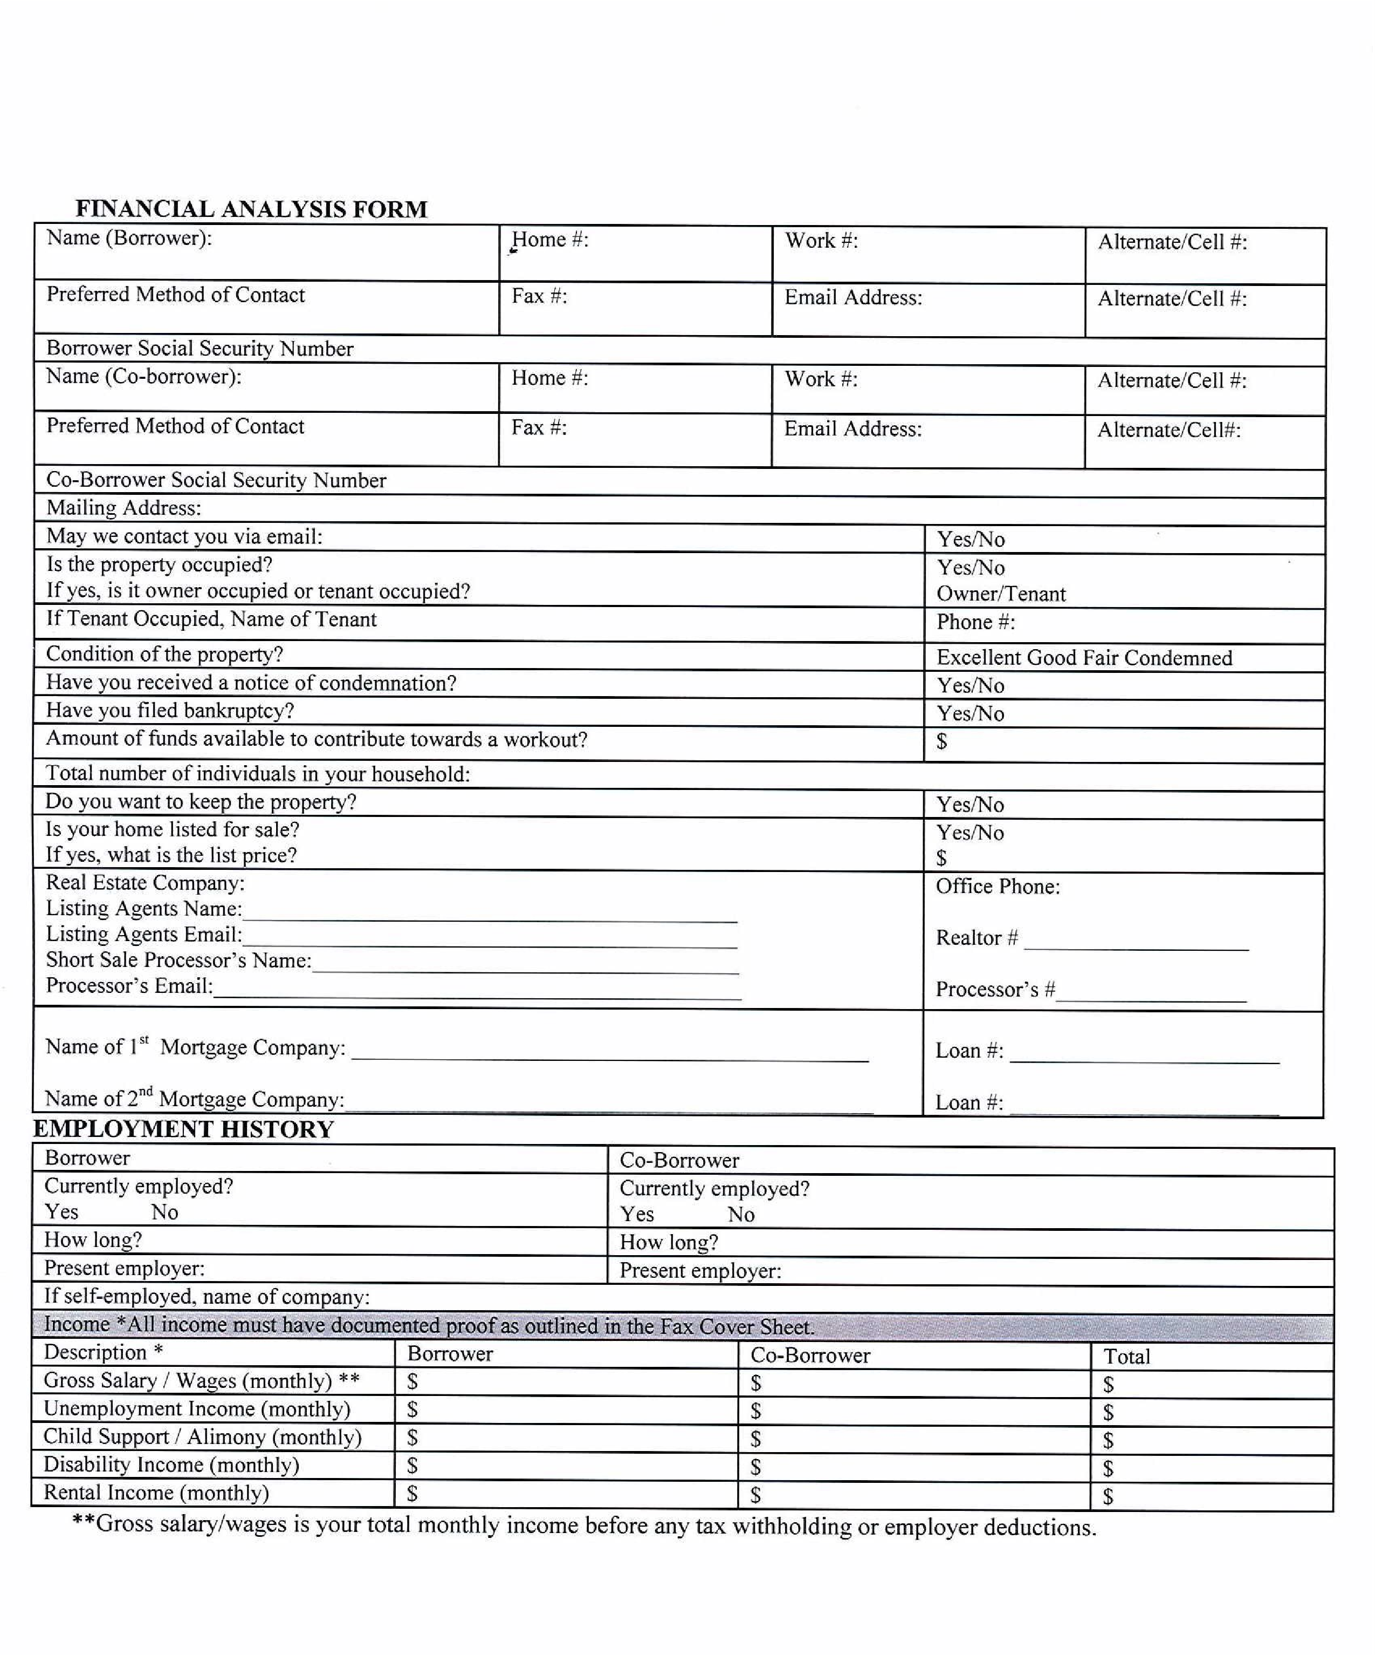
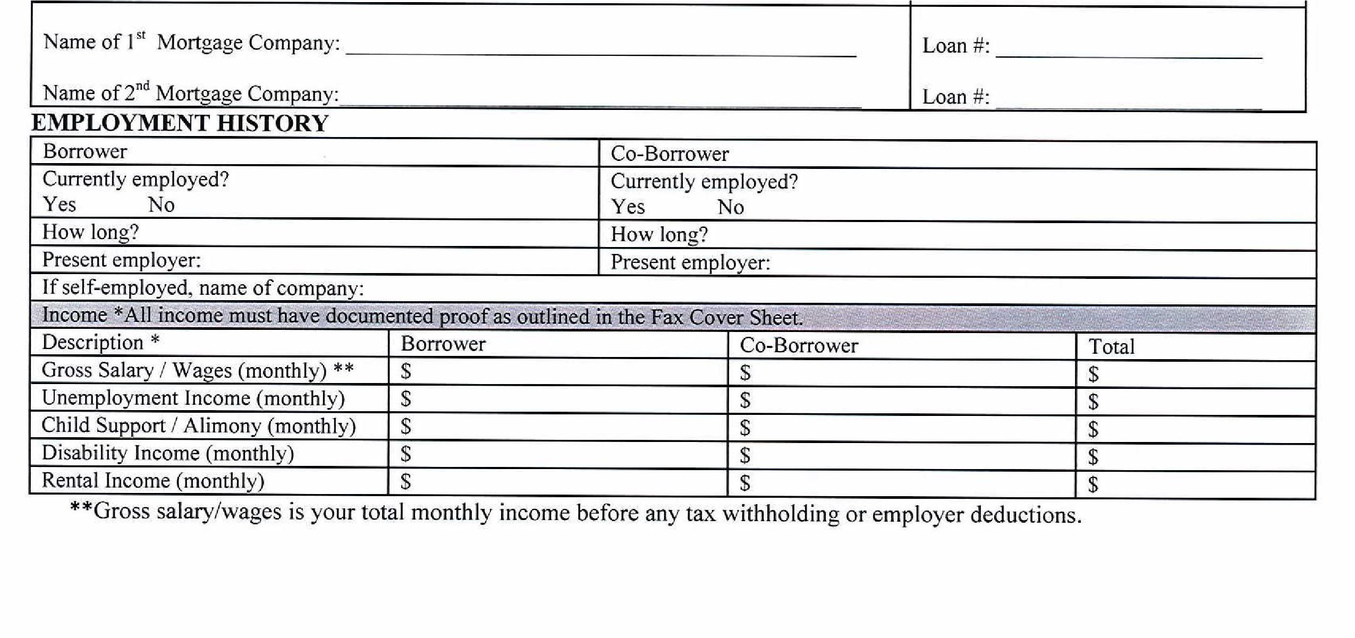

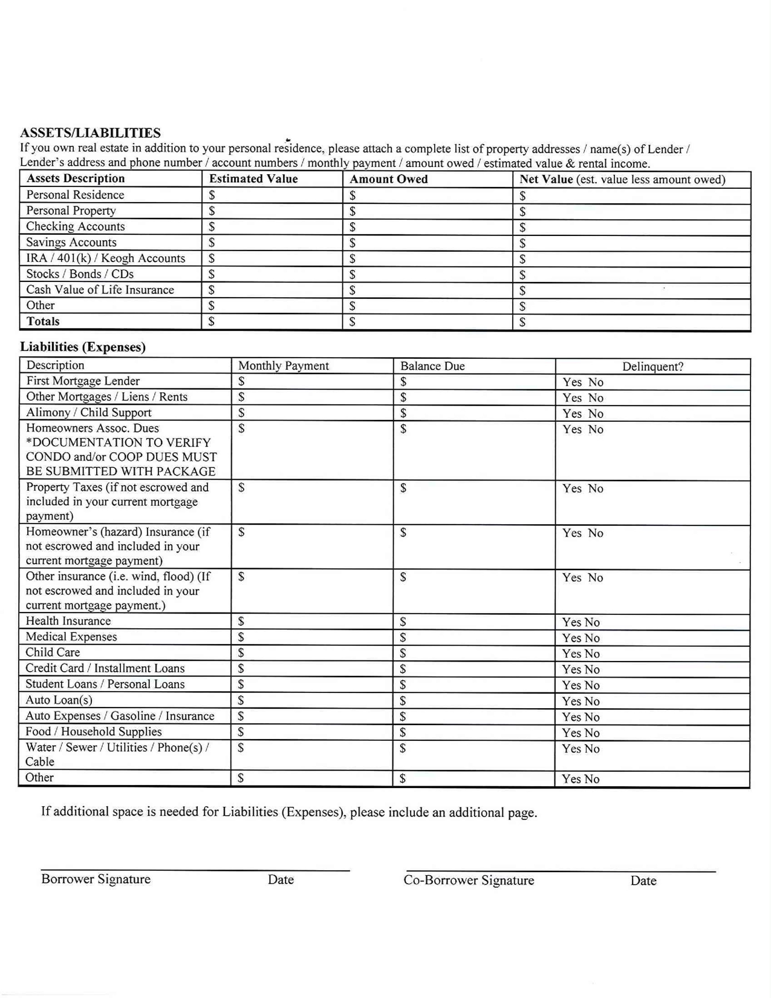
I (We) understand that the financial information on provided is an accurate statement of my (our) loan financial status. I (We) understand and acknowledge any on taken by the lender of my (our) mortgage loan on my (our) behalf will be made in strict reliance on the financial information on provided. My (Our) signature(s) below grants the holder of my (our) mortgage the authority to confirm the information on I (we) have disclosed in this financial statement to verify that it is accurate by ordering a credit report and to contact my (our) Real Estate.
Agent and/or credit counseling service representative if applicable.

Submitted this_____________ day of ___________________, of the year _________________

By: ___________________________________________________ Date ________________
Signature of Borrower
By: ___________________________________________________ Date: ________________
Signature of Co-Borrower
BORROWERS COMMENTS:

Hardship Letter Guidelines
A Hardship letter is required by lenders to consider your request for a Short Sale. You must be honest and explain your situation clearly. They need to understand why you desperately need their help and why you fell behind or why you are struggling. You must also have a legitimate reason for falling behind.

“I/We are requesting a short sale on our property because I/we are having problems making my/our monthly payment (or can no longer make our monthly payments) due to our financial difficulties created by:

I. Hardships - What are your hardships (current and past). For example-

- Unemployment, Reduced Income, Medical Bills, Job Relocation, Business Failure
- Death of Spouse or Family Member, Illness (Personal or family), Car Accident
- Adjustable-Rate Mortgage, Military Service, Incarceration, Damage to Property
- Divorce/Separation, Lawsuits, Eminent of Bankruptcy, Child Support Issues
- Issues with Tenants Not Paying, Destroying Property, Can't Find Renters to Occupy Property
- Property Values Have Dropped, there is No Way We Can Sell for What is Owed in This Market
- Loss of Retirement or Other Income Sources, Tax Issues
- Single Parent or Taking Care of Family Members

The following are the most important messages to get across to the Lender:
  - Why you will not be able to be current again on your loan.
  - We do not have enough income to make these payments.
(Explain how the adjustable rate has affected you if applicable)
  - Explain EACH financial difficulty in detail.
  - How many children/grandchildren do you have? Ages? Other dependents? e. Total Occupants?
  - What are you doing to better your situation (ex: credit counseling, any kind of counseling)
  - What happened to make to fall behind? Please be as specific as possible.

- Any Signed Exemptions of Documents - If you do not have bank statements pay stubs or tax returns, you will need.
to explain the reason in more detail in your letter as to "why" you cannot provide those documents. (i.e., I've been
unemployed for 6 months and have not been able to find work) Note- realize that if you don't have tax returns, then the bank will ask for Extension-Fillings. So, if you don't have Extension-Fillings either, explain why in this letter. (i.e. "I haven’t worked in over 2 years and so I haven't filed taxes nor extensions", or "I haven’t filed my tax returns, or the past 2 years and I failed to file extensions as well).

- Bankruptcy - You could also mention “I don’t want to have to file bankruptcy.”

Financial Hardship Affidavit
Borrower Name: _______________________________________________________________ Date of Birth ___________________
Co-Borrower Name: ____________________________________________________________ Date of Birth ___________________
Property Street Address: _______________________________________________________________________________________
Property City, State, Zip: _______________________________________________________________________________________
Account Number(s): _________________________________________________________________________________________
In order to qualify for a Short Sale, I/we am/are submitting this form to the Servicer and indicating by my/our checkmarks.
("_”) the one or more events that contribute to my/our financial hardship and difficulty in making payments on my/our mortgage loan.

Borrower Co-Borrower
Income has been reduced or lost for example: unemployment, underemployment, reduced job hours, reduce pay, or a decline in self-employed business earnings. Provide details under "Explanation" and have attached verifying documentation.
Household financial circumstances have changed. For example: death in family, serious or chronic illness, permanent or short-term disability, divorce, incarceration, increased family responsibilities (adoption or birth of a child, taking care of elderly relatives or other family members). Provide details under "Explanation" and have attached verifying documentation.
Expenses have increased. For example: monthly mortgage payment has increased or will increase, high medical and health-care costs, uninsured losses (such as those due to fires or natural disasters), unexpectedly high utility bills, increased real property taxes. Provide details under “Explanation" and have attached verifying documentation.
Cash reserves are insufficient to maintain the payment on my mortgage loan and cover basic living expenses at the same time. Cash reserves include assets such as cash, savings, money market funds, marketable stocks or bonds (excluding retirement accounts). Cash reserves do not include assets that serve as an emergency fund (generally equal to three times my monthly debt payments). Provide details under "Explanation" and have attached verifying documentation.
Monthly debt payments are excessive, and we are overextended with my/our creditors. we may have used credit cards, home equity loans or other credit to make my/our monthly mortgage payments. Provide details under "Explanation" and have attached verifying documentation.
If apply, state other reasons I/we cannot make our mortgage payments. Provide details under “Explanation" and have attached verifying documentation.
Explanation (Required):

If additional space is needed for Explanation, please include an additional page.

First Mortgage Company: ______________________________________ Account Number: _____________________ Initials: _____
Second Mortgage Company: ___________________________________ Account Number: _____________________ Initials: ______



