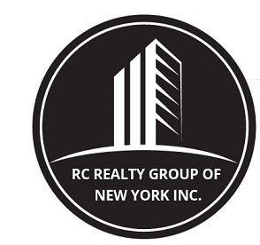

260 West 91st street, SUITE #1A,
NEW YORK, NEW YORK 10024
T: (646) 780-1856
F: (646) 813-1497
EMAIL: rcrealtynyc@gmail.com

WEBSITE: WWW.RCREALTY.NYC

Requirements to Rent an Apartment Without a Board Package

- Signed R C Realty Group of New York Inc. Rental Application Form, along with a $150.00 Non-refundable fee per person Certified check (made payable to R C Realty Group of New York Inc., cash or money order to complete the credit check. This is an amount that is non-refundable. Each person occupying the apartment must undergo a credit check. Additionally, if guarantors are involved, each guarantor will have to pay for a credit check. No exceptions.

- At times, there will be the requirement of “additional background/criminal check” (depending on the landlord), in which case an additional charge of $25.00 per person (non-refundable fee) certified check payable to R C Realty Group of New York Inc.

- Last two (2) years of federal tax returns for each person who will occupy the apartment.

- Copies of recent pay stubs for the last two months; if pay-stubs are not available, then a “hire letter” from the firm where you are to commence work, stating your intended salary and bonus on company letterhead, signed by a manager or HR person. If self-employed a notarized letter from accountant certifying your income.

- Most recent bank statements for the last two (2) months for checking and savings.

- Landlord letter stating that you are a tenant in good standing and that your rent has been paid in a timely manner during the length of your lease and/or copies of your latest rent checks for the last two months. If you are a student coming out of school, this element is waived, but will be required by your guarantor to be provided.

- If you are a college student we need a letter from the college stating attendance information.

- Two letters of reference, one personal, and one professional from an employer, work associate, colleague, or trade association you are affiliated with.

- Copies of any asset statements, (401K’s), brokerage accounts, along with copies of any other asset statements (i.e., real estate holdings etc.).

- Photocopy of your driver’s license and social security card. Resident aliens will be required to provide a copy of their passport along with a copy of their resident visa and/or Green Card

- If the building has a pet policy, a photo of your cat or dog will be required.

- Additionally, guarantors will be required to provide all above elements.

- Out of tri-state area (NY, NJ or CT) guarantors are allowed contingent on building, landlord/managing agent. Not all New York landlords accept out of tri-state area guarantors.

Please note requirements varies per building

* * * * * * * * * * * * * * * * * * * *

