2nd Annual Friendship Gathering
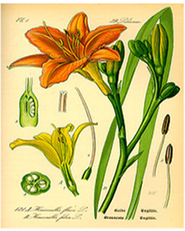
PIONEER GARDEN CLUB FRIENDSHIP GATHERING
Who: All Pioneer Garden Club Members and guests
What: Friendship Gathering for PGC members and guests. Many fun activities are planned such as a Table Decorating Contest, educational speaker, raffles, food and fun.
When: Saturday, February 23, 2019. 10:00 am – 2:00 pm.
Where: Ocala Golf Club, 3130 E. Silver Springs Boulevard, Ocala, FL 34470
Why: All proceeds will benefit Civic Beautification in the gardens of Silver Springs State Park.
More details will be sent to circle presidents as plan are finalized.
For more information, contact Jacqua Ballas, ballasjl@gmail.com, 352-239-3166

