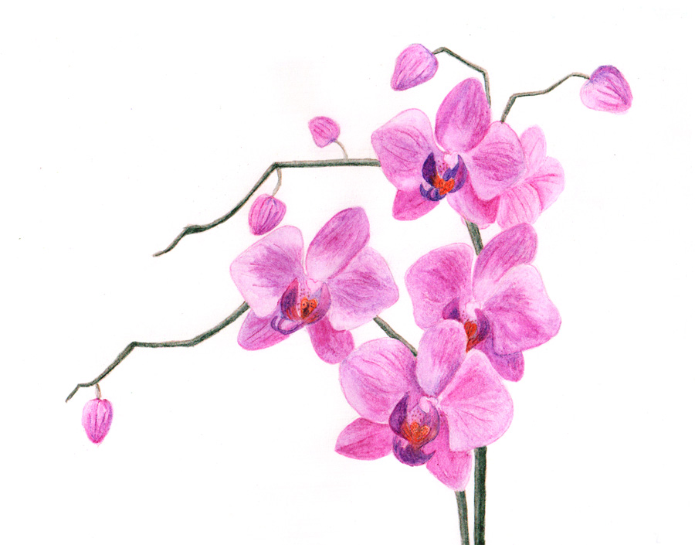

**Fun with Flowers - Learn to make an Orchid Kokedama**

**Program by Barbara McGhee, Morning Glory Circle of**

**Pioneer Garden Club of Ocala**

**Place: Ocala Police Department Community Room**

**402 S Pine Street, Ocala, FL 34471**

**Date: March 27, 2020 Time: 10 AM – 12 noon**

**Bring a Bag Lunch – Beverages Provided**

**Send Registration Form Below & Check Payable to Pioneer Garden Club**

**Jacqua Ballas, Membership VP**

**1391 SE 55th Avenue, Ocala FL 334480**

**352-239-3166**

**Registration closes: March 20, 2020**

**Member: $20.00 Non-Member: $25.00**

**Fee includes all materials needed for this program.**

Keep the Top Half of this flier for your Records

**Cut Along Line for Registration Form**

**\*\*\*\*\*\*\*\*\*\*\*\*\*\*\*\*\*\*\*\*\*\*\*\*\*\*\*\*\*\*\*\*\*\*\*\*\*\*\*\*\*\*\*\*\*\*\*\*\*\*\*\*\*\*\*\*\*\*\*\*\*\*\*\*\*\*\*\*\*\***

**REGISTRATION FORM: FUN WITH FLOWERS: March 27, 2019**

**Name ________________________________________________**

**Member_______________ Non-Member_________________**

**Email ____________________ Phone____________________**

**ATTACH CHECK PAYABLE TO Pioneer Garden Club**

**Treasurers Record: Date Check Received _______________________**