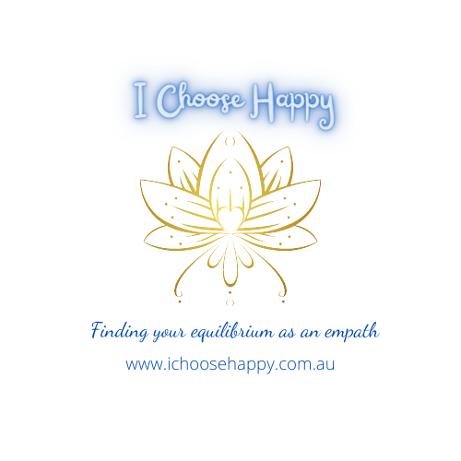
What happens in an Expressive Therapies/ Sand Tray + Symbol Work Session?

COMPLETION OR REVIEWING OF COMPLETED CONSENT FORMS

At the commencement of the session we review the relevant consent forms and discuss anything that arises in the process, which could relate to your physical, mental or emotional state.

DEALING WITH THE “I MUST GET THIS RIGHT’ OR ‘HELP…. I CAN’T DRAW OR DO ART’

Creating a safe and trusted space is crucial when working with people. In honouring this I strongly encourage you to share with me if there is anything that you don’t feel comfortable with or would like to change. This can include things such as preference for music, adjusting the room temperature and includes any particular expressive therapy methods used.

Some clients are concerned about ‘getting it right’ or being apprehensive about ‘not being able to draw or being ‘good at art’ but we work together to find ways that are most suitable to your personal learning and communication style. There are many methods used in Expressive Therapies and not all will suit you. And that is okay! Also clients will sometimes pick a symbol or draw something and then ask me to interpret what it is they have selected or drawn. Please note- I do not interpret any symbols selected nor do I interpret what is drawn or created. I will however (if appropriate), explore with you what has been created/ drawn or selected and what it is that you notice, see, sense, experience or feel in response to what has been created, drawn or selected.

A NATURAL PROCESS

A basic premise of Expressive Therapies, is that emotional trauma is healed in much the same way that the body repairs a physical injury – in a natural and instinctual way, provided that the right conditions are available. Safety and mutual trust are essential in this approach.

We discuss your main concerns and I will explain the different ‘doorways’ or methods we can work with. Together we are guided by your feelings and responses in opening which doors most suited to you and more important THE ONES YOU CHOOSE TO OPEN…

THE VARIOUS DOORWAYS TO WORK WITH YOUR INNER GUIDANCE IN EXPRESSIVE THERAPIES CAN INCLUDE-
- SHARING YOUR STORY
- THE PHYSICAL BODY - SENSATIONS / PAIN
- EMOTIONS – IDENTIFYING, FEELING AND EXPRESSING
- SYMBOLS
- SANDPLAY
- DRAWING (e.g. DRAWING A BODY MAP)
- VISUALISATION
- MEMORIES / DREAMS / IMAGES
- MOVEMENT

It is my heart-felt intention to treat you with the utmost respect, kindness and sensitivity, whilst honouring and abiding by the ethical guidelines that govern my clinical practice.

