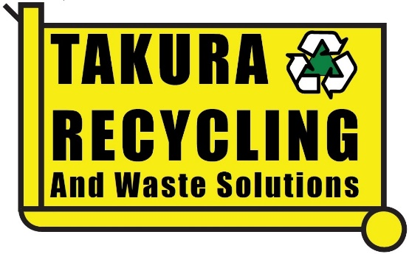
LOAD DECLARATION FORM

Date: Click or tap to enter a date.
Company/Business name: Click or tap here to enter text.
Contact Number: Click or tap here to enter text.
Truck Rego: Click or tap here to enter text.
________________________________________________________________
Please tick appropriate boxes & describe your load type
☐ My load DOES NOT contain any HAZARDOUS waste

☐ My load is clean and has one type of waste only
Waste type: Click or tap here to enter text.

☐ My load contains mixed waste
Waste types: Click or tap here to enter text.

☐ I am not sure what waste types are in my load

You MUST not leave the Resource Recovery Area until your load is inspected, and waste types have been identified.

Name of Driver:

Signature of Driver: _______________________________________________

Please note: Providing false or misleading information on this form will incur a penalty for sorting or transfer of residual non-declared waste.

