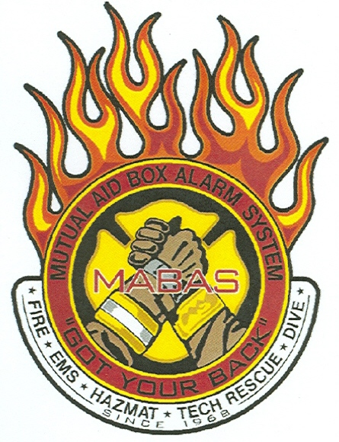
Division XII
Hazardous Material and Special Rescue Reimbursement Policy

Reimbursement of hazardous materials and special rescue costs involving a Division XII incident shall be accomplished in compliance with Federal law and State of Illinois Public Act 095-0497 (SB 1244).

I. The host agency is responsible for billing the party(s) who caused the incident in compliance with Federal law and State of Illinois Public Act 095-0497 (SB 1244).

II. At the time an incident occurs, it is the responsibility of the host agency to request of all the assisting agency(s) the necessary information in order to create a bill. It is the responsibility of the assisting agency(s) to provide the necessary information to the host agency within ten (10) working days of the incident.

III. When reimbursement is received, the assisting agency(s) will be reimbursed on the following basis:

A. Claims for the replacement of equipment will be reimbursed first.

B. Claims for personnel costs will be reimbursed second.

C. Claims for hourly vehicle rates will be reimbursed third.

IV. If less than the amount billed is received by the host agency, reimbursement to the assisting agencies will be proportionate to the total amount billed.

V. Division XII costs for equipment and vehicles will be submitted to the host agency by the Division XII Treasurer only after the Division Team Liaison has approved the accuracy of the bill. This information should be submitted to the host agency within 10 days of the incident. Division XII will not bill for any personnel costs.

VI. If Division XII equipment is damaged at an incident and needs to be immediately replaced in order to keep the Division Team in service, that equipment will be replaced by a vote of the members of Division XII with Division XII funds. Division XII may eventually be reimbursed under the provisions of item V of this policy.

