SOG-_ _ _-_ _ _ ( )
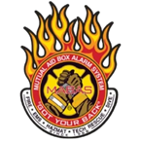 | MABAS Division XII  STANDARD OPERATING GUIDELINES
TITLE: High Rise Operations |  | SECTION/TOPIC:
NUMBER: |  | ORIGINAL ISSUE DATE: 01/01/2025
 |  | REVISED DATE:
Mabas Approval:
These SOGs are based on FEMA guidelines FA-197

Policy Reference

NFPA: 1021

NIMS: 100, 200, 700, 800

Purpose

Incidents within high-rise occupancies pose significant challenges to firefighters due to the building’s structural features and the potential life safety hazards. Personnel must maintain a high state of readiness when responding to and investigating a reported incident within the occupancies due to the likelihood signs of a problem may not be present from the exterior of the building. Personnel must assume a problem exists until officially determined by fire department personnel.

Scope

It must be understood that operations within high-rise occupancies must be implemented in a calculated and purposeful manner. It is difficult in high-rise occupancies to redirect operations once the tactics of an incident action plan have been implemented. It also must be understood safe and effective high-rise operations require longer than normal timeframes and extensive resources.

Policy Reference

NFPA: 1021

NIMS: 100, 200, 700, 800

Purpose

Incidents within high-rise occupancies pose significant challenges to firefighters due to the building’s structural features and the potential life safety hazards. Personnel must maintain a high state of readiness when responding to and investigating a reported incident within the occupancies due to the likelihood signs of a problem may not be present from the exterior of the building. Personnel must assume a problem exists until officially determined by fire department personnel.

Scope

It must be understood that operations within high-rise occupancies must be implemented in a calculated and purposeful manner. It is difficult in high-rise occupancies to redirect operations once the tactics of an incident action plan have been implemented. It also must be understood safe and effective high-rise operations require longer than normal timeframes and extensive resources.

Definitions:

Attack Stairwell: The stairwell chosen for standpipe hose operations for fire attack. This stairwell is discouraged to be used for evacuation/rescue due to smoke/heat/steam conditions. An alternate stairwell is to be deemed as an Evacuation Stairwell which is preferably not contaminated and is pressurized.

Core Type High Rise Building: A building in which the elevators, stairway, and building support systems are grouped together in one area of the building. This area could be in the center of the building as in the center core building type or on one of the sides of the building as in a side core building type.

Curtain Wall: A non-bearing wall, built between columns for the enclosure of the structure, but not supported at each story.

Evacuation Stairwell: This stairwell(s) is chosen by the IC. This is an alternate stairwell(s) to the Attack Stairwell that is not contaminated by smoke/steam/heat and is often air pressurized by imbedded building.

High-Rise: Any building over 6 stories in height

Mixing dampers: Dampers in the HVAC system which control the mixing of the return and outside air.

Plenum: An air compartment to which one or more ducts are connected and which form a part of an air distribution system. The space between the suspended ceiling and the underside of the floor above is used as a plenum for the collection of the return air.

PRV: Pressure Reducing Valve located on a standpipe.

Rapid Ascent Team: Companies assigned to use an elevator to ascend to the top floor and descend stairwells to conduct primary search operations. AKA: RAT.

Scissor Stairs: Two stairs constructed side by side in the core of a building in which their doors alternate the point of exit to opposite sides of the core.

Stack Effect: Stack effect is the movement of air into and out of buildings, chimneys, flue gas stacks, or other containers, resulting from air buoyancy. Buoyancy occurs due to a difference in indoor-to-outdoor air density resulting from temperature and moisture differences.

Standpipe: a rigid vertical or horizontal pipe to which fire hoses can be connected.

Guidelines & Information

Chief Officers and Company Officers will be responsible for ensuring compliance with the provisions of this SOG.

Chief Officers and Company Officers will conduct Company school to ensure that all members under their command understand this SOG.

It is the responsibility of all members to have a thorough knowledge of this SOG.

High Rise Firefighting Operations Safety. The safety of fire fighters and building occupants is the top priority at these incidents. To address this priority, the following principles and practices must be employed.

All personnel shall be in appropriate personal protective equipment based upon their location in relation to the incident and their assignment.

The incident command system shall be utilized for every incident covered by the provisions of this guideline. All provisions of the incident command system, when warranted, including Accountability, Safety Officer, Rapid Intervention, and Rehabilitation need to be implemented and adhered to throughout operations.

Reconnaissance activities are a critical aspect of the High-Rise operations. It is imperative that first in firefighting personnel accurately identify the location of the lowest level of fire along with an assessment of the volume/extent of fire and smoke. Based upon this information, the first arriving Officer responsible for fire attack will need to identify the most advantageous stairwell to be used for fire attack (a.k.a. FA stairwell) activities. Factors involved in the determination of the FA stairwell(s) should include the proximity of the stairwell to the main body of fire, stairwell position in relation to fire attack method, known/presumed number of occupants within the stairwell, and the ventilation features of the stairwell. All information related to the reconnaissance activities and the identification of the FA stairwell inclusive of its location must be relayed to the incident commander to support the development of the incident action plan.

Evacuation activities must be coordinated with a fire attack which includes the designation of evacuation stairwell(s) that is independent of fire attack activities. Additionally, and when available, the building communication system must be used to disseminate information to building occupants regarding general incident information and evacuation directions. The decision to implement a complete evacuation of the occupancy rests with the incident commander. The priority locations for search and evacuation include the fire floor(s), immediate floors above the fire, and then the remaining floors above the fire inclusive of the roof deck (if accessible to building occupants). It is imperative that all stairwells and all elevators be searched.

When responding to incident areas within a building for the investigation of a fire alarm or response to a suspected IDLH atmosphere, personnel should use the building stairwells to access any incident areas that are located on the fifth (5th) floor or below. Incident areas above the fifth (5th) floor can be accessed via building elevators while following the provisions outlined within this Standard Operating Guideline.

In most cases the initial attack hose line should be the 2 ½ inch line contained in the High-Rise pack with the 1 ¼ inch smooth bore nozzle. The 2 ½ inch line with a smooth bore nozzle will provide the fire attack crew with maximum ability for fire knock down with water supplies that may provide reduced pressures. Unless circumstances require otherwise, the fire attack hose line should be connected to the standpipe at the floor below the fire floor being attacked.

STRATEGIC PLAN: Determine fire floor / Verify fire floor (FIT) / Control building evacuation / Gain control of building systems / Confine and extinguish fire.

COMPANY FUNCTIONS AND RESPONSIBILITIES (Activated Alarm)
1st Due Engine – Size-Up, Keys & Recall Elevators, and Fire Investigation Team
1st Due Truck - Fire Investigation Team
1st Due Batt Chief – IC (Lobby)

COMPANY FUNCTIONS AND RESPONSIBLITIES (WORKING FIRE / HIGH RISE RESPONSE)

1st Due Engine – Size-Up, Keys & Recall Elevators, FIT, and 1st Attack hose line

1st Due Truck – FIT, OTIS, Primary search and evacuation of fire floor, support engine operations

2nd Due Engine – Assist 1st engine with 1st attack hose line operation.

2nd Due Truck – Assist with primary search of fire floor and floor above.

3rd Due Truck – Rapid Ascent Team top/down stairwell searches (ATTACK STAIRWELL)

3rd Due Engine –Connect into building fire suppression system and lobby control

4th Due Engine - Rapid Ascent Team top/down stairwell searches (EVACUATION STAIRWELL)

TYPICAL COMMAND STAFF ASSIGNMENTS (WORKING FIRE / MABAS BOX)
Initial IC/IC (Lobby)
Forward Fire Command Chief [two (2) floors below fire floor]
Fire Attack Chief
Lobby Control Chief
Plans Chief
Search & Rescue Chief
Medical Group Chief
RIT Chief
Safety Chief
Support & Logistics

High-Rise Activated Fire Alarm

For High Rise buildings, buildings over 6 floors or 60-feet requiring additional fire, EMS, and command resources for tactical reasons per the MABAS DIVISION 12 High Rise SOG, they will be recognized with a response district number with a final digit of ‘8’ or ‘9’ (e.g., ‘District 219’ indicating a High-Rise response in Bloomingdale District 21). The response shall be: Two (2) Engines, Two (2) Trucks, One (1) Ambulance, Two (2) Battalion Chiefs

Operational Procedures at Still Alarms (AFAs)

First arriving fire companies – Fire Investigation Team (F.I.T.)

The first arriving company will provide an initial size-up including:

Arrival on scene

Conditions

Length x Width, number of stories, and unique construction features

Type of occupancy (commercial or residential)

Actions taken

Directions of travel

High-Rise Personnel Deployment

When considering the task of developing and deploying the F.I.T. the officer of the first arriving company should always remember that the F.I.T. must consist of two (2) companies, ideally one (1) engine and one (1) truck but might consist of any combination of engines/ trucks.

Fire Investigation Team (FIT) Operational Procedures (1st Due Engine & 1st Due Truck/ Squad).

The mission of the FIT. A Fire Investigation Team (FIT) will be comprised of personnel from the 1st Due High Rise Engine company (including the DRIVER) and 1st Due Truck or Squad company, and a FIT will be placed into effect for all incident types upon arrival (e.g., activated alarm, cooking smoke, fire showing on arrival, etc.)

Additional Responsibilities of the FIT

Reconnaissance to report to the IC.

Mobilize adequate hose and tools to establish an effective 1st attack line operation.

The life safety of persons in immediate danger.

Means of egress of occupants and stairwell integrity.

Growth and spread of fire and smoke.

FIT Engine Company riding positions and tools. (All members shall have a portable radio)

Officer – TIC, hand light, bldg. keys, & one (1) 50-foot 2 ½” high rise hose pack

Driver - One (1) 50-foot 2 ½” high rise hose pack and standpipe bag

Nozzle – Two (2) 50-foot 2 ½” high rise hose packs with nozzle

Control (if staffed) – One (1) 50-foot 2 ½” high rise hose pack [Officer – no hose pack]

FIT Truck (or Squad) Company riding positions and tools. (All members shall have a portable radio)

Officer – TIC, halligan bar, RASP rope bag

Driver – halligan bar & sledge (Assigned as elevator operator)

OV - 8 ft. pike pole, hydraulic door opener, & extinguisher

Search (if staffed) – halligan and sledge or maul.

The 1st arriving High Rise Engine or Truck Officer (FIT) will be responsible for:

Checking the fire alarm panel and communicating findings to incoming companies

Obtaining building keys

Recalling and taking control of building elevators (Refer local high rise plans and elevator operating instructions)

Determining stairwell access for attack, evacuation, or for elevator failure.

Assemble FIT and ensure that all members of the FIT are properly equipped.

Investigating the reported location of the fire and communicating status to the IC.

Initiating fire extinguishment and/or rescue as warranted.

The FIT Truck Officer will serve as the Fire Attack Chief until relieved by a ranking officer.

Restrictions/ Considerations of the Fire Investigation Team

No single company will go above the main floor/ main lobby or grade entrance to make the initial investigation unless reliable information has been received from a competent, responsible party.

Stairwells will be used by the FIT when the reported fire floor is below the sixth floor.

One (1) member must always be left in the elevator, when the elevator is put into fire service mode if the building is so equipped. That member will transport firefighters from the main floor/ main lobby, drop them off three (3) floors below the reported fire floor, and return to the main floor/ main lobby immediately.

At no time will fire service personnel use the elevator unless it is in fire service mode.

If the elevators in the building are not equipped with emergency elevator recall, all elevators must be taken off the automatic control and switched to manual control.

All personnel entering an elevator car will be equipped with self-contained breathing apparatus (S.C.B.A.) and they shall be activated prior to ascending.

The operation of elevator cars in fire service mode will be performed exclusively by MABAS DIVISION 12 personnel. Preferred to be the driver of the truck or squad and designated as “Otis” on the radio and will remain for the duration of the incident until properly relieved.

No more than six (6) members plus their equipment in each elevator car, unless a larger-type car is being utilized (i.e., freight)

The F.I.T. will check at 5 floor intervals to ensure that the elevator is still under firefighter control, as well as check for smoke and water.

All companies will exit the elevator a minimum of three 3 floors below the reported fire floor.

The operator of every elevator must have some type of forcible entry tool, SCBA, portable radio, and one (1) extra SCBA bottle once a working fire is confirmed.

Between all companies entering, they will come in with a full complement of tools and equipment; and

If the reported fire on the fifth floor or lower, the F.I.T. will still recall the appropriate elevator bank, but will utilize the stairwells to walk up from the main floor/ main lobby, or grade entrance.

During the size-up, if it is determined that the size of the building, main floor/ main lobby and/ or reported fire floor will require additional resources to conduct a fire investigation, the next in unit should be requested to join the F.I.T. Notify the Battalion Chief; and

All Company Officers must notify the appropriate Chief(s) upon completion of assignment, and if they are unable to complete an assignment. In addition, the Company Officer must also notify the appropriate Chief if the company is assigned an additional task before the previous task is completed. The Chief Officer(s), in command of these specific operations, must immediately notify the Incident Commander. The Incident Commander will then make the necessary manpower adjustments to ensure the assignment is completed.

Command Staff Operations (High-Rise Response) refer to appendix for position checklists.

The Still Alarm Battalion Chief will communicate scene arrival and building information over DuComm Fire North, or main dispatch frequency, per department policy.

The first arriving battalion chief will establish the command post in the lobby/ main floor, or other appropriate location as logistics dictate, and will remain at the command post for the duration of the incident.

If extraordinary conditions exist, the command post and designations may be altered by the incident commander to fit the particular need. For example; On any occupancy, regardless of floors, where it is beneficial to run the operation following this high-rise SOG, the first arriving Chief Officer shall announce to all companies that the incident will be a “high-rise operation”.

Working Fire Response to a High-Rise Building (4 Engines, 3 Trucks, 1 Heavy Rescue, 4 Medics, 3 BCs, 2 Command Chiefs). In addition to AFA responsibilities the following shall be integrated:

FIT operations confirming a working fire.

Provide a secondary size-up to the I/C.

Communicate the Attack Stairwell and the establishment of an attack line to the fire and confirm the fire floor for FDC hook up.

The FIT truck company shall communicate to the engine officer to determine to either protect-in-place or evacuate the fire floor, assist with the hose stretch, and provide forcible entry/engine company support as needed.

The 2nd due engine shall immediately assist the 1st due engine on the 1st attack line.

Mobilize adequate hose and tools to establish an effective 1st attack line operation.

Assist the 1st Due High-Rise Engine on the attack line.

2nd Due Truck Company “working high rise fire” responsibilities.

Assist with primary search operations on fire floor and/or floor above the fire floor.

2nd Due Truck riding positions and tools. (All members shall have a portable radio)

Officer – TIC, Halligan bar, RASP rope bag and SCBA cylinder

Driver – Halligan bar, sledge, and SCBA cylinder

OV - 8 ft. pike pole, hydraulic door opener, and SCBA cylinder

Search (if staffed) – 8 ft. pike pole, Halligan/sledge, and SCBA cylinder.

3rd Due Engine “working high rise fire” response responsibilities.

The mission of the 3rd Due High-Rise Engine:

Position apparatus to connect into the building fire suppression system.

All personnel shall assist in connections and charging of system.

3rd Due Engine Officer shall report completed assignment to IC directly.

3rd Due Engine Officer and Nozzle position shall assume Lobby Control duties as designated by the IC or Lobby Control Chief.

3rd Due Truck Company “working high rise fire” responsibilities.

Primary top/down (if possible) search as Rapid Ascent Team in the Attack Stairwell.

4th Due Engine Company “working high rise fire” responsibilities.

Primary top/down (if possible) search as Rapid Ascent Team (Evacuation Stairwell(s).

As assigned by IC

1st Due Squad Company “working high rise fire” responsibilities.

Position apparatus and equipment for air re-supply and rescue as close to building entrance as possible.

Report to IC for assignment, default assignment is to initiate the search on the floor above and prepare for other duties as assigned.

4th Due Truck Company “working high rise fire” responsibilities (MABAS BOX).

Primary top/down search as Rapid Ascent Team.

5th Due Engine Company “working high rise fire” responsibilities (MABAS BOX)

Establish a 2nd attack line.

Relieve the 1st and/or 2nd due engine companies on the 1st attack hose line.

Primary top/down search as Rapid Ascent Team (either Attack or Evacuation Stairwells).

5th Due Truck Company (working high rise fire” responsibilities (MABAS BOX)

Report to the IC for assignment

6TH Due Engine and Truck Companies “working high rise fire” responsibilities (MABAS BOX)

Rapid Intervention Team

Chief Positions:

This first arriving Command Chief/ BC will assume the role of Incident Commander (IC), establish a command post in the lobby and ensure completion of the following tasks:

Review the pre-fire plan, floor plans, etc. and confer with the building representative (i.e., building engineer).

Confirm all assignments, redeploy if necessary.

Locate and supervise the operations of the FACP/communication/ command panel.

Confirm the fire floor, location, and extent of the fire.

Determine whether any announcements have been made on the public address system; if any evacuation is in progress; and the extent of the evacuation to what floors via what stairwells. Repeat or modify the announcement as required.

Establish communications with FIT and Forward Fire Command (FFC) on designated fireground channel.

Designate stairwells to be utilized for fire attack and for evacuation. Notify Dispatch of those designations by letter, name, and/or location of the stairwell.

Upgrade the alarm to a MABAS Box upon confirmation that the fire requires a lead out from the standpipe. Confirm staging location for extra alarm companies.

Ensure that adequate resources are available to accomplish systematic and thorough search of the entire structure, extinguishment, ventilation, and relied/ rotation of personnel.

Give progress reports on the status of the fire and status of the searches, including well-being checks received.

Duties for companies standing by: Lobby Control, Fire Attack, Search & Rescue, Forcible Entry, Ventilation, Support Area/ floor, Stairwell Support Companies, Salvage, Forward Staging Area.

Remain as Lobby Command Chief for the duration of the incident.

Next Arriving Battalion Chiefs or a Command Chiefs

2nd Arriving Chief: Forward Fire Chief

Conduct a face to face with initial IC and then will typically be assigned the Forward Fire Command position two (2) floors below the fire floor.

Contact the FIT company for status report. Confirm location and extent of the fire, identification of the stairwells, summary of actions taken/ progress made, and anything that requires further attention (C.A.N. report)

Maintain accountability of companies from the forward staging area and above.

Update the IC

Notify the IC if the fire needs to be attacked from a different front, request an additional chief to command/ coordinate that operation.

Coordinate the relief of personnel on the attack team using the three-company relief method.

One company on the line

One in the stairwell

One ready in reserve in the support area/ forward staging.

Assess the need for a support and rest area and notify the IC accordingly.

Coordinate search and rescue operations

Coordinate ventilation operations

Initiate salvage operations

3rd Arriving Chief: Fire Attack Chief

Conduct a face to face with the initial IC and after being designated at the Fire Attack Chief confer with FFC face to face regarding operations and accountability.

Proceed to the fire floor and take command of all operations on the fire floor and floor above under the direction of the FFC.

Conduct a size-up.

Check for extension and monitor smoke movement.

Provide progress reports to the FFC.

Monitor safety of all personnel on the fire floor and one floor above the fire, completing ongoing assessments of the fire and conditions.

Initiate salvage and overhaul operations.

4th arriving Chief: Lobby Chief

Report directly to the IC

Maintain communication with building representative(s).

Take charge of the second engine and ensure that FDC is being properly fed.

Ensure proper announcements are made via the public address system.

Ensure that stairwells and elevators are controlled/ unlocked.

Take control of the FACP and constantly monitor the stairwell phones (if used).

Identify occupancy and any persons who are self-identified as requiring special assistance.

Secure floor plans

Establish which elevators may be used in emergency fire operations mode including freight elevators. Place all elevators in fire service mode to prevent occupants from using them. Ensure all elevator cars are accounted for and searched.

Place another elevator in service to be used for fire companies. (2nd Otis)

Maintain control of the building systems such as the HVAC, utilities, generators, fire pumps and other built in safety equipment, ID unique hazards and onsite hazardous materials.

Shut down escalators to assist with evacuation of occupants.

Control the flow of civilian traffic in the lobby.

5th Arriving Chief: Plans Chief

Conduct a face-to-face with the initial IC regarding operations and accountability.

Coordinate all radio communications with dispatch.

Consider utilizing the radio in a box to assist with communications over IFERN (located in BN21)

Coordinate company assignments in conjunction with the IC.

Track companies between the staging area (on the street) and FFC/ forward staging area.

Control staging area.

Diagram/ Sketch the tactical board.

Research available water supply. For example, 250 West Schick has no hydrants in the lot tied to the municipal system, so we must go to the north side of Schick Road.

Upon receiving a report of occupants in distress or in need of assistance will relay that information to the IC, FFC, or S&R as appropriate and document the following:

Location of occupant

Time of call

Company assigned.

Outcome of call, either protected in place, evacuated to a lower floor, transported to the hospital, etc.

Provide update to main dispatch on outcome.

6th Arriving Chief: Search & Rescue Chief

Report to and confer with the IC.

Proceed to the FFC after being designated the Search & Rescue Chief.

Confer with the FFC on the status of ongoing search and rescue operations and establish an initial S&R Command Post 2 floors below the fire floors.

Notify the IC when that is in place.

Relocate to a floor above the fire as conditions change:

Determine resources needed to complete the search and rescue operation and advise the IC.

Assign and document companies to respond to occupants in need of assistance, verify completion of those assignments.

Assign companies to conduct a thorough and systematic search of each floor, hallway, stairwell, elevator car, elevator shaft. Notify the FFC when primary, secondary, and final searches are completed.

7th Arriving Chief: EMS Chief (Medical Group)

Report face-to-face with the IC in the lobby, receive briefing on the incident, and confer with the first-in ambulance.

An additional radio frequency might be recommended for EMS operations.

Set up EMS staging, triage, treatment, and transportation.

Determine whether this is an MCI, MVI, or requires specific communications with resource hospital. Communicate that plan with the IC.

Refer to Appendix A for Medical Operations

8th Arriving Chief: RIT Chief

Confer with IC, after being designated the RIT chief report to the FFC two floors below.

Assemble team and gather all essential tools and equipment including elevator rescue tools.

Conduct a size-up and obtain floor plans/ pre-fire plans.

Establish an area of operation one floor below the fire floor (if possible) and standby.

Monitor radio communications on all fireground channels being used.

9th Arriving Chief: Safety Chief

10th Arriving Chief: Support & Logistics Chief

Confer with the IC

Proceed three (3) floors below the fire and establish the support area. Notify the FFC of the exact location of the support area.

Assemble equipment, designate separate areas for full and empty SCBA.

Direct and ALS fire apparatus to operate the support area.

They should have appropriate medical equipment such as first-in bag, cardiac monitor, etc.

Consider utilizing a medic for a formal rehab area.

Provide any medical care to civilians/ firefighters as required.

Make oxygen available for civilians and firefighter personnel.

Assign one person to direct civilians/ firefighters exiting the stairwells or elevators to appropriate destination.

If needed designate a “rest area” one floor below the Support area and designate a person to be responsive for that floor including accountability of civilians/ firefighters as the enter and exit the support area.

APPENDIX A – High Rise Emergency Medical Operations
INTRODUCTION:
Fires in a high-rise building, as defined in the MABAS DIVISION 12 High-Rise Building Firefighting Policy, has the potential to be mass casualty incident/multiple victim incident (MCI/MVI) where the number of patients and the nature of their injuries make the normal level of stabilization and care unachievable; and/or can tax resources to manage the scene under normal operating procedures. It is critical to establish the Medical Group at the beginning of the incident to allow for incident growth and to prevent loss of life. It is recommended that all EMS Operations be conducted on a separate fireground channel.

- COMPANY FUNCTION AND RESPONSIBILITIES:
  - FIRST ARRIVING MEDIC UNIT (Command and Triage Officer) - Working High Rise Fire:
    - The Officer of the first EMS unit on scene establishes the Medical Group until relieved by a Command Chief and will serve as an aid to the assigned Chief Officer:
      - The first arriving Medic Unit Officer shall report to the Lobby/Incident Command with their medical equipment and gurney, and establish the Medical Group
      - The Medical Group Officer shall report to and remain near the Command Post and establish the Medical Group position in the Command Area.
      - The Triage Officer will be responsible for maintaining numbers of patients, categories of patients, establishing a triage location and giving progress reports to the Medical Group Officer and Incident Command.
      - The Triage Officer will be given a list of the companies working in their Group.
      - The Driver of the first arriving Medic Unit will assist with the establishment of the Medical Group and assume the Triage Officer once a Command Chief is assigned or, if an MCI/MVI should be declared.
      - Set up triage and begin to triage any patients found. They will also begin treatment until help arrives.
  - SECOND ARRIVING MEDIC UNIT (Treatment Officer and Transport Officer) - Working High Rise Fire:
    - The second arriving Medic shall report to the Medical Group with their medical equipment, PPE, and gurney to establish triage.
    - The Medic Unit itself should be parked away from the building in a position so as not to block other companies.
    - The officer from the second due ambulance will assume communications with the resource hospital and will work with Treatment and Transport Officers to coordinate hospital availability set up treatment area.
    - The driver from the second due Medic Unit will become the Treatment Officer, overseeing the treatment of patients on the scene.

  - THIRD ARRIVING MEDIC - Working High Rise Fire:
1.3.1 The third due Medic Unit will assist in support and treatment in the EMS/Triage area.
    - The officer of the 3rd due Medic Unit will assist with the set-up of the treatment area and then assume the role of Transport Officer. The Transport Officer will use the information from the Medical Control Officer and staging to pair patients with ambulances for transport.
    - Track each patient that leaves the scene of the incident.
    - The driver will assist in either triage of patients or treatment of patients as needed and assigned.
  - FOURTH ARRIVING MEDIC UNIT (RIT Medic Unit) - Working High Rise Fire:
    - The fourth due Medic Unit will assist in support and treatment in the EMS/Triage area, until a working fire is confirmed and RIT is assigned.
    - Once RIT is assigned, this medic crew outfitted in full PPE, plus SCBA (if available), their medical equipment, stair chair, spare SCBA bottles (if available) and gurney and report to the RIT Chief and/ or RIT company.
    - The medic crew will be under the direction of the RIT Chief and use the radio frequency assigned to the Forward Fire Command.
    - In the event the responding medic unit is not equipped with SCBA, the IC (or designee) can reassign to fill any gaps in reassigned units.
  - Additional Arriving Medic Units:
    - Once a working fire is confirmed, additional Medic Units shall be requested by the Incident Commander, with all additional Medic Units reporting into Staging until assigned.
    - Report to the incident staging officer until assigned.
    - Other responder(s) begin(s) primary triage using START or Jump START triage and SMART tag systems.
- MEDIC UNIT EQUIPMENT REQUIREMENTS:
  - All Medic Units reporting to the lobby shall have the following equipment:
    - Stretcher with a backboard and c-collars/head bed.
    - Stair chair.
    - Jump bag with medications with extra oxygen cylinders.
    - MCI Kit with tags, clipboards.
    - Cardiac monitor & medic unit’s cell phone

- Rehab– Rehab should always be considered by Command for high rise fires. Rehab must be established as soon as possible with one or two medic units to be assigned to set up and maintain rehab for other working companies. Command should consider putting this group on the same floor as the Support Area under the direction of the Support and Logistics Chief. In most situations, this location will be three (3) floors below the fire floor.
MABAS DIVISION 12 HIGH RISE FIREFIGHTING STANDARD OPERATING GUIDELINE
HIGH RISE INCIDENT COMMANDER CHECKLIST

CHIEF OFFICER HIGH RISE BOX ASSIGNMENTS

□ INCIDENT COMMAND

□ FORWARD FIRE COMMAND

□ FIRE ATTACK CHIEF

□ LOBBY CONTROL

□ PLANS CHIEF

□ SEARCH & RESCUE CHIEF

□ MEDICAL GROUP

□ RIT CHIEF

□ SAFETY CHIEF

□ SUPPORT & LOGISTICS
Appendix B High Rise Command Position Checklists
MABAS DIVISION 12 HIGH RISE FIREFIGHTING STANDARD OPERATING GUIDELINE
HIGH RISE INCIDENT COMMANDER CHECKLIST
□ SET UP COMMAND POST IN LOBBY (Remain in position for duration of incident).
□ PORTABLE COMMAND BOX SET UP.
□ COMMUNICATE WITH FFC OR FIT FOR INFORMATION.
□ LOCATE/SUPERVISE OPERTION OF BUILDING COMMAND/COMM PANEL
(Until arrival of the Lobby Control Chief).
□ REVIEW FLOOR PLAN (QUICK REFERENCE BOOK if available).
□ CONFER WITH BUILDING ENGINEER OR RESPONSIBLE PARTY.
□ PA SYSTEM ANNOUNCEMENTS BY FIT OR BLDG MGMT (Repeat or Modify as needed).
□ CONFIRM SITUATION ENCOUNTERED (e.g., fire conditions, extent, location, etc.)
□ ESTABLISH COMMUNICATIONS WITH FFC / FIT.
□ CONFIRM FIRE FLOOR, FIRE ROOM(S), AND EXTENT OF FIRE.
□ SMOKE CONDITIONS: Light – Moderate – Heavy.
□ ATTACK & EVAC STAIRWELLS CONFIRMATION TO DUCOMM.
CONFIRMATION OF WORKING FIRE
□ 1 LINE: MABAS BOX ALARM 2 LINES: MABAS 2ND ALARM
□ REPORT FIRE EXTENT, LOCATION, ROOM(S), SMOKE CONDITIONS, & STATUS
OF OCCUPANTS.

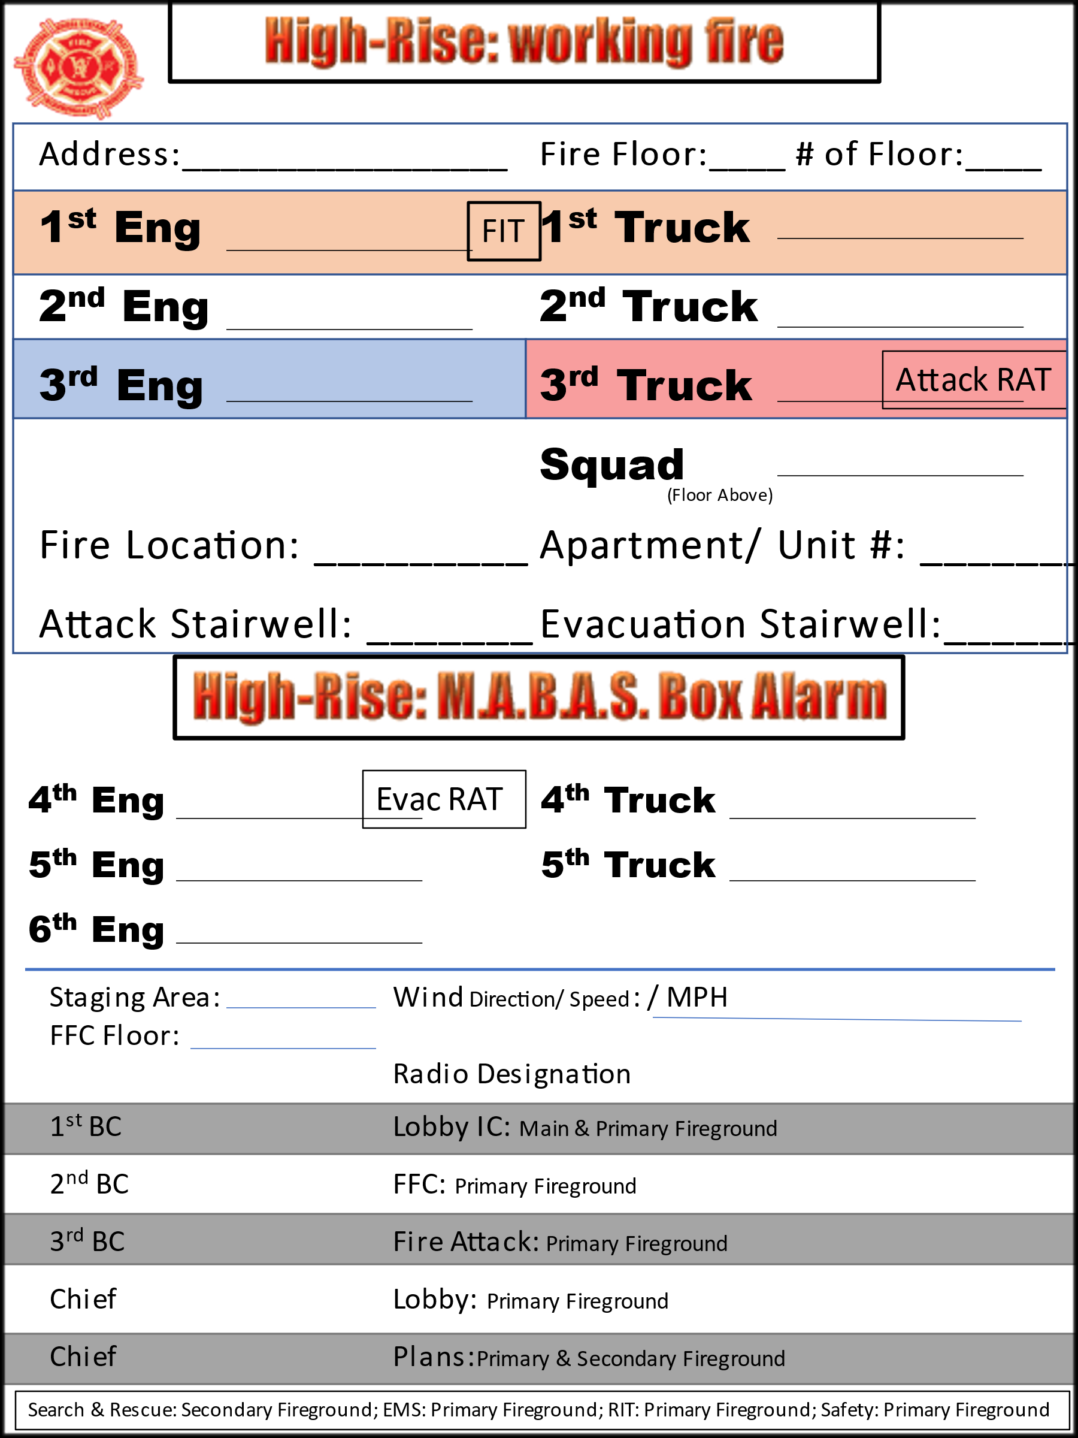
MABAS DIVISION 12 HIGH RISE FIREFIGHTING STANDARD OPERATING GUIDELINE
HIGH RISE LOBBY CONTROL CHIEF CHECKLISTS

LOBBY CONTROL CHIEF HIGH RISE BOX ASSIGNMENTS

□ REPORT TO INCIDENT COMMAND (PLANS CHIEF).

□ SET UP COMMAND BOX IN LOBBY WHERE APPROPRIATE.

□ COMMAND PANEL CONTROL AND OPERATION & BUILDING PREPLANS.

□ 3RD DUE ENGINE PERSONNEL TO ASSIST WITH LOBBY CONTROL OPERATIONS.

□ FIRE COMMAND PANEL BUILDING ANNOUNCEMENTS FOR OCCUPANTS
(To be repeated and/or modified as needed)

□ STAIRWELL PHONES TO BE USED (if available) AS ALTERNATE COMMUNICATIONS

□ UNLOCK STAIRWELL DOORS (if available) VIA FIRE CONTROL PANEL.

□ VERIFY ATTACK AND EVACUATION STAIRWELLS.

□ SECURE THE BUILDING ENGINEER OR BUILDING REPRESENTATIVE:
- CONTROL CENTRAL HVAC SYSTEM.
- ELECTRICAL SYSTEM CONTROLS.
- ELEVATOR SYSTEM CONTROLS.
- NATURAL GAS SERVICE.
- SECURITY SYSTEM ACCESS.
- FIRE PUMP OPERATIONS.

□ CONFIRM TOTAL NUMBER OF STAIRWELLS & ELEVATORS (All are recalled).

□ SECURE BLG OCCUPANT LIST AND OCCUPANT ‘SPECIAL NEEDS’ LIST.

□ LOCATE AND OPEN ATTACK & EVACUATION STAIRWELL DOORS.

□ SUPERVISE (Using fire companies via I/C) THE FLOW OF EVACUEES OUT OF
STAIRWELLS AND LOBBY.

□ USE ‘RUNNERS’ FROM FIRE COMPANIES TO COMPLETE ASSIGNMENTS AND RELAY INFORMATION TO I/C (If needed).

MABAS DIVISION 12 HIGH RISE FIREFIGHTING STANDARD OPERATING GUIDELINE
HIGH RISE PLANS CHIEF CHECKLIST

PLANS CHIEF HIGH RISE BOX ASSIGNMENTS

□ REPORT TO I/C.

□ PROVIDE TWO (2) PORTABLE RADIOS TO COMMAND POST

□ SET UP COMMAND BOX.

□ DUCOMM COMMUNICATIONS VIA FIRE NORTH, IFERN, AND/OR CELL PHONE.

□ TRANSMIT INCIDENT PROGRESS REPORTS EVERY TEN (10) MINUTES.

□ TRANSMIT ANY NEED FOR ADDITIONAL ASSISTANCE VIA I/C.

□ TRANSMIT INCIDENT PROGRESS REPORTS EVERY THIRTY (30) MINUTES
AFTER MABAS BOX IS STRUCK OUT.

□ COORDINATE WITH LOBBY CONTROL FOR SEARCH AND RESCUE OPERATIONS.

MABAS DIVISION 12 HIGH RISE FIREFIGHTING STANDARD OPERATING GUIDELINE
HIGH RISE FORWARD FIRE CHIEF CHECKLIST

FORWARD FIRE CHIEF
□ REPORT TO I/C AND POSITION TWO (2) FLOORS BELOW FIRE FLOOR.
□ PORTABLE COMMAND BOX SET UP.
□ SUPERVISE FIT COMPANIES.
□ PROGRESS REPORTS FREQUENT TO I/C.
□ CONFIRM WORKING FIRE / LEAD OUT OFF STANDPIPE / CONFIRM ATTACK & EVACUATION STAIRWELLS.
□ VERIFY & REPORT: FIRE & SMOKE CONDITIONS / OCCUPANT STATUS /
EVACUATION STATUS / SEARCHES BEING CONDUCTED
□ ADDITIONAL RESOURCES (As needed).
□ PAR PAST LOBBY CONTROL.
□ COMMUNICATE WITH FIRE ATTACK CHIEF ON FIRE FLOOR.
□ COORDINATE SEARCH & RESCUE NEEDS (Until S&R Chief arrives).
□ COORDINATE VENTILATION / SALVAGE OPERATIONS.
□ COMMUNICATE WITH RIT CHIEF, SAFETY CHIEF, AND SUPPORT & LOGISTICS.

MABAS DIVISION 12 HIGH RISE FIREFIGHTING STANDARD OPERATING GUIDELINE
HIGH RISE FIRE ATTACK CHIEF CHECKLIST

FIRE ATTACK CHIEF

□ REPORT TO I/C FOR BRIEFING.
□ REPORT TO FORWARD FIRE COMMAND TO CONFER.
□ REPORT TO FIRE FLOOR TO ASSUME COMMAND OF ALL OPERATIONS.
□ VERIFY ATTACK & EVACUATION STAIRWELLS.
□ ADDITIONAL RESOURCES (As needed) via FORWARD FIRE COMMAND.

□ COORDINATE PAR AND RELIEF OF PERSONNEL.

□ PROGRESS REPORTS TO FORWARD FIRE COMMAND.

□ SUPERVISE OVERHAUL AND SALVAGE OPERATIONS.

MABAS DIVISION 12 HIGH RISE FIREFIGHTING STANDARD OPERATING GUIDELINE
HIGH RISE SEARCH & RESCUE CHIEF CHECKLIST
(A separate fireground channel is recommended for Search and Rescue operations)
SEARCH & RESCUE CHIEF
□ REPORT TO I/C FOR BRIEFING.
□ REPORT TO FORWARD FIRE COMMAND TO CONFER.
□ ESTABLISH A S&R COMMAND POST (Based on fire conditions & floor plan).
□ VERIFY ATTACK & EVACUATION STAIRWELLS.
□ ADDITIONAL RESOURCES (As needed) via FORWARD FIRE COMMAND.
□ COORDINATE PAR AND RELIEF OF PERSONNEL.
□ RESCUE REQUESTS TO BE ASSIGNED SPECIFIC COMPANIES (Advise I/C).
Document assignments and verify the completion of each assignment.
□ PROGRESS REPORTS TO FORWARD FIRE .
□ ESTABLISH A THOROUGH & SYSTEMATIC SEARCH OPERATION OF:
- EACH FLOOR & ALL HALLWAYS.
- ELEVATOR LOBBY’S, SHAFTS, AND CARS.
- STAIRWELLS (TOP/DOWN SEARCHES RAPID ASCEND TEAMS).
Document assignments and verify the completion of each assignment.
□ MAINTAIN COMPANIES ON CERTAIN FLOORS TO COVER WELL-BEING CHECKS AND OCCUPANTS SHELTERING IN PLACE.
□ NOTIFY FORWARD FIRE OF SEARCH OPS STATUS OF:
- COMPLETED PRIMARY SEARCHES.
- COMPLETED SECONDARY SEARCHES.
- COMPLETED FINAL SEARCHES.

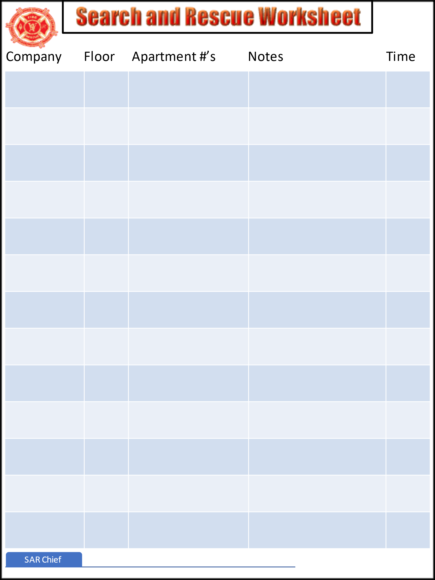

MABAS DIVISION 12 HIGH RISE FIREFIGHTING STANDARD OPERATING GUIDELINE
HIGH RISE SUPPORT & LOGISTICS CHIEF CHECKLISTS

SUPPORT & LOGISTICS CHIEF

□ REPORT TO I/C FOR BRIEFING.
□ REPORT TO FORWARD FIRE TO CONFER.
□ SET UP SUPPORT & LOGISTICS THREE (3) FLOORS BELOW FIRE FLOOR.
□ REQUEST FIRE COMPANY(S) TO ASSEMBLE RESOURCES AS NEEDED.
□ COMPANIES ASSIGNED TO SUPPORT & LOGISTICS WILL BRING EXTRA
SCBA AIR CYLINDERS TO THE SUPPORT AREA.
□ SET UP A REHAB AREA ON THE SAME FLOOR (if possible).
□ REPORT RESOURCE STATUS/NEEDS DIRECTLY TO I/C.
□ MAY REQUEST ALS FIRE COMPANIES AND/OR MEDIC UNITS TO
SUPPORT/REHAB AREA AS NEEDED FROM I/C.

MABAS DIVISION 12 HIGH RISE FIREFIGHTING STANDARD OPERATING GUIDELINE
HIGH RISE SAFETY CHIEF CHECKLIST

SAFETY CHIEF HIGH RISE BOX ASSIGNMENTS

□ REPORT TO INCIDENT COMMAND (PLANS CHIEF).
□ REVIEW FLOOR PLAN (QUICK REFERENCE BOOK if available).
□ CONFIRM PAR AND COMMAND/COMPANY ASSIGNMENTS.
□ CONFER WITH BUILDING ENGINEER OR RESPONSIBLE PARTY (If needed).
□ REPORT TO FORWARD FIRE FOR INFORMATION REGARDING SAFETY IN OPERATIONS, STRUCTURAL INTEGRITY, ENERGIZED SOURCES, STACK
EFFECT, ETC.
□ CONFIRM FUNCTIONALITY OF THE RIT CHIEF AND RIT TEAM.
□ CONFIRM FUNCTIONALITY OF EMS & REHAB IN SUPPORT AREA.
MABAS DIVISION 12 HIGH RISE FIREFIGHTING STANDARD OPERATING GUIDELINE
HIGH RISE RIT CHIEF CHECKLIST

RIT CHIEF HIGH RISE BOX ASSIGNMENTS

□ REPORT TO INCIDENT COMMAND (PLANS CHIEF).
□ REVIEW FLOOR PLAN (QUICK REFERENCE BOOK if available). Knowledge of the location of stairwells, elevators, hallways, floor plans, dimensions, ventilation abilities,
penthouse and roof configuration, etc.
□ CONFIRM PAR AND COMMAND/COMPANY ASSIGNMENTS.
□ REQUEST ONE (1) ENGINE, ONE (1) TRUCK, AND ONE (1) MEDIC (if possible)
TO COMPRISE OF THE HIGH-RISE RAPID INTERVENTION TEAM.
□ INVENTORY THE RIT EQUIPMENT/TOOLS AND ASSIGNMENTS.
□ STAGE RIT ONE (1) FLOOR BELOW THE FIRE FLOOR FOR RAPID ACCESS
TO THE FIRE FIGHTING OPERATIONS.
□ RIT CHIEF SHOULD CHECK-IN WITH THE FORWARD FIRE COMMAND TO
ACCESS ANY CHALLENGES AND/OR PROGRESS.
□ RIT PERSONNEL SHALL CONSTANTLY MONITOR FIRE OPERATIONS RADIO
TRANSMISSIONS IN THE EVENT OF A MAYDAY TRANSMISSION.
□ RIT PERSONNEL SHALL REMAIN IN A STANDBY MODE PREPARING TO DETERMINE THE BEST ACCESS TO THE FLOOR ABOVE, THE EQUIPMENT THAT WILL BE NEEDED, AND KNOW THE SEVERITY OF THE FIRE CONDITIONS AT ALL TIMES.

MABAS DIVISION 12 HIGH RISE FIREFIGHTING STANDARD OPERATING GUIDELINE
HIGH RISE MEDICAL GROUP CHECKLIST
(A separate fireground channel is recommended for Medical Operations)

□ REPORT TO I/C.
□ SET UP COMMAND POST IN LOBBY (Remain in position for duration of incident).
□ PORTABLE COMMAND BOX SET UP.
□ MEDICAL GROUP COMMUNICATE ON A SEPARATE FIREGROUND CHANNEL .
□ ASSUME MEDICAL GROUP DUTIES UNDER THE I/C.
□ CONFER WITH I/C ON MEDICAL NEEDS OF FD PERSONNEL & OCCUPANTS.
□ ESTABLISH MEDICAL GROUP AREAS:
- STAGING AREA
- TRIAGE AREA
- TREATMENT AREA
- TRANSPORT AREA
□ ASSUME COMMAND OF ALL PATIENT CARE.
□ PROGRESS REPORTS TO I/C.
□ ADDITIONAL RESOURCES (MABAS BOX LEVELS) THROUGH I/C.

MABAS DIVISION 12 HIGH RISE FIREFIGHTING STANDARD OPERATING GUIDELINE
HIGH RISE MEDICAL GROUP CHECKLIST

MEDICAL GROUP HIGH RISE EMS BOX ASSIGNMENTS

□ MEDICAL GROUP PLANS POSITION

□ STAGING OFFICER

□ TRIAGE OFFICER

□ TREATMENT OFFICER

□ TRANSPORTATION OFFICER
Fire Department
Communications Panel Template

This message will serve as the first message delivered:

Attention! This is not a drill. This is the __________ Fire Department. We have firefighters investigating the report of a fire on the _______ floor. Please remain calm and in a safe location. I will update you again very shortly. (REPEAT MESSAGE)

This message will serve as the second message delivered:

Attention! This is the _________ Fire Department. We have confirmed a fire on the ______ floor. Please evacuate floors ______ only. Use the ________ stairwell to evacuate. I will update you again as quickly as possible. (REPEAT MESSAGE)

This message will serve as the third message delivered:

Attention! This is the ___________ Fire Department. The fire has been extinguished and conditions will be back to normal very shortly. (REPEAT MESSAGE)

