SACSAS Academy, Wangoo 2016

**Sponsored by Sidhartha and Gopika**

**Patriot’s day function :**

School children attending the school assembly.

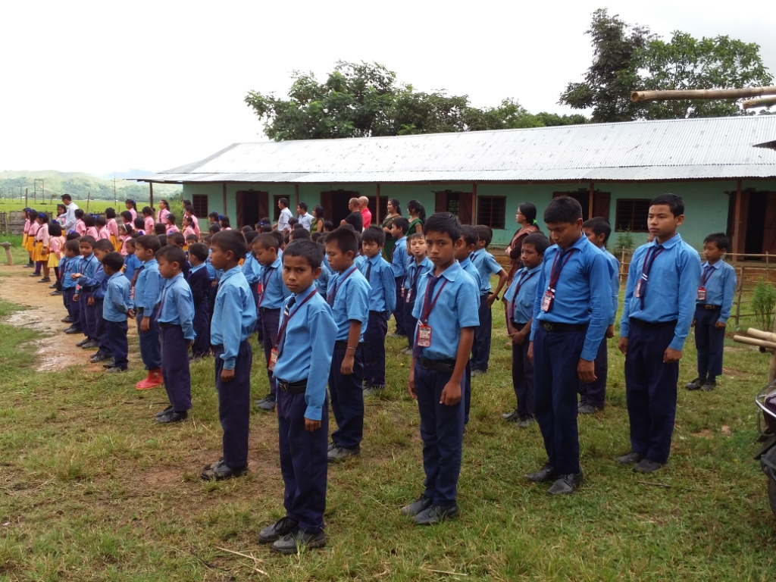

**School chidren attending the Patriot’s day function with their guardians.**

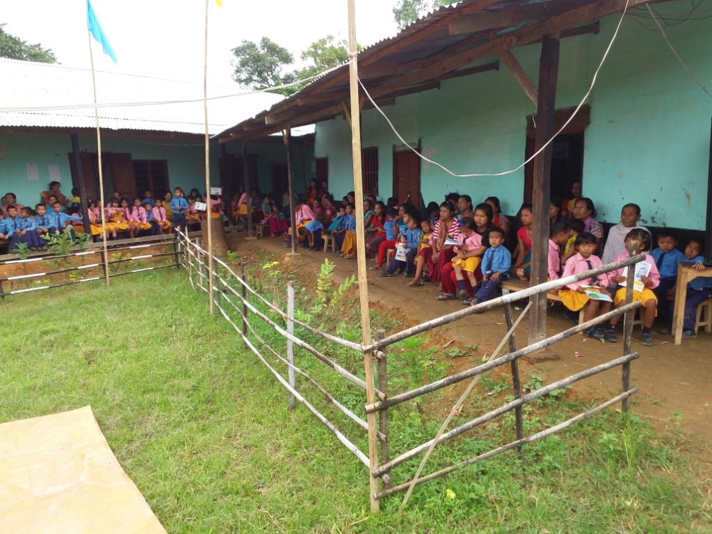

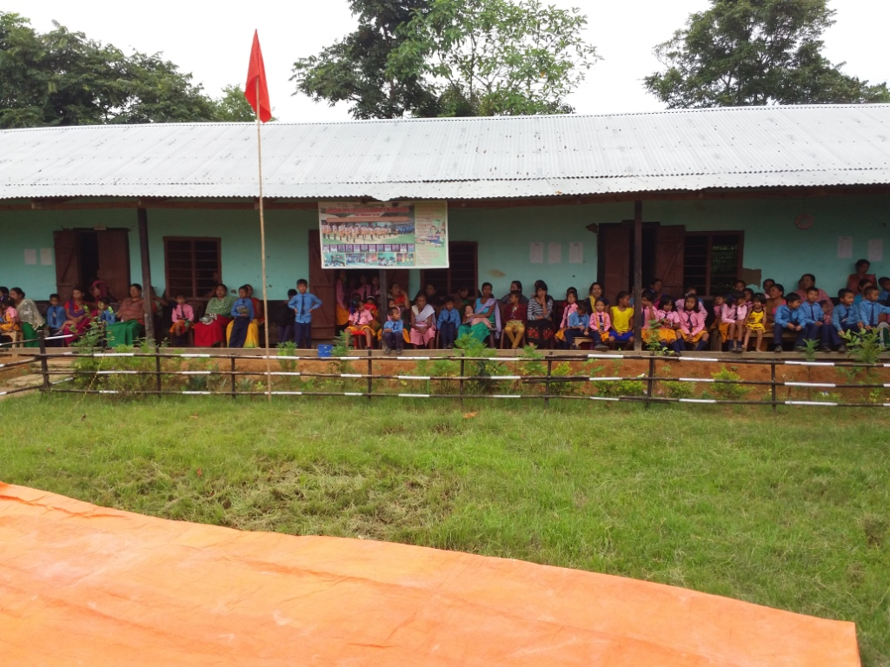

**School chidren attending the Patriot’s day function with their guardians.**

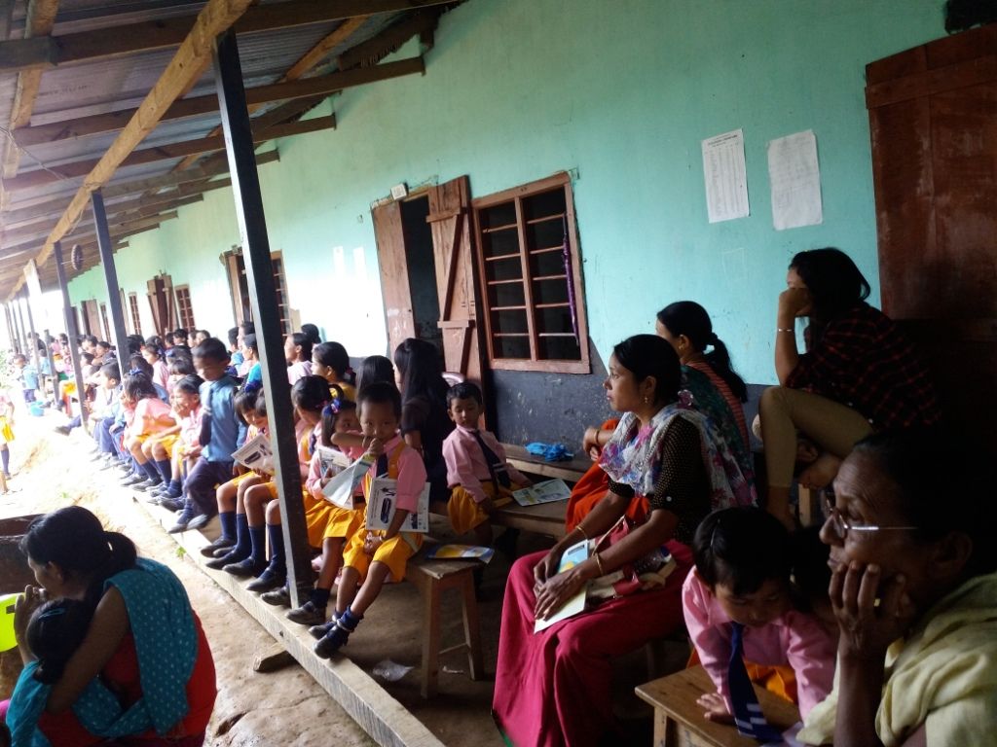

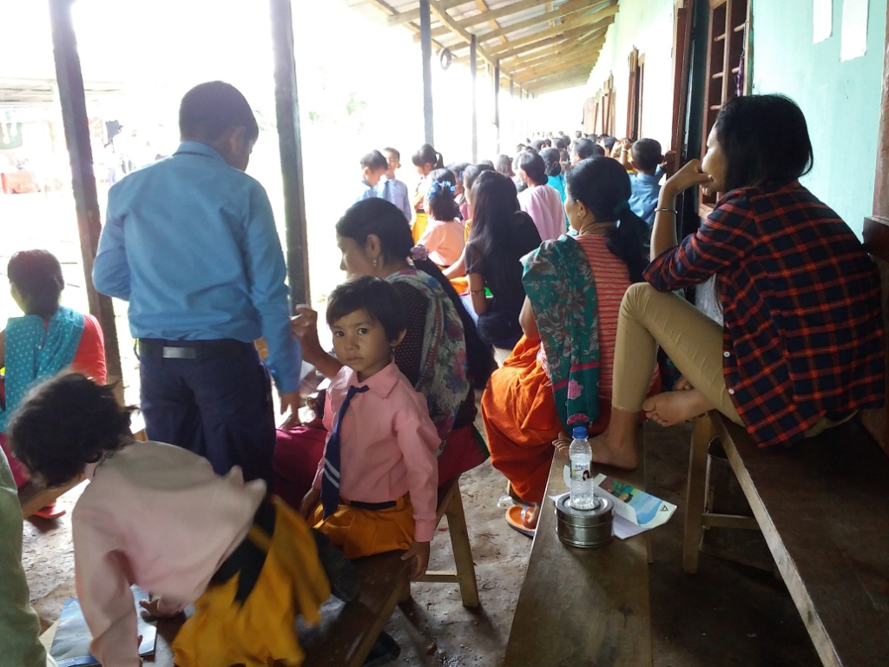

**School chidren attending the Patriot’s day function with their guardians.**

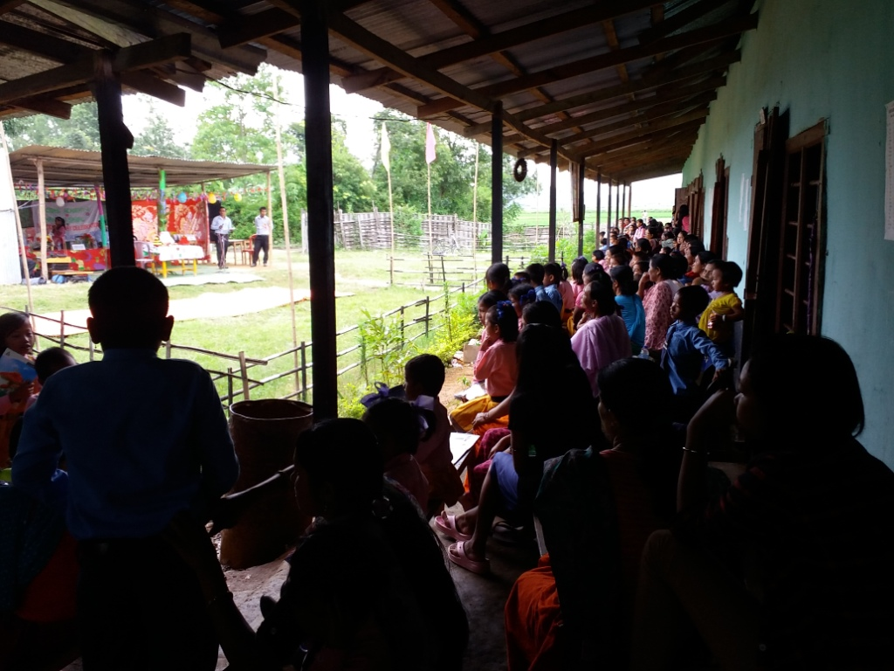

**School chidren attending the Patriot’s day function with their guardians.**

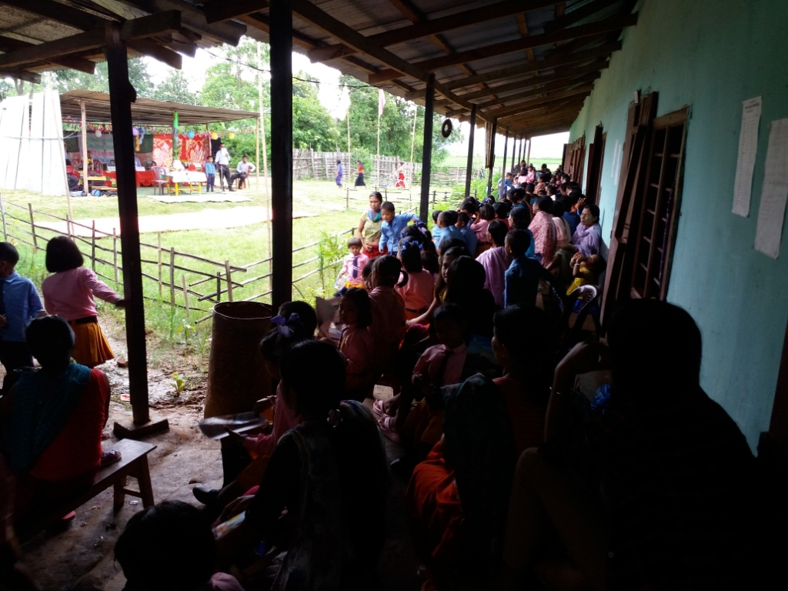

**School chidren attending the Patriot’s day function with their guardians.**



**School children reciting the poems.**

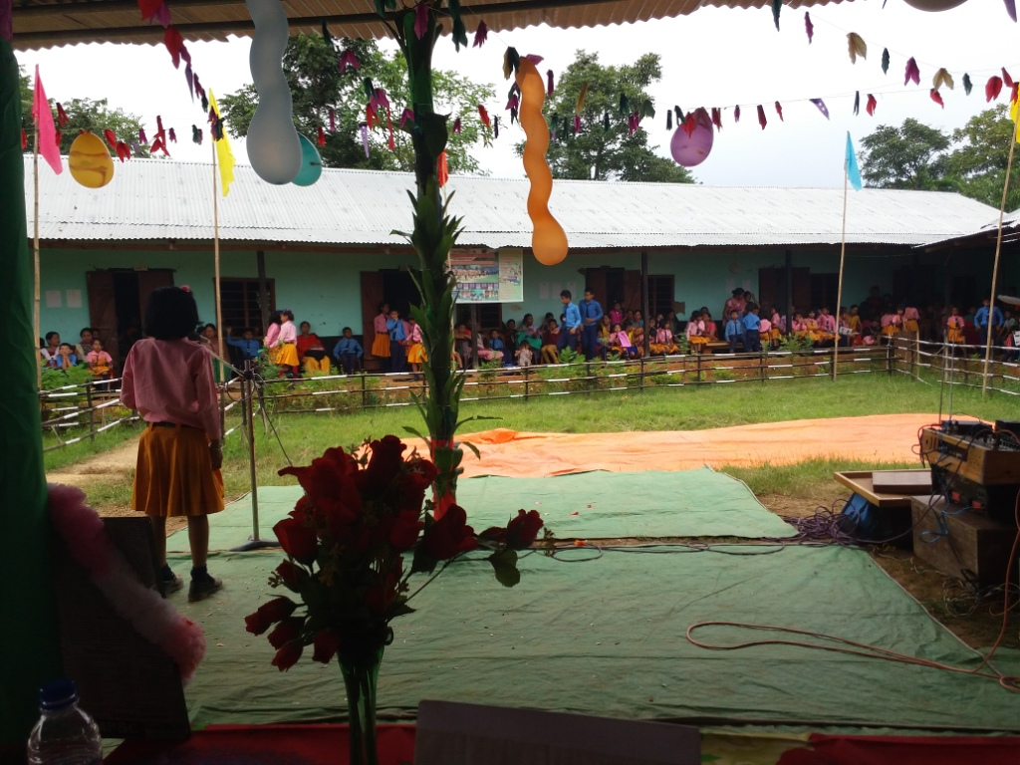

School children presenting the batches to Y. Surjit Kumar Khuman, Gen. Secy.

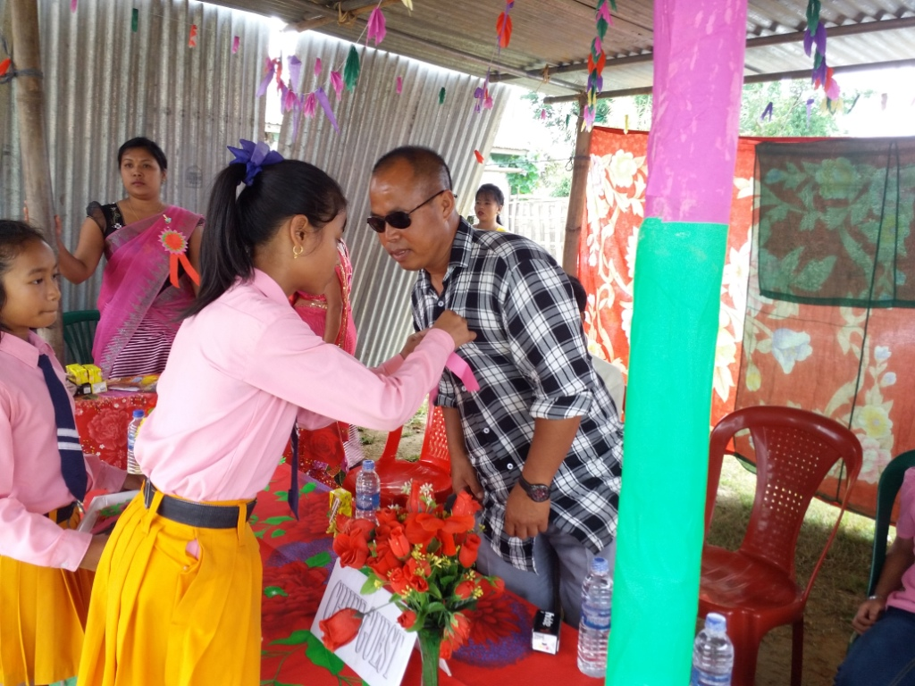

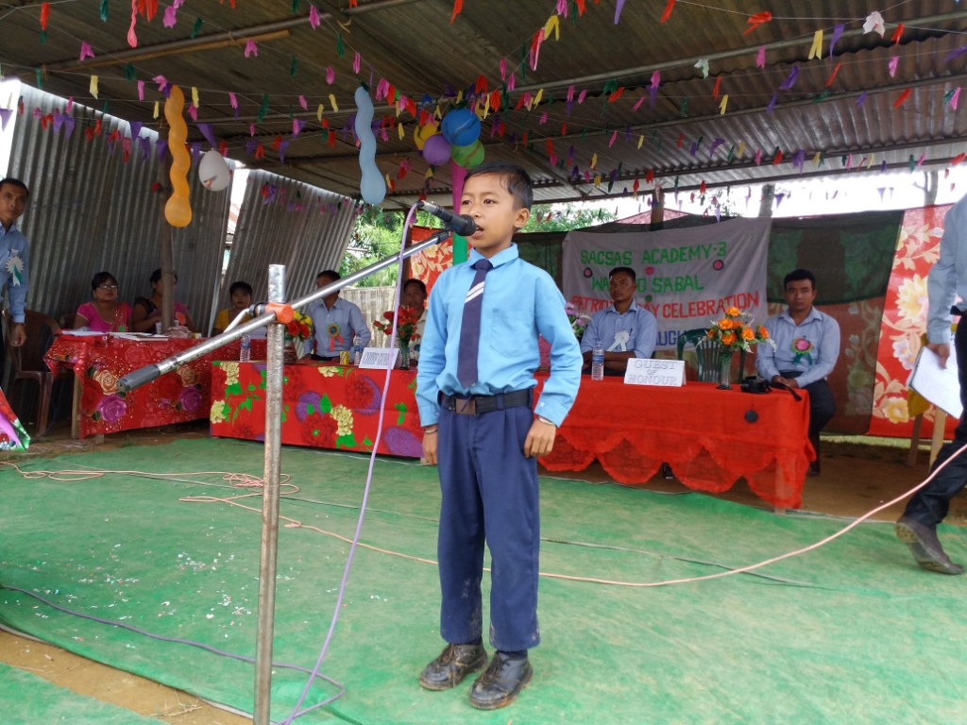

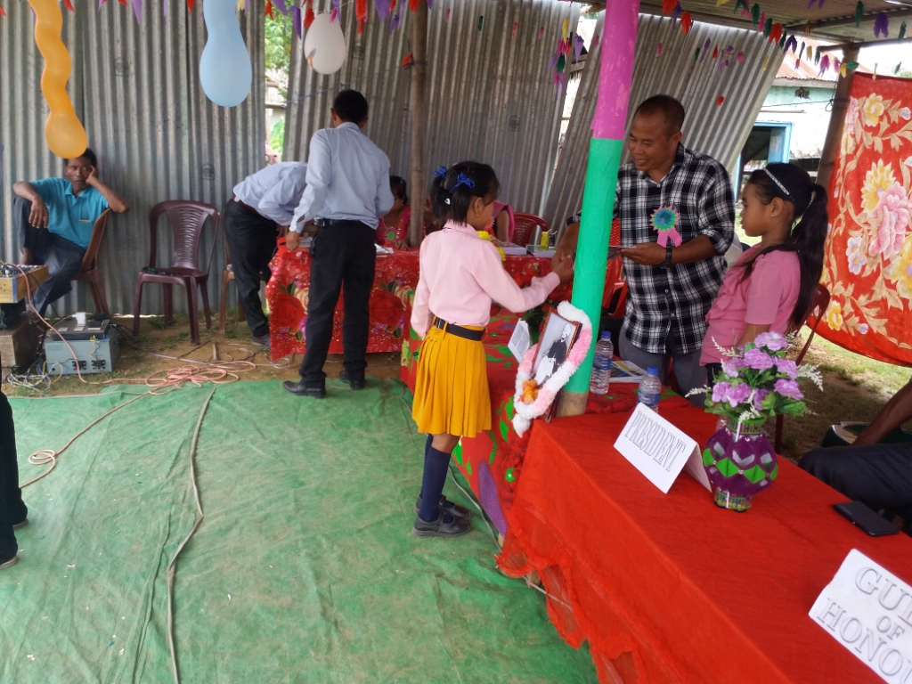

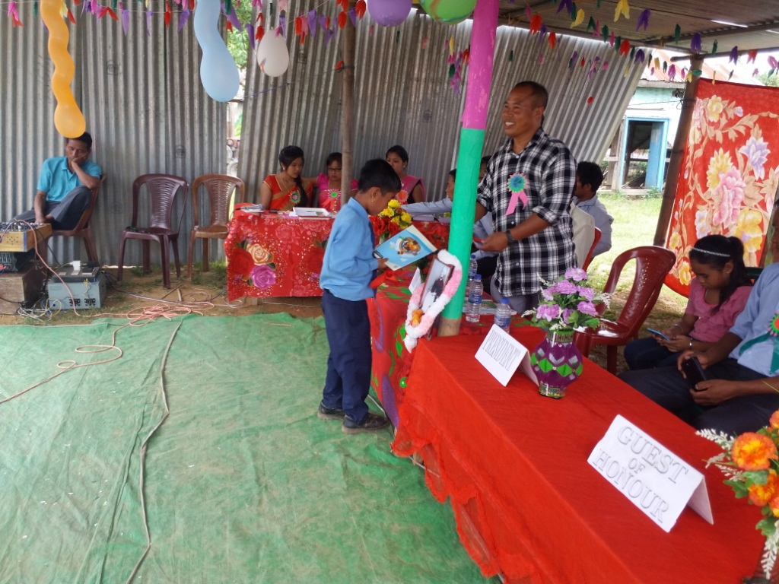

Giving Speech by Y.Surjitkumar Khuman

Gen.Secy. SACSAS Academy,Manipur.

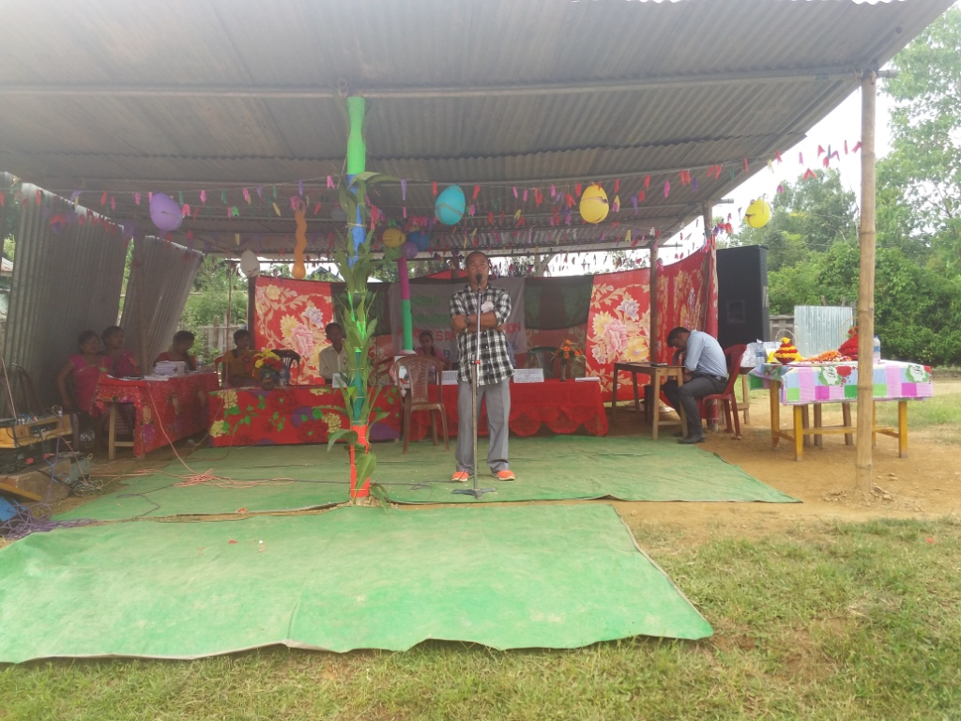

**Teacher’s Day celebration 2016**.

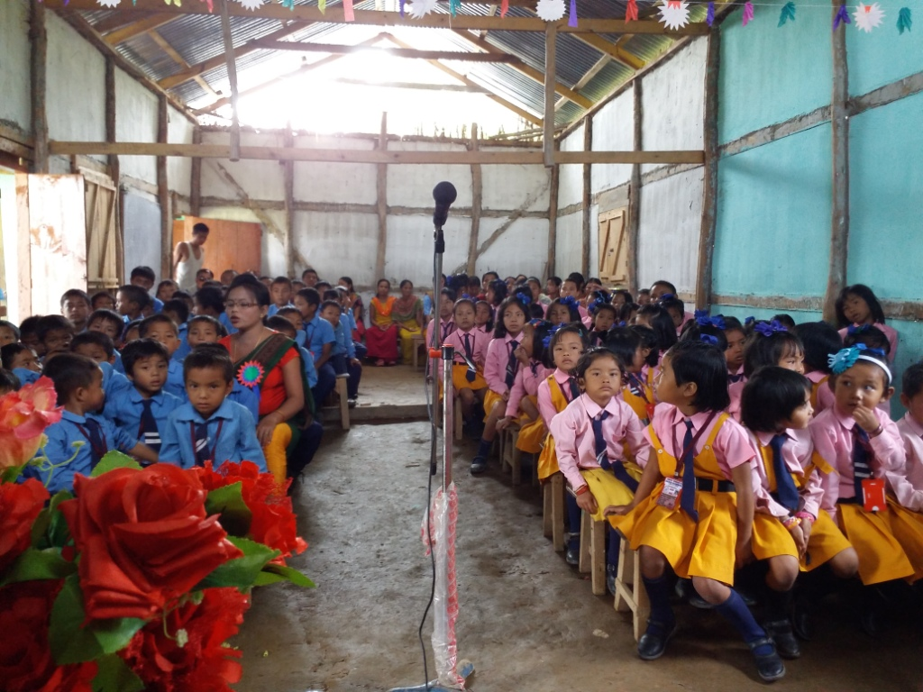

Giving speech by Y. Surjitkumar khuman

