**SACSAS Academy,Wangoo 2015**

**Sponsored by:- Sidhartha and Gopika.**

**View of SACSAS Academy**

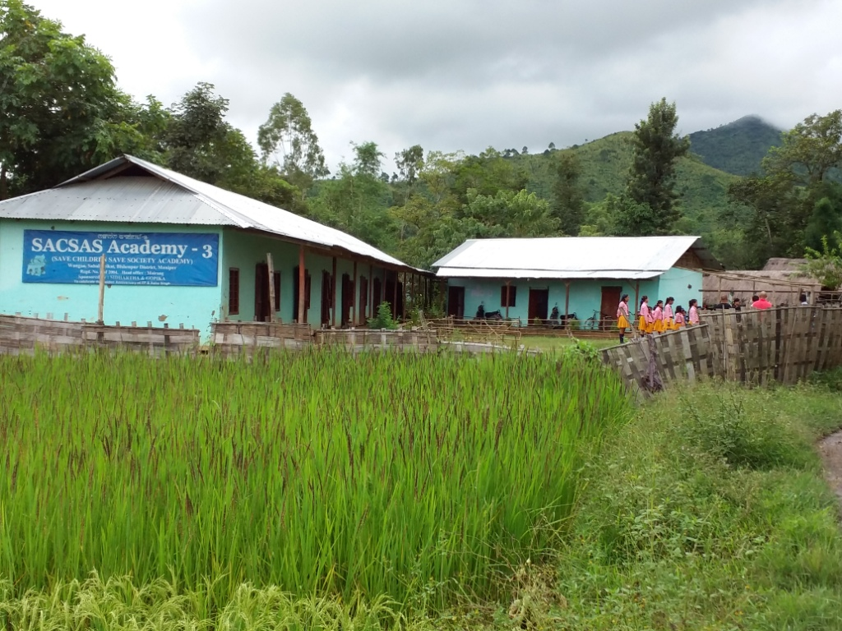

**Annual School Function 2015**

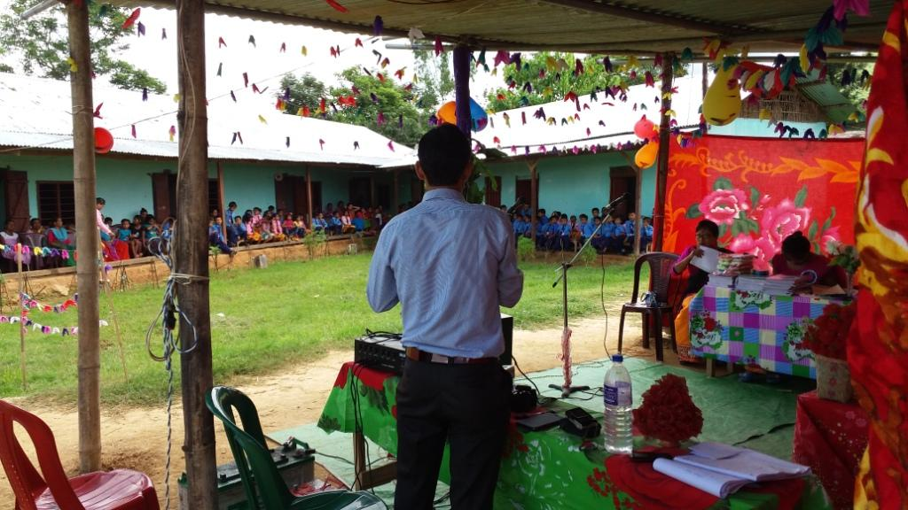

**School children presenting the opening song.**

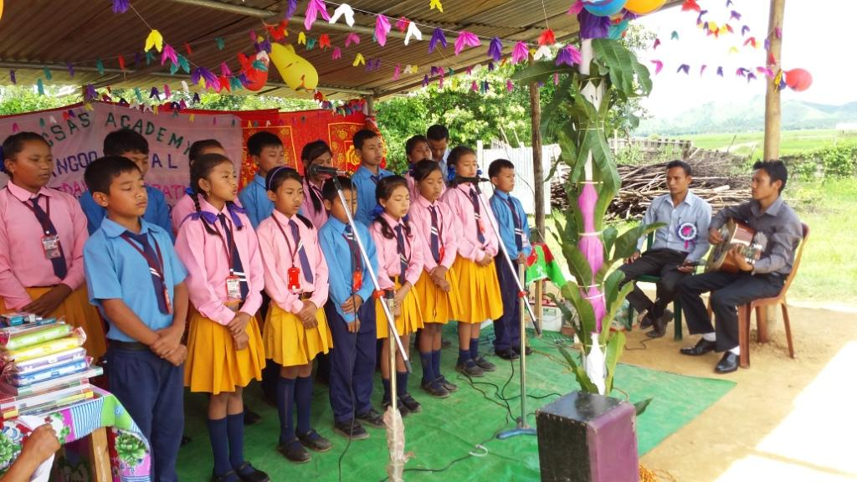

School Children reciting poems

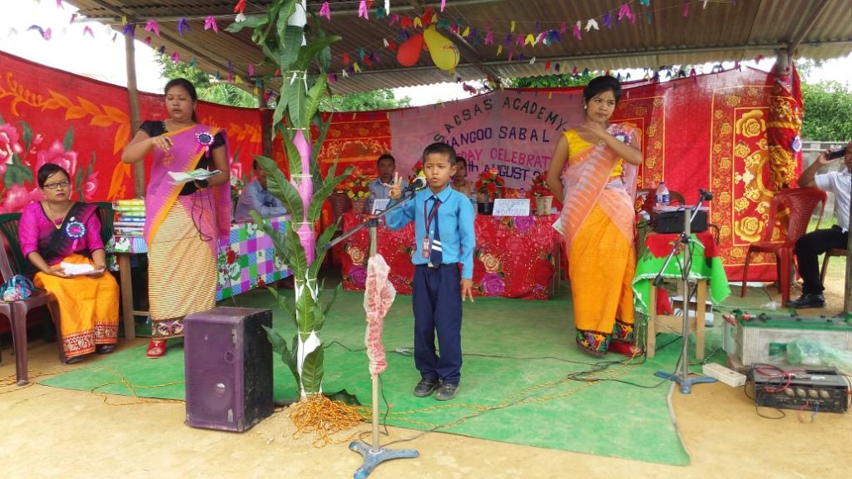

**Students with N. Shantikumar president SACSAS Academy, Manipur.**

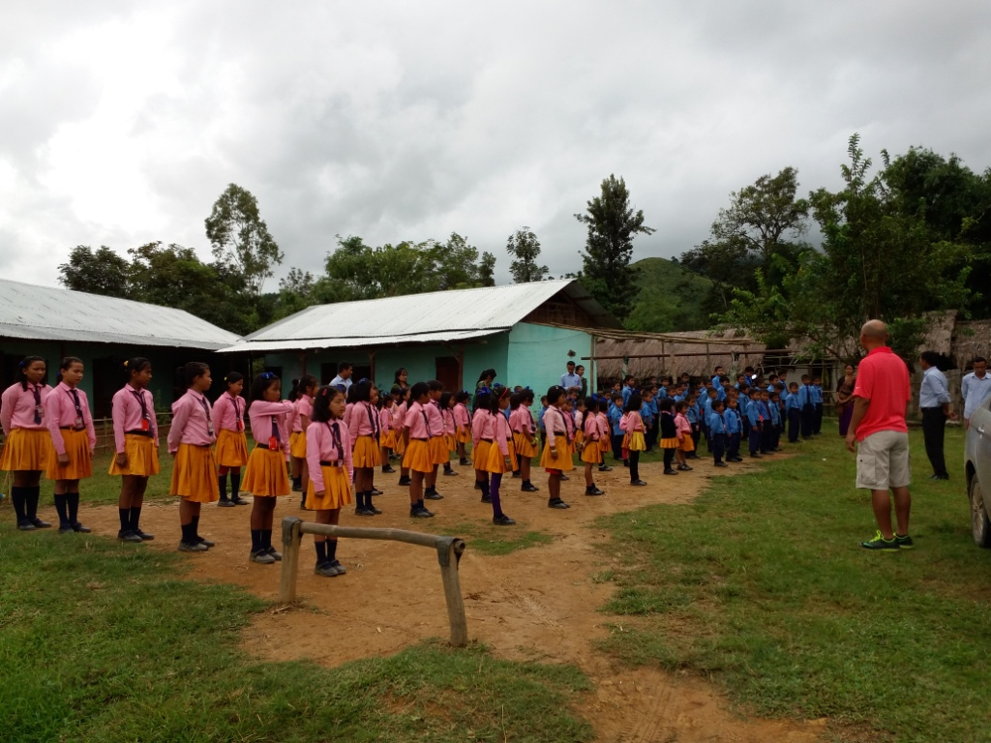

**School children assembling with N. Shanti Kumar, President SACSAS Acedemy, Manipur**

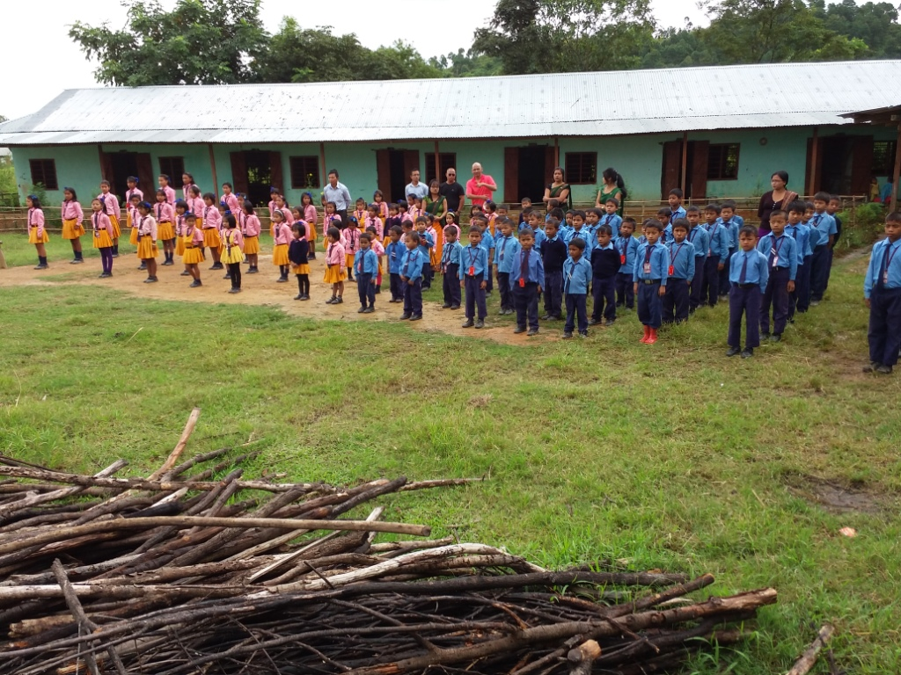

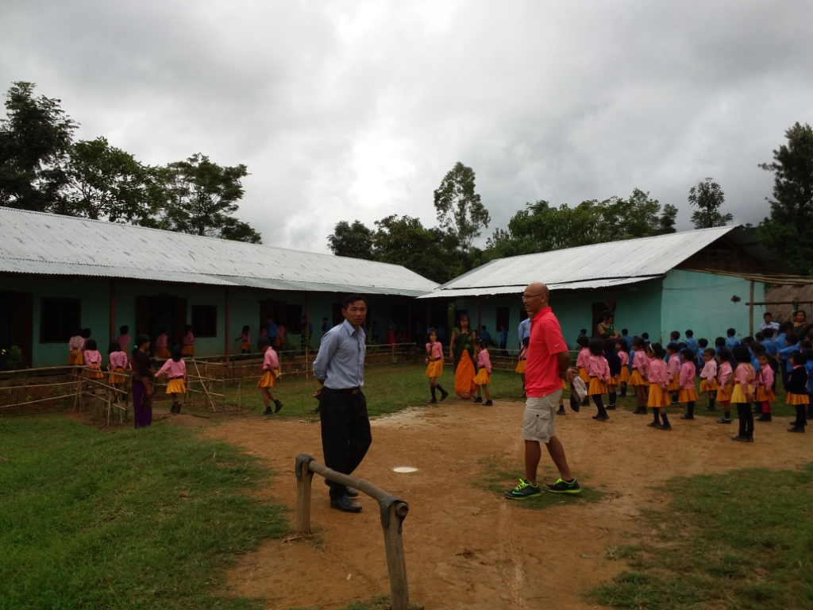

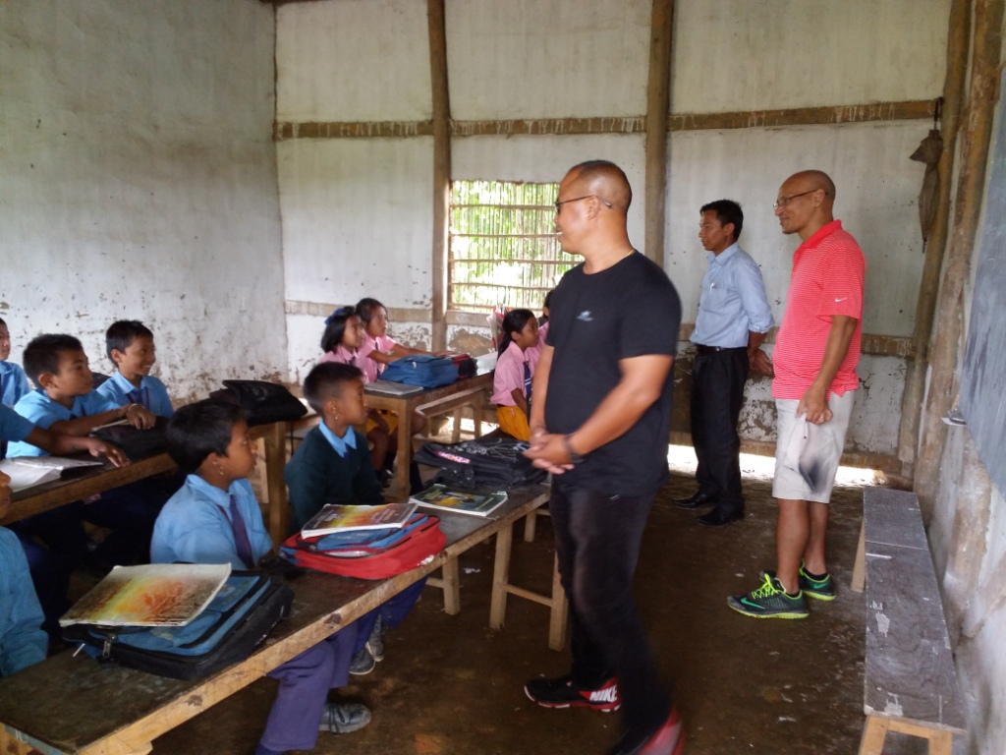

**School Inspecting by SACSS Academy , lead by N. Shanti Kumar, Pesident SACSS Acdemy, Manipur**

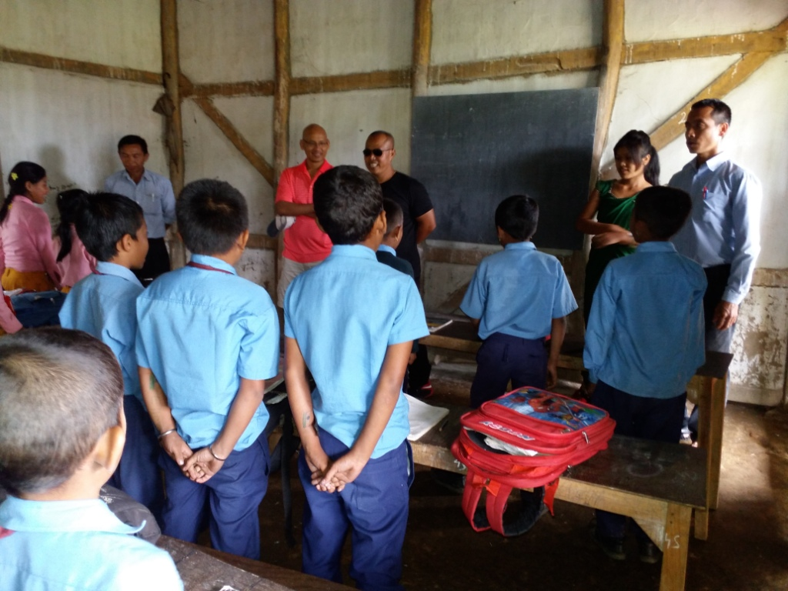

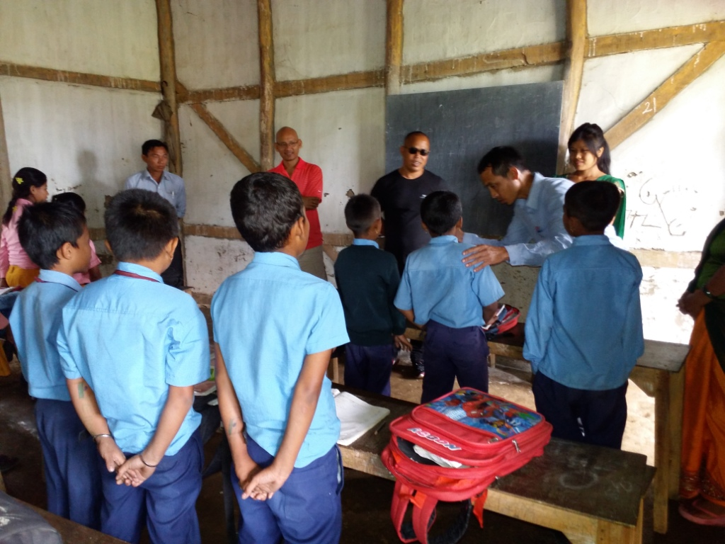

**School children assembling with N. Shanti Kumar, President SACSAS Acedemy, Manipur**

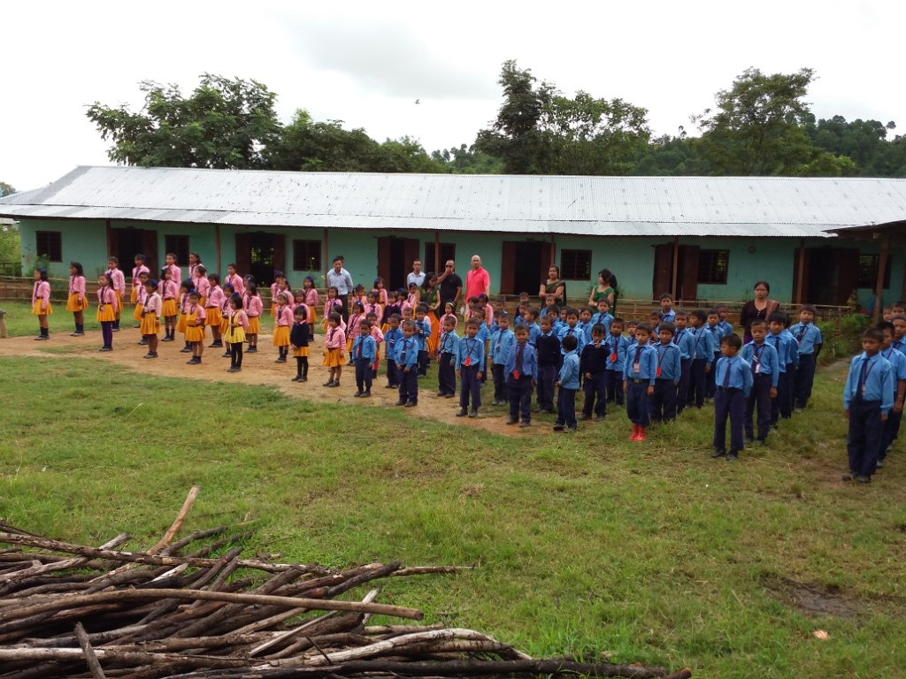

**School Children returning back to their homes after class.**

