**SACSAS Academy,Wangoo 2016**

**Sponsored by Sidhartha and Gopika**

Wangoo Teacher’s day ceremony

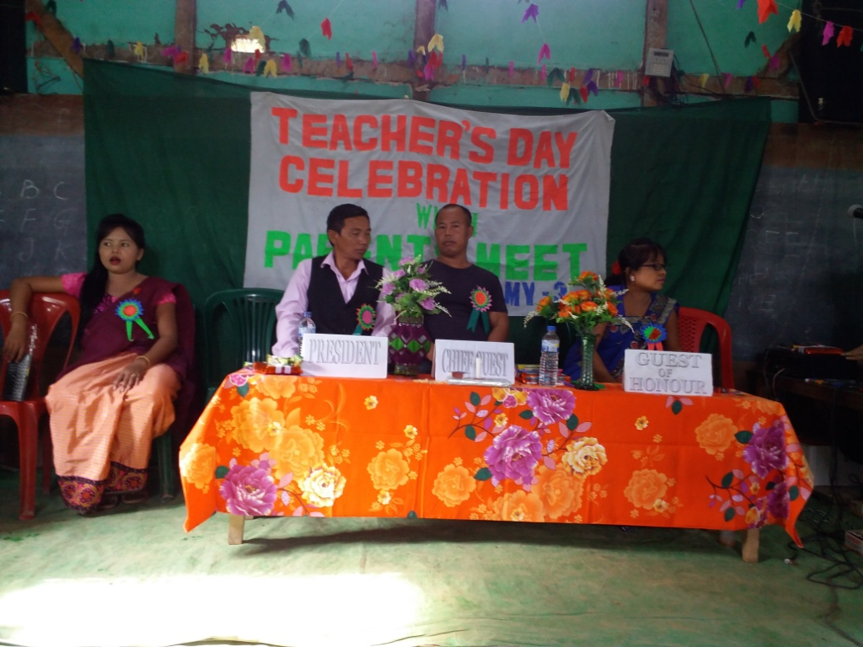

School children attending the programme by taking their refreshments.

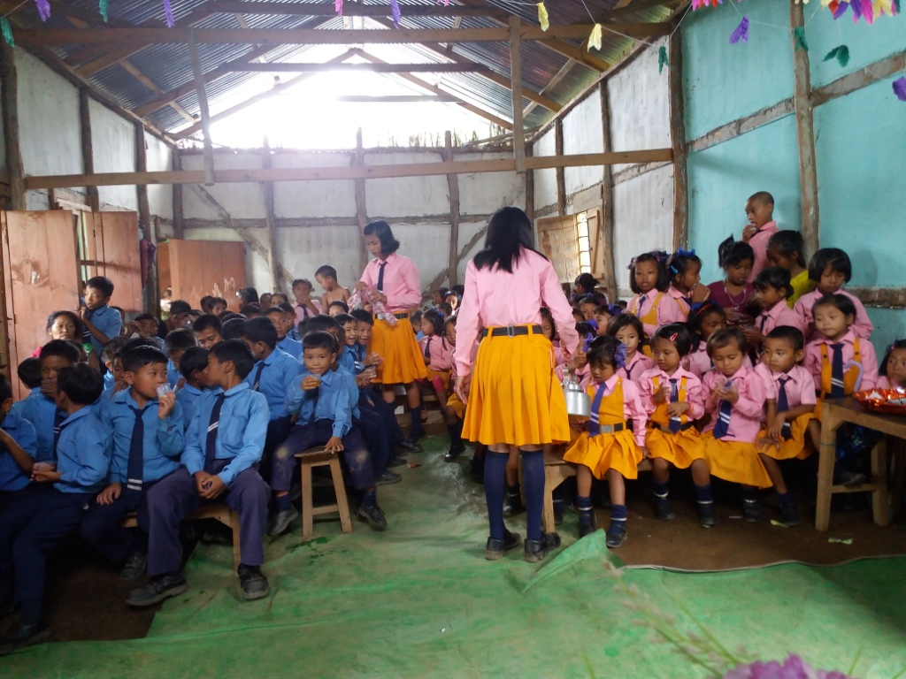

Giving speech by Y.Surjitkumar Khuman. Gen. Secy. SACSAS Academy.Manipur:

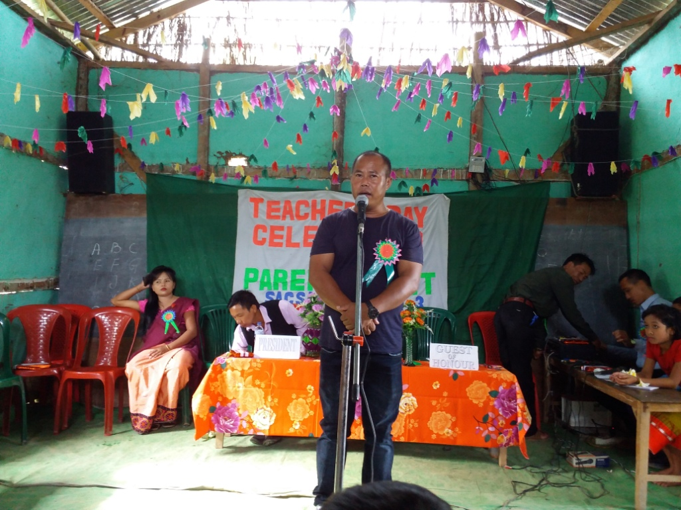

Students intarraction programme condutcing by Y. Surjit Kumar Khuman, Gen. Scy. regarding the techer’s day:

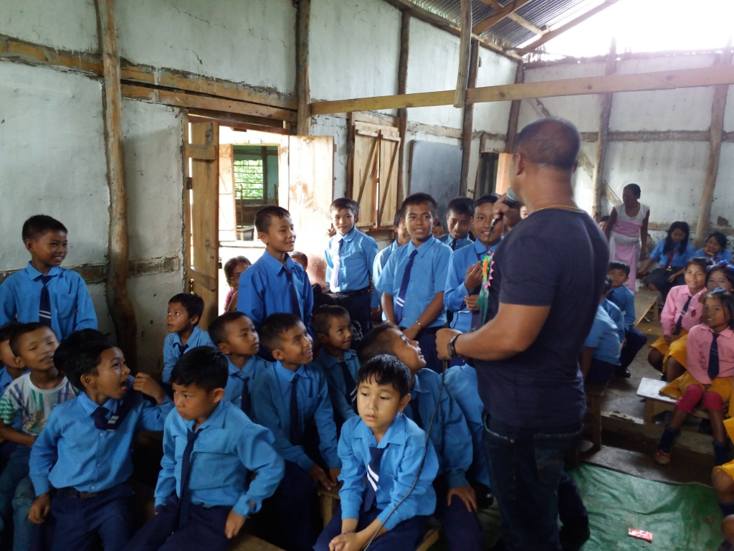

School children performing the entertainment programme:

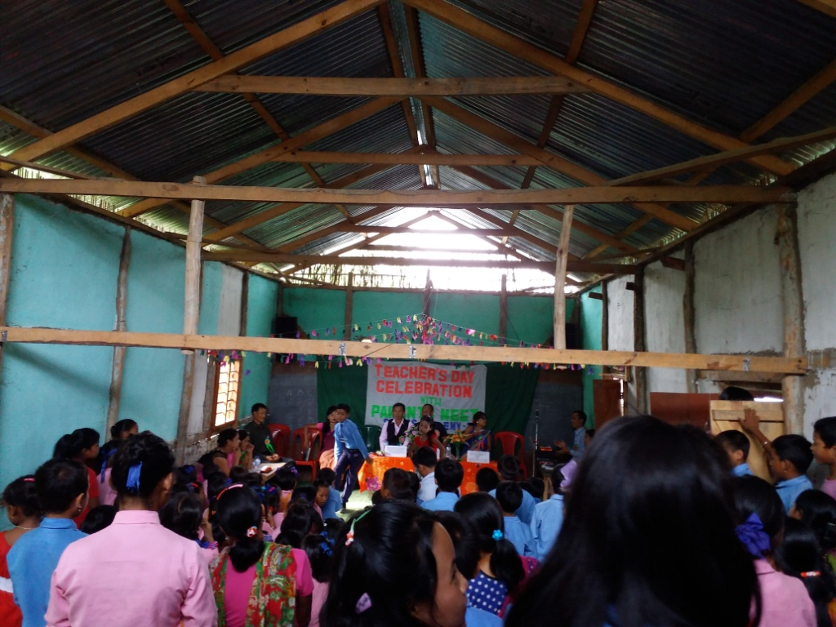

School children performing the entertainment programme:

