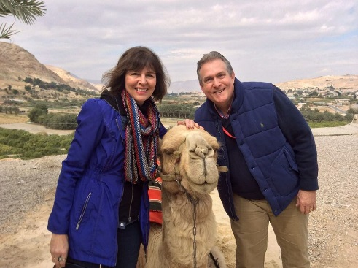

Dear Pilgrim,

SHALOM! Please review the following information which will help you know how to prepare and pack for our 2018 pilgrimage to the Holy Land

Recommended books to read (available on Amazon):
In the Steps of Jesus by Peter Walker
How to Walk in the Footsteps of Jesus by Hela Crown-Tamir
Killing Jesus by Bill O’Reilly
The Source by James Michener

Weather: Temperatures average 60 plus degrees during the day. Plan to bring clothing that you can “layer” by taking it off and/or putting it on to help you adapt to daily temperatures.
Dress: Plan to dress casual and comfortable jeans, slacks, etc.) Ladies there is no need to bring dresses or skirts unless that is your personal preference. Make sure to wear comfortable shoes; bring a collapsible hand held umbrella and hat. Glorianne and I like to keep our “stuff" in a backpack which can be left on our bus. If you have low blood sugar you may want pack nuts and other sources of protein. Bottled water is available on our bus throughout the day.
Prescriptions: If you use prescription medications and/or over the counter drugs it's important that you bring them with you and keep them in your carry-on piece of luggage along with a change of clothes in the event your luggage doesn't arrive with you in Tel Aviv (this has never happened to anyone on our pilgrimages to date, but we want you to be prepared).
Travel Itinerary: We are scheduled to depart from Dulles Airport on Air Canada, Mon, Jan 22, at 9:50 am with a stop in Toronto, and then on to Tel Aviv arriving at 10:15 am on Tues, Jan 23. We will depart Tel Aviv on Thursday, Feb 1, at 11:55, stop in Toronto, and arrive back at Dulles at 8:25 pm. Plan to check-in at the airport 3 hours before our flight is schedule to depart and go immediately to the gate of our departure. Please call our cells at 703.470.1077 (Dean) or 703.380.7009 (Glorianne) if you encounter any problems. Please reconfirm our flight with Air Canada 24 hours prior to our departure to check for any flight/schedule changes by calling 1-888-247-2262 (you will receive your tickets approximately 30 days before departure).

Baggage: For Air Canada baggage guidelines for Economy Class please go to www.aircanada.com.

The Transportation Security Administration has a 3 -1-1 rule you can use to help you remember what you can bring in your carry-on luggage onboard an aircraft.
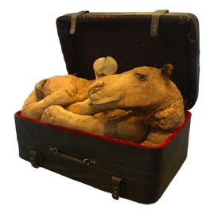
3 – Liquids, gels, and lotions must be in a container that is 3.4 ounces (100ml) or less (by volume).
1 – All your items should fit into a 1-quart clear, plastic, zip top bag.
1 – Each passenger is allowed one carryon bag. This must be taken out of your carry-on luggage, and placed on a bin to pass through the screening machine. We would encourage you to wear heavier clothing items like coats on the plane (and storing them in the overhead bin) to help keep your suitcase weight down.

Baggage: For Air Canada baggage guidelines for Economy Class please go to www.aircanada.com (please note: if you want to bring a camel home from the Holy Land make sure and leave extra room in your suitcase:)

Rest on the Plane: We would encourage you to bring ear plugs to help you rest on the plane if you are sensitive to noise along with a face mask to block out light. If you have a regular schedule for drinking caffeinated coffee or tea you may want to decaffeinate prior to leaving until you are back into a normal routine after we arrive in the Holy Land.
Meals: We leave our hotel each day around 8 am. following a buffet breakfast (included). We stop for lunch around 1 p.m. (lunches not included in your package average around $12 per day). One restaurant we visit offers you an option of ordering St. Peters Fish in the $25 range. We return to our hotel every evening for a buffet dinner (wine, beer, and other alcoholic beverages are available at dinner, but not included in your pilgrimage package). You can bill them to your room or pay your server at the end of your meal).
Restroom Breaks: Throughout our pilgrimage we take regular bathroom breaks. If you have any special physical or personal needs make sure to let us know.
Gratuity’s: All gratuities are included in your pilgrimage package.
Love Offering: You will have the opportunity to participate in a freewill love offering at the end of our pilgrimage to bless our guide and driver. Envelopes will be placed on tables at breakfast and dinner on the day before we depart for home. Gifts are presented to our guide and driver with a card signed by all at our farewell celebration dinner.
Credit Cards: U.S. Currency and credit cards are received in the places we will visit. Make sure you contact your credit card companies to let them know the dates you will be traveling in the Holy Land.
Electronic Adapters: Two Prong Chargers for converting from 220 to 110 volts are used in Israel; you can get them at most electronic stores or order them via Amazon, etc.
Cell Phone: Wi-Fi is available in our hotels and on the bus. For international cell service please work with your cell phone provider.
Listed below are items you are encouraged to take on our pilgrimage:
BACKPACK/CARRY ON LUGGAGE FOR THE PLANE
Passport (make sure your passport is valid for at least 6 months after you leave Israel)
Red Imagine Name Tags (You will wear these at all times once we arrive in Israel)
Security pouch (these are convenient to wear around your waist)
Wallet with cash
Prescription Medications
Toiletries (must be 3 ozs or less and fit in a quart bag]
An extra shirt, underwear, socks
Extra glasses (if you wear them)
Bible, Journal and pens
Book for reading
Camera
I-Pad
Phone
Electronic Converters/Adapters (Two Prong Chargers for converting from 220 to 110 used in Israel);
Snacks

RECOMMENDED LADIES LIST
5 Shirts
5 Pants
3 Tank Tops for Layering
2 sweaters
1 Lightweight Coat (wear onto plane)
Lightweight Thermal Vest
A Few Silk Scarves for Warmth and Color
Cheap Jewelry
Underwear and Socks
PJ's
Bathing Suit, Cover-up, Flip Flops
Hat / Gloves / Ear Muffs
3 Pairs of Shoes (1 pair flats for the evening)
Sunglasses
Umbrella
Extra glasses (if you wear them)
Bible, Journal and pens
Umbrella (small and collapsible)
Sunscreen
RECOMMENDED MEN’S LIST
5 Shirts; 2 Long Sleeved, 3 Short
5 T-Shirts
3 Pants
2 Sweaters
Underwear and Socks
1 Light Weight Coat (wear onto plane)
Long Sleeved Windbreaker
Lightweight Thermal Vest
2 Caps / Hats and
Gloves / Ear Muffs / Scarf
PJ's
2 Pairs of Comfortable Walking Shoes
Bathing Suit, Flip Flops
Sunglasses
Umbrella (recommend small collapsible style)
Sunscreen
Umbrella (small and collapsible)
Extra glasses (if you wear them)
Bible, Journal and pens
Electronic Converters/Adapters (Make sure to purchase the "Two Prong Chargers" used in Israel)
Sunscreen

