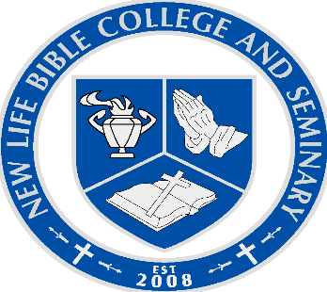
TRANSCRIPT REQUEST FORM

NAME:______________________________________________ Present Grade______
Last First Middle
Date of Birth:_______________________________ Counselor__________________

CHECK ONE:

TRANSCRIPT REQUEST:_________ (Includes all test scores)

_________ (Transcript only, no test scores)

_________ (Transcript only, no test scores)

SEND TRANSCRIPT TO: SPECIAL DIRECTIONS:
Tisha Ray, Administrator ____________________________
Name of Person or Office
New Life Bible College and Seminary ____________________________
Name of College, University, School
P.O. Box 1248 ____________________________
Address
Hope Mills, NC 28348 ____ ____________________________
City, State, Zip

Authorization to release school records and all test scores to the agency listed above:
Signature of Parent (if student is under 18)_____________________________
Signature of Student (if age 18 or over)________________________________

Office Use: Date Sent & Initials:_______________________

