I think most of my patients understand that while I love the practice and science of medicine, faith is also a very important part of my life. For those who are interested, I felt I should post an article that my priest asked me to write. This chronicles and documents something miraculous which happened in my practice, and I felt that sharing this might encourage some. Please understand that the Mission of Dynamic Healthcare is “To understand the patient, their environment and ourselves in order to deliver the best medical care possible in the spirit of hope and joy.” We care for all patients regardless of their faith position and understanding. None the less, this story is compelling and needs to be shared. So, as I share this, please understand it in the context of the Dynamic Healthcare mission. – Dr. Hollister

Miracles Still Happen – December 2021
The testimony of Ripley Hollister, MD FAAFP
And when he had taken the scroll, the 4 living creatures and the 24 elders fell before the Lamb, each holding a harp, and golden bowls full of incense, which are the prayers of the saints. Rev. 5:8.
What I write now will be from my perspective as a believer in Christ and a practicing physician of over 30 years. Firstly, I acknowledge and praise God for the miracles happen daily throughout our lives.We all witness such things as the miracle of birth and life, miracles of unexpected blessing, miracles of salvation, answered prayers for safety and the like; I testify now about something of a different magnitude. I’m talking about a scientifically unexplainable occurrence that is outside daily experiences. Something so outside of chance or statistical explanation, that it can only be related to a supernatural act of the divine.
Next, a word about faith/prayer, and medicine/science. Each is tremendously important and neither negates nor contradicts the other. Both can and should comfortably exist and occur at the same time. In Genesis 1:26-31, God gave the command that humankind should subdue and have dominion over the earth and all living things (v28). Thus “in the beginning” mankind was to be a scientist, to explore and answer questions. God did not just give us the answers, we must pursue and explore and figure it out for ourselves. Likewise, we are to have faith and trust in our Creator. Both things happen at the same time.
So it is that when my patients have some terrible malady, I frequently suggest that they read and follow the directive in James 5:13-16. To call for their elders, to have a time of mutual confession and prayer for one another (v16), and in turn, to be prayed over and anointed with oil. I also suggest that they seek the best medical advice and counsel available. In other words,praying for and believing in healing does not mean to check your brain at the door, take every good and faithful step toward physical and spiritual health to which God guides you.
Now, on with my testimony. This concerns a very special person to me. We will call her “Jewel” for the sake of confidentiality. (She has given full permission to share her medical and spiritual details.) Jewel has been a tremendous friend over the years, in addition to being my patient. She was diagnosed and received expert medical care for a malignant melanoma on her back about 4 years ago. She went to all recommended follow up appointments and kept up on her routine medical issues as well. Now, melanoma is a nasty disease, and it is notorious for waiting years, then coming back without warning.Earlier this year (2021) Jewel began to have some abdominal pain which responded initially to therapy, but slowly got worse. After numerous attempts to define and treat her pain, we unfortunately found that the melanoma was back in spades. It had become active again and metastasized to her liver. Her pain was from a rapidly expanding mass that had reached the size of a grapefruit in her liver.
Here is a picture of this nasty tumor from July of 2021. The PET scan shows her liver on the left of the image, her stomach (as black air) on the right (these are on the anatomically opposite side of the body), and the bright white metabolically active tumor in front (top of the image). (These are actual PET images, the only thing I’ve done is to remove confidential info. These are the images physicians view.)
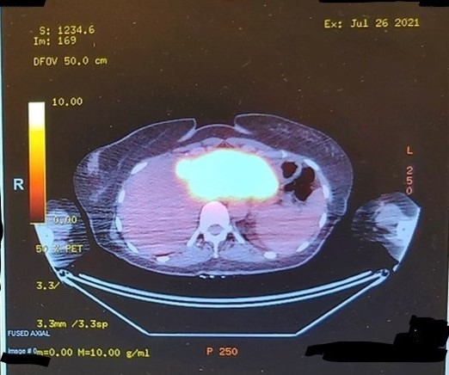
Metastatic melanoma, in the past, has generally been a rapid death sentence, but medicine has advanced and with appropriate therapy life expectancy has improved significantly. Jewel, a woman of faith, followed the best available medical advice and underwent recommended testingand the newest and best immunotherapy. She dutifully and faithfully prayed (as did we all) and followed James 5. Her experience with chemo was not pleasant, but tolerable. Her initial round of immunotherapy was complete after approximately 3 months. Her follow-up PET scan was scheduled. It was sometime during this process that her Miracle occurred. My prayer with fellow parishioners went something like this: “Lord God, we pray that her PET scan will not only show that her therapy has been effective, but also that we see evidence that your Miraculous hand has been at work.”
Now, I’ll let you know that prior to seeing or calling the patient, physicians will often discuss cases amongst themselves and decide on the best optionsfor therapy ahead a difficult encounter where tough news is delivered. We do thisto have reasonable therapeutic options available immediately when delivering and discussing a serious diagnosis with the patient.
It was so in this case, that the Tumor Board (a group of physicians that treat cancer medically, surgically and with radiation) had collaborated on her case during her initial diagnosis for therapeutic recommendations, and they had meet again, after chemo, to discuss and viewher therapeutic response.
Jewel had her follow-up PET scan on Oct 27, 2021. She and her husband went into the oncologist office to await the report on her response. The oncologist came into the exam room and said something like, “I’m not quite sure how to explain this ….”
Jewel firmly held her husband’s arm as they thought, briefly, that this might be bad news.
Her oncologist quickly understood that Jewel was scared by the initial statement.
The oncologist said, “No, no I didn’t mean that …. This is GOOD news.”
Whew.
“Let me just show you your scans. First, is your initial scan (shown above). You remember the bright spot that is the tumor?
Now, here is the second scan.”
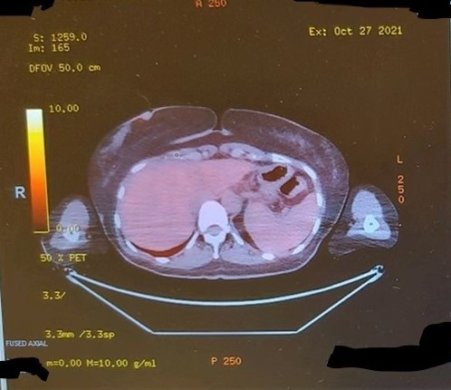

The difference was obvious ….. The bright white tumor was …. GONE!!!
The oncologist asked Jewel the question, “Do you see any cancer?” as she pointed to the image.
Jewel and her husband carefully looked at the image and said, “No, we don’t.”
(Now, I have to tell you, I love what the oncologist said next, referring to the Tumor Board’s meeting about Jewel’s response to therapy.)
“Well”, she said, “neither did anyone else.”
Wow …. I hope you will understand, despite our newest successes with this disease, this was not to be expected. It is a Miracle.
The Tumor Board reviewed the case and Jewel’s MRI of the liver showed some areas of concern, where to prior melanoma had been. They decided that, given the insidious nature of melanoma,that area must be removed. It would be a big surgery – not just laparoscopy. We had to resect all this area and check for residual cancer. She would be in ICU for couple of days after this difficult surgery. We all continued in prayer.
Long story short. The surgery took about half the anticipated time in the OR. She was “downgraded” (you gotta love some of our medical expressions) to non-critical and never even went into the ICU. Instead, she went home in 3 days.
Oh alright, you’re probably wondering, what did the pathology report show?
Well, and this is also heartwarming, the surgeon’s resident sort of snuck into see Jewel while her attending, the oncology surgeon, was stuck in the OR. The resident just couldn’t wait … the pathology report is clean … NO cancer. I GOTTA tell you – this is huge! Another Miracle? Well, no, just additional evidence of God’s initial work.
So … Why did God accomplish this? What’s the point? Why doI share this testimony?
First, I firmly believe that,except for an understanding that “All things work together for good” (Romans 8:28),most of thedifficult “whys” in life are unanswerable to our temporal understanding. (Job 38&39).
Next, Miracles still happen.
And probably most important, God sometimes gives us a brief enlightenment about His purposes. We then say, “this is why” it happened. We’rejust viewing the tip of the iceberg. And so it is with this Miracle I am sure.
After receiving Jewel’s post therapy PET scan report, I was in private prayer and praise for God’s faithfulness. I received a word from God. Now, I hope you won’t think I’m nuts, but occasionally I do hear something from the LORD. This would be different than just an inner witnessfromreading scripture, or an agreement with a message in a sermon, or something like that. This is a deeper communication from the LORD. Something that rings deep within my soul from the depths of my spirit. It is not something I heard from soundwaves landing on my tympanic membrane, transmitted by my ossicles, through the oval window, into the cochlea and registering into the cortical hearing centers. None the less, I would call it - hearing the voice of God. This “word”, I understood, is for us all.A result of Jewel’s answered prayer, and in response to my wondering of God about why Jewel experienced this Miracle, when many do not get this sort of answered prayer.
God spoke to me this message, and it is for you as well …. The LORD said,
“I hear your prayers.”
Please, just let that sink in for a second, or a minute or two.
You know … ofttimes, I’ve felt like my prayers are just nice wishes, they just bounce off the ceiling or drift haplessly off into the cosmos.
God wants you to know. He hears them all!!! And, according to his purposes and will, He answers them all.
Lord, in your mercy, hear our prayer.
I can now, with deep assurance and conviction, say …..He does!
Ps. I have one observation to offer. After this experience, when I hear someone say “My thoughts and prayers are with you” I feel a little let down. Your thoughts cannot be with me, they remain with you. And unfortunately, your prayers being with me means nothing. However, if you really want to help, your prayer to God will be heard, and there is nothing more precious to me than that.
And now, my prayer for you.(Please read James 4:1-10).
May the LORD Bless you and keep you,
May your prayers (that He hears) be given in humility and submission to His will,
May He grant your deepest desires, as you seek to please Him.
Dr. H

