GFLS Times

|  |  |  |
| --- | --- | --- |
|  | | |
| August I've been Expecting You Facebook Cover coverlayout.com ... | | |
|  |  |  |
| **Contact Information** (403) 272-4661  3425 – 26th Ave SE,  Calgary AB T2B 2P2  <https://gfls.org>  <https://www.facebook.com/gfls55/> | Want to sign up for our  E-newsletter?  Send email to [rebecca@gfls.org](mailto:rebecca@gfls.org)  Outline Email Icon. Line Mail Symbol For Website Design Stock ... | Hours of Operation  Monday to Friday  9 am to 4 pm  Closed over lunch  12 pm to 1 pm |
|  |  |  |

Center Closed

Monday August 3rd, 2020

***A message from our Executive Director***

Hello and Welcome August!

I am writing this just after our first Bingo since March.  What a day!  It was lovely to see our center full of our members again.  To hear laughter, talking and to see each of the attendees enjoying being together after such a long and difficult time.  It was wonderful!

For those of you who maybe worried or hesitant about coming back to the center I want to let you know the precautions we are taking to keep you safe.  Close your eyes and let’s take a walk together back to the center.

Please put on your mask before you enter.  If you don’t have one we will be happy to provide you with one. As you walk in you will be asked to hand sanitize.  Please feel free to lube up!  As you walk to the reception desk one of our amazing volunteers will take down your name and direct you to the area of your program, social or activity.  Once you’ve made it to your spot feel free to take off your mask and enjoy your time – keeping in mind social distancing.  If you need to leave your area, please put back on your mask and utilize the hand sanitizer along the way.  You will notice that our auditorium has new tables.  These gems help us provide better social distancing during activities and events in the auditorium.  They look great and are super functional.  Although we are not serving lunch, our Chef Annette has got your hunger covered.  For a mere $2- there is a variety of fresh baked goods and free coffee, tea and flavored water available.  You will notice our new full-time Janitor walking around the center. Her name is Missy and she is responsible for all the sanitizing and cleaning. Her goal is to maintain a well sanitized facility and to keep us healthy and safe.  When you are ready to leave be sure to ask the receptionist about our Frozen Meals Program, The Pie of the Month Fundraiser, Mind, Muscle and Memory Bag and Cozy Corner Craft Bag.  These are great programs we had started during the pandemic and we would love for you to take advantage of while they are still running.

You have been missed.  You are welcome to come back.  We are following all protocols to keep you safe.

If you have any questions, please feel free to call me at 403-272-4661 or email at [jenna@gfls.org](mailto:jenna@gfls.org).

Looking forward to seeing you again!

Jenna Jepson

Executive Director

August 2020 Calendar of Events

|  |  |  |  |  |  |
| --- | --- | --- | --- | --- | --- |
| MONDAY | TUESDAY | WEDNESDAY | THURSDAY | FRIDAY | SATURDAY |
|  |  |  |  |  | 1 |
| **3**  **Center Closed** | **4**  **“Grand Opening”**  **Social 10 am**  **9:30 am Crafts**  **1 pm Social** | **5**  **10:30 am Walking Club**  **1 pm Social** | **6**  **9:00 am**  **“Everyone Welcome Social”**  **5 Star Bingo** | **7**  **9:00 am Tai Chi**  **1:00 pm Workshop “Mindfulness Retreat”** | **8** |
| **10**  **10 am Social**  **2:00 pm Zumba** | **11**  **9:30 am crafts**  **1 pm Social** | **12**  **10:30 am Walking Club**  **1 pm Social** | **13**  **9:00 am**  **“Everyone Welcome Social”**  **9:00 am – 1:00 pm**  **“Foot Clinic”** | **14**  **9:00 am Tai Chi**  **1:00 pm Workshop “Mindfulness Retreat”** | **15** |
| **17**  **10 am Social**  **2:00 pm Zumba** | **18**  **9:30 am crafts**  **1 pm Social** | **19**  **10:30 am Walking Club**  **1 pm Social** | **20**  **9:00 am**  **“Everyone Welcome Social”**  **5 Star Bingo** | **21**  **9:00 am Tai Chi**  **10:30 am Bee’s Knees**  **1:00 pm Workshop “Mindfulness Retreat”** | **22** |
| **24**  **10 am Social**  **2:00 pm Zumba** | **25**  **9:30 am crafts**  **1 pm Social** | **26**  **1 pm**  **“Tupperware bingo”** | **27**  **9:00 am**  **“Everyone Welcome Social”**  **9:00 am – 1:00 pm**  **“Foot Clinic** | **28**  **9:00 am Tai Chi**  **10:30 am Bee’s Knees**  **1:00 pm Workshop “Mindfulness Retreat”** | **29** |
| **31**  **10 am Social**  **2:00 pm Zumba** |  |  |  |  |  |

** Please note, schedule may change due to unforeseen circumstances. **

** All fitness classes are to resume this month, but we encourage people to drop in if interested **

** Drop-in rates for Zumba, Tai Chi & Bee’s Knees are as follows; **$7.50 per class**. ** class size will be limited (8)

**Everyone needs to register for the Tupperware Bingo, maximum 45 people. Tickets will be given to all who register. No ticket, no entry!**

***A Message from our President***

I don’t know about you, but I have missed the Center since it closed in March. Sure, I have been there to consult with staff, sign documents such as grant applications and cheques, and to check on progress of the renovations. But the Center is more than that for me, it’s about getting together with you during the programs, supper and lunches. I miss the kids who clean the tables at Wednesday lunches, Dave and his kids from LinkAges, and the staff, volunteers and folks from Memory Plus. Not to mention line dancing and ukulele lessons. I have missed you.

But there is good news. We are taking measured steps to re-open. Measured because we want to absolutely ensure that when you come you will be as safe as we can make it. Jenna, her staff and volunteer activity leaders have been trained to ensure that we adhere to Alberta Health Services requirements.

Things will be different, consider only the social distancing requirement, but I want to encourage you to return and to once again be among your friends.

I can also report that our renovations project is virtually complete. All that’s left are a few finishing touches and of course final inspections. New furnaces, each equipped with air conditioning; just in time for the dog days of summer.

Hope to see you soon in a safe, comfortable environment.

***Jim***

|  |
| --- |
| ***Menu Available for August***  Beef Barely Soup  Minestrone  Hearty Italian Sausage Soup  Beef Stew  Stuffed Peppers  Turkey Vegetable Soup  Sweet & Sour Meatballs w/ rice  Baked Cannelloni with Cheese & Spinach  Ask about our dessert Options.  All meals cost $5.00 / each. Contact the center to place your order at  (403) 272-4661  or via email at [support@gfls.org](mailto:support@gfls.org) |

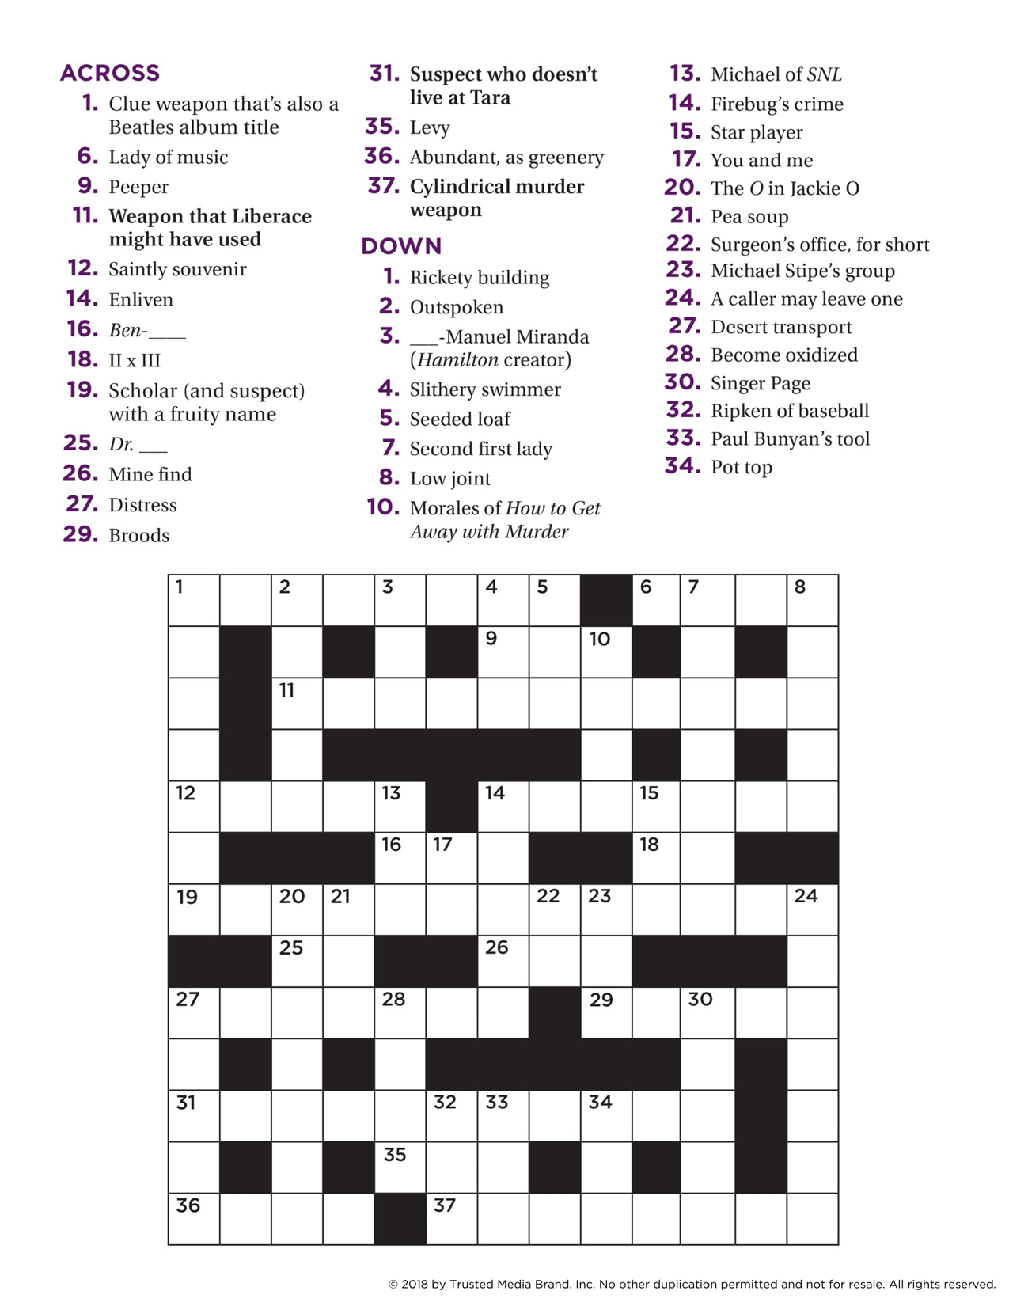



**Greater Forest Lawn 55+ Society**

Presents:

“Pie of the Month” FUNDRAISING EVENT

We are at it once again this year! We are excited to bring you our “Pie of the Month” Fundraising Event. We present for August, **Homemade Beef Pot Pie,** assembled by Annette Tanner and GFLS Volunteers. **Our pies come frozen and packaged, but uncooked.** This way our customers are able to bake their pies at their convenience.

**Cost:**

**5” pies $6.00**

Pre-orders will be taken starting August 4th. Deadline for ordering August 21st, 2020.

Forms of Payment; cash, cheque, or email transfer.

Makes cheques payable to Greater Forest Lawn 55+ Society, send EMT to [support@gfls.org](mailto:support@gfls.org).

All pies will be available for pick-up on August 28th from 10 am to 4 pm.

Please contact the center if additional information is needed: (403) 272-4661 or via email at [support@gfls.org](mailto:support@gfls.org)

Thank you for your support!



**Foot Clinic**

Thursday August 13th & August 27th 2020

9:00 am to 1:00 pm

**Call Tracy at (587) 433 – 0648** to book an appointment



***Workshop: “Mindfulness Retreat”***

*Take time to breathe. Take time to create. Take time to reflect, take time to let go. A book that’s unique in the way it mixes reading and doing,*A Book That Takes Its Time*is like a mindfulness retreat between two covers*.

**Start Date:** Friday August 7th

Starting at 1 pm

**Cost: $45.00** (includes book & supplies)

**Location:** 3425 – 26th Ave Se

Greater Forest Lawn 55+ Society

If interested contact (403) 272-4661 to register.

This is a 12 week workshop filled with exercises, creativity, discovery and homework!



Where: 3425 – 26th Ave SE

*Greater Forest Lawn 55+ Society*

When: Wednesday, August 26th 2020

Time: 1 pm – 3pm

**Prizes to be won!**

Doors open at 12 pm, join us for lunch

Lunch combo $5.00

(Hotdog, drink, and baked goodie)

Must register for this Bingo, max 45 participants.

Call (403) 272 – 4661 to register, deadline August 24th 2020

**Must have tickets to enter Bingo (no exceptions)**

**GFLS Housekeeping Services**

Do need some extra help with cleaning around the house?

Give Rebecca a call for more information and rates.

(403) 272 – 4661 ext. #108

All our housekeeping staff are equipped with PPE and abide by Alberta Health Services standards.

Safety of our clients is number one!



There are 27 figures of speech hidden in this picture. For example….cats got your tongue, time flies. There’s two, can you find the rest? Please email responses to [rebecca@gfls.org](mailto:rebecca@gfls.org) and I will let you know if you are correct!



GFLS Men’s shed

**We have had a very busy Month in July, check out our projects!**

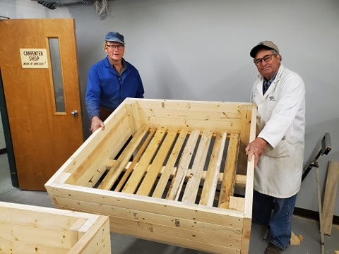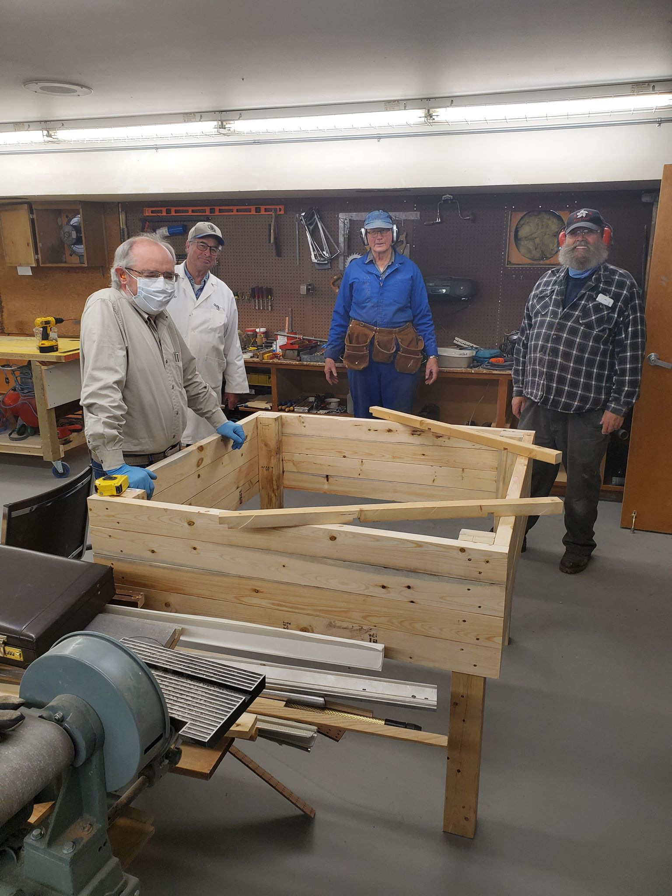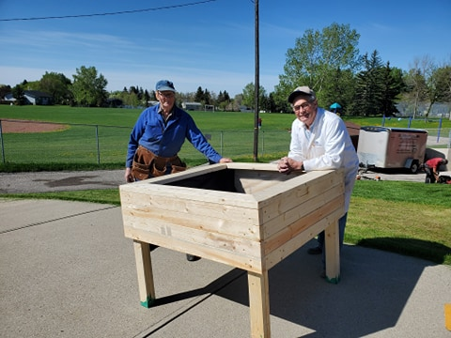

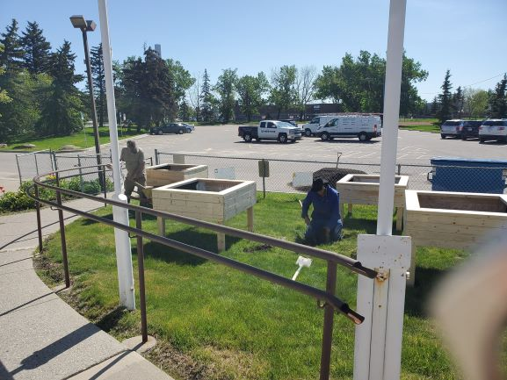

Our Garden Boxes are complete, have you seen them? Come and check it out. Our shop has been under construction and we are almost done, just a few more touches. Interested in joining? Give us a call or drop in.

