*Suggested Meeting Structure*

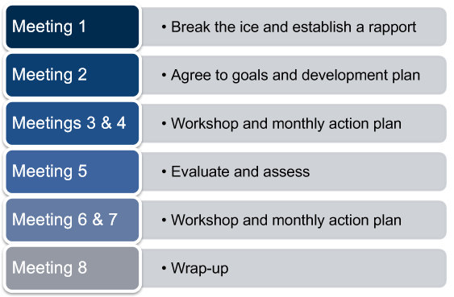*1st Meeting*

*Break the ice and build rapport*

**Opening the Meeting**

* Ask/establish reason for participating & what you are both hoping to learn
* Take notes and listen with intent
* Set meeting expectations & boundaries (meeting times/dates/availability)
* Get to Know Each other - share areas of expertise, acquired business knowledge, and a broad context of career – this should be candid and authentic

**Conversation Starters**

1. *What are you hoping to gain from this experience?*
2. *What do you love most about your job?*
3. *What was a proud moment of your career?*
4. *What is an area or skillset you are struggling to master?*
5. *What is a group, topic, or person who you’d like to have more exposure to?*

**Close the meeting**

* Review SMART Goal Template and Pre-meeting process
  + Mentor reviews the principles of SMART goals in preparation for editing and improving Protégé’s goals
* Obtain Protégé’s commitment to come to the next meeting with SMART goals outlined and a draft Development Plan
* Develop a meeting schedule