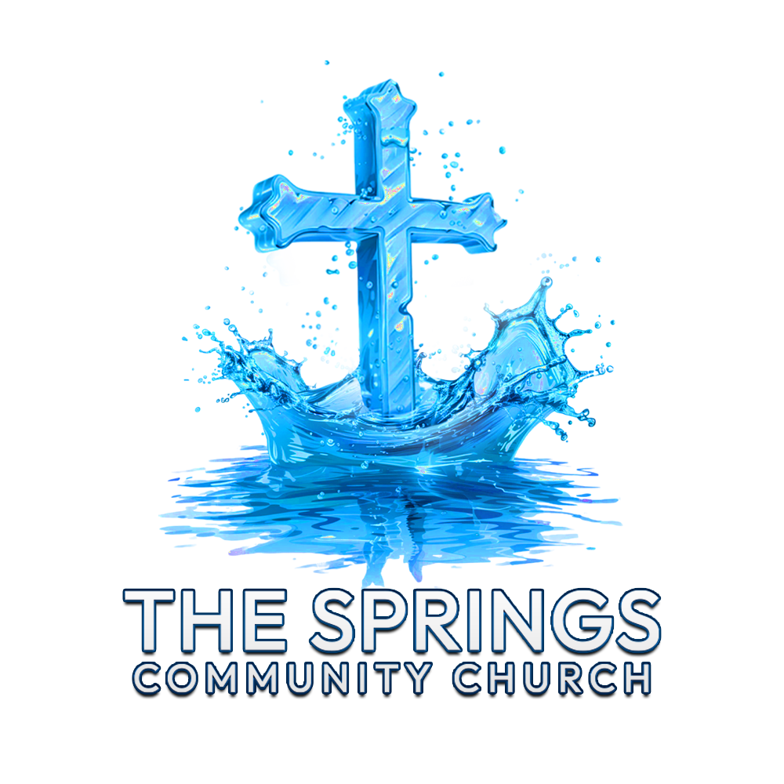
The Springs Community Church
By-Laws
THE SPRINGS COMMUNITY CHURCH
BY-LAWS
--------------------------------------
ARTICLE I: NAME AND PURPOSE
--------------------------------------
Section 1. Name
The name of this organization shall be The Springs Community Church (hereinafter referred to as “the Church”).
Section 2. Purpose
The purpose of the Church is to glorify God by:
1. Worshiping Him in spirit and truth.
2. Proclaiming the Gospel of Jesus Christ to the community and beyond.
3. Nurturing spiritual growth through discipleship, teaching, and fellowship.
4. Demonstrating Christ’s love through acts of service and compassion.
5. Strengthening families and building a thriving community of believers.
6. Functioning as a Christian church organized exclusively for religious, educational, and charitable purposes, in accordance with Section 501(c)(3) of the Internal Revenue Code.
--------------------------------------
ARTICLE II: STATEMENT OF FAITH
--------------------------------------
The Church affirms the foundational tenets of Christian faith as outlined in the Bible, including belief in:
1. The Trinity – God the Father, Son, and Holy Spirit.
2. The authority and inerrancy of Scripture.
3. Salvation by grace through faith in Jesus Christ.
4. The resurrection of Jesus Christ and His return.
5. The Great Commission to make disciples of all nations.
--------------------------------------
ARTICLE III: MEMBERSHIP
--------------------------------------
Section 1. Eligibility
Membership is open to any individual who:
1. Professes faith in Jesus Christ as Lord and Savior.
2. Is baptized by immersion or other accepted biblical method.
3. Agrees to abide by the Church’s Statement of Faith and these By-Laws.
Section 2. Responsibilities
Members are expected to:
1. Regularly attend worship services.
2. Participate in ministries and programs.
3. Support the Church through time, talent, and treasure (tithes and offerings).
4. Live in accordance with biblical principles.
Section 3. Termination of Membership
Membership may be terminated by:
1. Personal request.
2. Transfer to another church.
3. Death.
4. Church disciplinary action based on biblical guidelines (Matthew 18:15–17).
--------------------------------------
ARTICLE IV: GOVERNANCE
--------------------------------------
Section 1. Leadership Structure
A. Elders
Duties & Responsibilities:
- Guard doctrine and protect the church from false teaching (Titus 1:9).
- Provide spiritual oversight and assist in setting policy for teaching, worship, and membership, supervising ministries with the Pastor.
- Shepherd and mentor members (Acts 20:28).
- Hold the Pastor accountable through support, correction, and encouragement.
- Assist in church discipline (Matthew 18:15–17).
- Pray for the church, including anointing and visiting the sick (James 5:14).
Authority:
- Govern spiritual matters and protect doctrinal purity.
- Exercise authority collectively as a council.
- May approve budgets, oversee hiring, and supervise pastoral transitions.
B. Deacons
Duties & Responsibilities:
- Meet practical needs of the church (Acts 6:1–6).
- Support Elders and the Pastor by allowing them to focus on prayer and teaching.
- Manage church resources and facilities.
- Organize volunteers and oversee hospitality and benevolence ministries.
Authority:
- Limited to practical and service-oriented functions, under Elder oversight.
C. Pastors
Duties & Responsibilities:
- Preach and teach the Word of God (2 Timothy 4:2).
- Cast vision and set spiritual direction for the church, and maintain and develop community affairs.
- Shepherd the congregation and provide spiritual counseling (1 Peter 5:2).
- Administer ordinances such as baptism and communion.
- Lead worship services and oversee the order of service.
- Train and equip leaders and volunteers (Ephesians 4:11–12).
- Provide pastoral care, including hospital visits, funerals, and weddings.
- Oversee staff and church operations.
Authority:
- Authority to teach and interpret Scripture.
- Authority to lead church operations in alignment with the church’s mission.
- May have final say in spiritual and theological matters unless otherwise outlined by church governance.
- Works collaboratively with the Elders and Deacons on major decisions.
D. Executive Board
- Consists of 3 to 7 members, selected from current Elders and Deacons.
- Serves in both advisory and administrative capacities.
- Members serve 3-year terms, with a maximum of 6 consecutive years.
- Selected by a two-thirds (⅔) majority vote of the congregation at the annual meeting.
Section 2. Congregational Meetings
1. An annual meeting shall be held to review finances, elect leaders, and set ministry goals.
2. Special meetings may be called by the Elders or upon written request by 10% of active members.
Section 3. Voting
1. Active members 18 years and older are eligible to vote.
2. Voters must actively attend and support the church with tithes and offerings.
3. A quorum of 25% of active members is required for all official votes.
--------------------------------------
ARTICLE V: FINANCES
--------------------------------------
Section 1. Stewardship
- The church shall operate on a budget approved annually by the congregation.
- Deacons manage finances to implement ministry objectives and all checks and disbursements of funds require two signatures.
Section 2. Audits
- A financial review or audit shall occur every two years to ensure accountability.
Section 3. Dissolution
- Upon dissolution, all assets shall be distributed to one or more non-profits aligned with the Church’s purpose that cannot benefit a church board member or leader (e.g., St. Jude’s).
--------------------------------------
ARTICLE VI: MINISTRIES
--------------------------------------
The Church shall establish ministries lead by elders and supported by deacons to fulfill its purpose, including but not limited to:
1. Worship and Music
2. Family and Community Outreach
3. Discipleship and Education
4. Missions and Evangelism
--------------------------------------
ARTICLE VII: AMENDMENTS
--------------------------------------
- By-Laws may be amended by a two-thirds (⅔) vote of active members at a meeting with 30-day written notice.
--------------------------------------
ARTICLE VIII: MISCELLANEOUS
--------------------------------------
Section 1. Indemnification
- Church leaders and staff shall be indemnified for actions taken in good faith in their official roles.
- Individuals acting outside the law on their own accord shall be personally liable.
Section 2. Non-Discrimination
- The Church welcomes all people regardless of race, ethnicity, or economic status, in accordance with the Gospel.
--------------------------------------
ARTICLE IX: REMOVAL OF CHURCH LEADERSHIP
--------------------------------------
Section 1. General Principles
1. Leaders serve under the authority of Christ and the local church (Col. 1:18; 1 Pet. 5:2–3).
2. Leaders must maintain biblical standards of integrity and doctrine (1 Tim. 3; Titus 1).
3. Removal shall be biblical, fair, and protective of both the leader and the church.
Section 2. Grounds for Removal
A Pastor, Elder, or Deacon may be removed for:
1. Doctrinal deviation.
2. Moral failure or misconduct.
3. Neglect of duty.
4. Disorderly conduct or causing division.
5. Physical or mental incapacity that hinders service.
Section 3. Removal Procedures
A. Pastor
- Initiation: Written petition by majority of Elders or ⅓ of membership.
- Investigation: Elders meet privately with the Pastor to seek restoration (Gal. 6:1).
- Vote: Special meeting with 14-day notice; ⅔ voting members required for removal.
- Appeal: Pastor may submit a written response but no appeal after the vote.
B. Elder
- Initiation: Majority of Elders (excluding the one in question) or 25% of voting members.
- Investigation: Remaining Elders counsel and consider restoration.
- Vote: Simple majority of members present at a duly called meeting.
C. Deacon
- Initiation: Elders may review for removal based on grounds in Section 2.
- Decision: Two-thirds (⅔) vote of active Elders.
- Notification: Written notice to the Deacon and church within 7 days.
Section 4. Restoration
- Goal is always repentance, reconciliation, and restoration.
- A removed leader may be reinstated after demonstrating repentance and regaining trust with Elder and congregational approval.
Section 5. Confidentiality
- All proceedings regarding removal are strictly confidential, shared only with those directly involved.
--------------------------------------
Adopted by the Congregation of The Springs Community Church on [Date].
Signatures
Elder Chair: ___________________________
Pastor: ___________________________
Secretary: ___________________________

