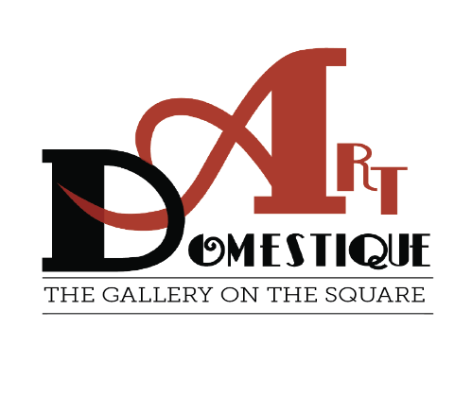
Hello All,
You are invited to paint en plein aire in Washington, Iowa June 13,14,15. The city of
Washington and areas of Washington County are available for you to paint; landscapes,
flowers, historical buildings, or something else. The painting will begin any time after
registration opens at 4:00 p.m. on Friday, June 13th with a nocturne; and will continue until Sunday, June 15th. Your two completed paintings are due at Art Domestique Gallery by 1:00 p.m. on Sunday for judging. You will continue from 1:00 to 4:00 p.m. with a Quick Paint of Washington sites. Art Domestique is conveniently located across from Central Park.
DATES: June 13th-15th, 2025
REGISTRATION/FEE: Cost: $30.00. Check-in and stamping of materials will be available at Art Domestique Gallery on Friday, June 13th, between 4:00 p.m. thru 7:00 p.m. or Saturday the 14th of June after 7 a.m. For those participating in the Friday nocturne, paintings should be submitted between 7:00- 7:30 a.m. at the gallery opening. Coffee, water, iced tea, and pastries will be available Saturday morning.
Sunday the 15th, Artwork MUST be framed, (wire hanging system only) ready to
hang by 1:00 p.m. at Art Domestique Gallery. A framing table will be available for your
use after 11:00 a.m. The central portion of the Gallery will be used to display your
work.
Sales of the paintings produced Friday evening, all day Saturday, and Sunday morning
will be done through Art Domestique Gallery and the gallery will retain 25%
commission.
ART SALES 2:00 p.m. - 5:00 p.m.
AWARDS CEREMONY 4:30 p.m. – 5:00 p.m.
At 4:30 p.m., the artists will move inside for the Awards Ceremony. Art Domestique will
be offering a 1st Place Award of $500., 2nd Place Award of $250., 3rd Place Award of
$150., plus Honorable mentions, Quick Paint Award.

Regards,
Art Domestique Board of Directors

Art Domestique Gallery, Washington, IA
En Plein Aire Registration 2025
Dates: Friday, June 13 - Sunday, June 15, 2025

First Name: _____________________ Last Name: ____________________________

Address: ________________________ City, State, Zip: ________________________

Cell #: _________________________ Email: ________________________________

Website: _____________________________________________________________
............................................................................................................................................
Registration Fee: $30.00 (postmarked by June 1, 2025).
We will accept two (2) plein aire paintings done previously to be displayed “for sale” beginning Friday, June 13th.
.........................................................................................................................................................
Please print this form, enter information, and MAIL to:
Art Domestique, Plein Aire, 118 S. Iowa Ave., Washington, IA 52353
Make check out to: “Art Domestique, Plein Aire”
...................................................................................................................................................................

I agree to bear all risk and expense for any loss, theft, or damage to my paintings or other personal
property or injury to my person, regardless of cause.
I indemnify and hold harmless Art Domestique Gallery, from and against any claim, suit, action, liability or
expense arising out of any matter which would result from exhibiting or using images of my paintings for
publicity.
The participating artist and all paintings submitted may be photographed and/or videotaped by Art
Domestique Gallery for promotional purposes. The winner of the 1st Prize agrees to give Art Domestique Gallery full license to make prints of winning painting, in any form we see fit, for the purpose of promoting Art Domestique Gallery. Participation in this event is “at your own risk”. All participants must use due care under the circumstances to comply with rules, regulations, statues, and laws of the state where the event is held.
My signature on this registration form verifies that I agree to the above statement.

Signature X ____________________________________________Date: ________________________

If you have questions, please feel free to contact Jane at Art Domestique: 319-653-8550 or by email at:
artdomestique@gmail.com

