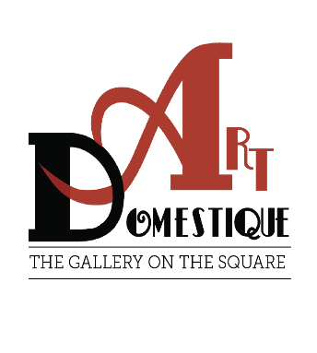

**SE Iowa Photographers**,

Art Domestique Gallery invites you to be a part of the **“As We See It 2026”** photography show.

The Photography Show will be held from **January 5, 2026 to January 31, 2026** at Art Domestique Gallery, **118 S. Iowa Ave., Washington, IA 52353.** There will be an **entry fee of $15. for adults and $10. for students.** There will be a cash award for best of show and also a patron award for this year’s photography show.

Photographers from South East Iowa are being invited to this show.

Our Gallery would like to offer you, the photographer, an opportunity to showcase your work in our beautiful gallery space. The **photographs** that will be showcased **must be For Sale**. A commission of 25% on sales will be charged by the gallery. Price your work accordingly.

**Please let the gallery know by Sunday, December 21, 2025 of your intention to exhibit at the gallery** by calling: **319-653-8550** or by e-mail at: [artdomestique@gmail.com](mailto:artdomestique@gmail.com). We will need your name, phone number, and e-mail address at this time.

You may submit up to **4 pieces** for the show. Please make sure that your photographs are framed and ready to hang. (No saw-tooth hangers.) Art Domestique will make the labels for your show. **We will need the following information sent** to [artdomestique@gmail.com](mailto:artdomestique@gmail.com) by **Friday, December 19, 2025**: Please provide your last name, first name, and title, and price for each piece and this same information attached on the back of your work.

**Your work needs to be delivered to the gallery by Friday, December 26, 2025**. Hours for the gallery are 10 – 4 pm, Wednesday through Friday. Arrangements can be made if you prefer to deliver at a different time by calling **319-653-8550** or email at [artdomestique@gmail.com](mailto:artdomestique@gmail.com).

We will hold a reception for you, the photographers, at Art Domestique Gallery in Washington where refreshments will be served. The date for this **reception is Friday, January 16, 2026 from 5:30-7:30 pm. Awards will be presented at the reception.**

Board of Directors

Art Domestique Gallery