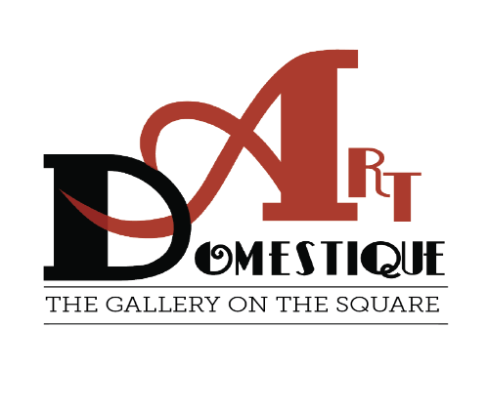
Hello All,
You are invited to paint en plein aire in Washington, Iowa June 7, 8, 9. The city of
Washington and areas of Washington County are available for you to paint; landscapes,
flowers, historical buildings, or something else. The painting will begin any time after
registration opens at 4:00 p.m. on Friday, June 7th with a nocturne; and will continue until Sunday, June 9th. Your two completed paintings are due at Art Domestique Gallery by 1:00 p.m. on Sunday for judging. You will continue from 1:00 to 4:00 p.m. with a Quick Paint of Washington sites. Art Domestique is conveniently located across from Central Park.
DATES: June 7th -9th, 2024
REGISTRATION/FEE: Cost: $30.00. Check-in and stamping of materials will be available at Art Domestique Gallery on Friday, June 7th, between 4:00 p.m. thru 7:00 p.m. or Saturday the 8th of June after 7 a.m. For those participating in the Friday nocturne, paintings should be submitted between 7:00- 7:30 a.m. at the gallery opening. Coffee, water, iced tea, and pastries will be available Saturday morning.
Sunday the 9th, Artwork MUST be framed, (wire hanging system only) ready to
hang by 1:00 p.m. at Art Domestique Gallery. A framing table will be available for your
use after 11:00 a.m. The central portion of the Gallery will be used to display your
work.
Sales of the paintings produced Friday evening, all day Saturday, and Sunday morning
will be done through Art Domestique Gallery and the gallery will retain 25%
commission.
ART SALES 2:00 p.m. - 5:00 p.m.
AWARDS CEREMONY 4:30 p.m. – 5:00 p.m.
At 4:30 p.m., the artists will move inside for the Awards Ceremony. Art Domestique will
be offering a 1st Place Award of $500., 2nd Place Award of $250., 3rd Place Award of
$150., plus Honorable mentions, Quick Paint Award.

Regards,
Art Domestique Board of Directors

