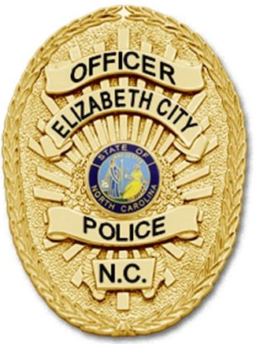In Pursuit Of Excellence

TO: Community Partners

Elizabeth City, North Carolina

FROM: Treven G. Franks

Administrative Services Liaison

SUBJECT: Expungement Workshop Memorandum & Flyer

DATE: November 16, 2017

Dear Community Partner(s):

At this time, I am pleased to announce the Elizabeth City Police Department on February 23, 2018 (Friday) will be hosting an Expungement Workshop that is open to the general public and it’s free of charge.

There will be two sessions taking place on this date. The first will kick off at 2:00pm and the second session will start at 6:00 pm. We strongly encourage our community partners to put the word out in the community about this workshop in an attempt to boost participation and tell prospect attendee to bring their criminal record with them to the workshop.

During this workshop, members from the Pasquotank County NAACP, NC Works, Youth Build, NC Probation and Parole, Local Attorneys and civic groups will be in attendance. Attached to this memorandum is the original flyer for this workshop

In the meantime, please get the word out about this workshop and we look forward to seeing you on February 23, 2018. If you should have any questions or concerns, you can contact me at (252) 621-7133 or (252) 722-4964.

Yours in Service,

Officer T. Franks

Administrative Services Liaison

EXPUNGEMENT WORKSHOP
HOSTED BY:
ELIZABETH CITY POLICE DEPARTMENT

Put Your Past Behind You!
Friday, February 23, 2018
Session One – 2:00 PM & Session Two – 6:00 PM
Come let us and others BEGIN or CONTINUE the process of helping you clear your record so that you can be eligible for various career opportunities. This workshop is free of charge! Please bring your criminal record to this workshop!
Elizabeth City Police Department, Training Room
305 E. Main Street
Elizabeth City, North Carolina 27909

For more information contact:
Officer T.G. Franks
Office: (252) 335-4321 ext. 7133
Cell: (252) 722-4964

