Gael-Talk
Learning Gaelic
Year 2
Caibideil 2-1

Nas fheàrr a’ Ghàidhlig bhriste n’ a’ Bheurla chliste!

Better Broken Gaelic than fluent English!

A little reminder –
We really should pay the piper
(mòran taing to those who have!)

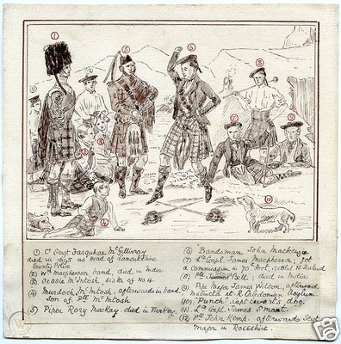

Please send donations for the class to Paypal:
profmcintyre@yahoo.com
the amount is up to you, but the suggested donation is $5

Clàr na seachdaine (schedule of the week)

- Fàilte! Sean fhacal na seachdain:
- Facal na seachdain: dùthaich
- Còmhradh na Seachdain –
- Òran na seachdain – Chì mi na mòrbheanna

Fàilte! Sean Fhacal na Seachdaine
- Is còir do dhuine dàimh a bhith aige ri dùthaich (a) athraichean
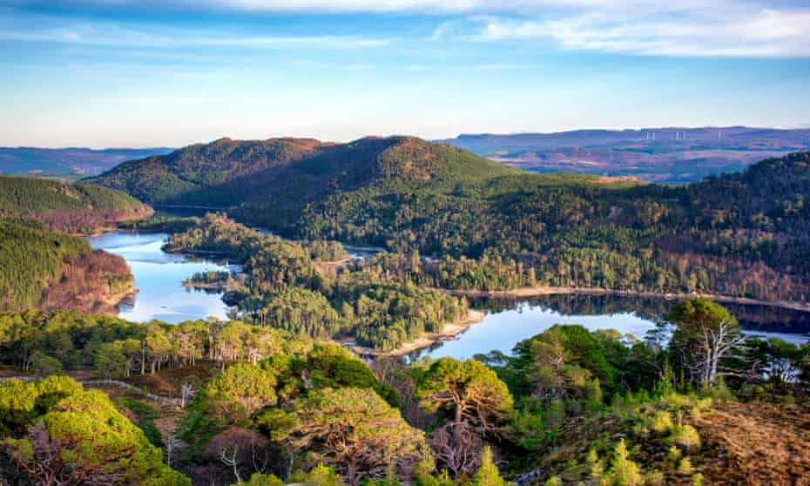

A Person ought to have an attachment to the land of his ancestors
  - Còir = right, proper
  - Dàimh = relationship, kinship, affinity
  - Dùthaich = subject of today’s talk

Facal na Seachdaine: Dùthaich
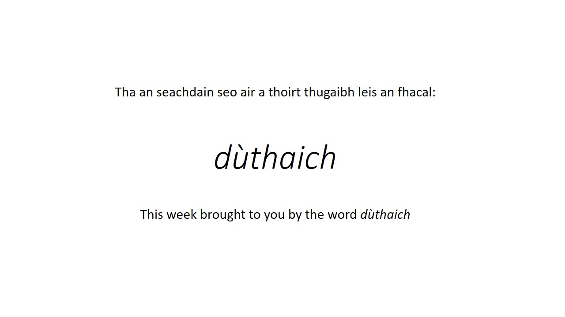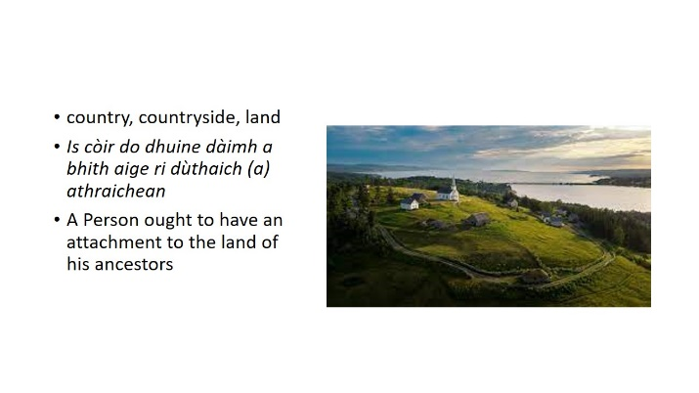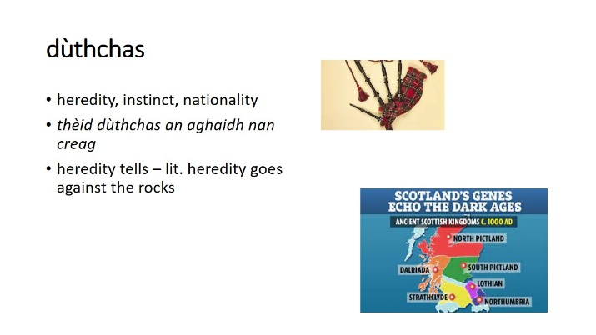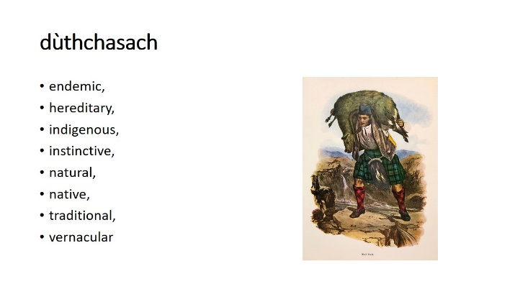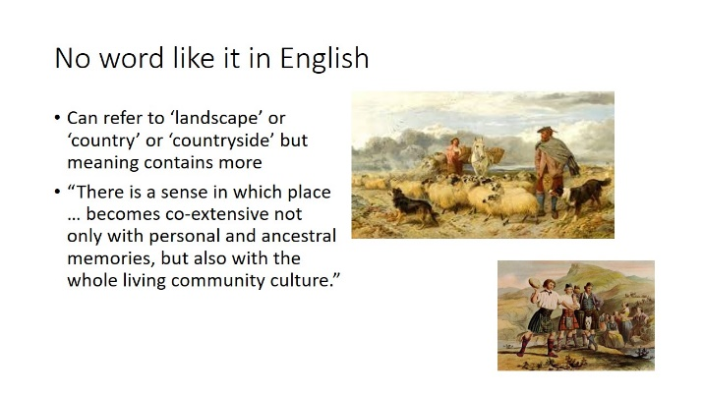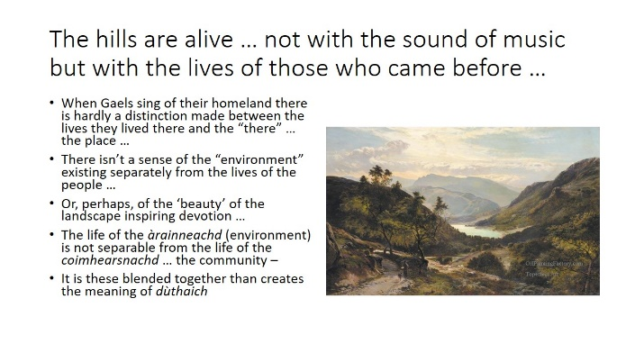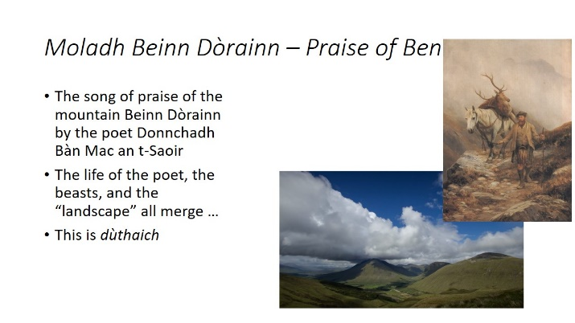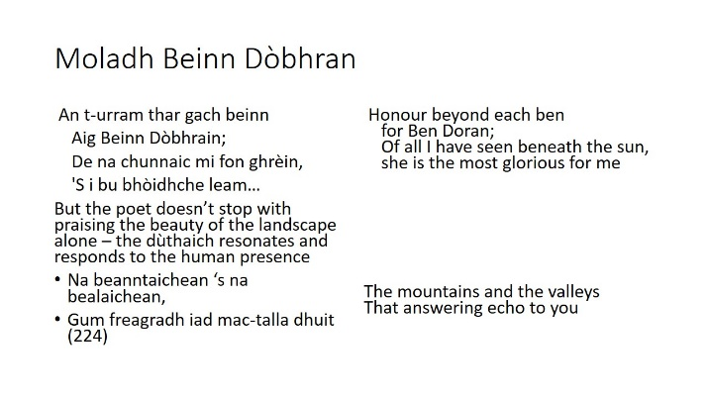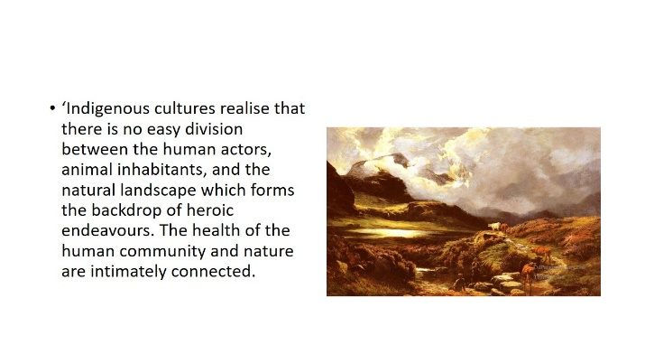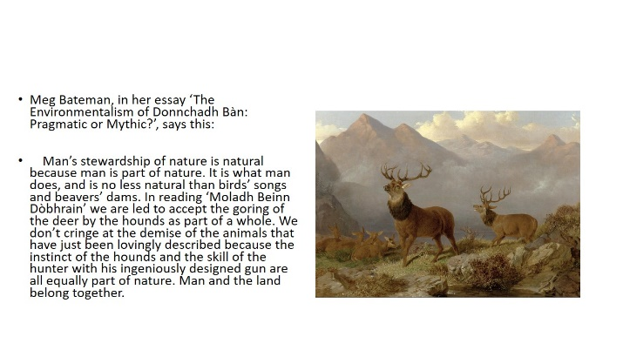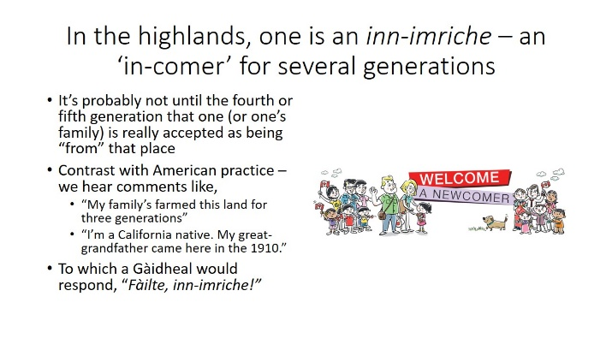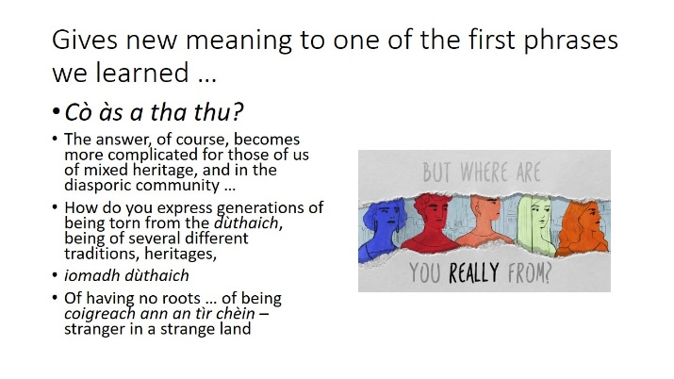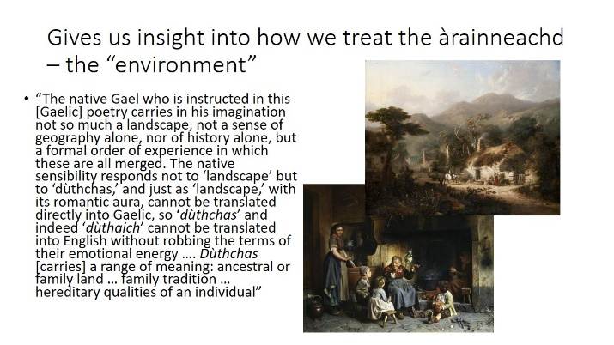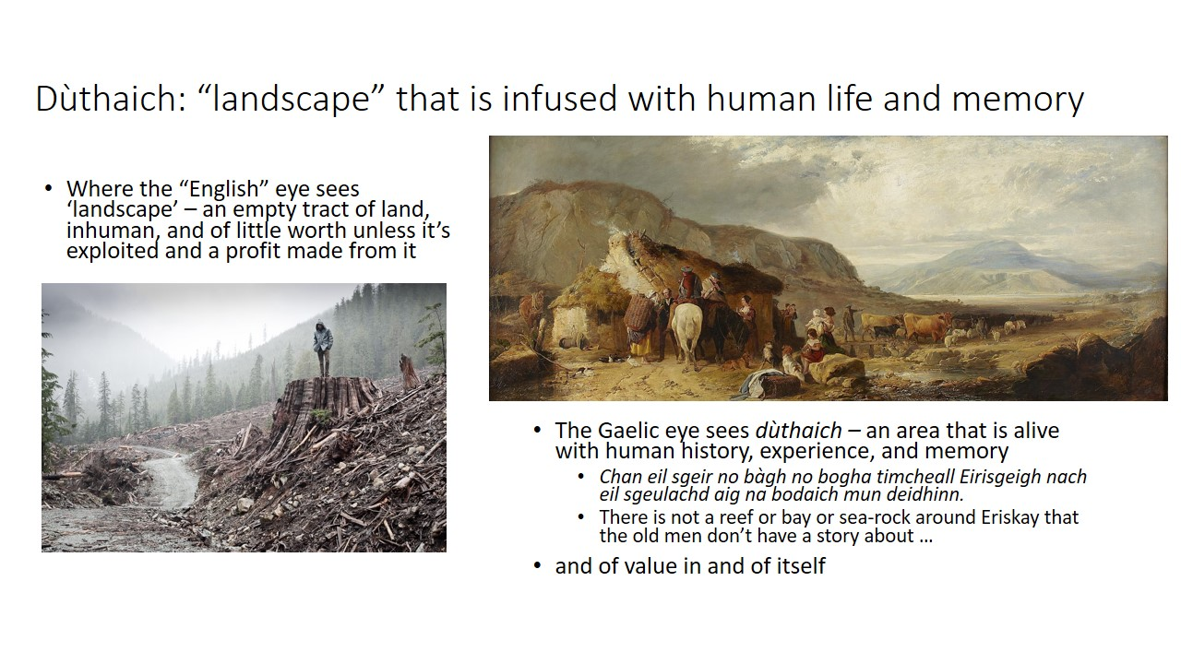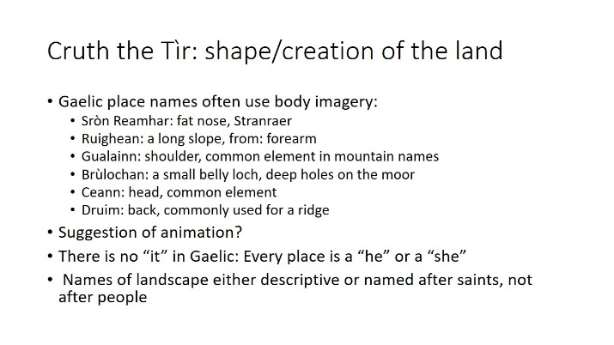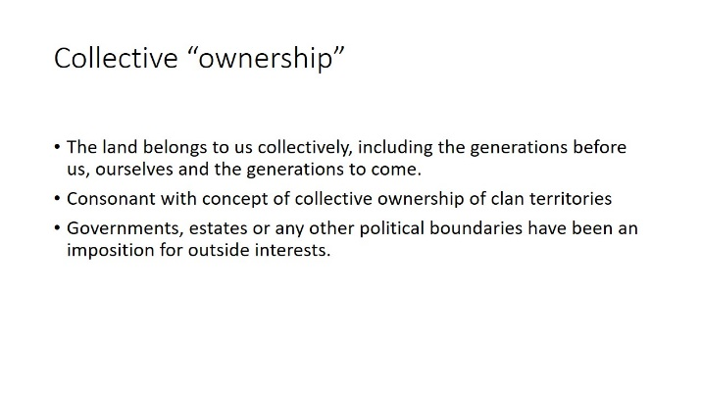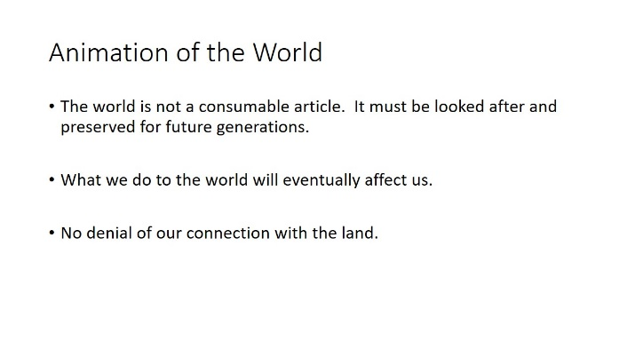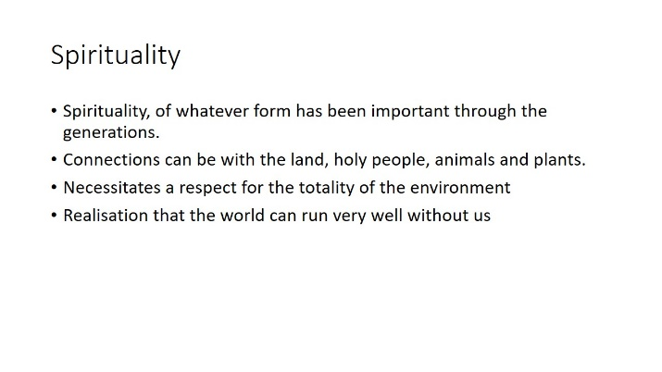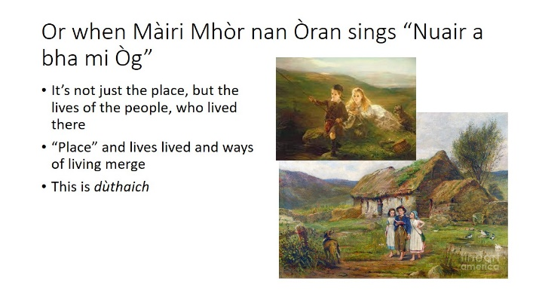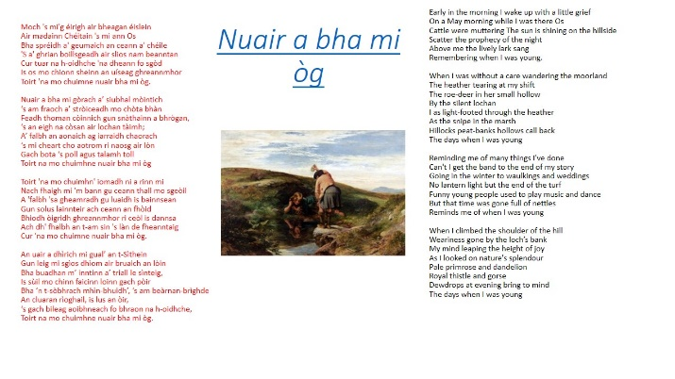

Còmhradh na seachdaine
looking up in dictionary is ‘fair’

- introduce yourself to your partner
- tell your name
- ask your partner’s name
- say where you are from
- where you live
- tell about the place where you live

- tell about your family
- ask about your partner’s family
- tell about your spouse/significant other, children, parents,friend(s)
  - are they tall?
  - short?
  - young?
  - old?
  - what do they like to do?
  - where do they work?

- tell what you ‘do’
- learn gaelic ?
- work?
- hobby?

- talk about the weather
- is it cold? Warm?
- wet? raining?
- is there snow?
- is there wind?

- Tell about your holidays
- Dè an d’ rinn thu airson Nollaig?
- Dè an do dh’ith thu airson dìnneir Nollaig?
- An deach thu dhan phartaidh Oidhche Chailein?

Òran na seachdaine
Chì mi na mòrbheanna
https://www.youtube.com/watch?v=lE3j0UuyL5s
Chì mi na mórbheanna  Séist:  O chì, chì mi na mòr-bheanna  O chì, chì mi na còrr-bheanna  O chì, chì mi na coireachan  Chì mi na sgoran fo cheò  Chì mi gun dàil an t-àite san d'rugadh mi  Cuirear orm fàilte sa chànain a thuigeas mi  Gheibh mi ann aoidh agus gràdh nuair a ruigeam  Nach reicinn air tunnachan òir  Sèist  Chì mi na coilltean, chì mi na doireachan  Chì mi ann màghan bàna is toraiche  Chì mi na féidh air làr nan coireachan  Falaicht' an trusgan de cheò  Sèist  Beanntaichean àrda is àillidh leacainnean  Sluagh ann an còmhnuidh is còire cleachdainnean  'S aotrom mo cheum a' leum g'am faicinn  Is fanaidh mi tacan le deòin | I see the great mountains  Chorus:  Oh, I see, I see the great mountains  Oh, I see, I see the lofty mountains  Oh, I see, I see the corries  I see the peaks beneath the mist  I see, straight away, the place of my birth  I will be welcomed in a language which I understand  I will receive hospitality and love when I reach there  That I would not trade for tons of gold  Chorus  I see woods there, I see thickets there  I see fair, fertile fields there  I see the deer on the ground of the corries  Shrouded in a garment of mist  Chorus  High moutains with lovely slopes  Folk there who are always kind  Light is my step when I go bounding to see them  And I will willingly remain there for a long while  Chorus

