**Gael-Talk**

**Learning Gaelic**

**Year 2**

**Caibideil 2-10**

*Zoom link:*

<https://us02web.zoom.us/j/86793281836?pwd=WXUvQmJJdkxhRHdjaTV4YWxyYTVpQT09>

*Nas fheàrr a’ Ghàidhlig bhriste n’ a’ Bheurla chliste!*

Better Broken Gaelic than fluent English!

A little reminder –

We really should pay the piper

(*mòran taing* to those who have!)

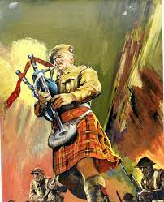

*Please send donations for the class to Paypal*:

[profmcintyre@yahoo.com](mailto:profmcintyre@yahoo.com)

The amount is up to you, but the suggested donation is $5 per lesson

**Clàr na seachdaine (schedule of the week)**

* Fàilte!
* Sean fhacal na seachdain –… An t-acras
* Còmhradh na Seachdaine – Anns a’ chidsin (a-rithist)
* Sgeul na Seachdaine - Peadar Rabaid
* Òran na seachdaine - Brochan Lom
* ***Sean fhacal na seachdaine***

['S math an t-annlann an t-acras](https://www.faclair.com/ViewEntry.aspx?ID=EA87FC164083FAED82BAFC241E9F1B82)

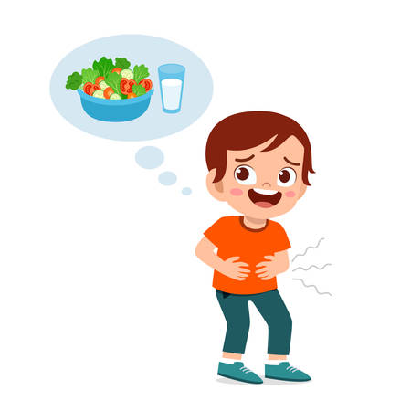

Hunger is the best/a good sauce

annlann 1 accompaniment (culinary; traditionally anything served alongside the staple (meat, cheese etc) but sometimes referring to all dishes served during a meal) 2 condiment, dressing

acras air …

* tha an t-acras orm = I’m hungry (is hunger on me)
* a bheil an t-acras ort? are you hungry
* tha an t-acras air = he is hungry
* tha an t-acras oirre = she is hungry
* tha an t-acras oirnn = we are hungry
* tha an t-acras oirbh = you(pl/form) are hungry
* tha an t-acras orra = they are hungry
* tha an t-acras air Seumas = Seumas is hungry

**Facal na seachdaine**

[còir](https://www.faclair.com/ViewEntry.aspx?ID=6134E9450FB004A30DE6AB5A98886857) [https://www.faclair.com/Graphics/listen.png](https://www.faclair.com/Listen/coir.mp3)  
*adjective* 1 kind(ly) 2 decent, virtuous, civil 3 worthy 4 honest 5 proper, (be)fitting 6 dear... (in correspondence)

A Sheumais còir = Dear Seumas (beginning a letter)

Iain còir = Dear John

[còir](https://www.faclair.com/ViewEntry.aspx?ID=2F087F65174A13168F52BE3355156855) / / [https://www.faclair.com/Graphics/listen.png](https://www.faclair.com/Listen/coir.mp3)  
*noun, fem.* còrach, *iol.* Còraichean 1 right 2 justice 3 duty, obligation

’S e mo chòir a th’ innte! It’s my right!

[coire](https://www.faclair.com/ViewEntry.aspx?ID=212D7978C8B9C500EAB8245BA84C640F) / /  
*noun, fir.* *iol.* –an 1 kettle 2 corrie 3 cauldron

Tha an coire teth.

[ann an coire teth](https://www.faclair.com/ViewEntry.aspx?ID=52A4879511746BB1C918110118082D55) [https://www.faclair.com/Graphics/listen.png](https://www.faclair.com/Listen/ann-an-coire-teth.mp3) in a hot pot = 1 in turmoil (*fig.*) 2 in a panic (*fig.*)

Pour tea

From a *coire*

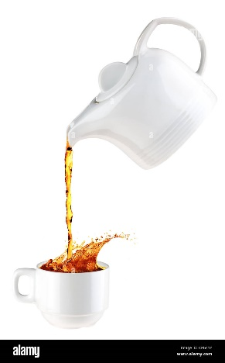

**~~**

coire n. fem. /kɤrʲə/ pl. –annan 1. blame, fault 2. offence, wrong

[an robh dad coire an-sin?](https://www.faclair.com/ViewEntry.aspx?ID=A233C5DDAF962E1E08290F8FD3712156) [https://www.faclair.com/Graphics/listen.png](https://www.faclair.com/Listen/an-robh-dad-coire-an-sin.mp3) was there anything wrong with that?

’S e mo choire a th’ innte! (My bad! My fault)

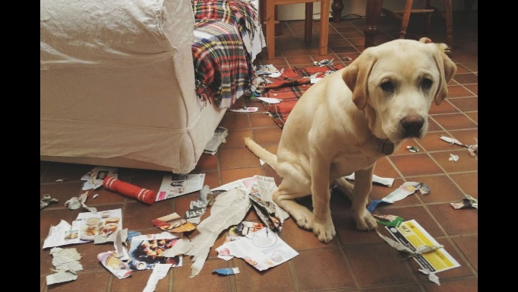

Mo choire

My error / err

**Còmhradh na seachdaine**

Today, we’re going to engage in còmhradh / conversation. Start with the following prompts, but feel free to go as far afield as you like (as long as you stay in the Gaelic field!)

With your partner(s), create a story or a description or a dialogue about making and eating a meal. Include the food, what meal it was, how it was made, who ate it. Refer to the following vocabulary sheets. Looking up in dictionary is ‘fair’ as well.

Verbs used

* Rinn – made
  + A’ dèanamh – making
* Chòcairich – cooked
  + A’ Còcaireachd – cooking
* fhraidhig – fried
  + a’ fraidheadh – frying
* bhruich – boiled, cooked, broiled
  + a’ bruich – boiling, cooking, broiling
* sguab – swept
  + sguabadh – sweeping
* dh’ith – ate
  + ag ithe – eating
* dh’òl – drank
  + ag òl - drinking
* nigh – cleaned
  + a’ nighe – cleaning
* fhuin – baked
  + a’ fuineadh – baking
* measgaich = mix
  + a’ measgachadh

Other vocabulary:

* Lite = oatmeal
* Brochan = porridge
* Milis = sweet
* Frids = fridge
* Uaireadair = clock or watch
* Spàin = spoon (one)
* Sgudal (anns a’ bhinne)
* bonnach-uighe – omelette
* Sgian = knife, sgèinean = knives
* Stòbh = stove
* Spàin = spoon
* Bobhla = bowl
* Cupan = cup
* Maidse = match
* Truinnsear = plate
* àmhainn meanbh-thonn - microwave oven
  + abhainn = river > a-ven / a-win
* measan = fruit
* cearc-fhrangach = French chicken/ turkey
* iogart = yogurt
* biadh beag (greim-bìdh, snaoic) = snack
* Meagsagach - Mexican
* Sìneach = Chinese > she-nach
  + Note the long “*ì*” – short / *sineach* = mammal >shin-nach
  + & sionnach = fox (>shu-nach)
* Albannach - Scottish
* Eadailteach - Italian

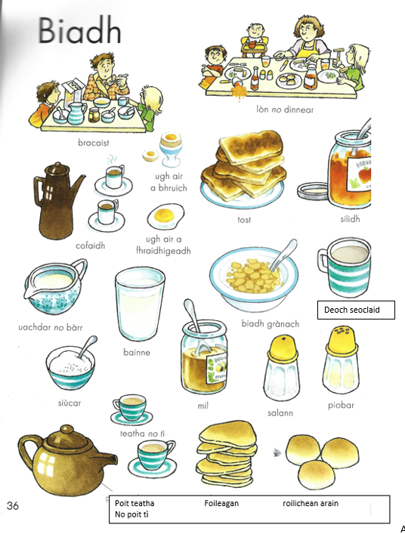

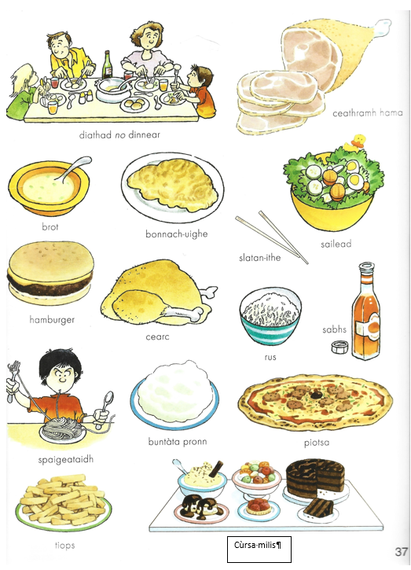

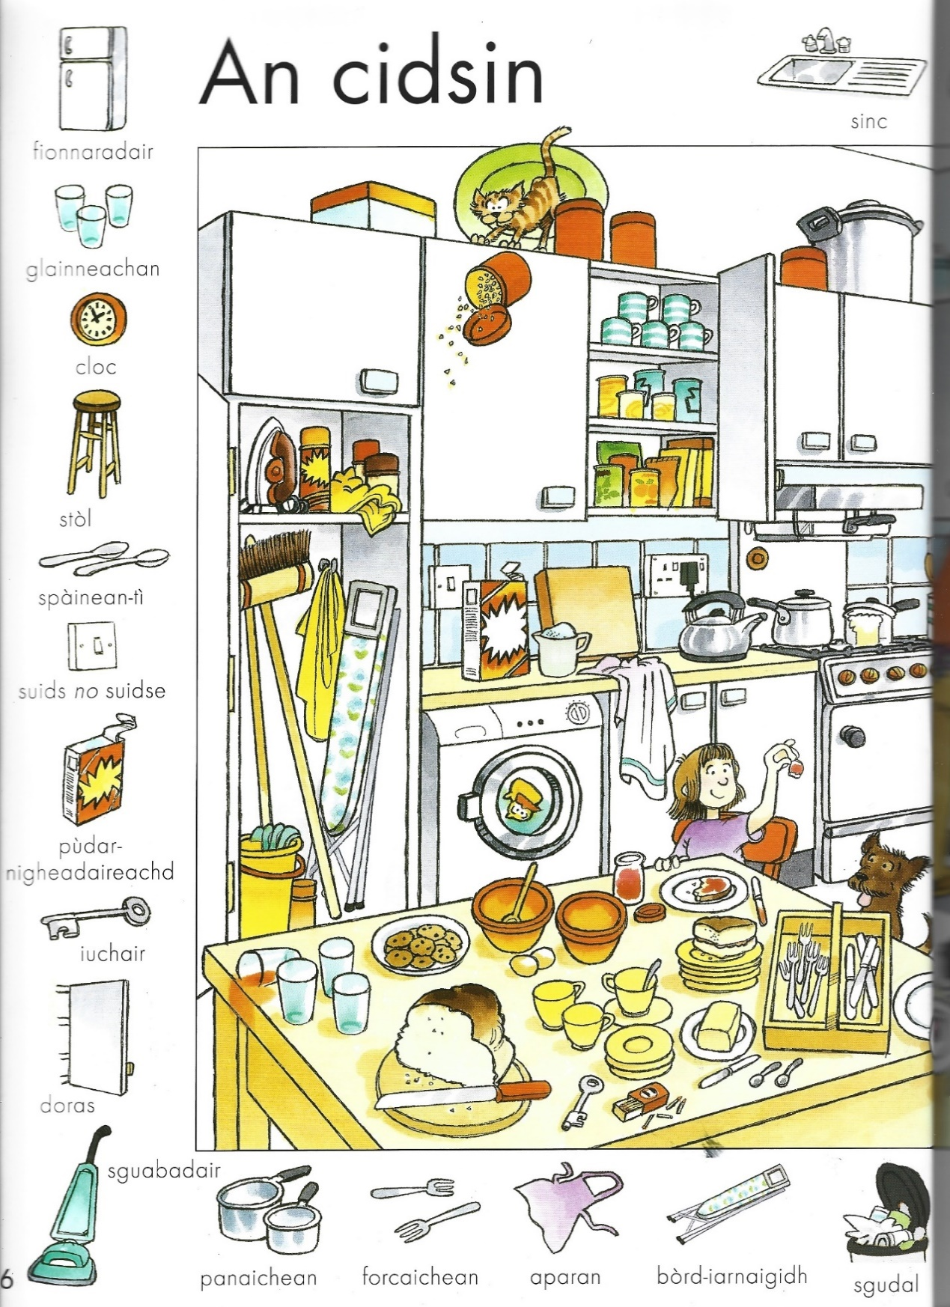

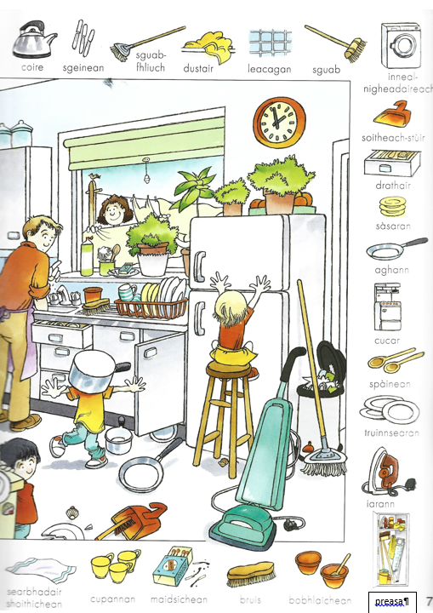

**Còmhradh:**

**Ceistean airson Còmhradh -**

1. Dè an toil leat a bhith a’ còcaireachd?
   * Dh’ithe mi brot glasraich an-diugh
2. Am bi thu a’ coimhead air programan còcaireachd air an telebhisean?

[reasabaidh](https://www.faclair.com/ViewEntry.aspx?ID=14D77F502F9A4FDA9653F24BAD9E9408) / reasabaidhean = recipe(s)

eadar-lìon = internet

1. Ciamar a dh’ionnsaich thu còcaireachd?
   * Seanmhair = grandmother, mo sheanmhair > sean(a)mhair
2. Am bi thu a’ còcaireachd airson do theaghlaich?

Context whether bidh = future or habitual

1. Am bi do chèile a’ còcaireachd?
   * Dè bhios iad a’ dèanamh?
   * Cuideachail = helpful
2. Ciamar a bhios tu a’ còcaireachd uighean?
   * Dòighean diofar = different ways
   * Air am fraighegadh
   * Air bhruich
3. Cò bhios a’ nighe os dèidh còcaireachd?

* Mo dhuine = my husband / mo phiuthar my sister

1. Dè an uair a bhios tu ag ithe dìnnear?

Còig uairean

Pm=feasgar , sia uairean feasgar 6pm

Am = sa mhadainn, 8 uairean sa mhadainn

Aon uair deug feasgar

Uair sa mhadainn = 1 am (in morning)

1. Ciamar a bhios tu a’ còcaireachd cearc?

Ann am [àine-chaoire](https://www.faclair.com/ViewEntry.aspx?ID=5A1382CE208361F67E33D84F72D8EE3B) *boir.* *iol.* àithean-caoire barbecue; àine = pleasure; caoire = genitive of *coire*

1. Am bi thu a’ fraigheag rud sam bith? Dè?

Rud sam bith = anything

Tha droch fhàileadh ann = bad smell on it

‘s ann ann an Alba bidh iad a’ fraigheag Snickers!

1. Am bi thu a’ fuine aran?

Ainmeil ! famous

1. Dè nach toil leat a bhith a’ còcaireachd?
2. An toil leat a bhith ag ithe ann an taigh-bidh?
   * Dè seòrsa thaigh-bidh?
3. Am bidh thu a’ cleachdadh slatan-bidh nuair a bhios tu ag ithe bidh Sineach?
4. An toil leat cofaidh geal no cofaidh dubh?
5. An toil leat teatha geal no teatha dubh?
6. Dè bhios tu a’ dèanamh anns an àmhainn?
7. Dè bhios tu a’ dèanamh ann am panaichean?
8. Dè biadh nach toil leat?
9. Am bidh thu ag ithe feòil no glasraich a-mhàin?
10. An toil leat còcaireachd?
11. An toil leat cèic no paidh no briosgaidean airson cùrsa milis?
12. Dè cho mheud de ghlainneachan uisge a bhios tu ag òl gach latha?
13. Nuair a bhios tu òg dè biadh am bu toil leat?
14. Am bi thu ag ithe biadh beag (greim-bìdh, snaoic) anns an latha?
15. An toil leat biadh [Meagsagach](https://www.faclair.com/ViewEntry.aspx?ID=5FBA71A9E90D743C23D8D75CB19D3266)?
    * Dè?
16. An toil leat biadh Sìneach?
    * Dè?
17. An toil leat biadh Albannach?
    * Dè?
18. An toil leat biadh Eadailteach?
    * Dè?
19. Nam biodh taigh-bidh agad,
    * dè seorsa bhiadh am biodh tu a’ dèanamh?
    * what would the decor be like?
    * Càit’ am biodh e?
    * Dè seorsa chèol am biodh tu a’ cluich?

**P 52 – 2-10**

**Sgeul na Seachdaine**

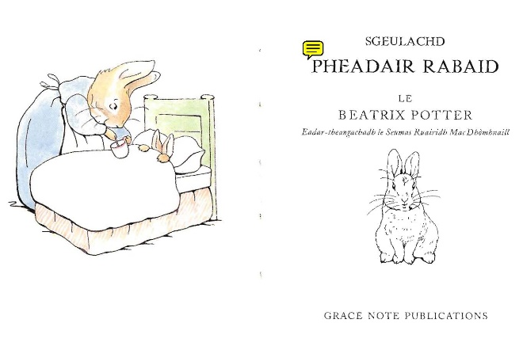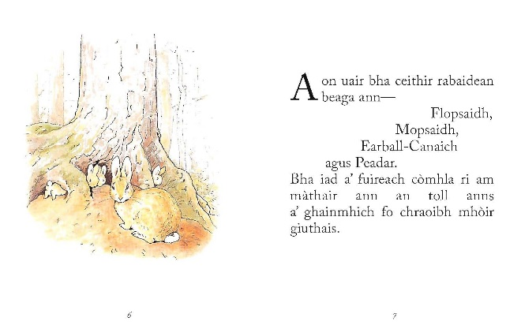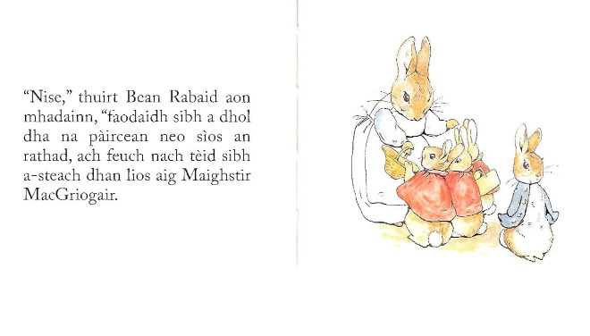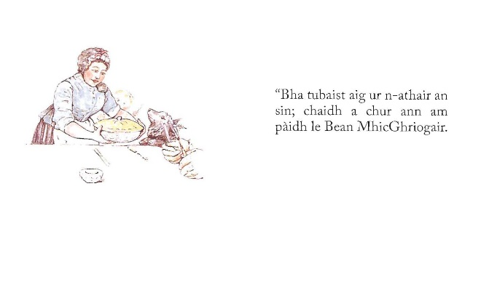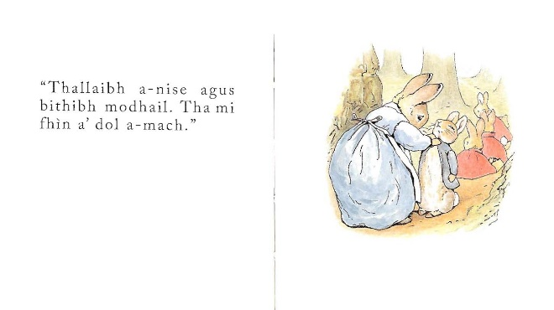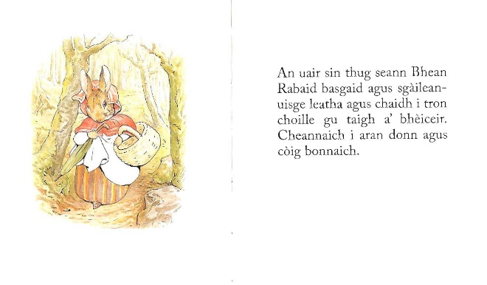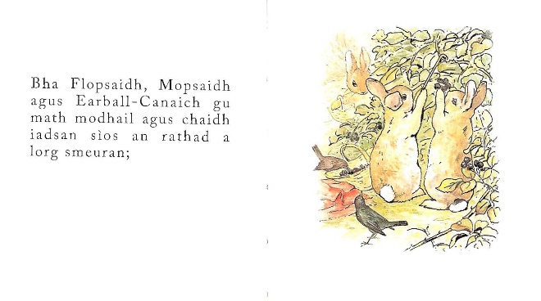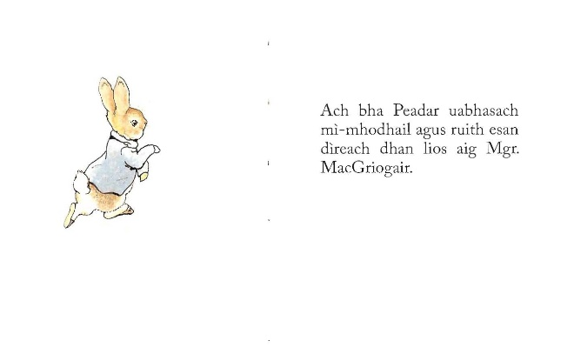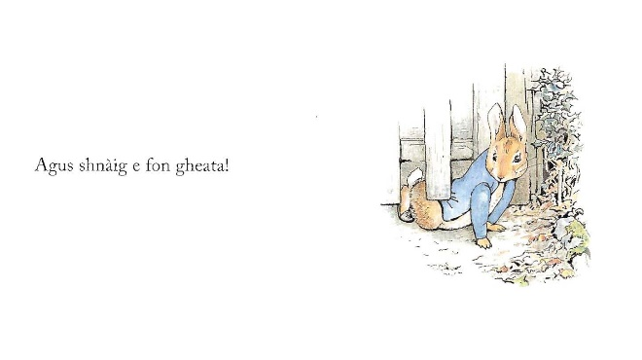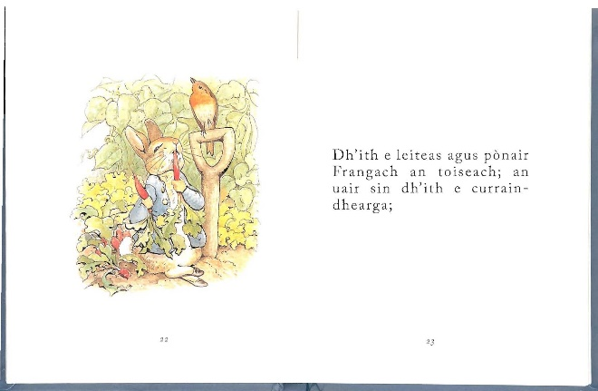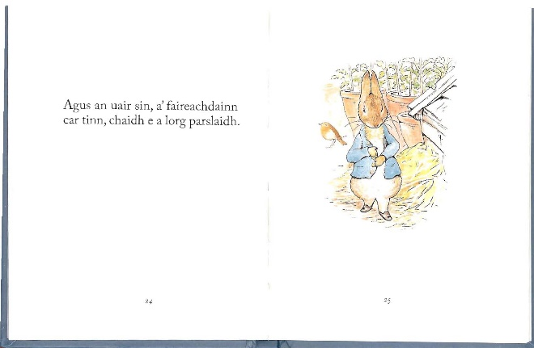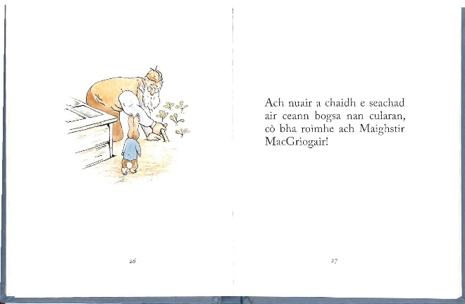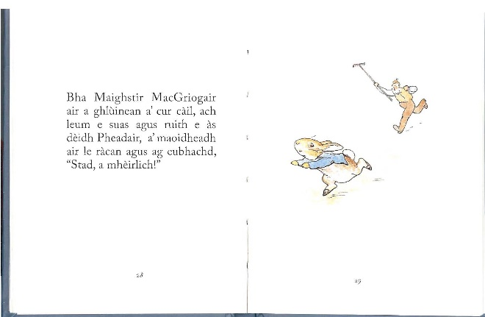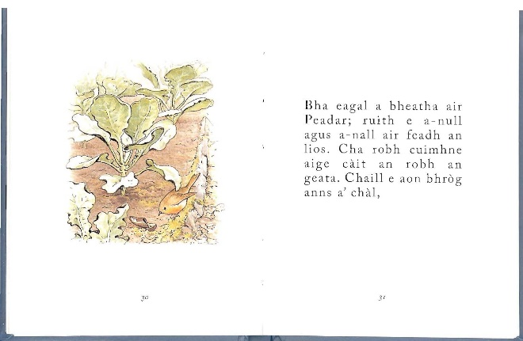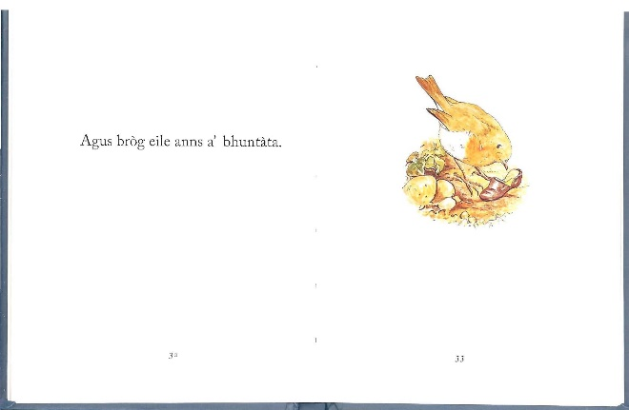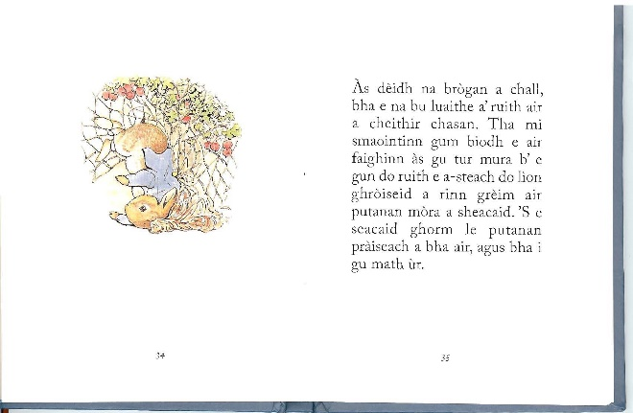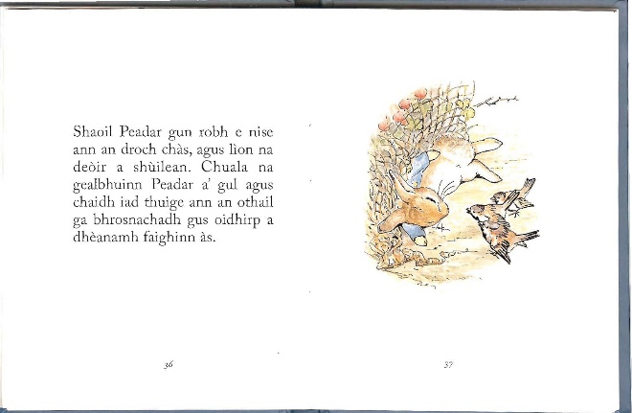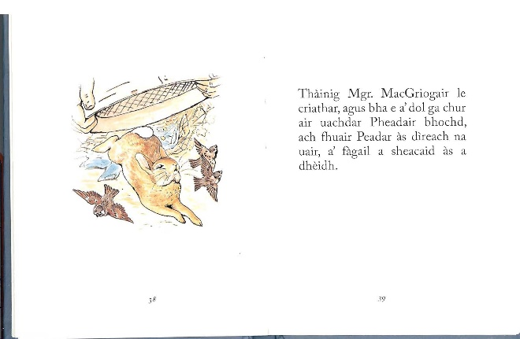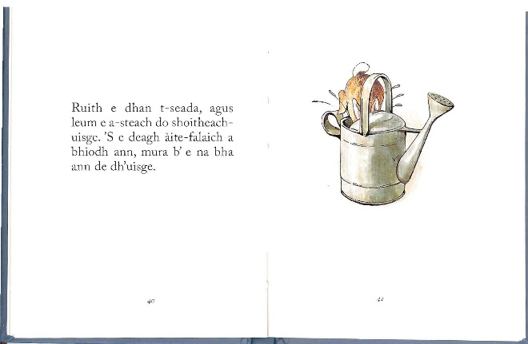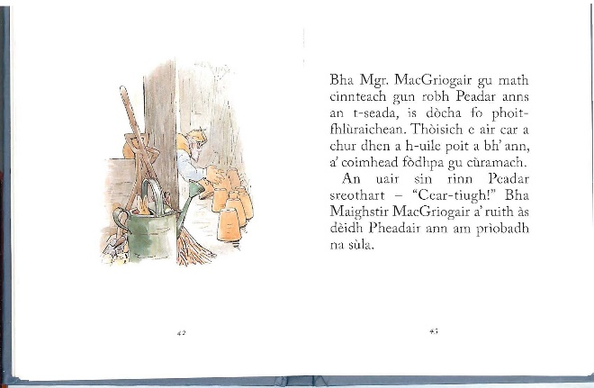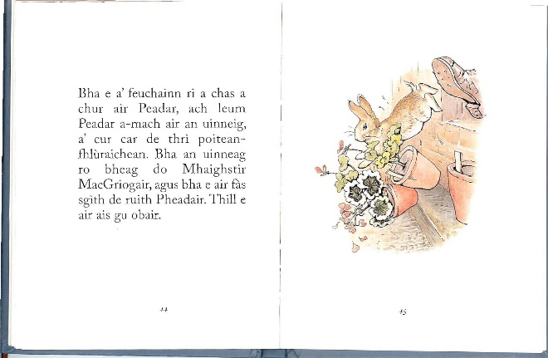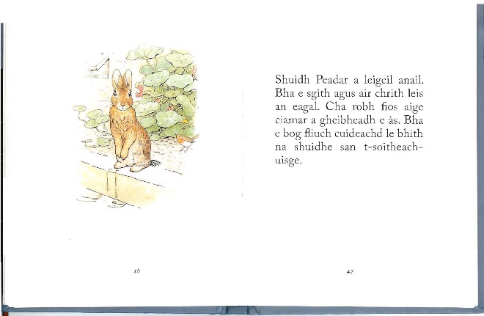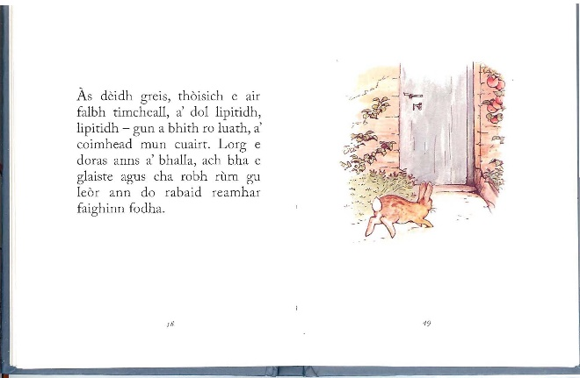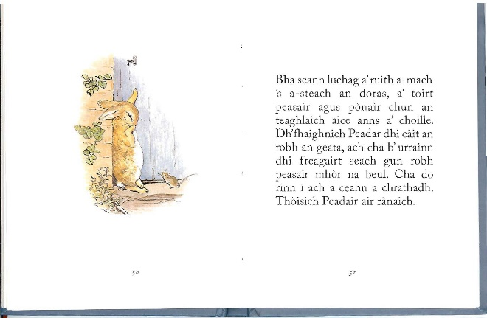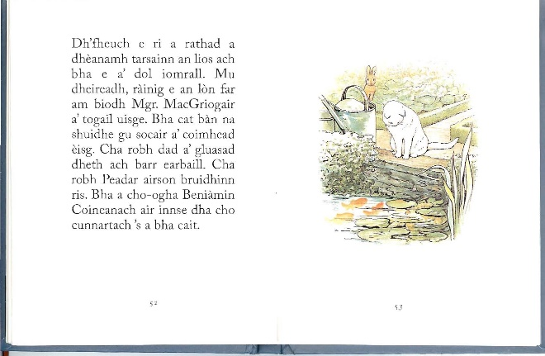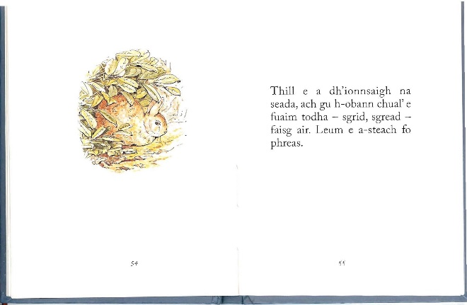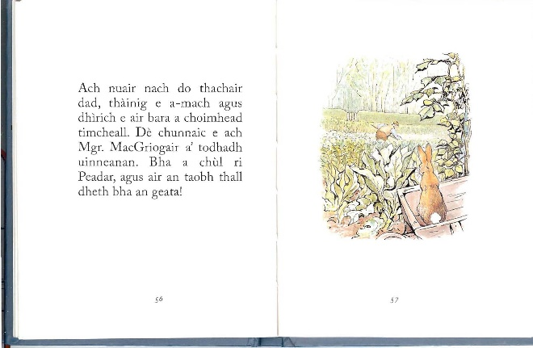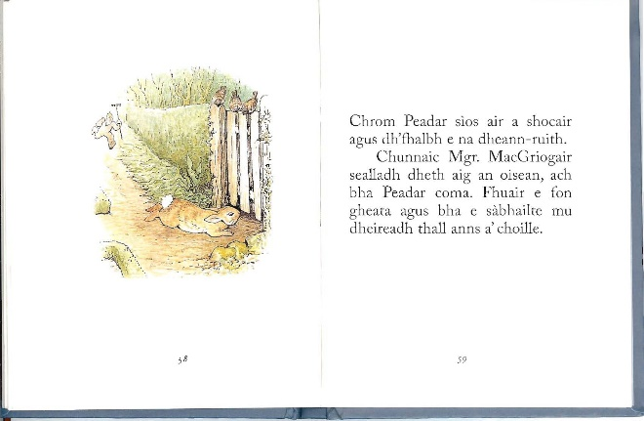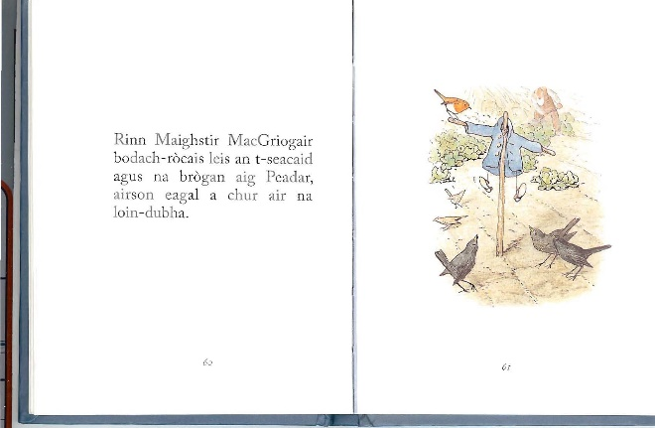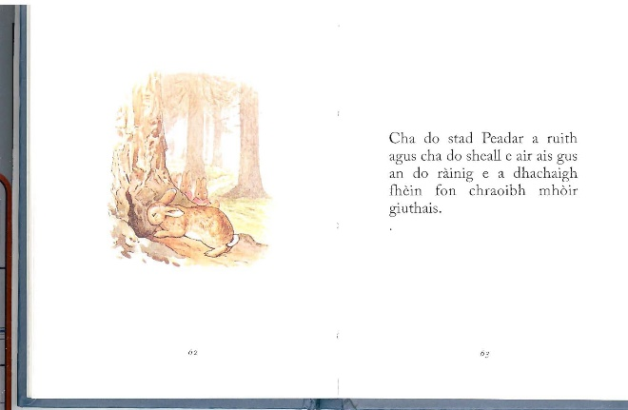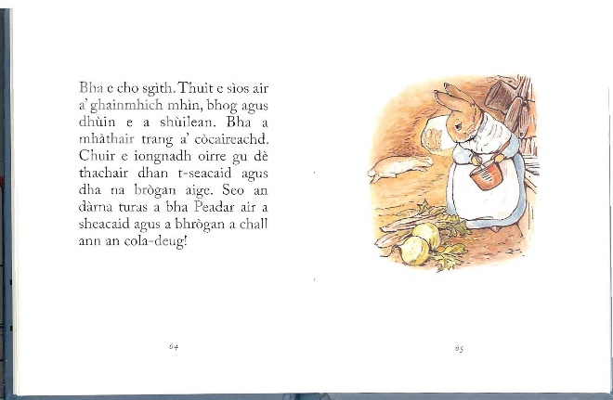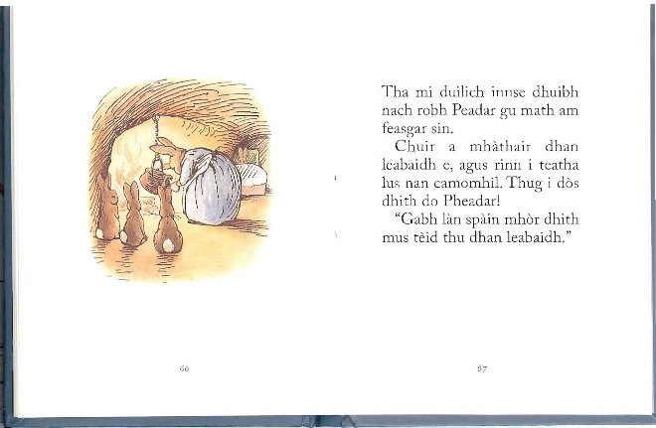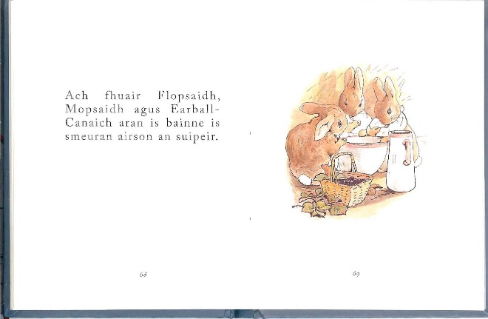

**Òran na seachdaine**

Appropriate to our theme of the week:

### 'S toigh leam fhìn Buntàta 's Ìm

<https://learngaelic.scot/littlebylittle/songs/buntata/index.jsp>

|  |  |
| --- | --- |
| ’S toigh leam fhìn buntàta ’s ìm, ’S toigh leam fhìn na caileagan,  ’S toigh leam fhìn buntàta ’s ìm,  Is nighneagan a’ bhaile seo. | I myself like potatoes and butter,  I myself like the lassies,  I myself like potatoes and butter,  And the lassies of this town. |

If we have time, another food-oriented song:

Longer: <https://www.youtube.com/watch?v=gCoa7Fmt2Q0>

Shorter: <https://www.youtube.com/watch?v=sjim2wN9pqo>

|  |  |
| --- | --- |
| Brochan lom, tana lom, brochan lom sùghain,  brochan lom, tana lom, brochan lom sùghain,  brochan lom, tana lom, brochan lom sùghain,  brochan lom, ‘s e tana lom, ‘s e brochan lom sùghain.  Brochan tana, tana, tana, brochan lom sùghain, brochan tana, tana, tana, brochan lom sùghain, brochan tana, tana, tana, brochan lom sùghain, brochan lom, ‘s e tana lom, ‘s e brochan lom sùghain.  Thugaibh aran dha na gillean leis a' bhrochan sùghain  Thugaibh aran dha na gillean leis a' bhrochan sùghain  Thugaibh aran dha na gillean leis a' bhrochan sùghain  Brochan lom 's e tana lom 's e brochan lom na sùghain  Seo an rud a gheibheamaid o nighean gobh' an dùine,  Seo an rud a gheibheamaid o nighean gobh' an dùine,  Seo an rud a gheibheamaid o nighean gobh' an dùine,  Brochan lom 's e tana lom, 's e brochan lom sùghain | Porridge thin and meagre, porridge thin from sowans.  Porridge thin and meagre, porridge thin from sowans.  Porridge thin and meagre, porridge thin from sowans.  Porridge thin, it is meagre and thin, it is porridge thin from sowans.  Give ye bread to the young men with sowans-gruel,  Give ye bread to the young men with sowans-gruel,  Give ye bread to the young men with sowans-gruel,  Porridge thin, it is meagre and thin, it is porridge thin from sowans.  This is what we used to get from the smith's daughter at the Dun  This is what we used to get from the smith's daughter at the Dun  This is what we used to get from the smith's daughter at the Dun  Porridge thin, it is meagre and thin, it is porridge thin from sowans. |

'[sowans](https://en.wikipedia.org/wiki/Sowans" \o "Sowans)' (the fermented juice of oatmeal husks boiled, in bygone times a favorite article of food in Scotland.