Gael-Talk
Learning Gaelic
Year 2
Caibideil 2-16

Zoom link:

https://us02web.zoom.us/j/86793281836?pwd=WXUvQmJJdkxhRHdjaTV4YWxyYTVpQT09

Nas fheàrr a’ Ghàidhlig bhriste n’ a’ Bheurla chliste!

Better Broken Gaelic than fluent English!

A little reminder –
We really should pay the piper
(mòran taing to those who have!)



Please send donations for the class to Paypal:
profmcintyre@yahoo.com
The amount is up to you, but the suggested donation is $5 per lesson

Clàr na seachdaine (schedule of the week)

- Fàilte!
- Sean fhacal na seachdain –… feed the beast!
- Sgeul na Seachdaine – An Gruffalo
- Còmhradh na Seachdaine – Conversation of the week
- Òran na seachdaine - “Dh’fhalbh mo rùn”

- Sean fhacal na seachdaine
Mir am beul na bèiste.

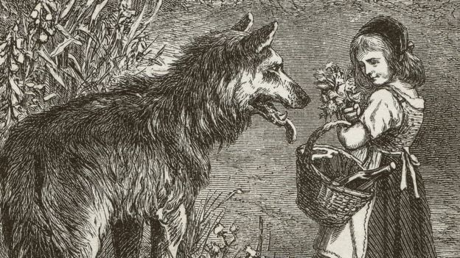
A bite for the monster's mouth.
This saying is probably founded on the story of the traveler and the wolves, whom he temporarily stopped by throwing out one thing after another.
In other words, an expedient for temporarily staving off disaster

Today, we’re going to finish

“An Gruffalo”

and engage in conversation and questions about it!
d. 25 / crioch an nathair
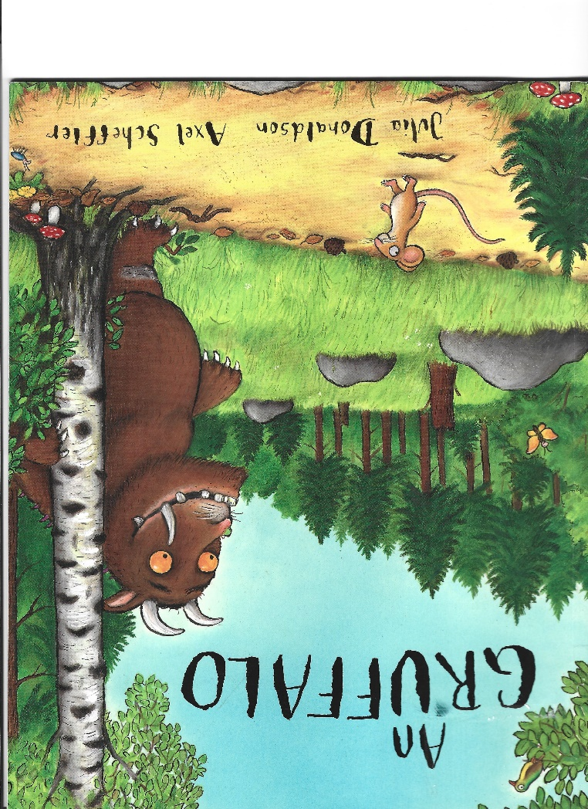
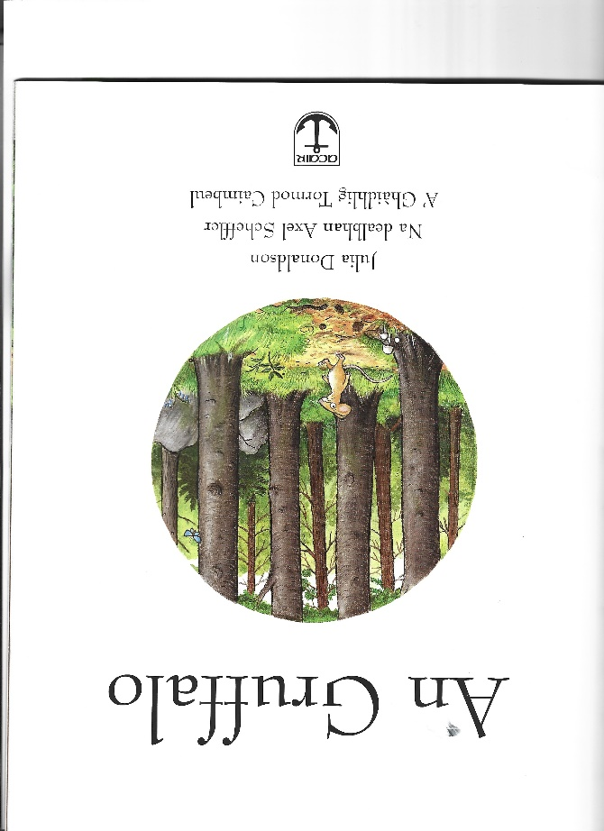
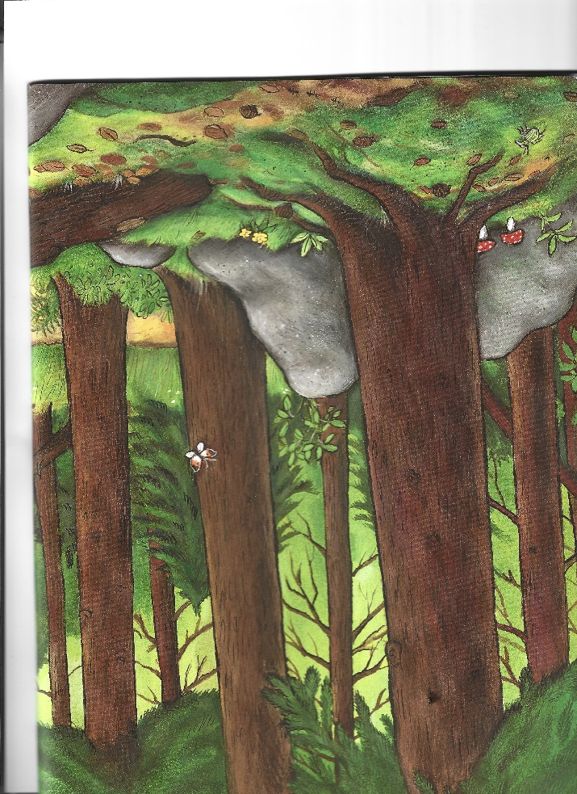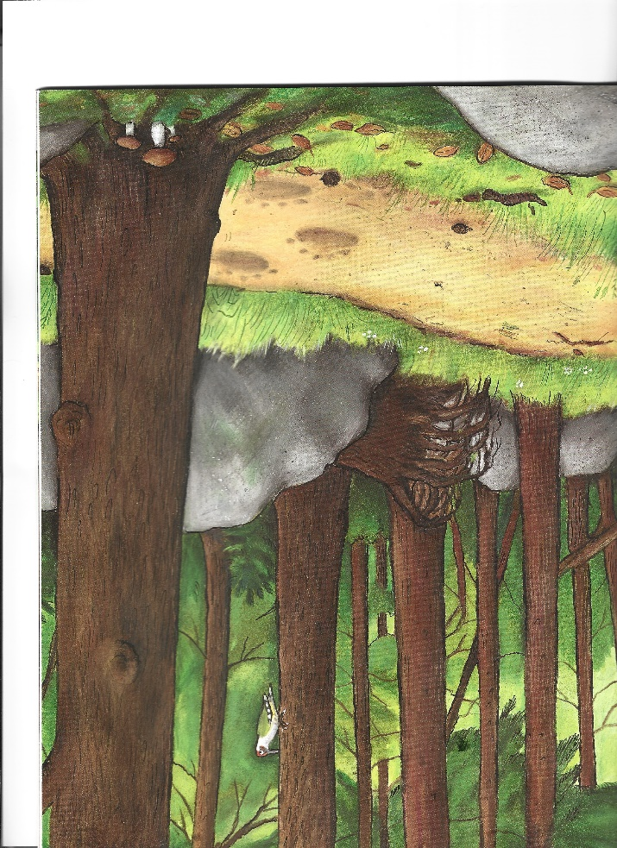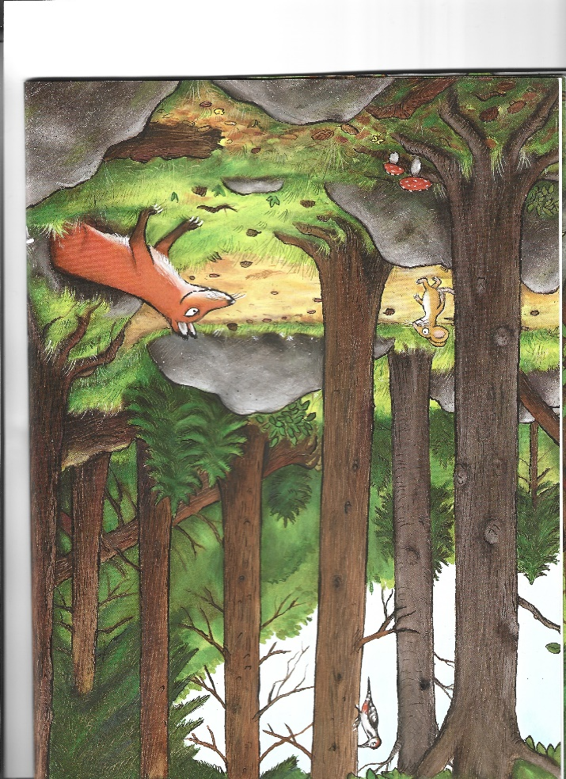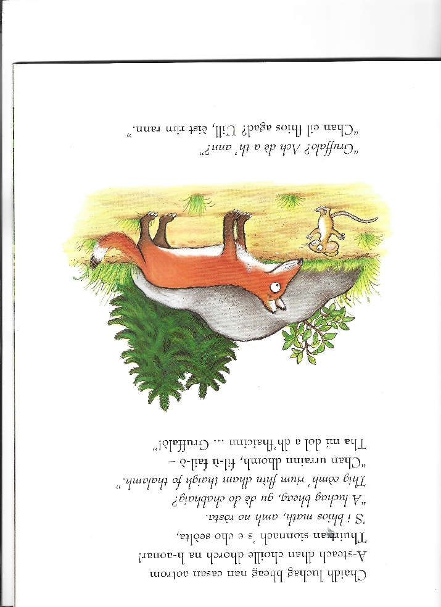
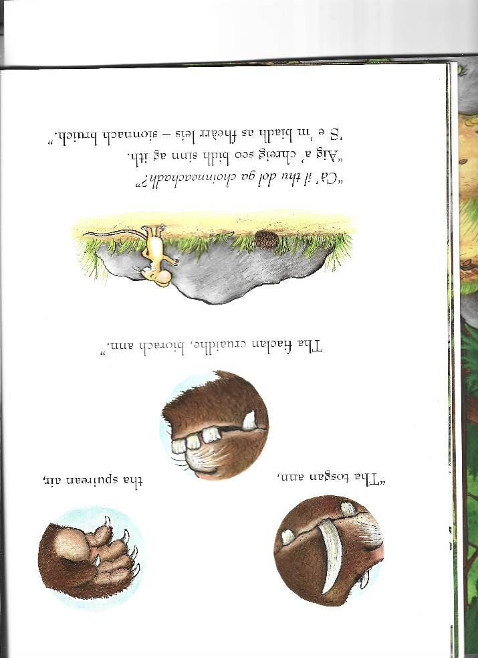

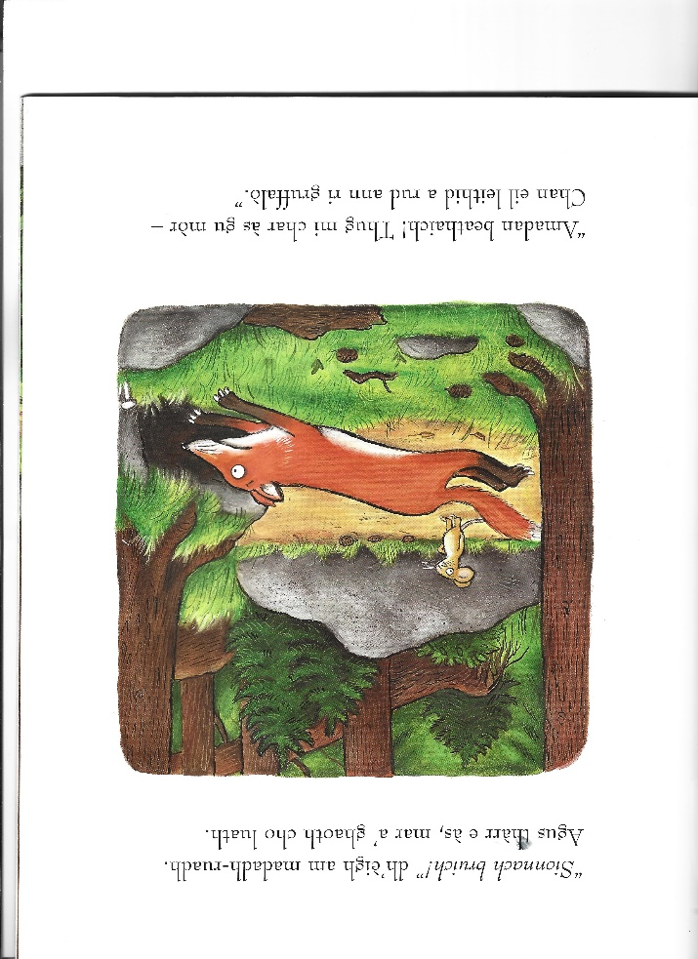
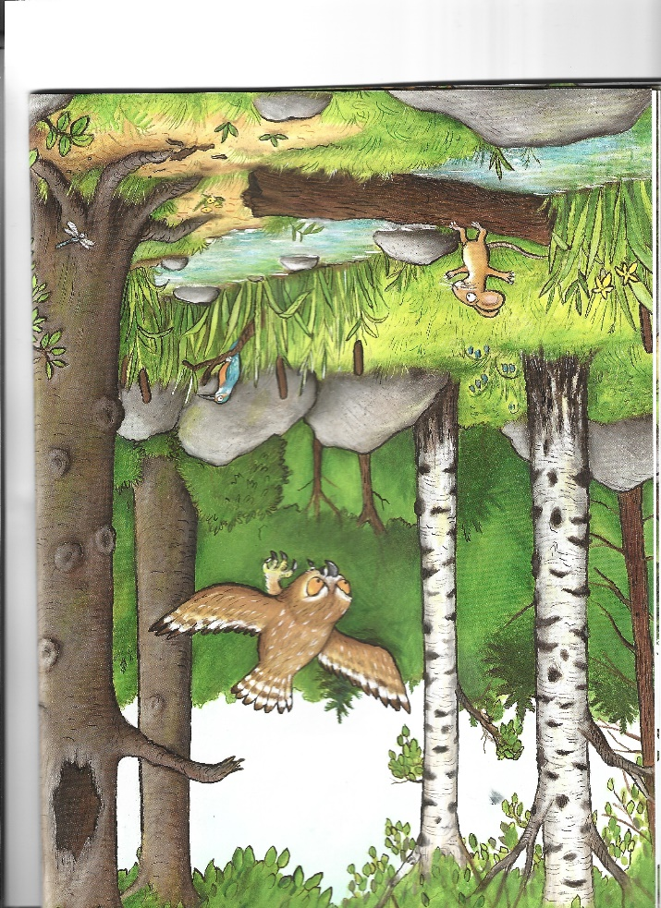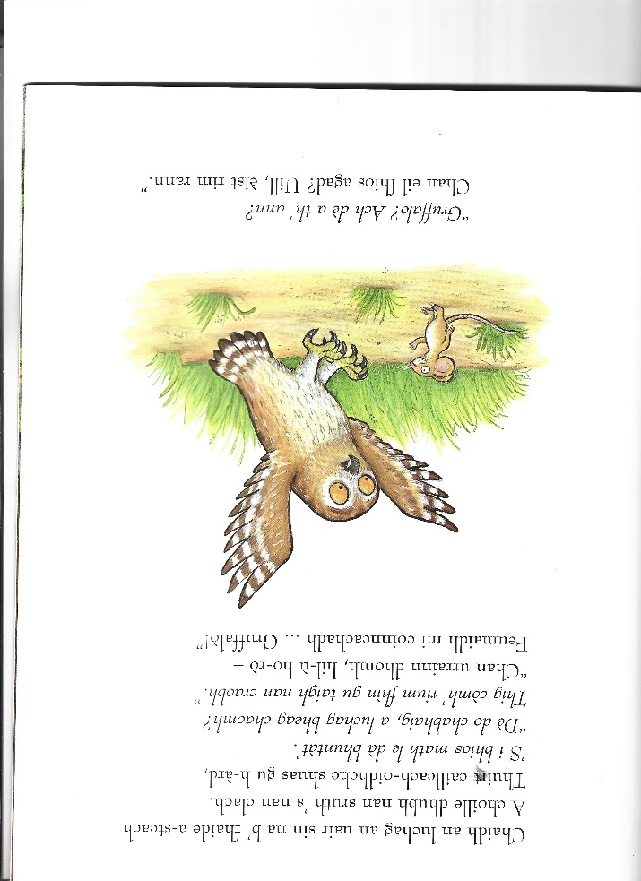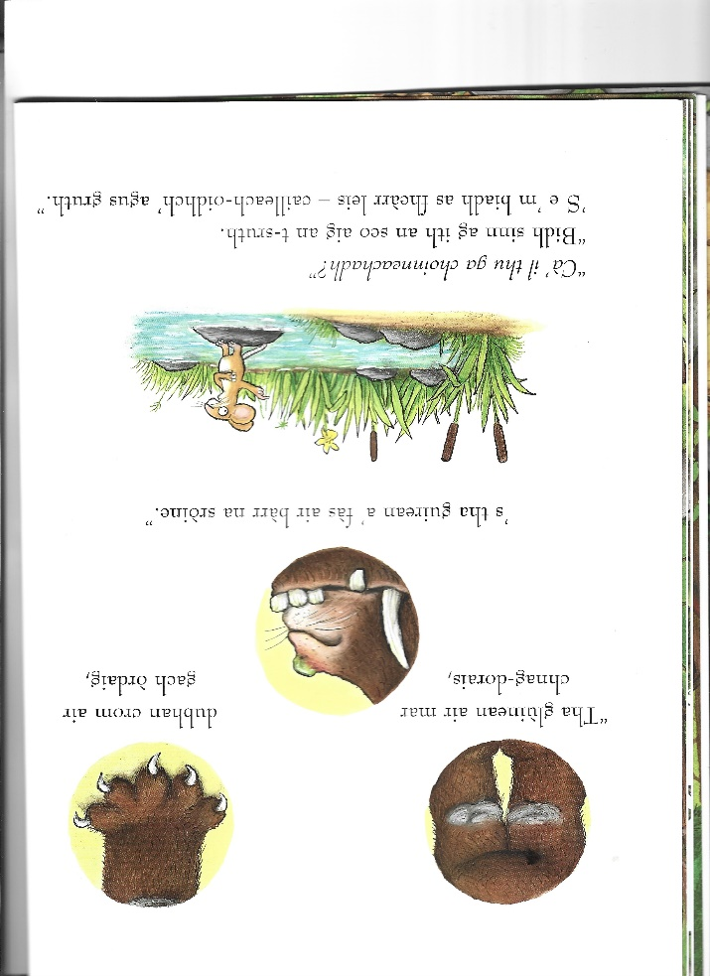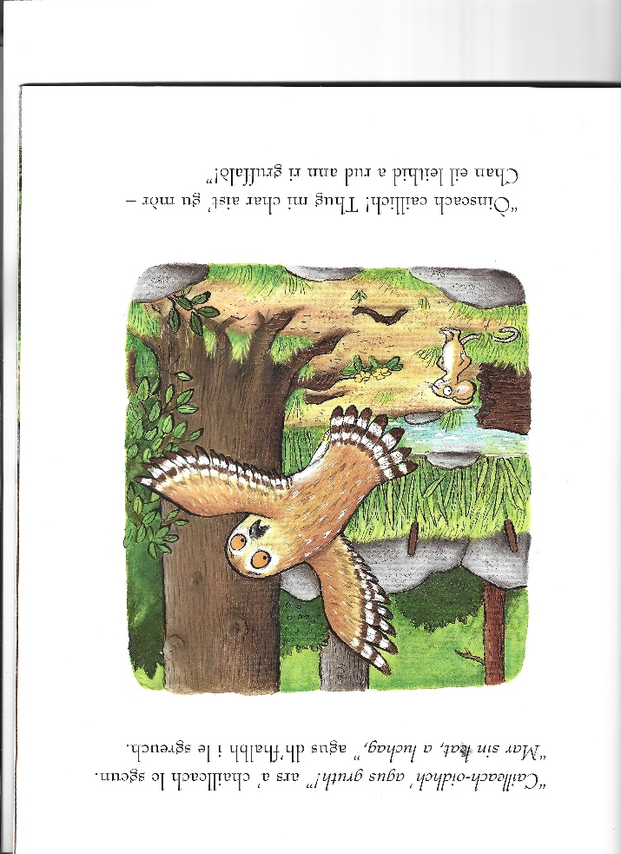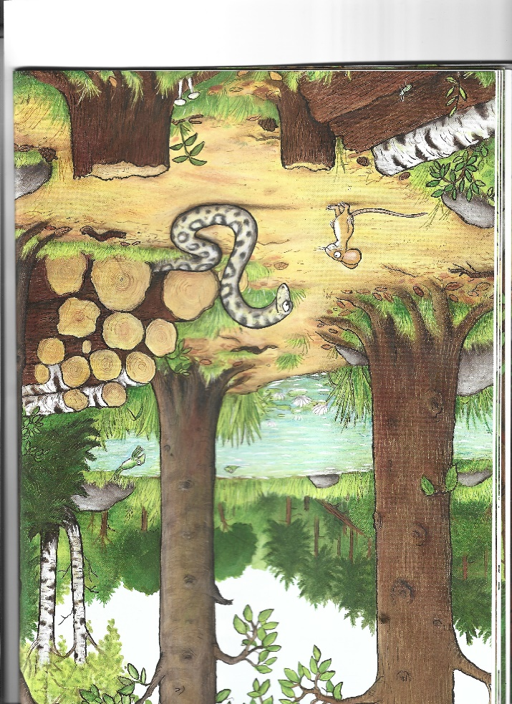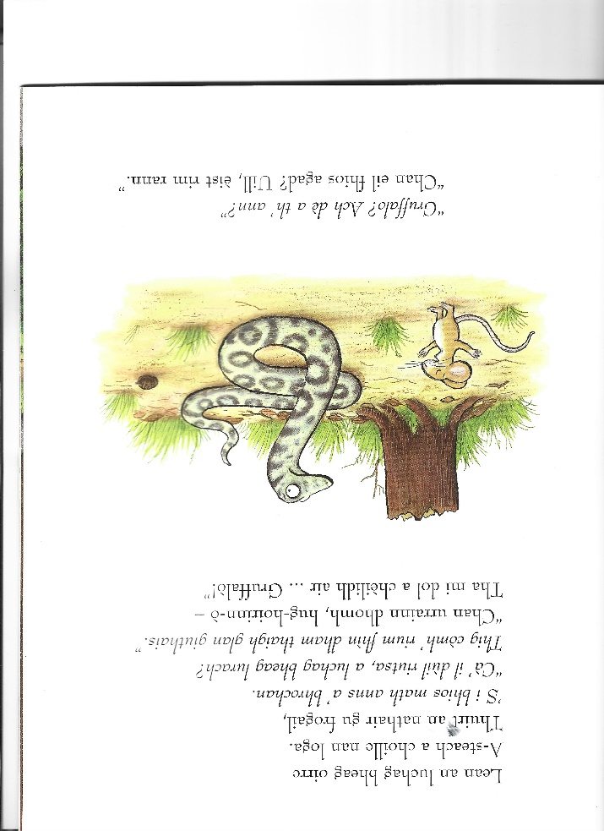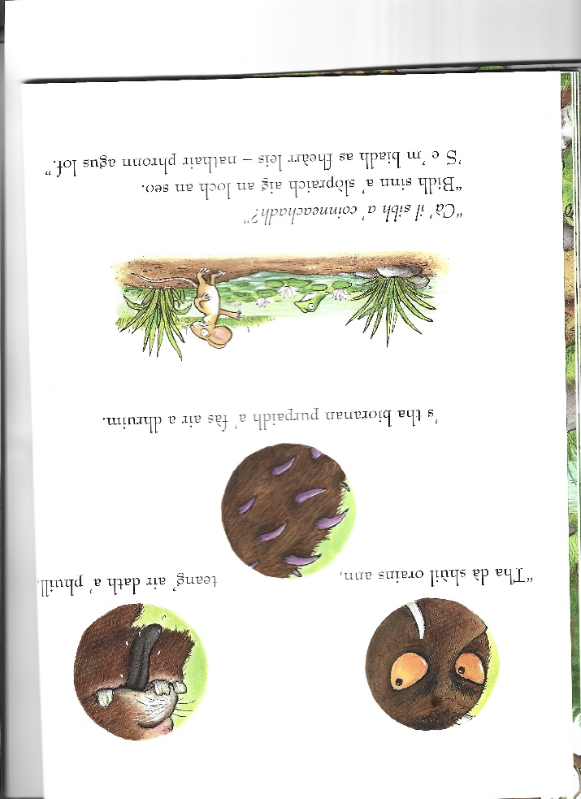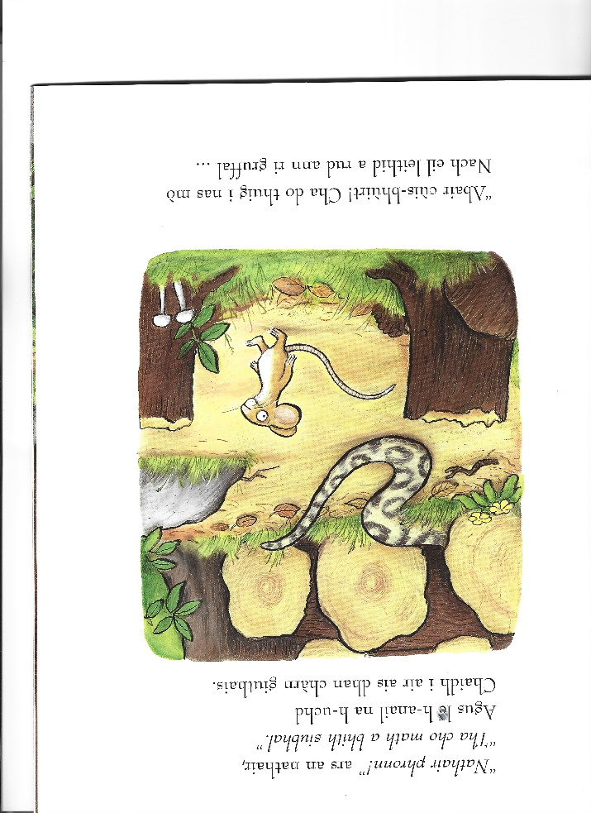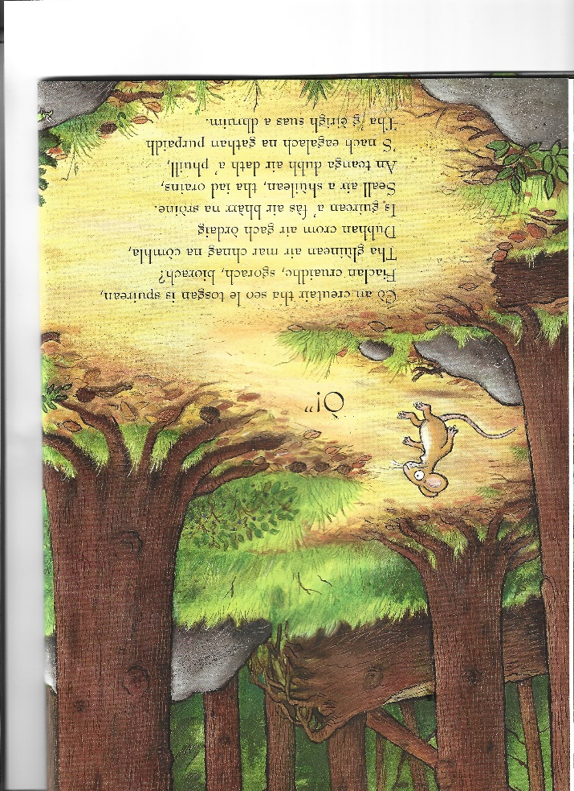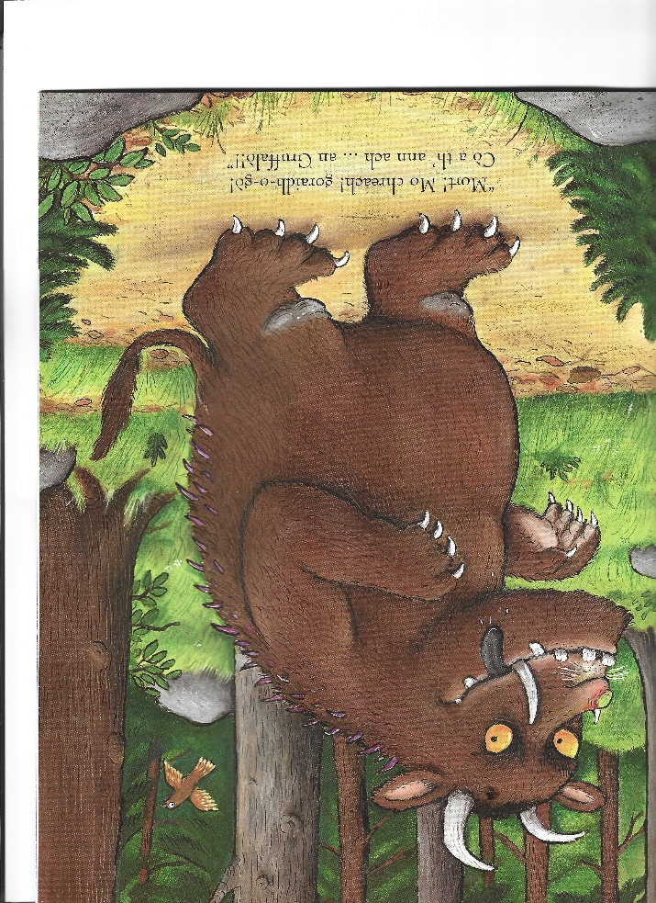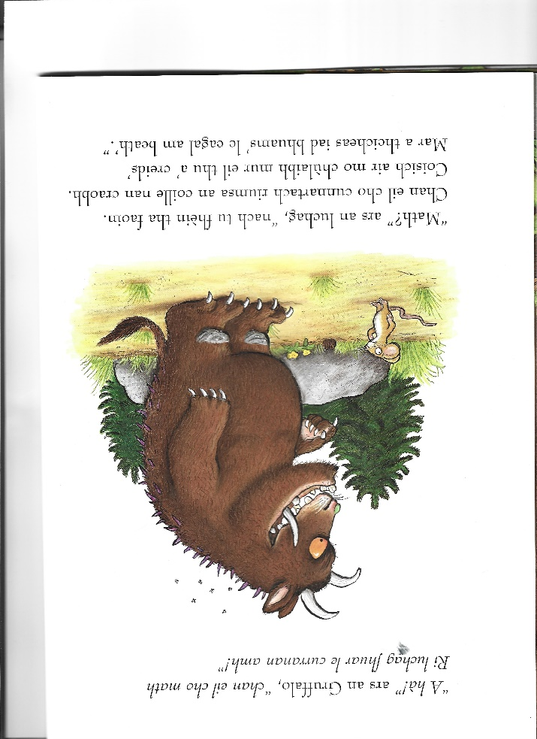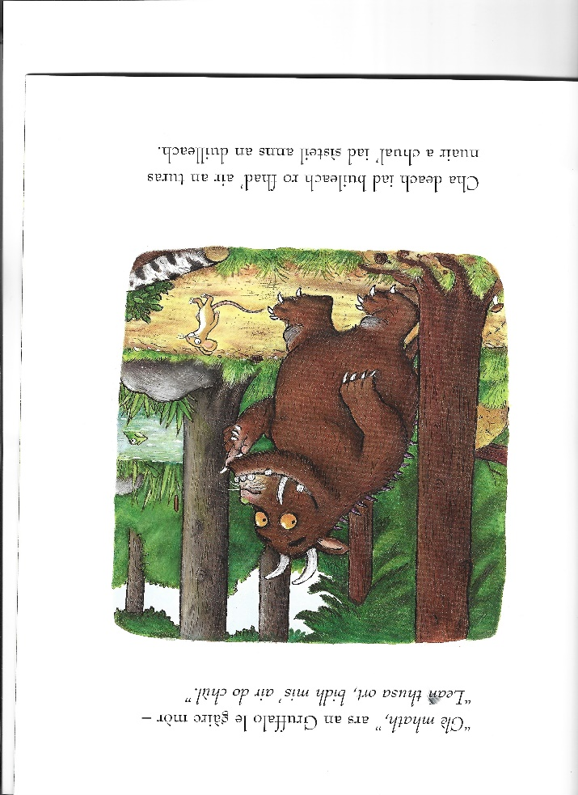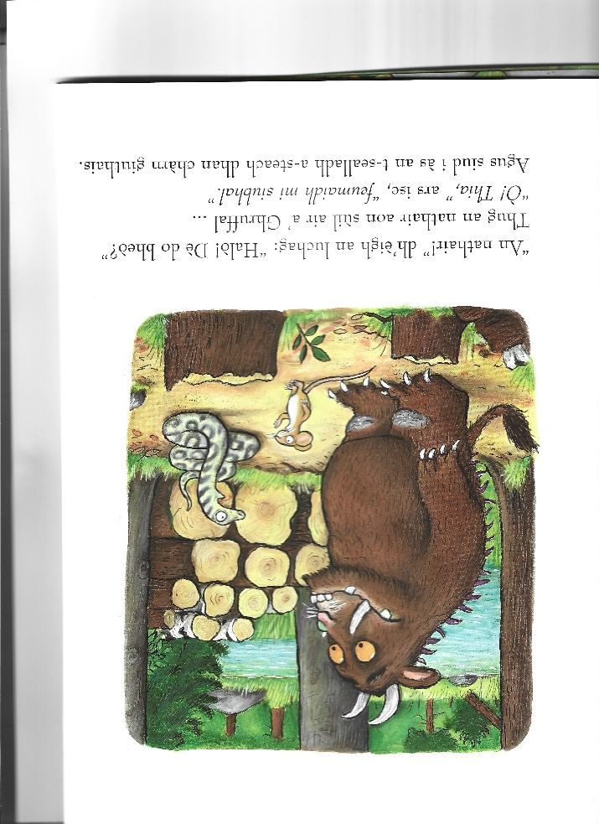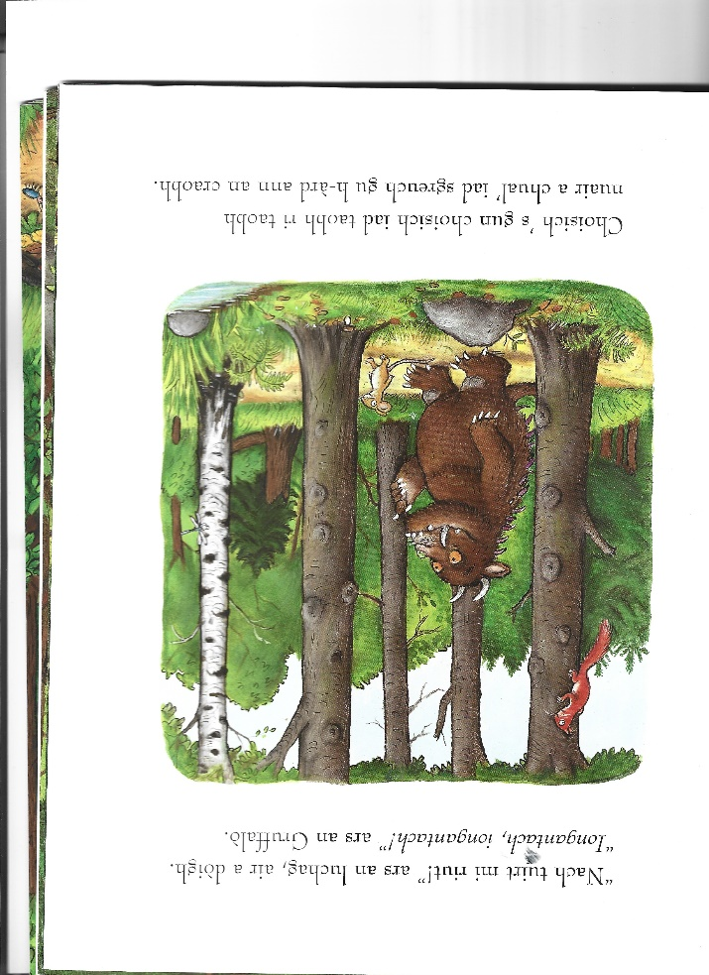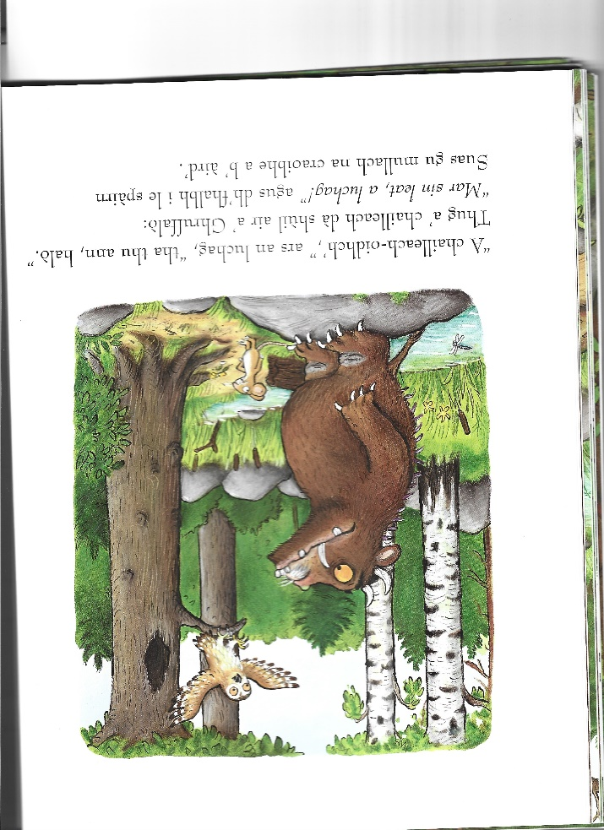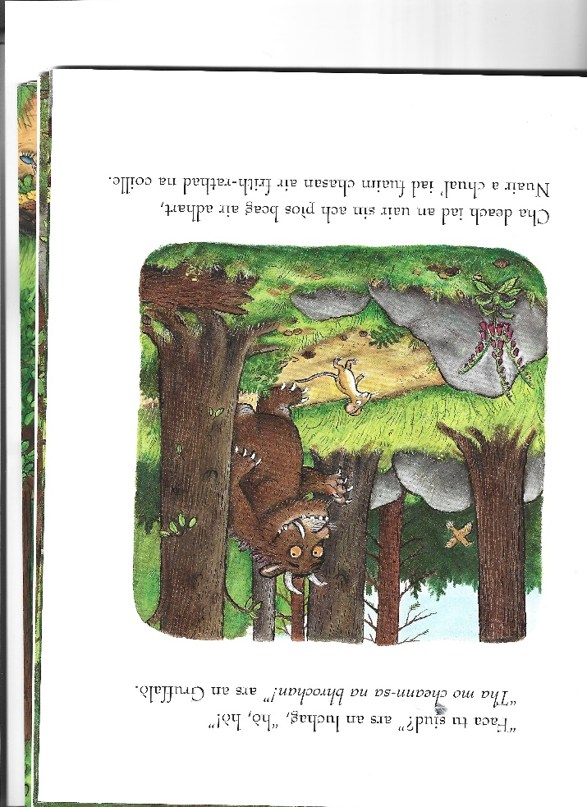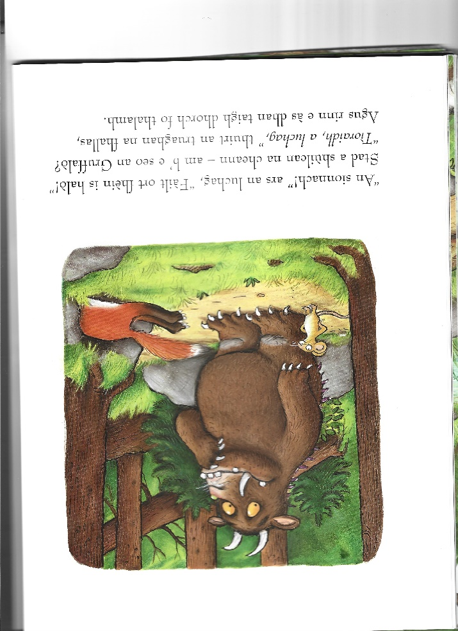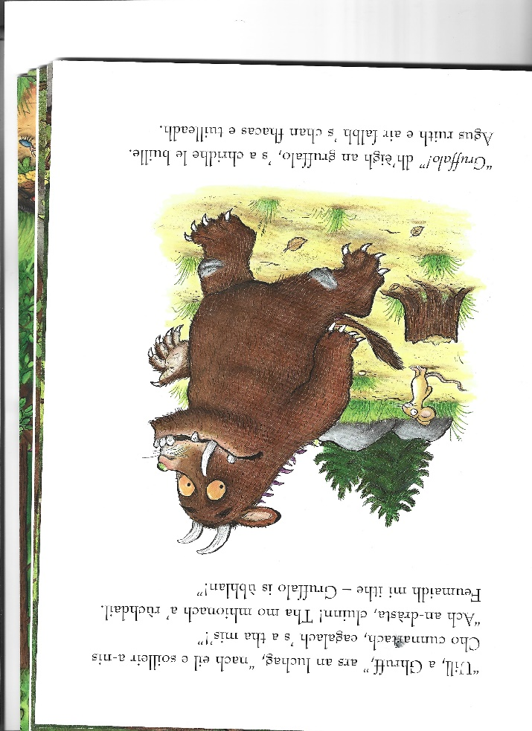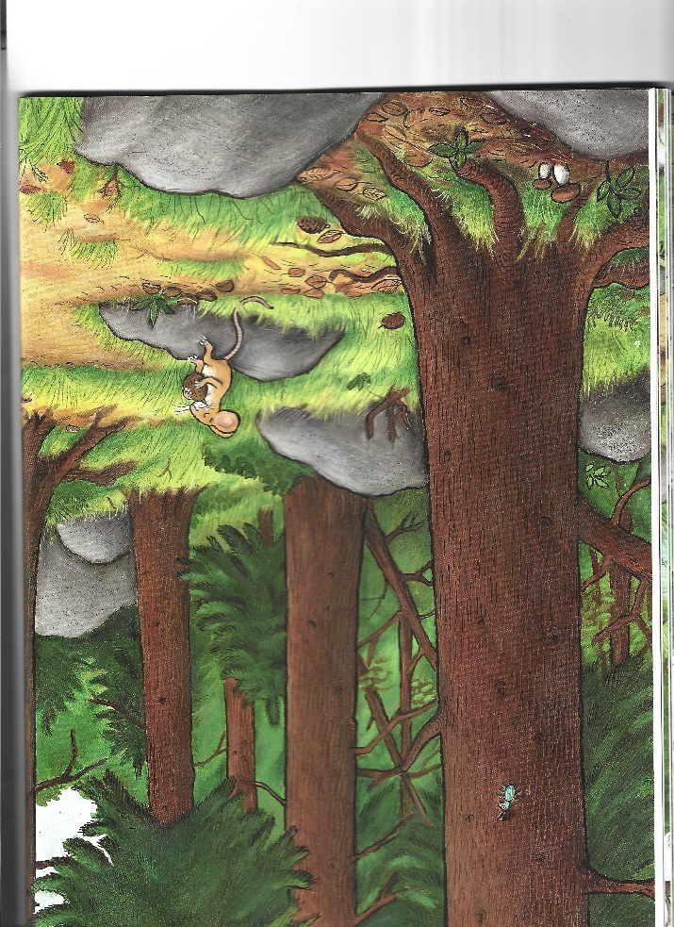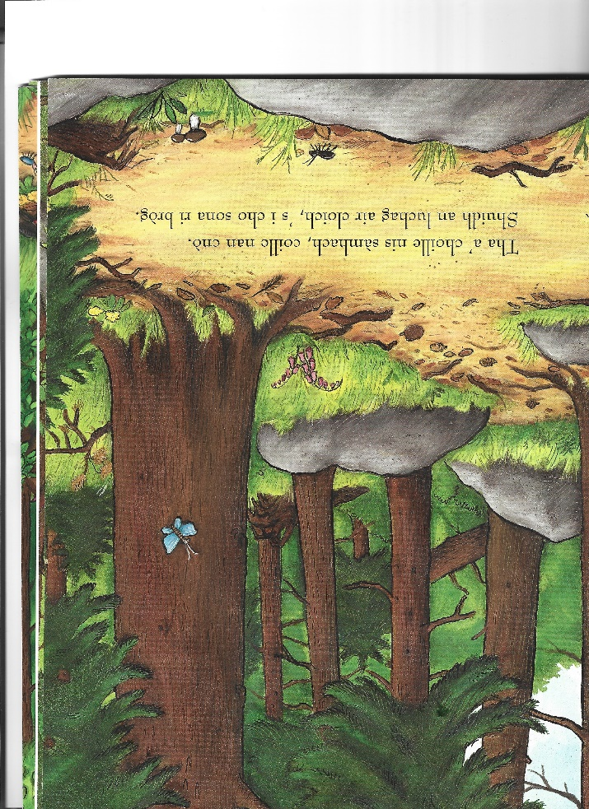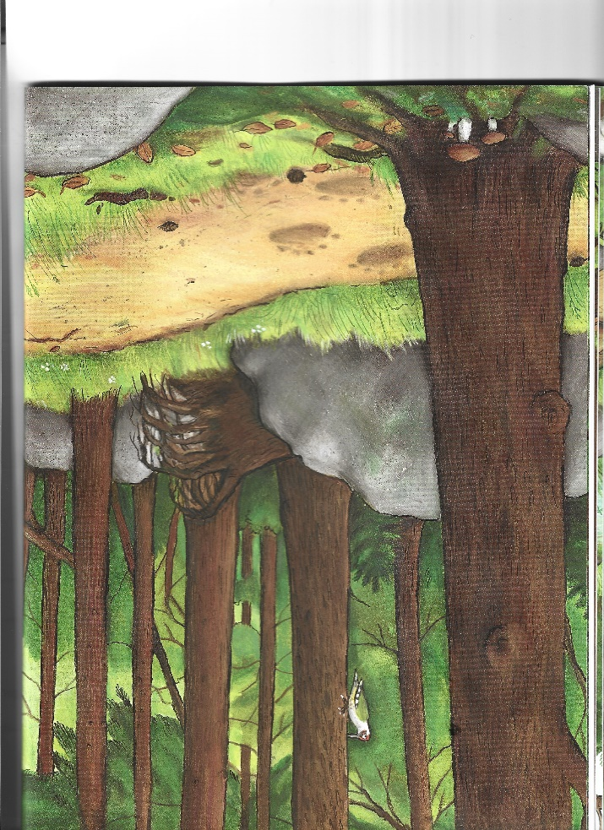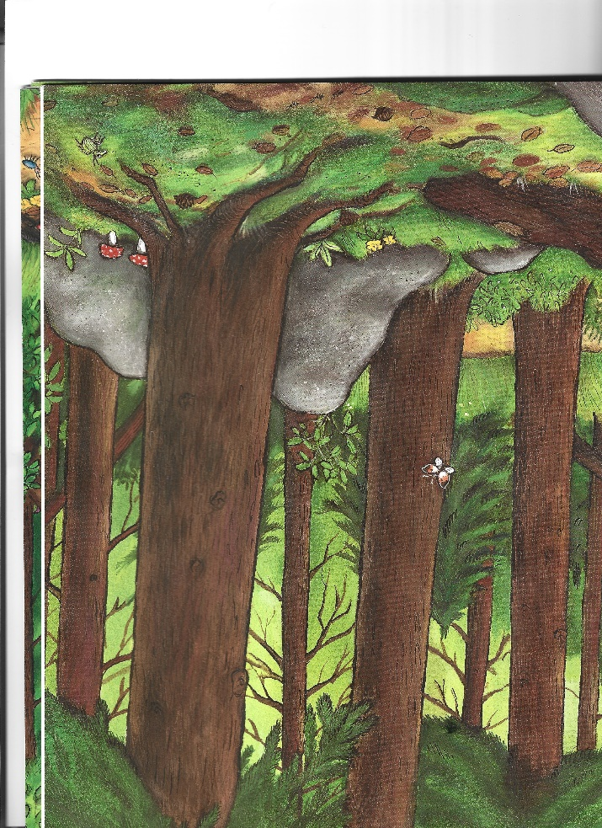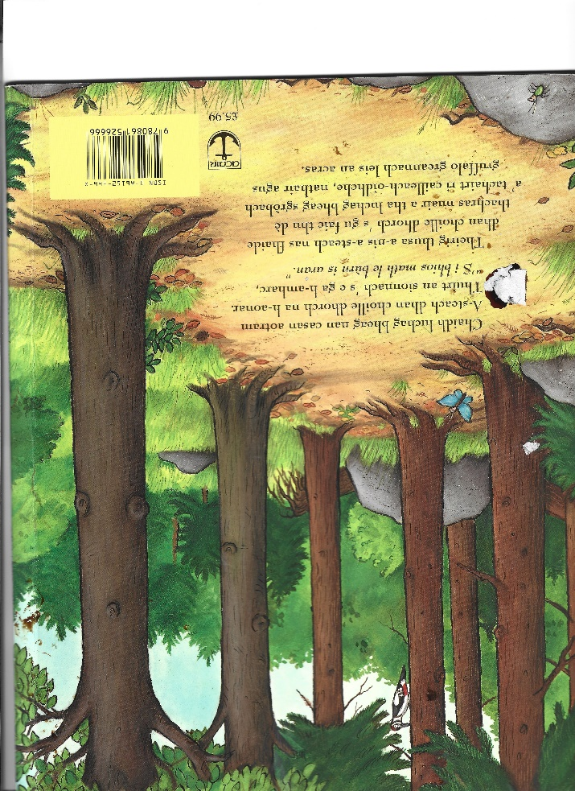
Ceistean
- Dh’innis an luchag don chailleach-oidhche gu bheil an Gruffalo ag ithe
  - Cailleach-oidhche ‘s gruth
  - Sionnach bruich
  - Nathair pronnadh
- Dh’iarr an sionnach air an luchag a dhol
  - Dhan taigh glan-giuthais
  - Dhan taigh fon thalamh
  - Gu taigh nan craobh
- A bheil an Gruffalo beag no mòr?
- A bheil an Gruffalo donn no bàn?
- Carson an tuirt an luchag gum biodh i a’ coinneachadh a’ Ghruffalo? (Why did the mouse say he was meeting a gruffalo?)
- Carson an do ruith na bèistean air falbh nuair a dh’innis an luchag mu dheidhinn an Gruffalo? (Why do the animals run away when the mouse tells them what the Gruffalo is like?)
- Ciamar an do dh’fhairich an luchag nuair a chunnaic i an Gruffalo a’ chiad turas? How do the think the little mouse felt when the Gruffalo actually turned up??
- Nam biodh tu nad luchag, am biodh tu a’ dol anns na taighean aig na bèistean? (mar an nathair no an sionnach?) Carson no carson nach biodh? (If you were the mouse, would you have gone into any of the animals’ homes? Why or why not?)
- An tuig an luchag gun robh an Gruffalo fìor? (Did the mouse really believe there was such a thing as a gruffalo?
- Cuin a dh’atharraich an luchag a barrail mun an Gruffalo? When did he change his mind?
- An do dh’innis an luchag an fhìrinn mun an Gruffalo? An d’ rinn seo i math no dona? Was the mouse telling the truth about the gruffalo? Does this make him a good or bad character?
- A bheil a’ choille sàbhailte airson luchag? Do you think the woods are a safe place to be if you are a mouse?
- Can you design your own scary character?
- What do you think owl ice-cream or scrambled snake would look like?
- Look at how a gruffalo is described in the book. How would you draw one from the description if you didn’t look in the book?
- Dè seòrsa bhèistean a bhios a’ fuireach anns a’ choille?
- Dè seòrsa de rudan eile a bhios anns a’ choille?
- Carson a tha na bèistean anns an sgeulachd ag iarraidh an luchag a bhith gan cèilidh (a’ dol còmhla riutha)?
- Carson a bheil iongnadh air an luchag nuair a thachair i an Gruffalo?
- Cò tha na Ghruffalo?
- Dè tha an Gruffalo ag ithe?
- Càit’ a bheil an Gruffalo a’ fuireach?
- Carson a tha eagal air na bèistean ron Gruffalo?
- Dè tha sionnach ag ithe?
- Dè tha cailleach-oidhche ag ithe?
- Dè tha nathair ag ithe?
- Dè thuirt an luchag gu bheil i ag ithe?

Òran na seachdaine
“Dh’fhalbh mo rùn”

https://youtu.be/bQC-tffRGkU
Dh'fhalbh mo rùn 's dh' fhàg e 'n cala | My love has gone and left the harbor
Dh'fhalbh mo rùn e ho o hiu | My love has gone e ho o hiu
Thog e na siùil ùr ri crannan | He raised the new sail to the mast
Dh'fhalbh mo rùn 's dh' fhàg e 'n cala | My love has gone and left the harbor
Dh'fhalbh mo leannan (bh)uam a Ìle | My sweetheart has left me from Islay
Air long rìomhach nan tri crannan | On the beautiful three-masted ship
Dh'fhalbh mo leannan 'uam a dh' Eireann | My sweetheart has gone from me to Ireland
'S as a dhèidh cha bhi mi fallain | And after that I won't be well
Chuala mi gun d'rinn thu rèiteach | I heard you were betrothed
'S gu dè feum a bh’ as a' ghealladh? | So what was your promise worth?
Chuala mi gun d'rinn thu pòsadh | I heard you got married
'S cha d' dh' fheòraich thu mi gu d’ bhanais | And you didn't invite me to your wedding
Chan eil annam ach nighneag òg | I am but a young girl
Is gur e seòladair mo leannan | And it is the sailor that I love
Thuirt na mnathan gur e am beud e | The women said that it was a pity
Gun tug mi mo spèis dhan mharaich’ ' | That I should give my love to the seaman
Mo run an Leatheanach Bàn | My love is the fair MacLean
'S ann dhut thug mi mo ghràdh ’s mo ghealladh | To you I gave my love and my promise

