Gael-Talk
Learning Gaelic
Year 2
Caibideil 2-17

Zoom link:

https://us02web.zoom.us/j/86793281836?pwd=WXUvQmJJdkxhRHdjaTV4YWxyYTVpQT09

Nas fheàrr a’ Ghàidhlig bhriste n’ a’ Bheurla chliste!

Better Broken Gaelic than fluent English!

A little reminder –
We really should pay the piper
(mòran taing to those who have!)

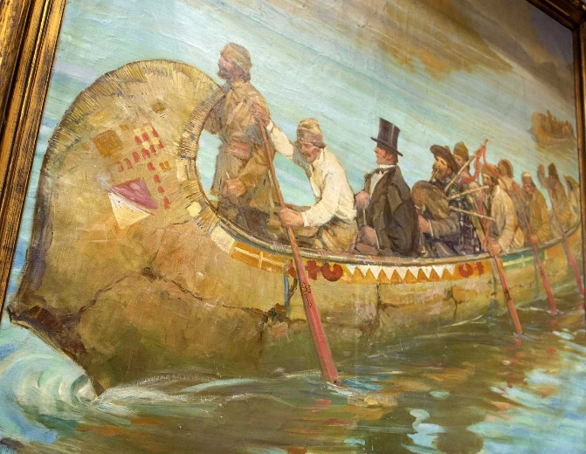

Please send donations for the class to Paypal:
profmcintyre@yahoo.com
The amount is up to you, but the suggested donation is $5 per lesson

Clàr na seachdaine (schedule of the week)

- Fàilte!
- Sean fhacal na seachdain –…
- Sgeul na Seachdaine – Sgeulachd a’ Choire
- Còmhradh na Seachdaine – Conversation of the week
- Òran na seachdaine - Mairead nan Cuiread

- Sean fhacal na seachdaine
Chan eil thu tuilleadh 's sean airson ionnsachadh fhathast

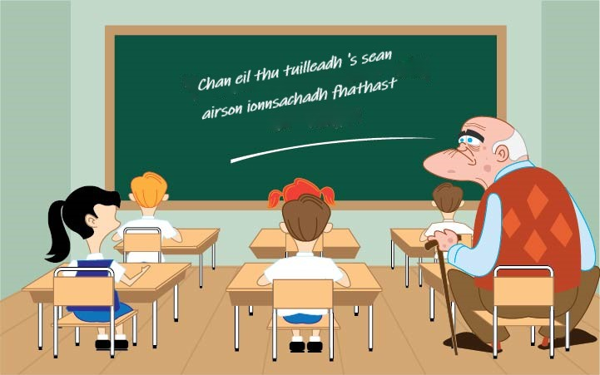

You aren’t too old to learn yet.

Sgeulachd na Seachdaine
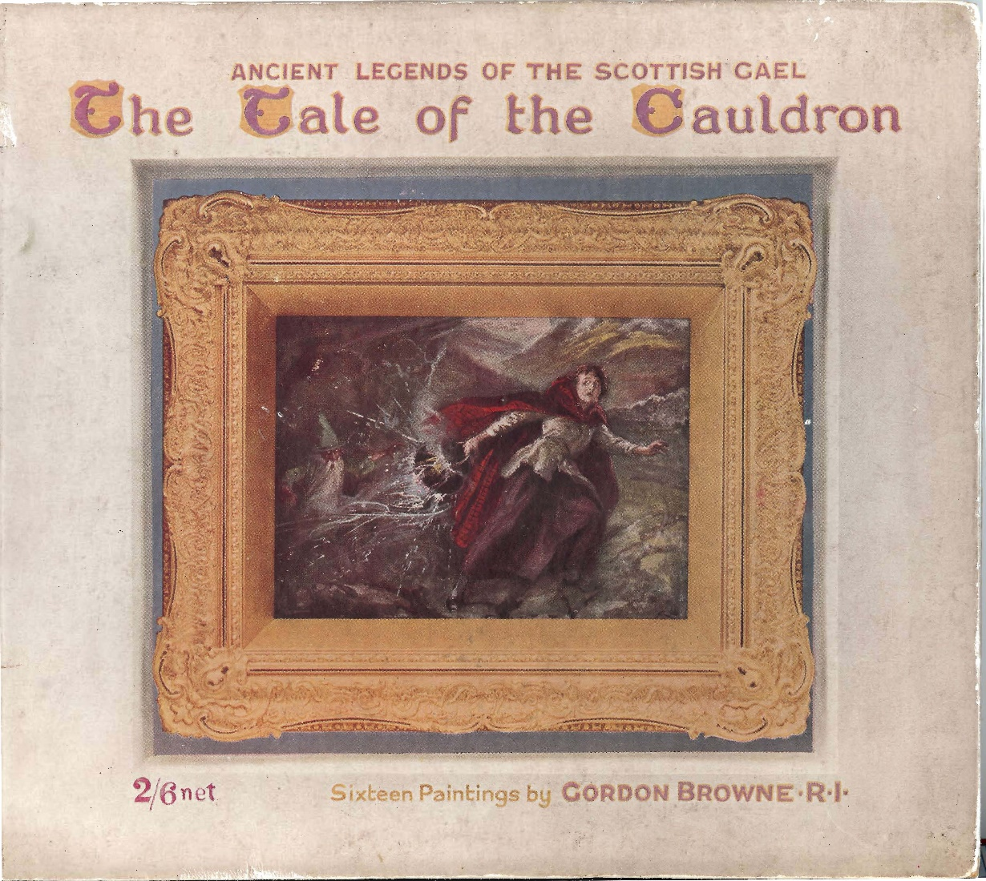

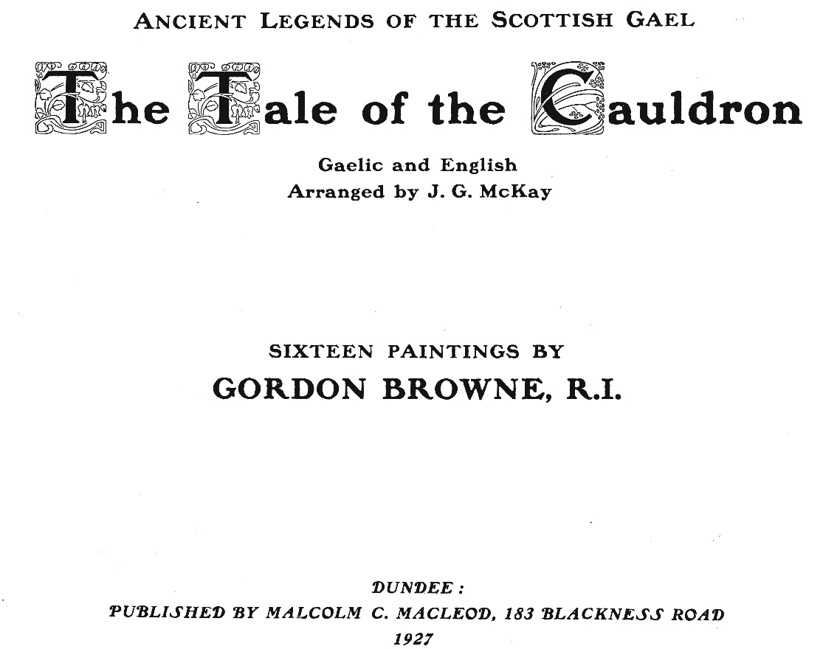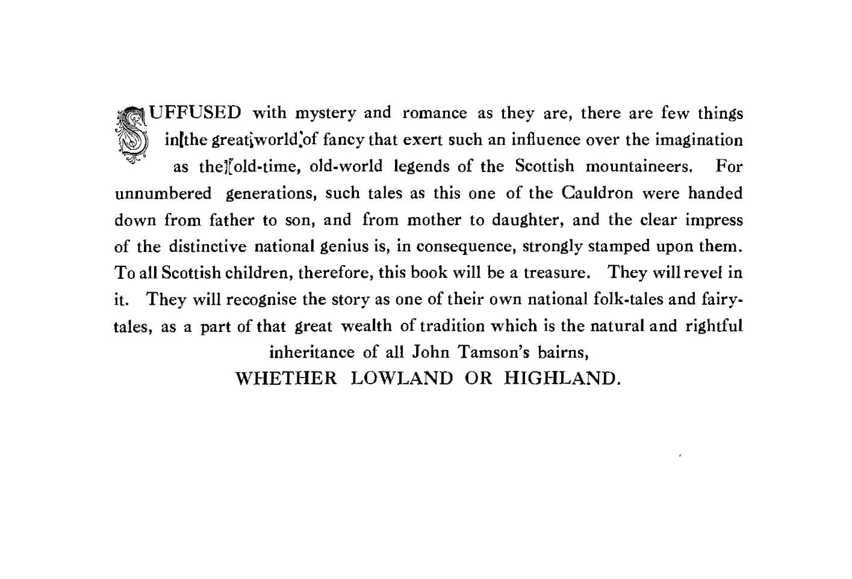
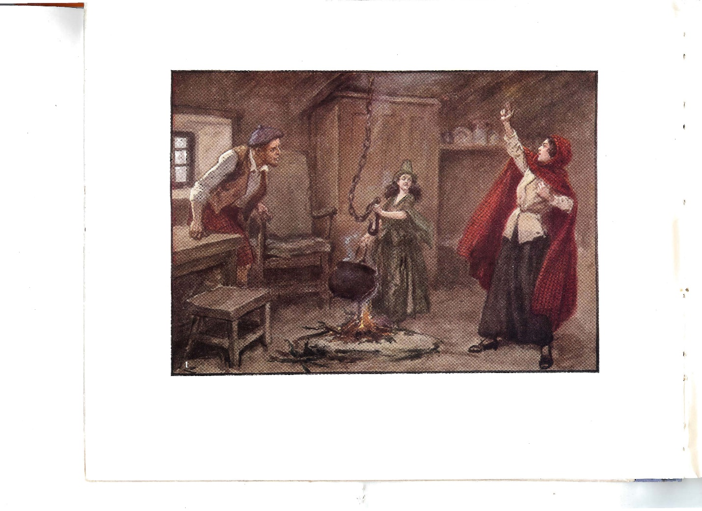
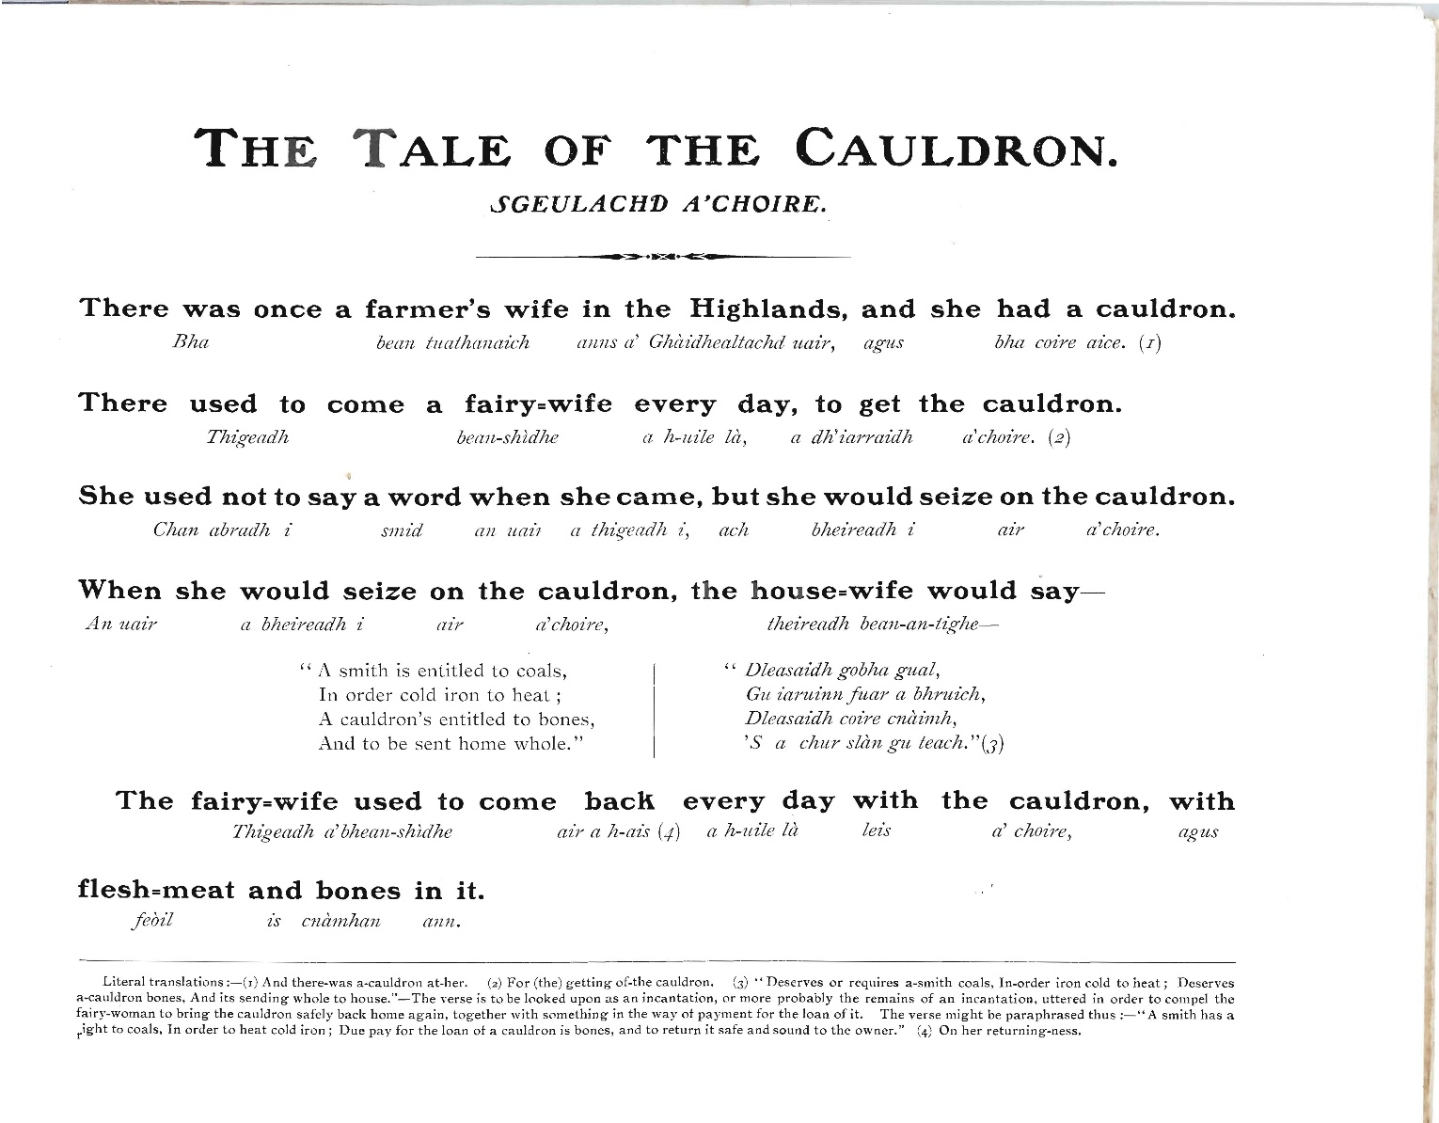

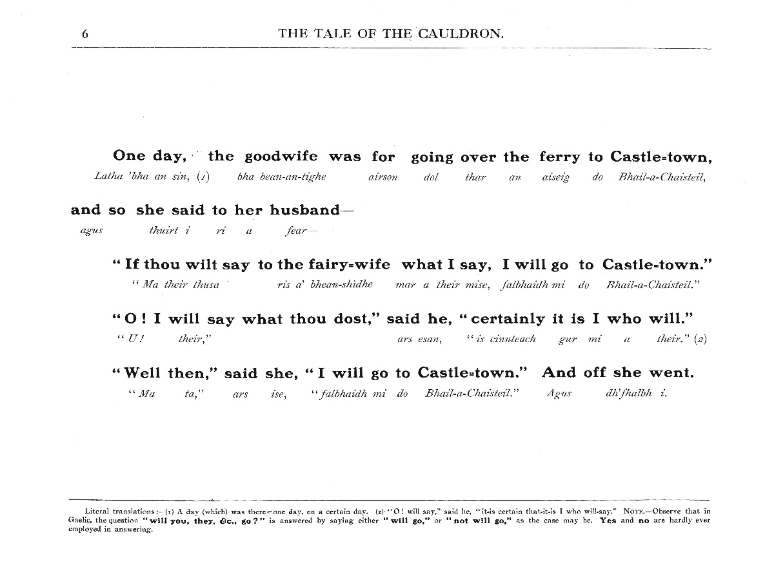

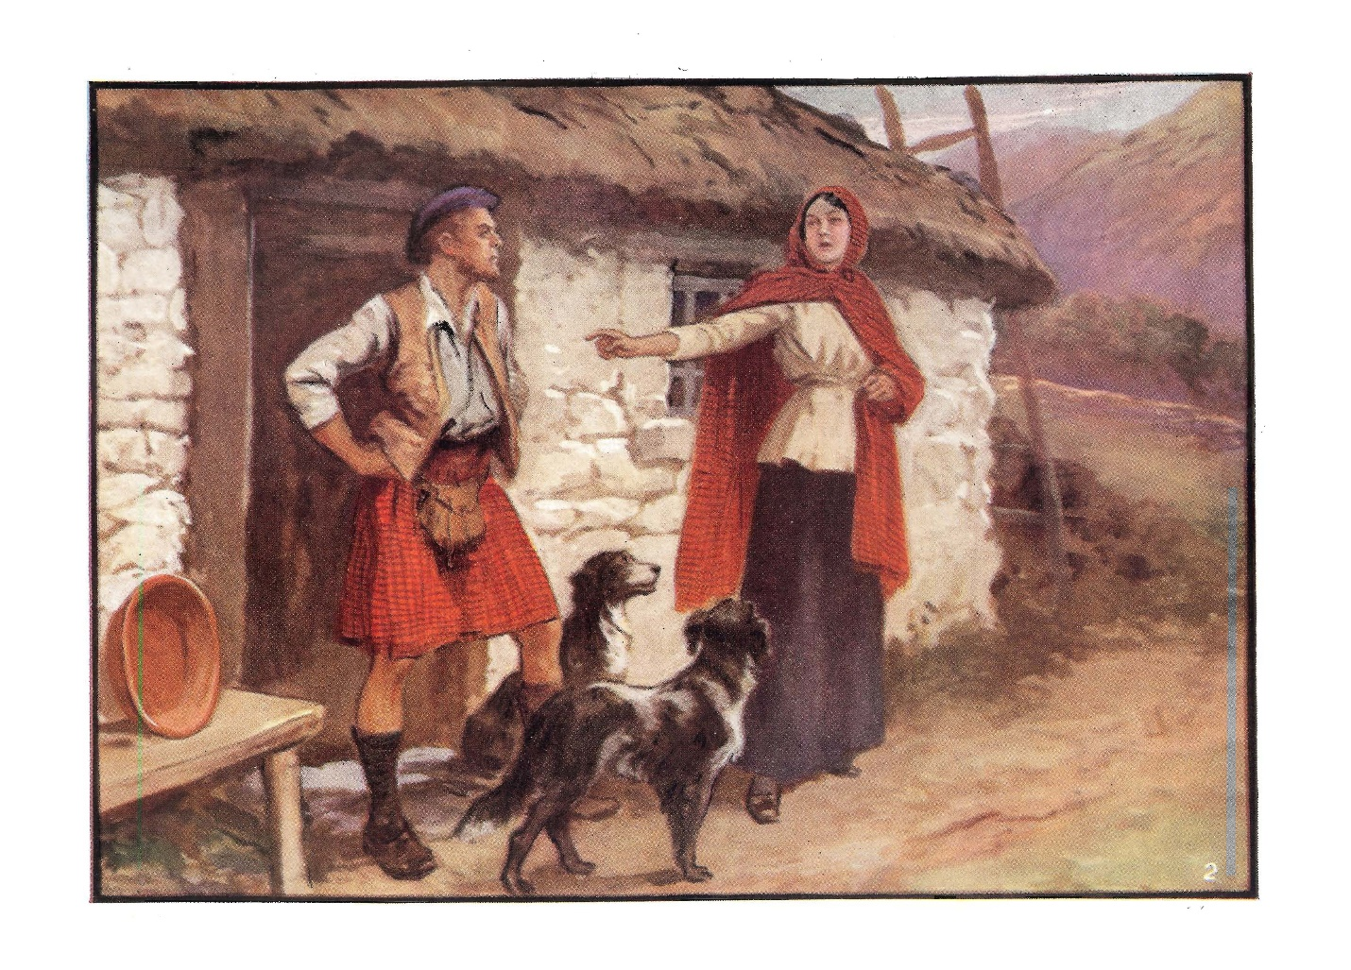

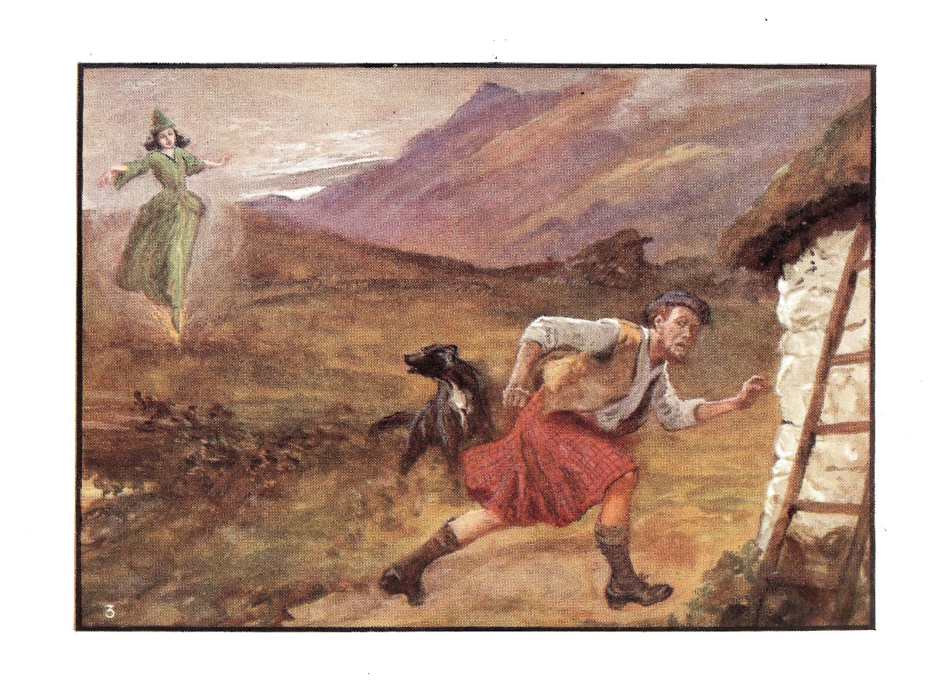
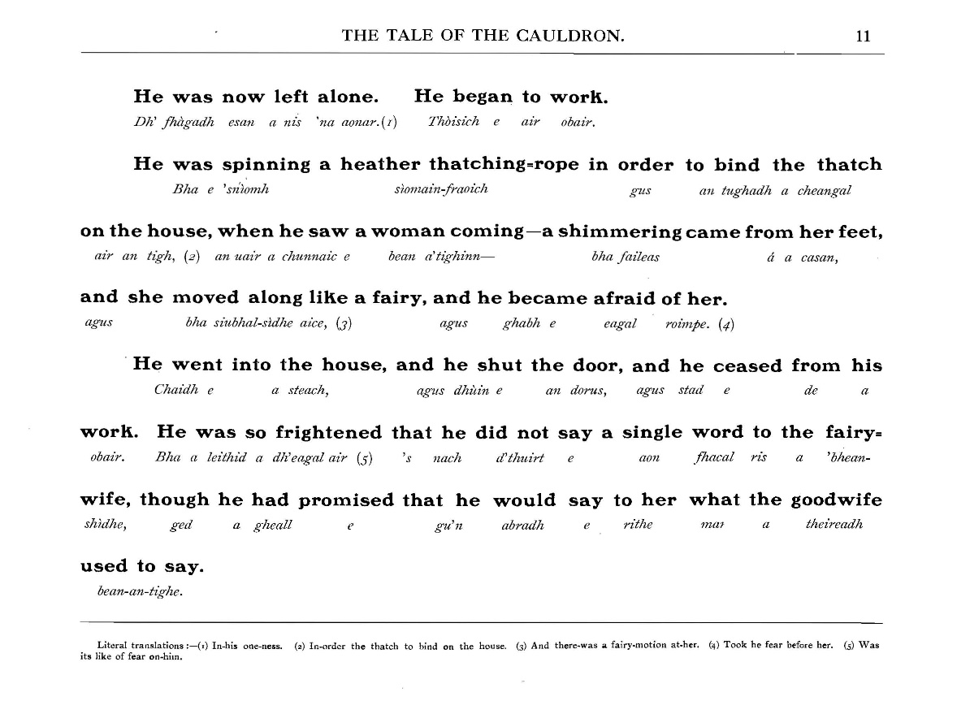

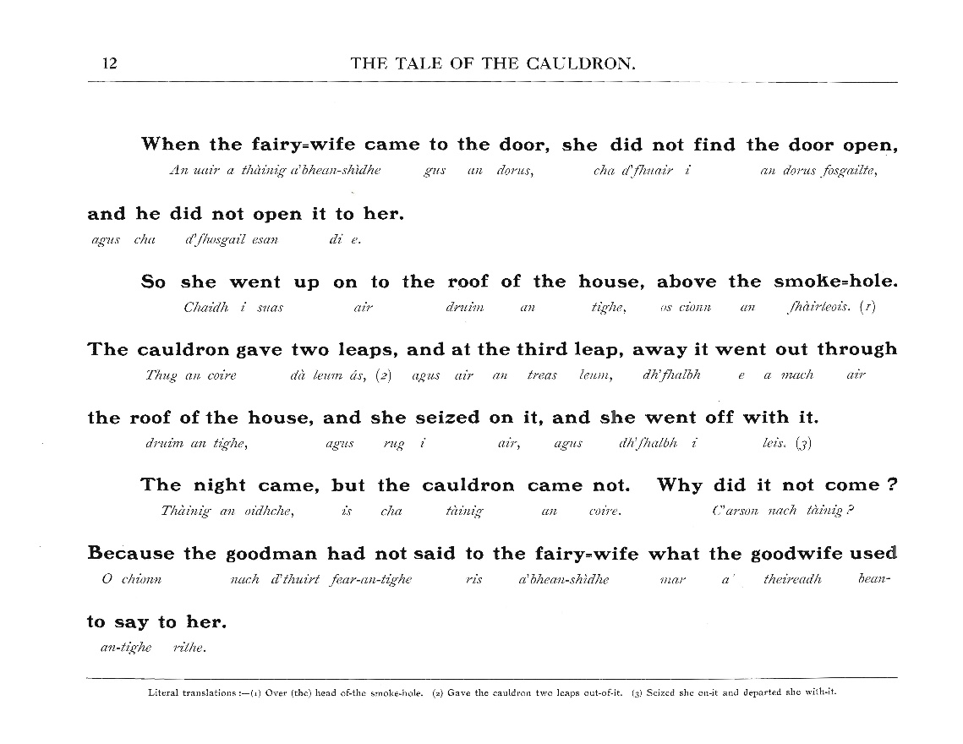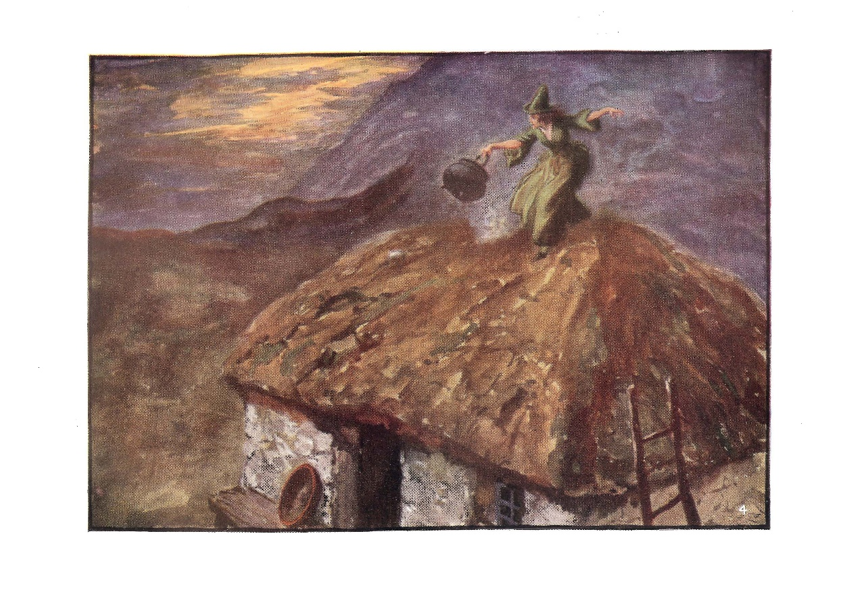

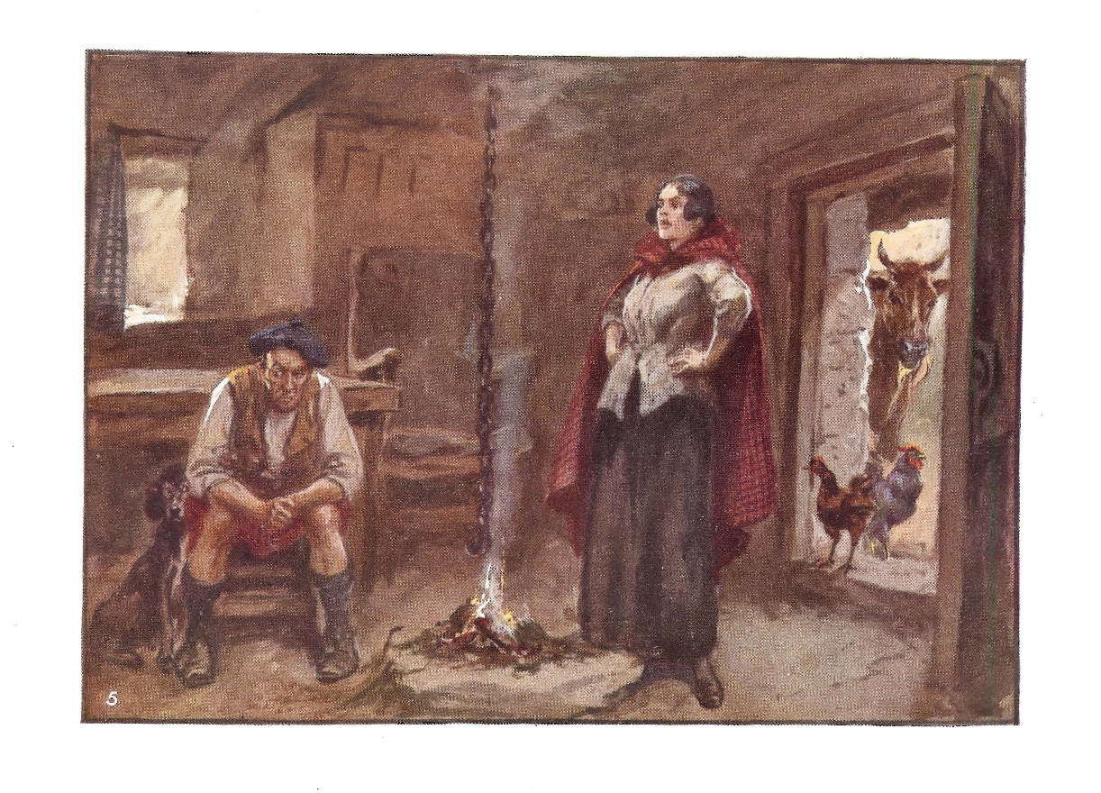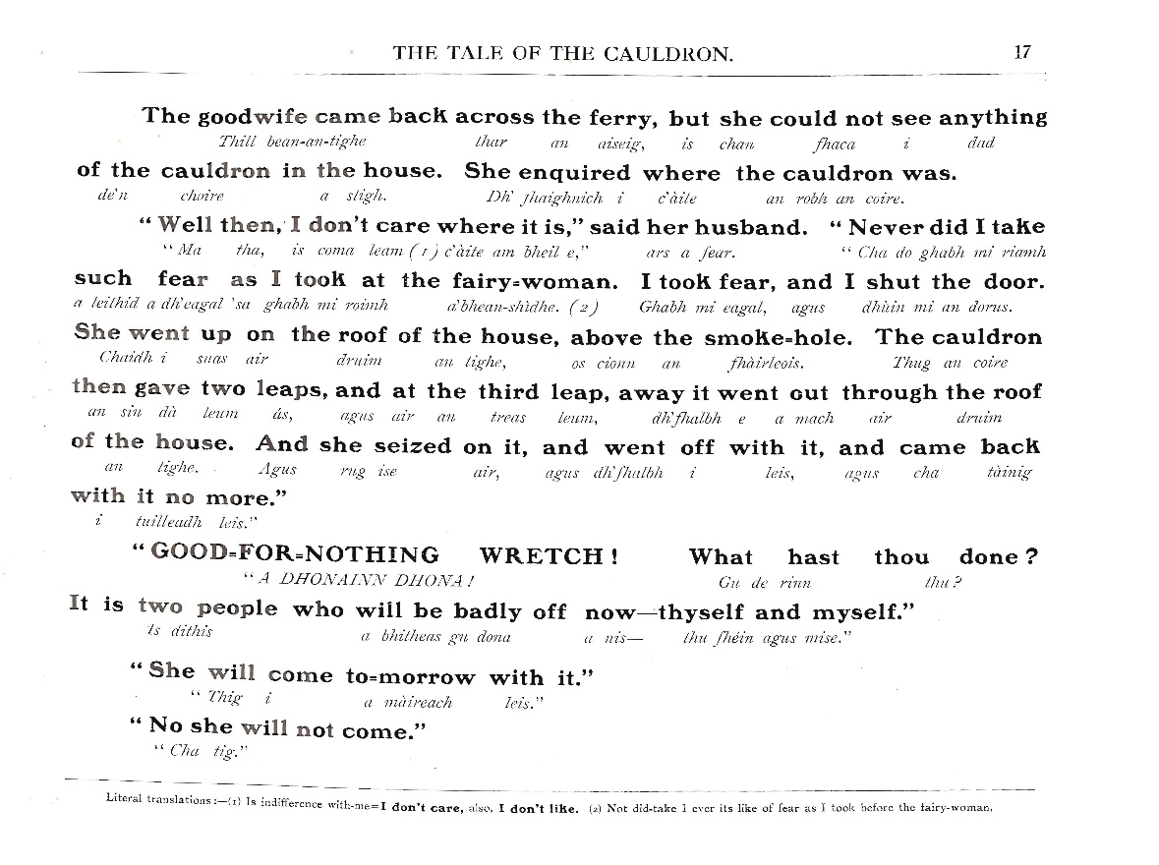

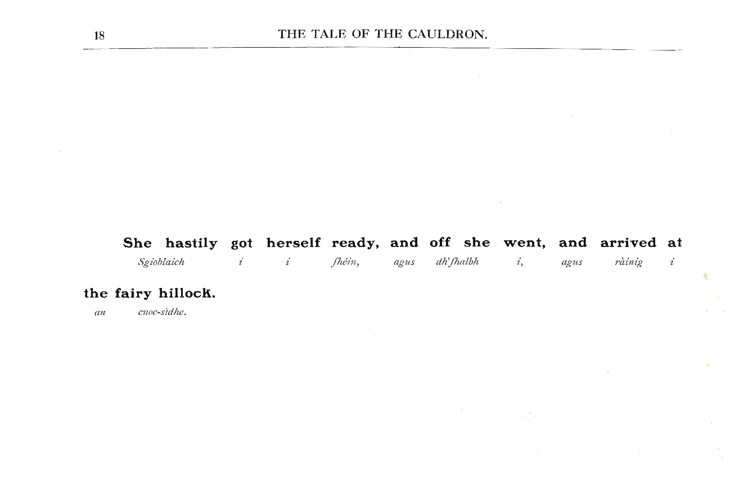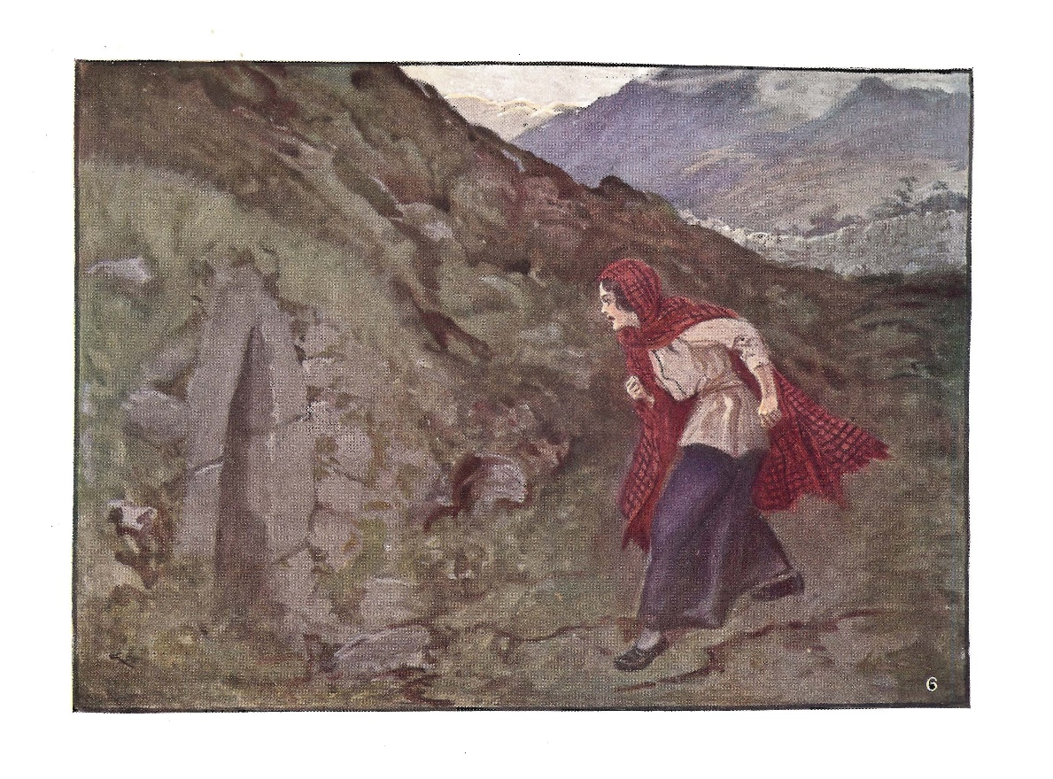

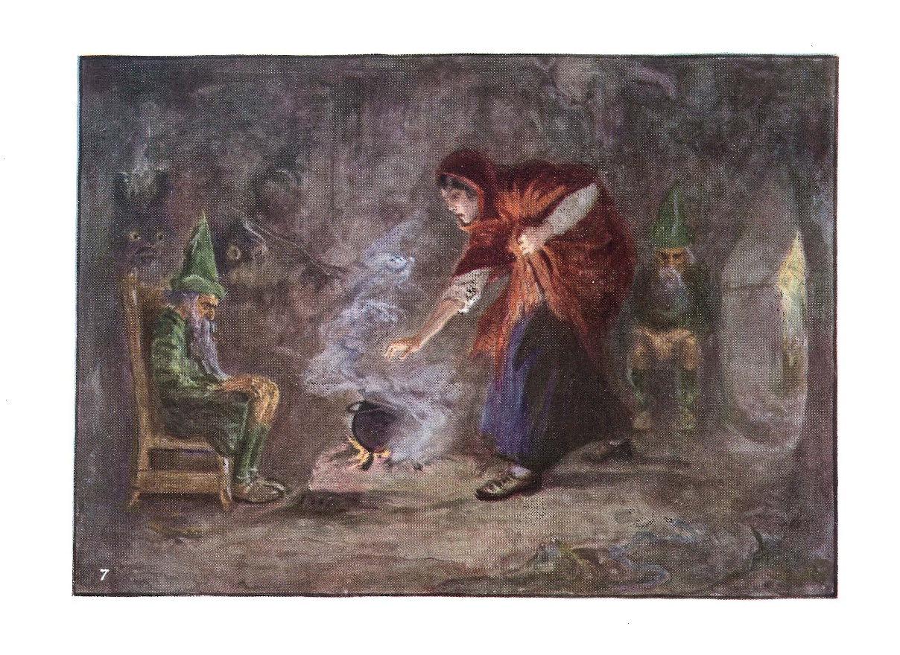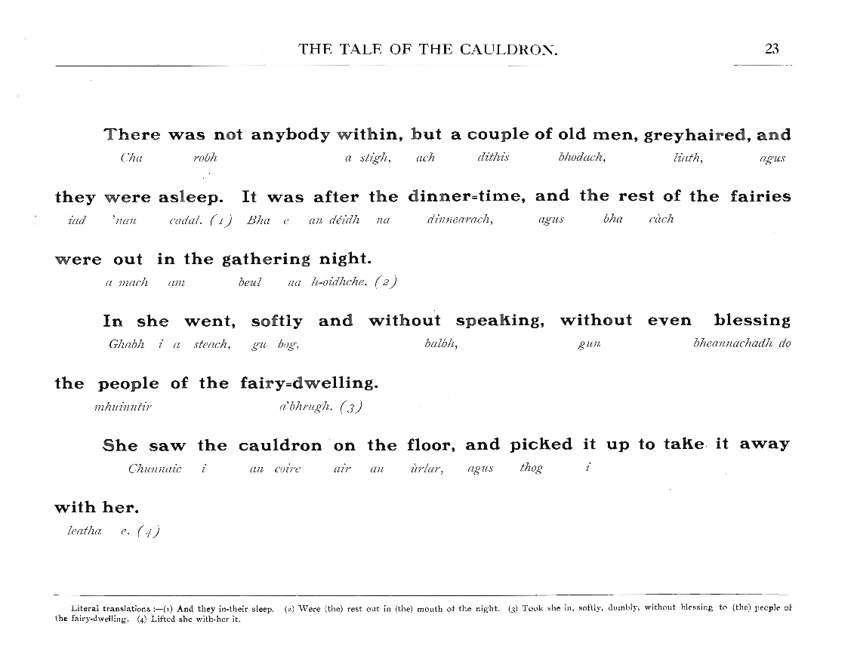

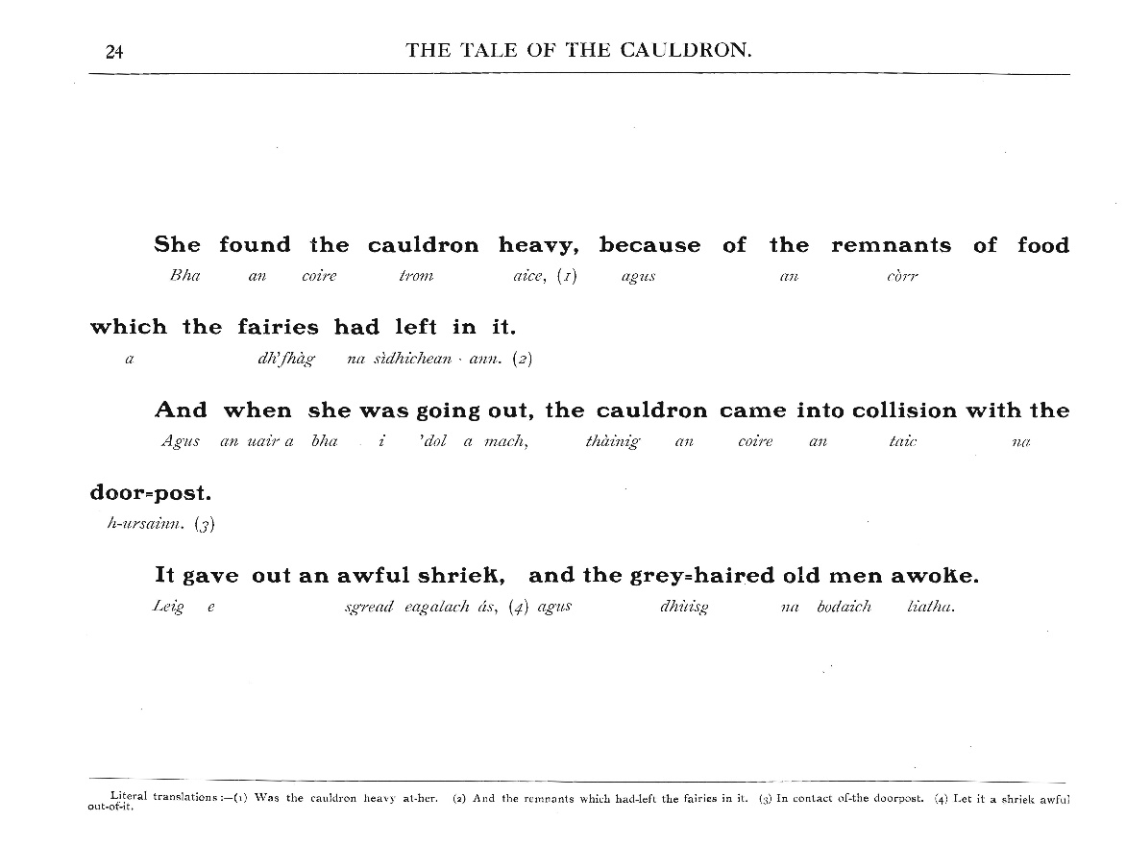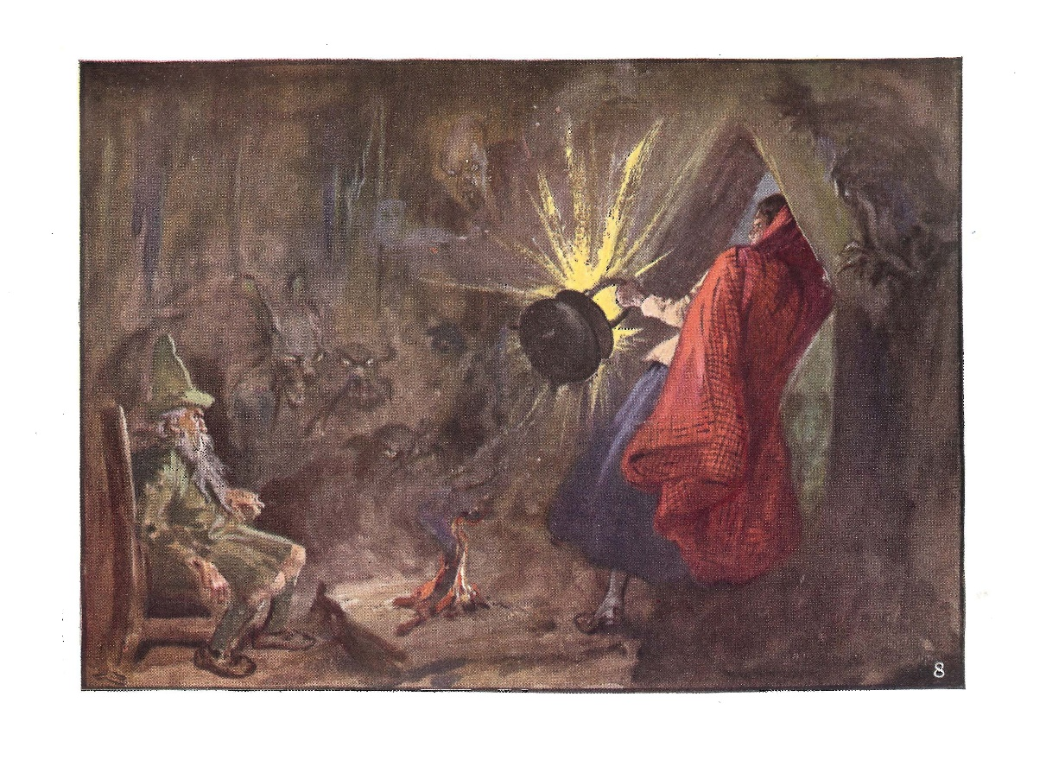

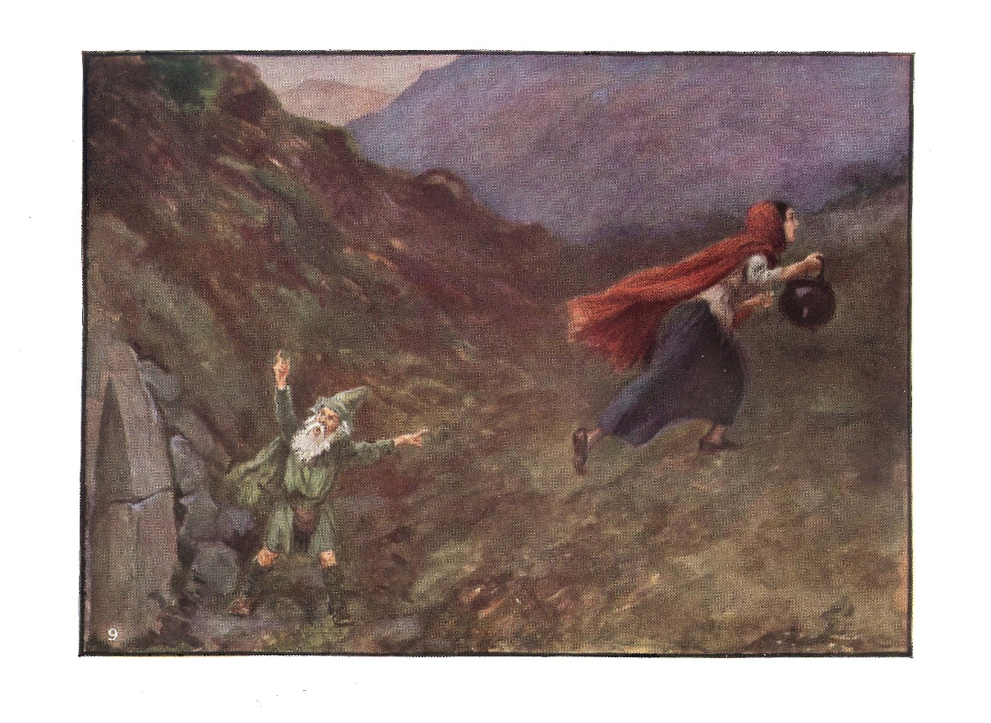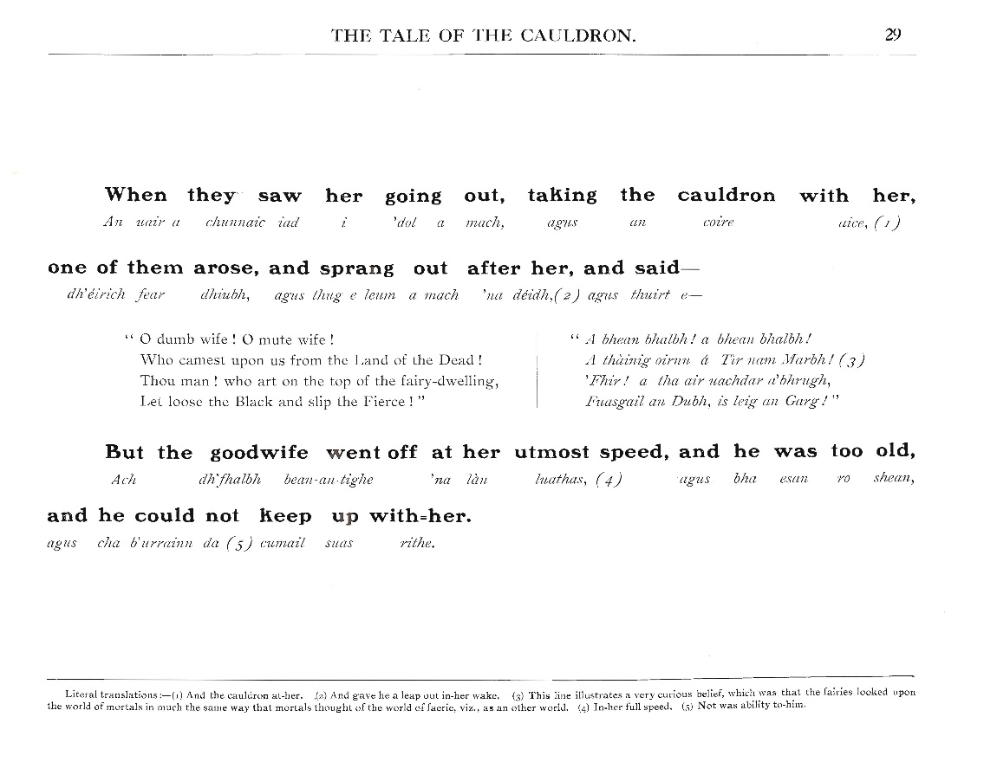

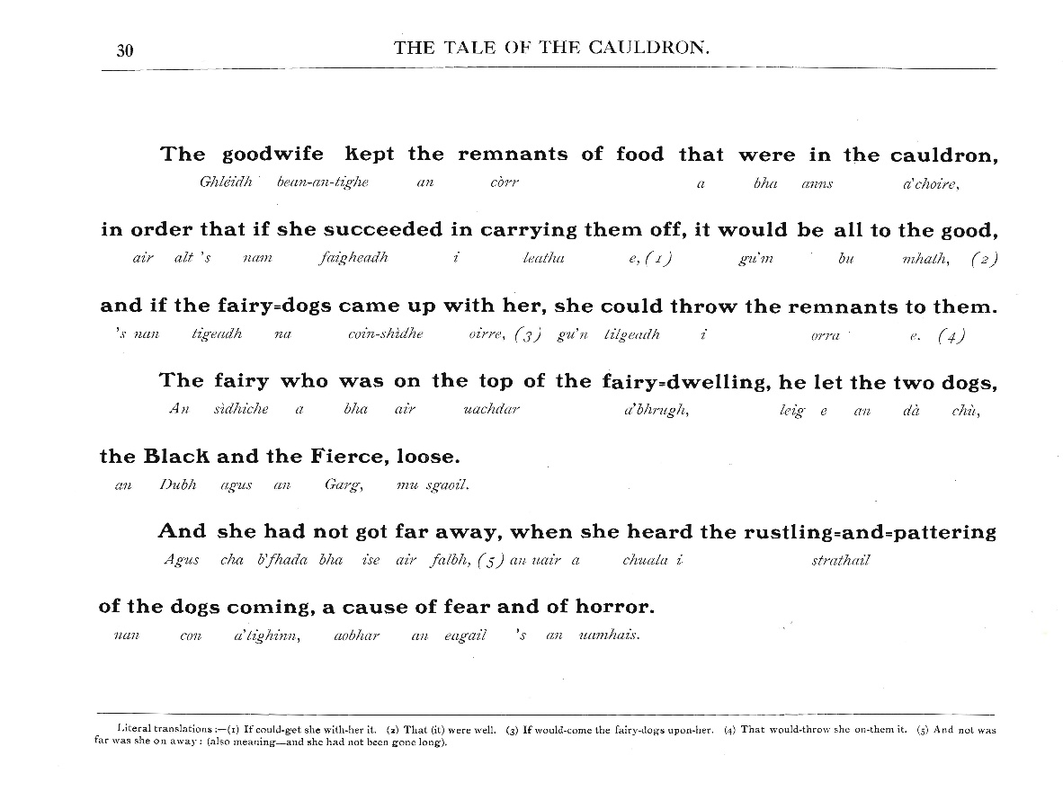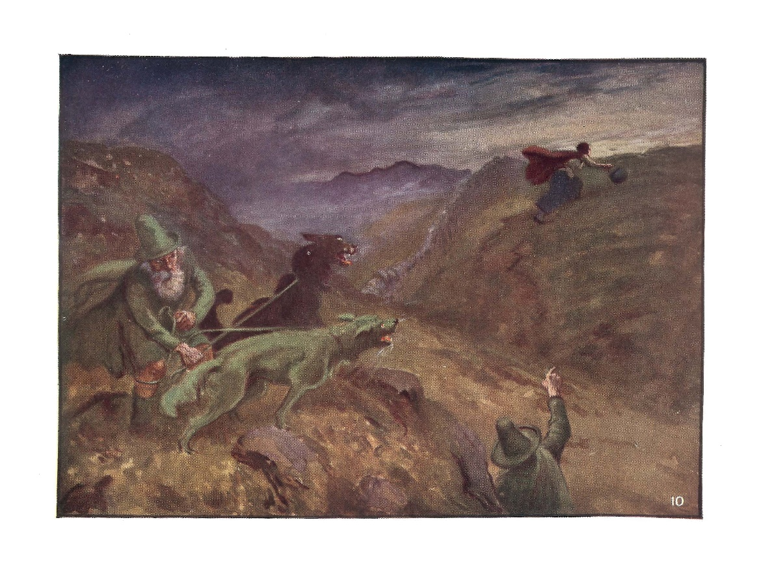

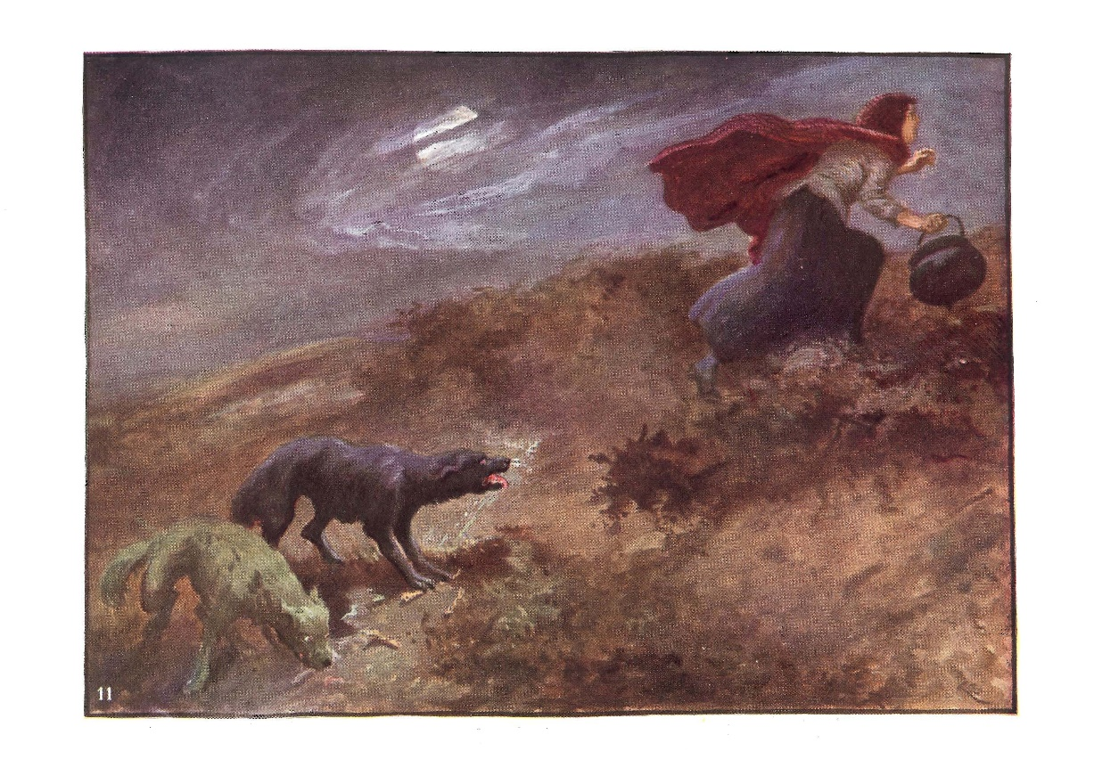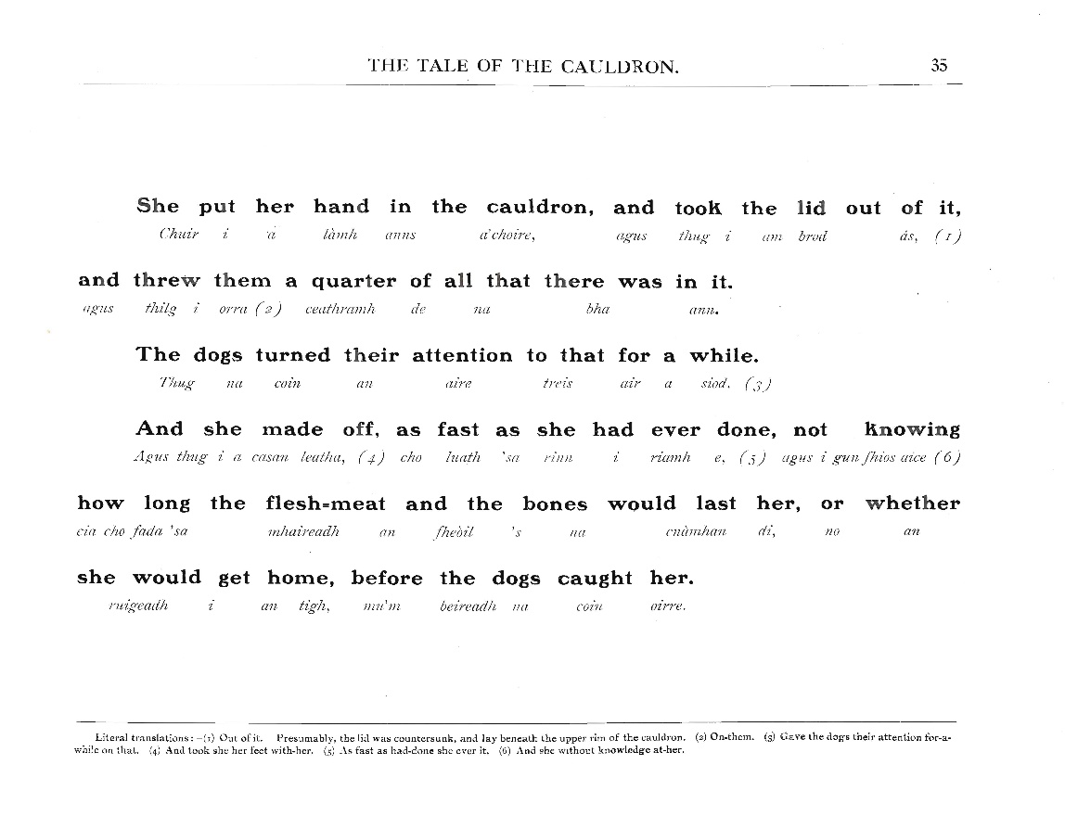

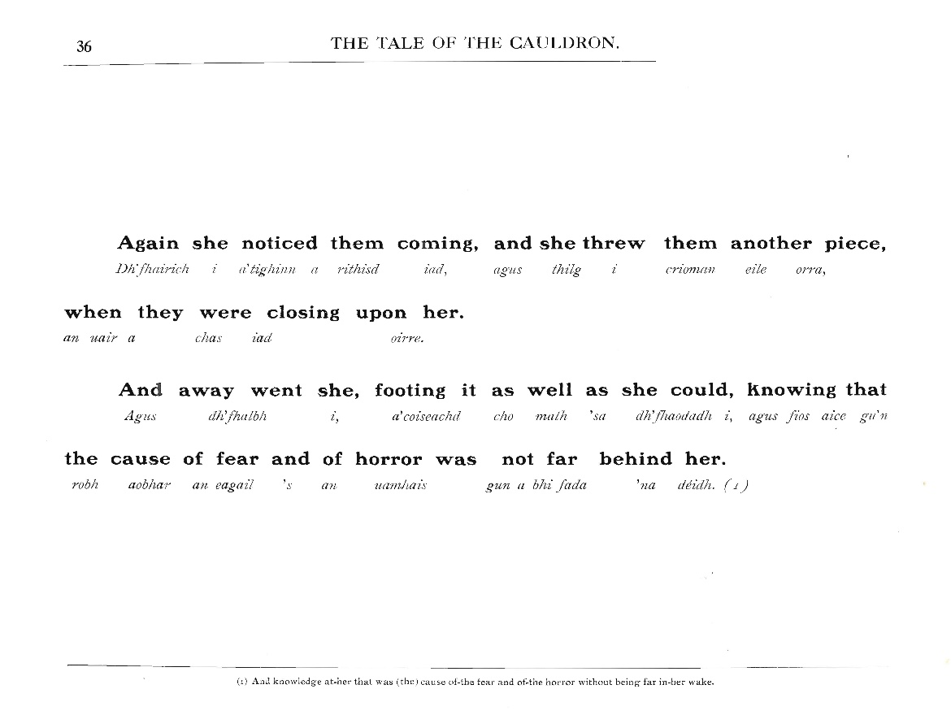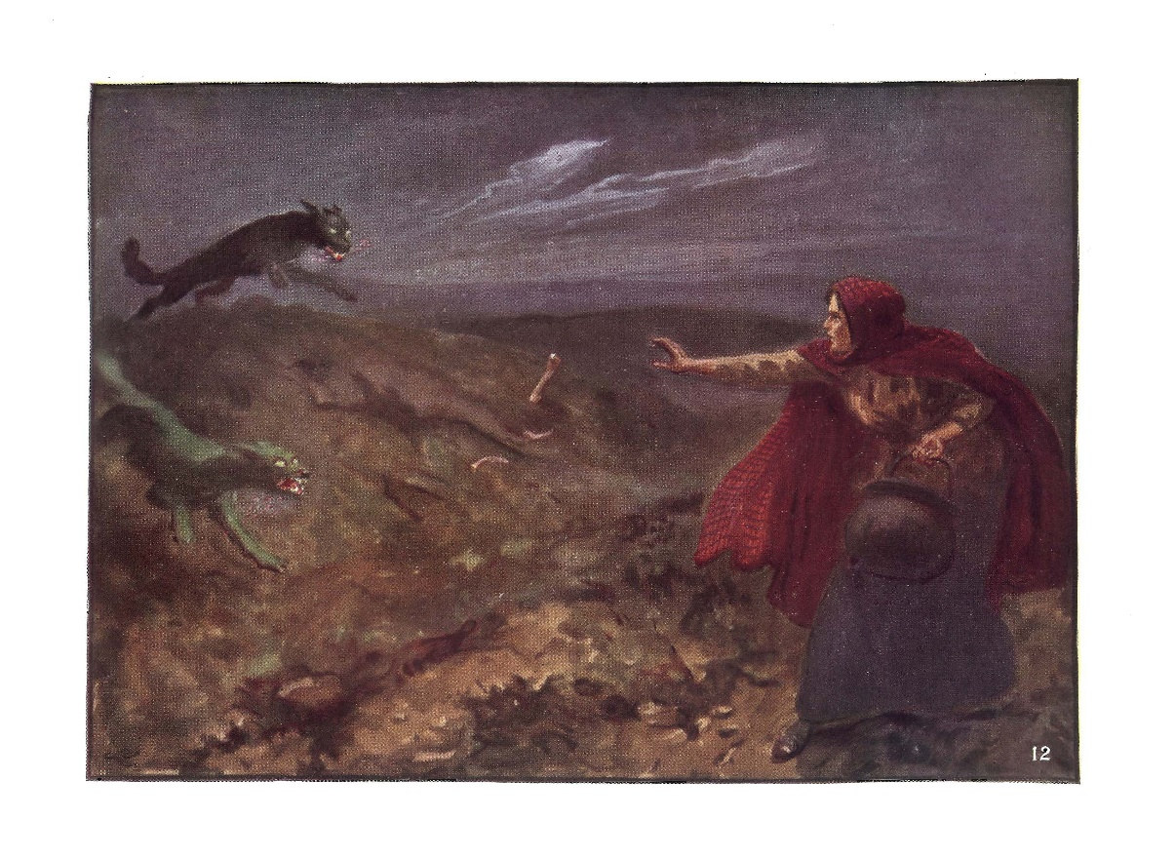

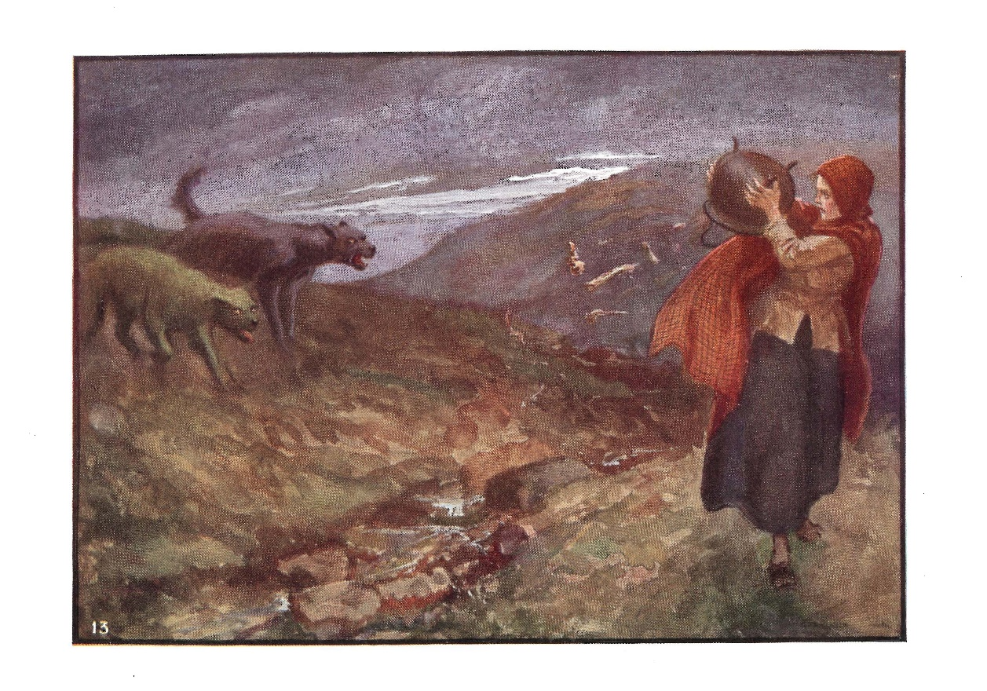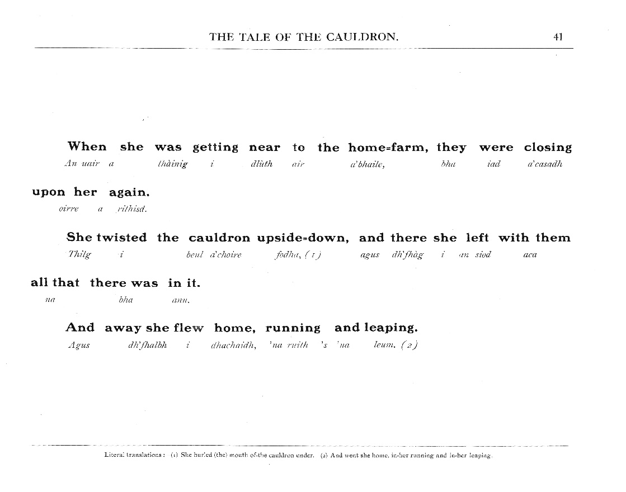

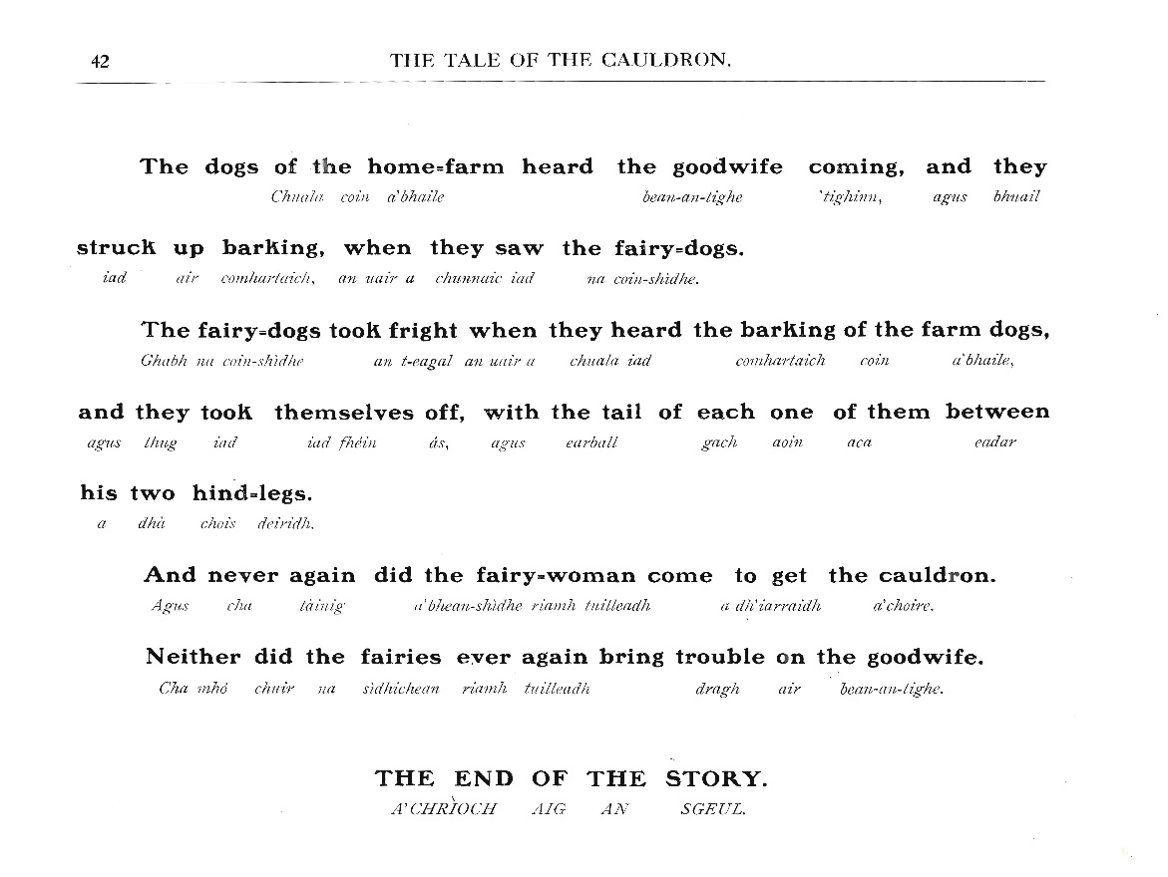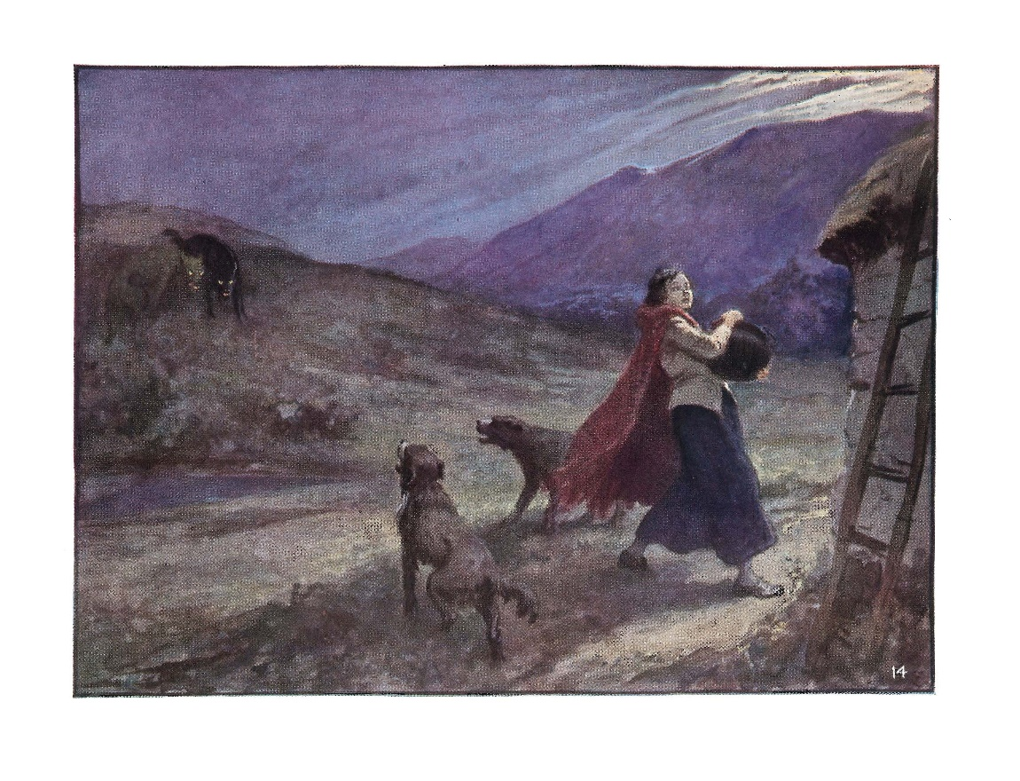

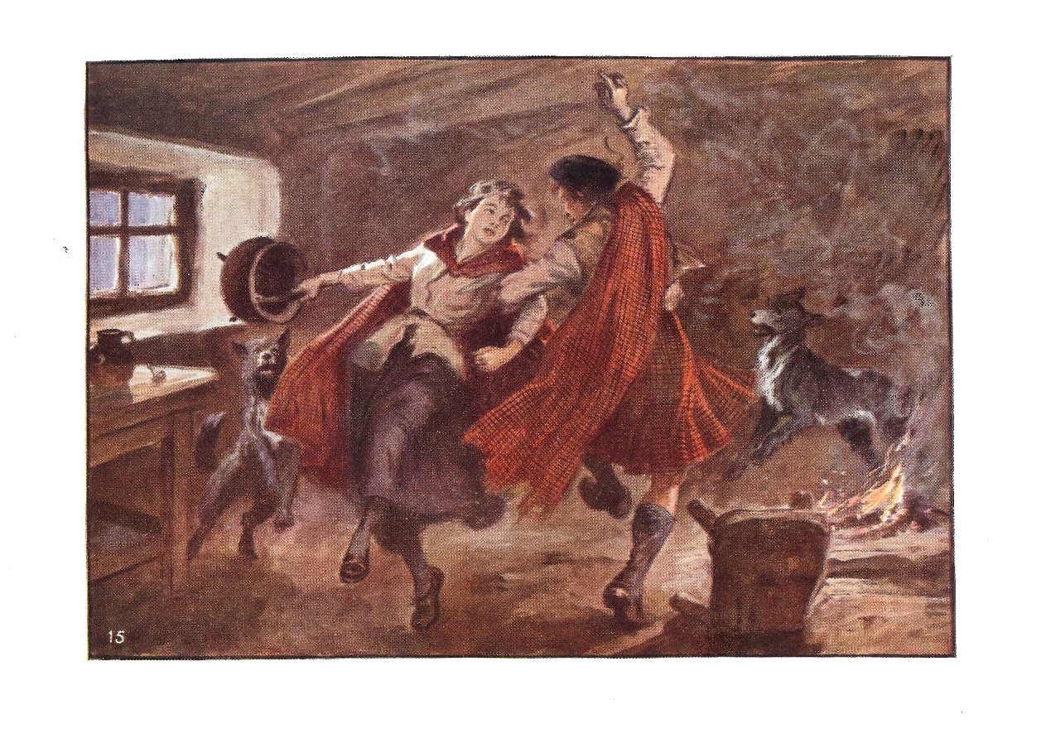
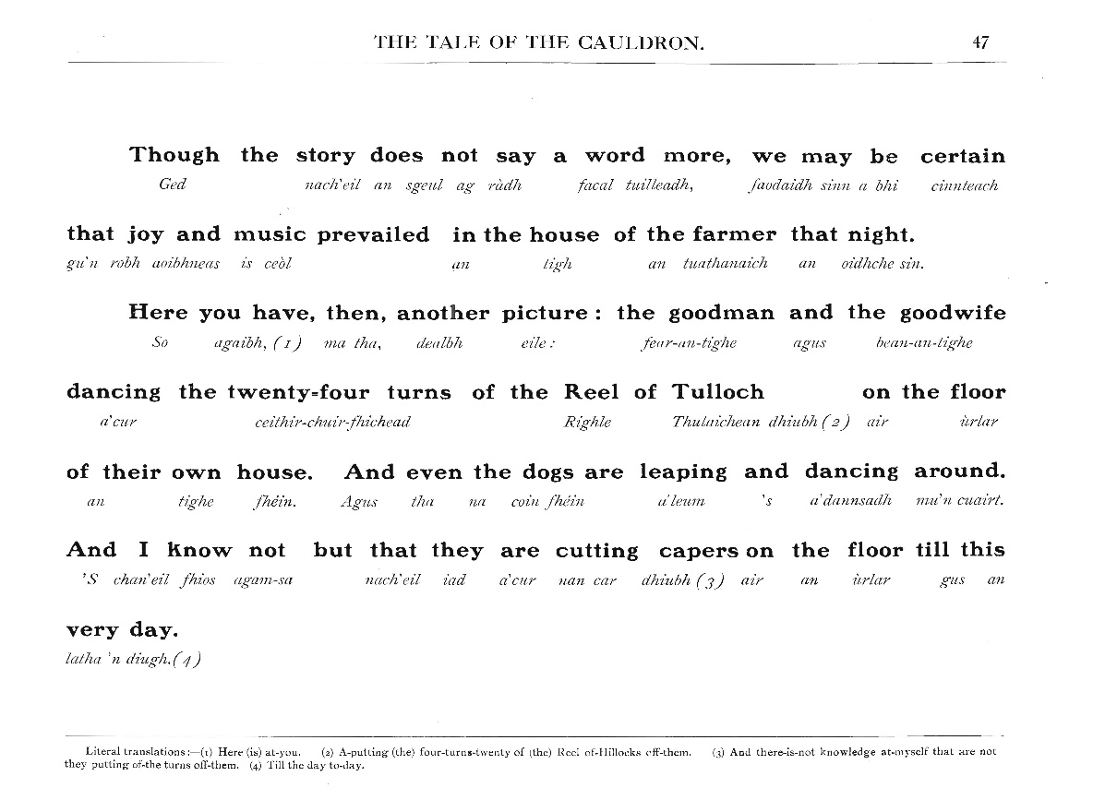

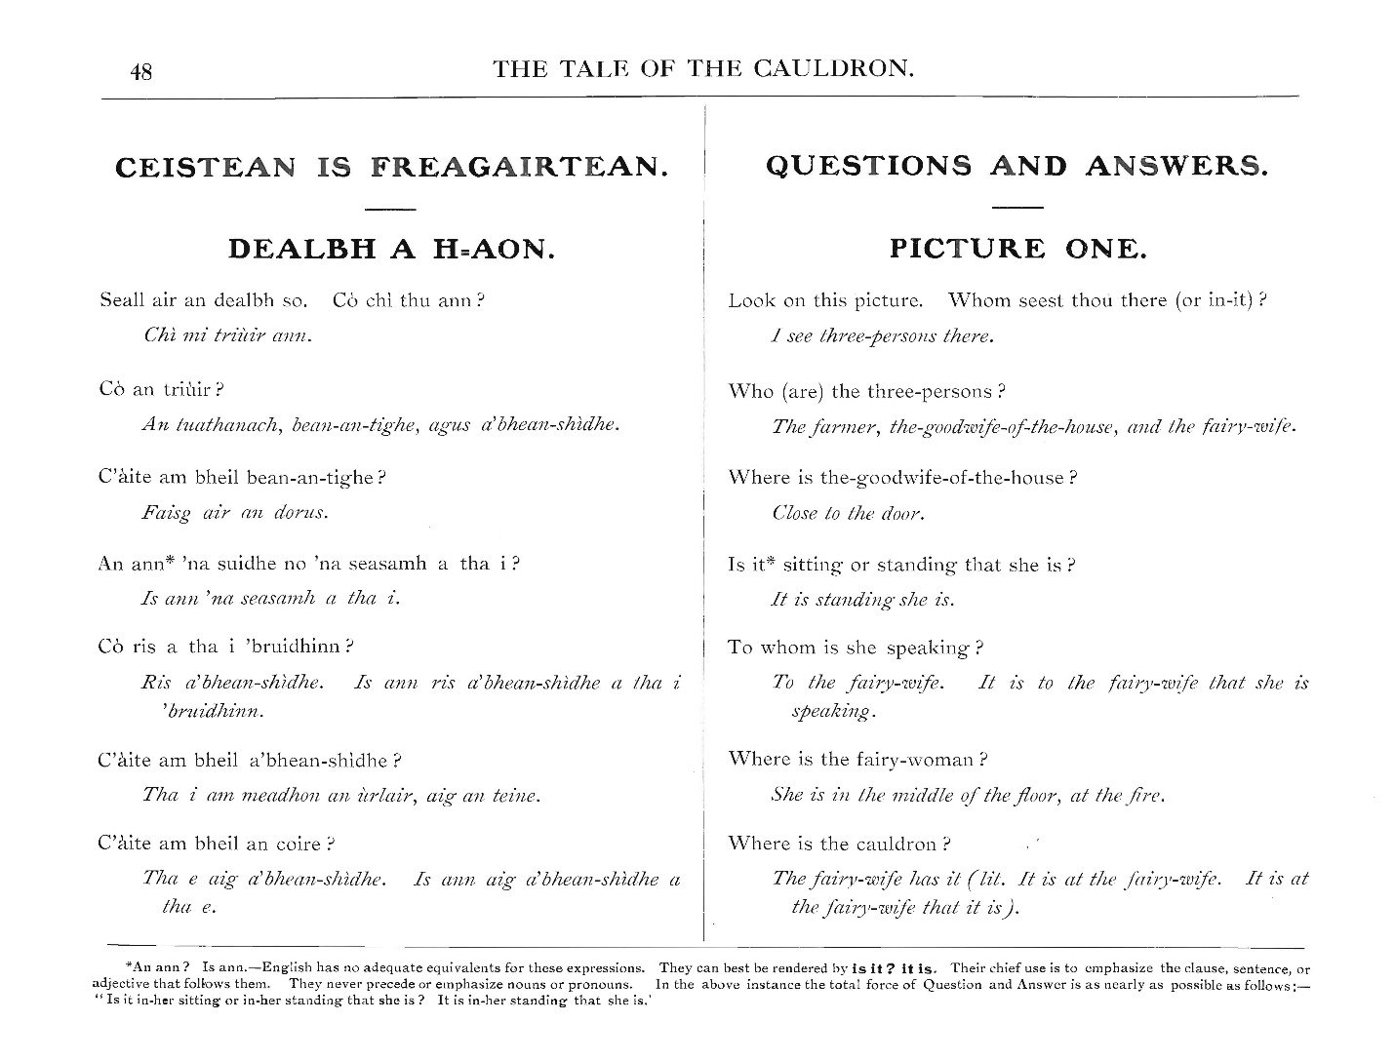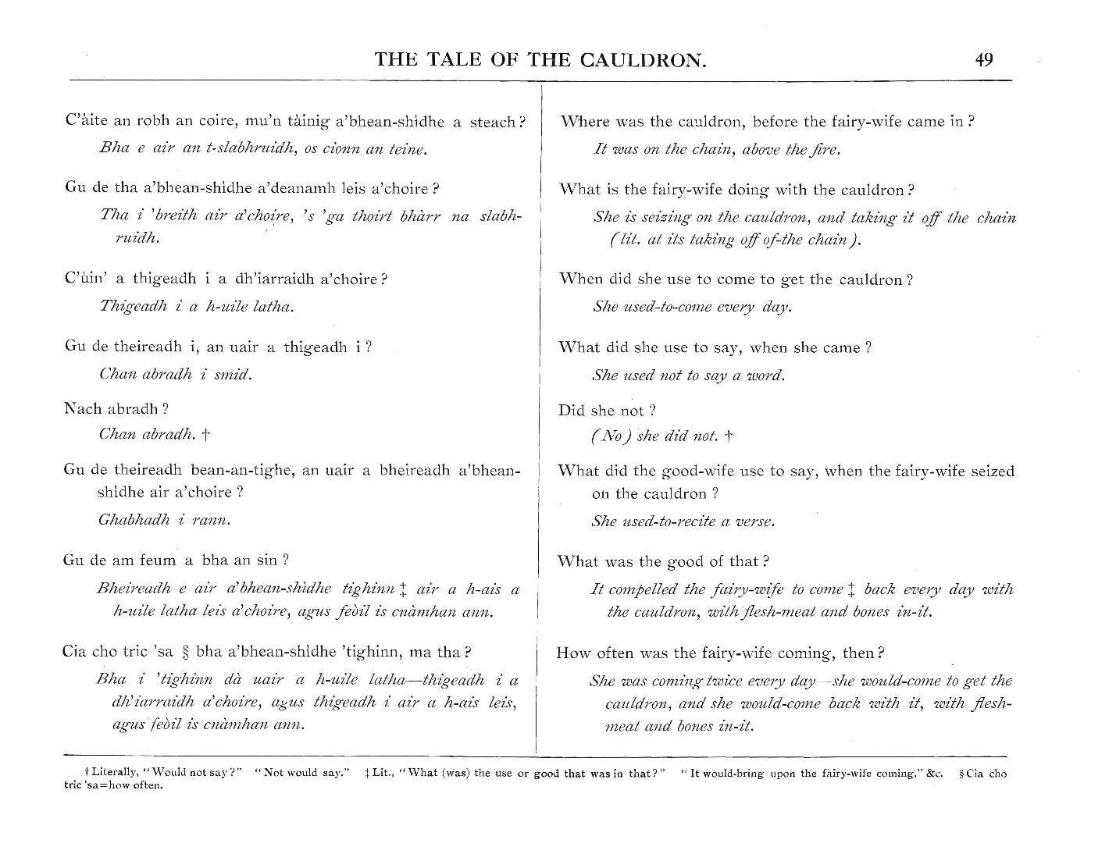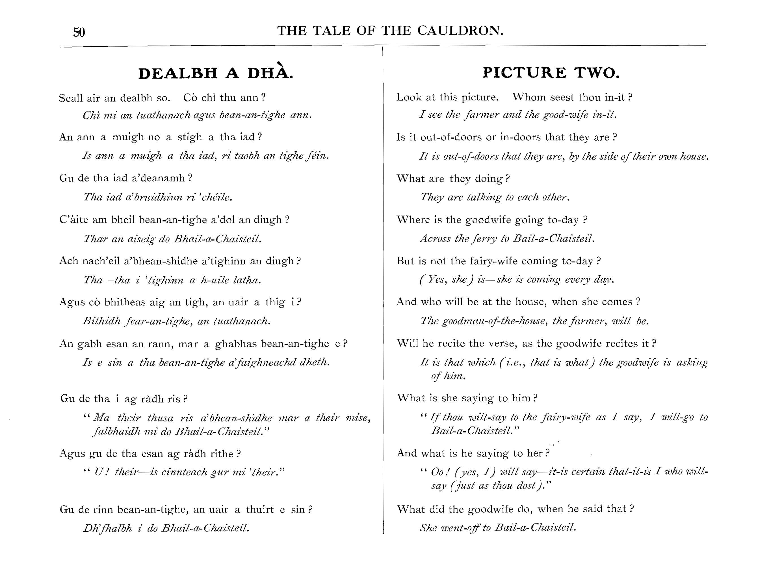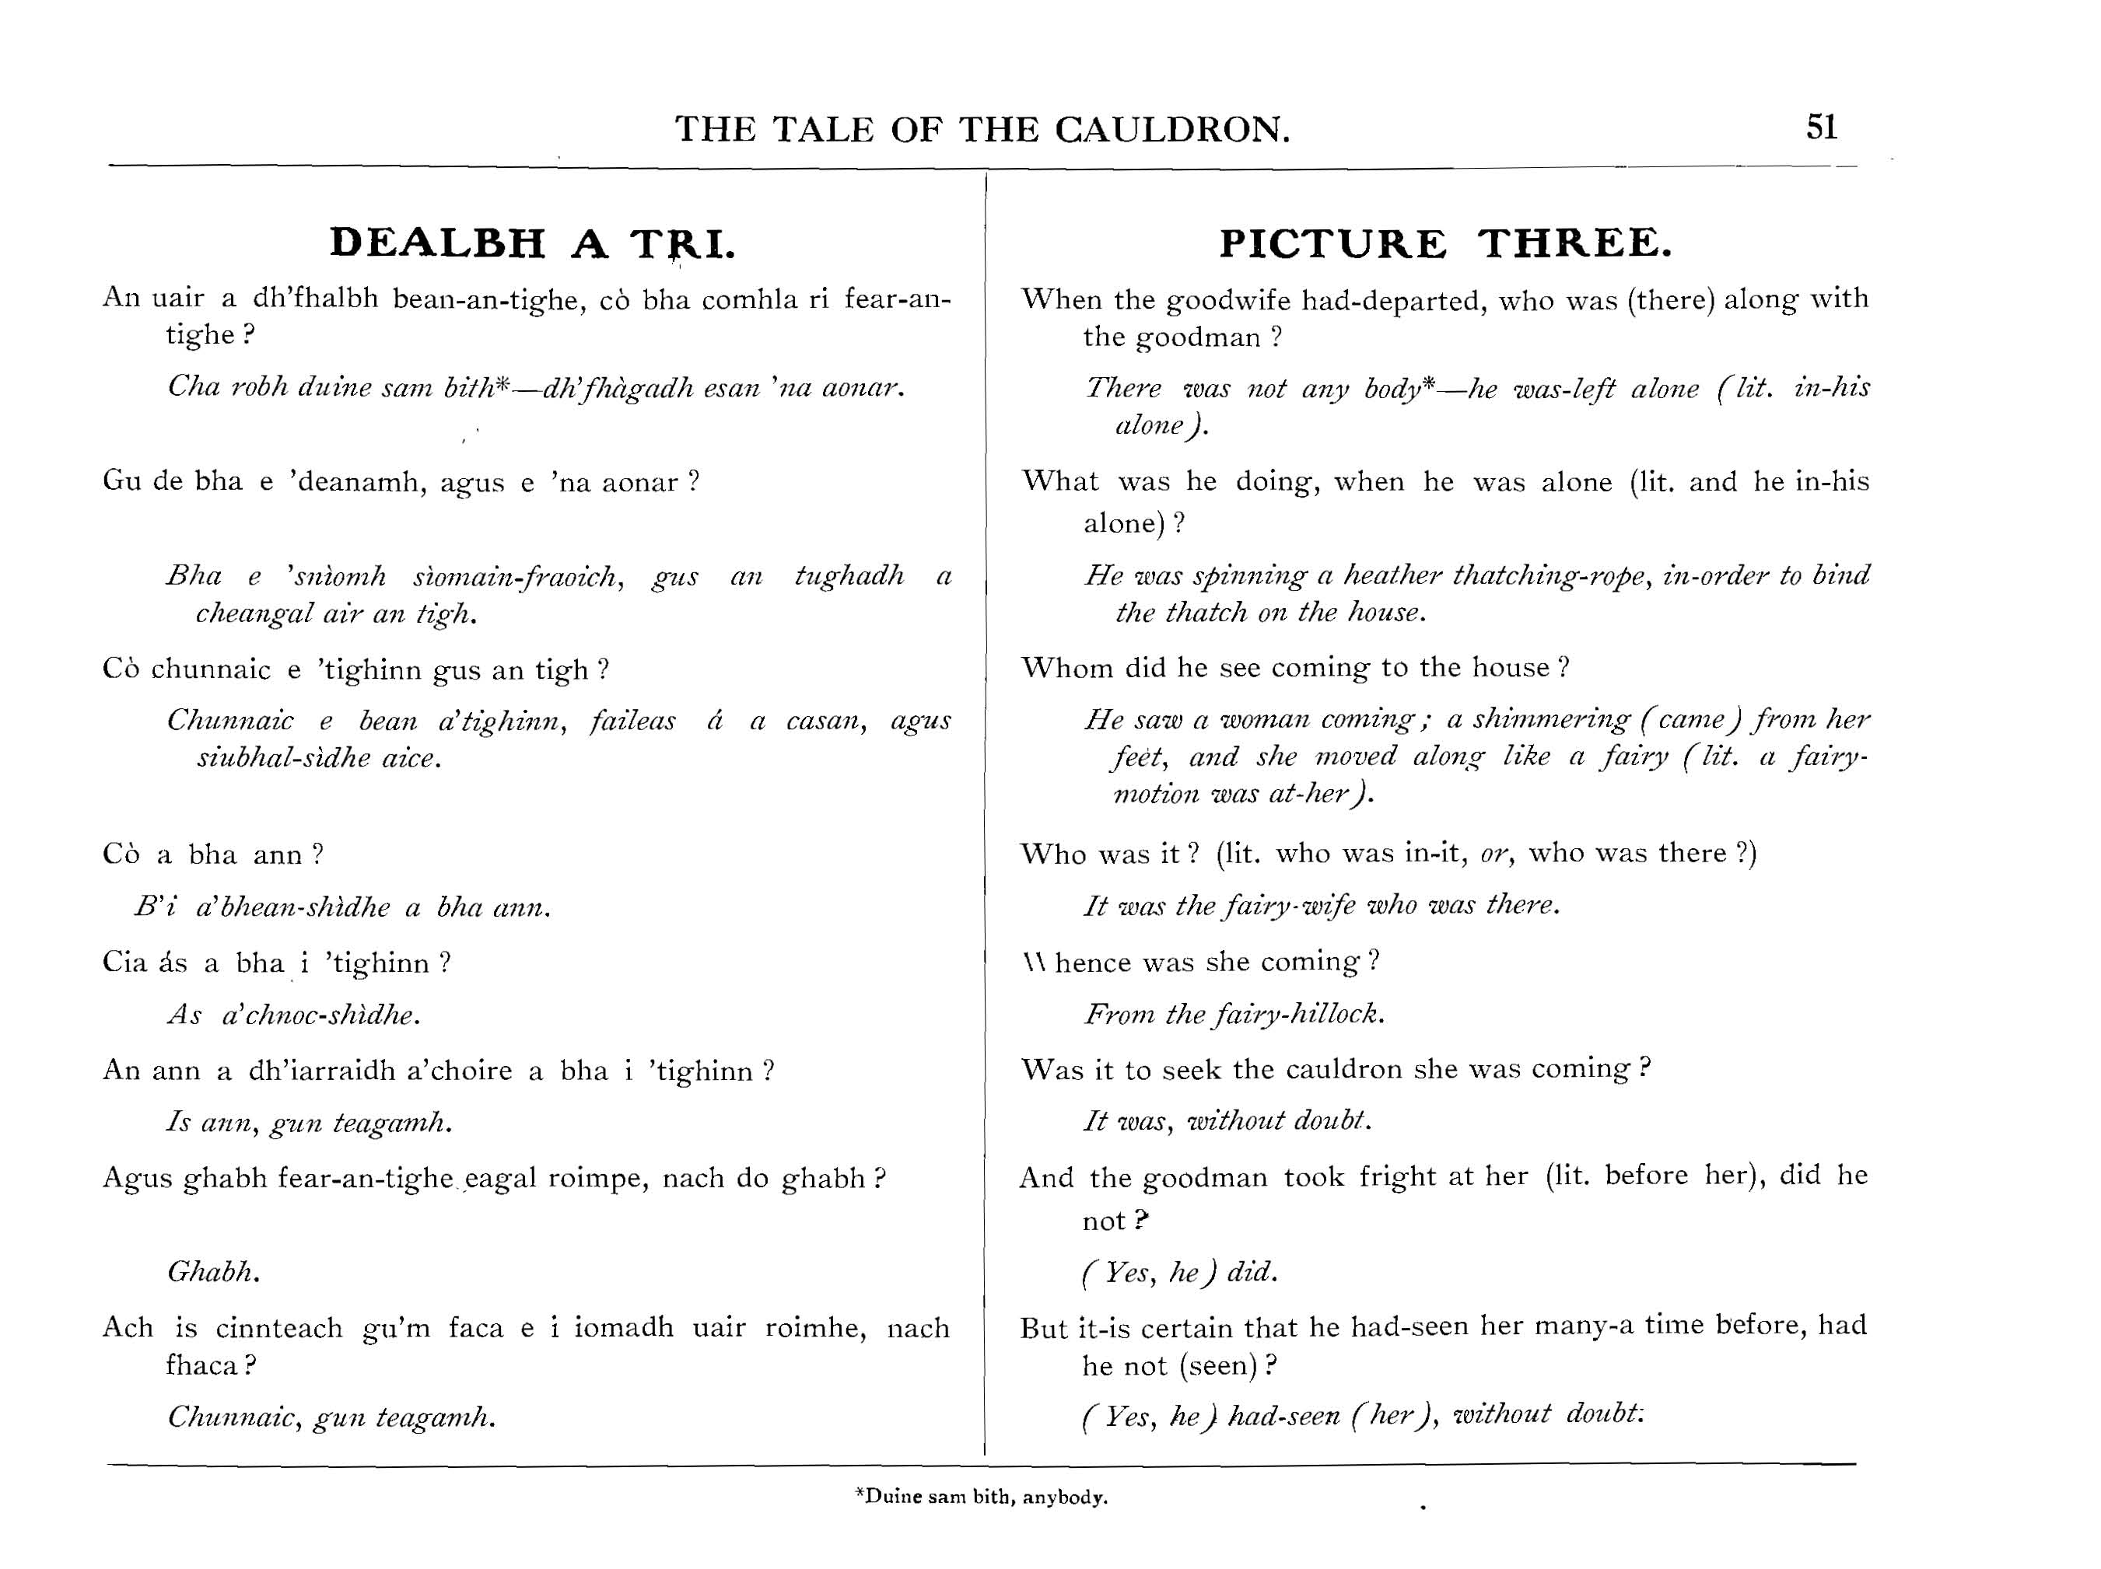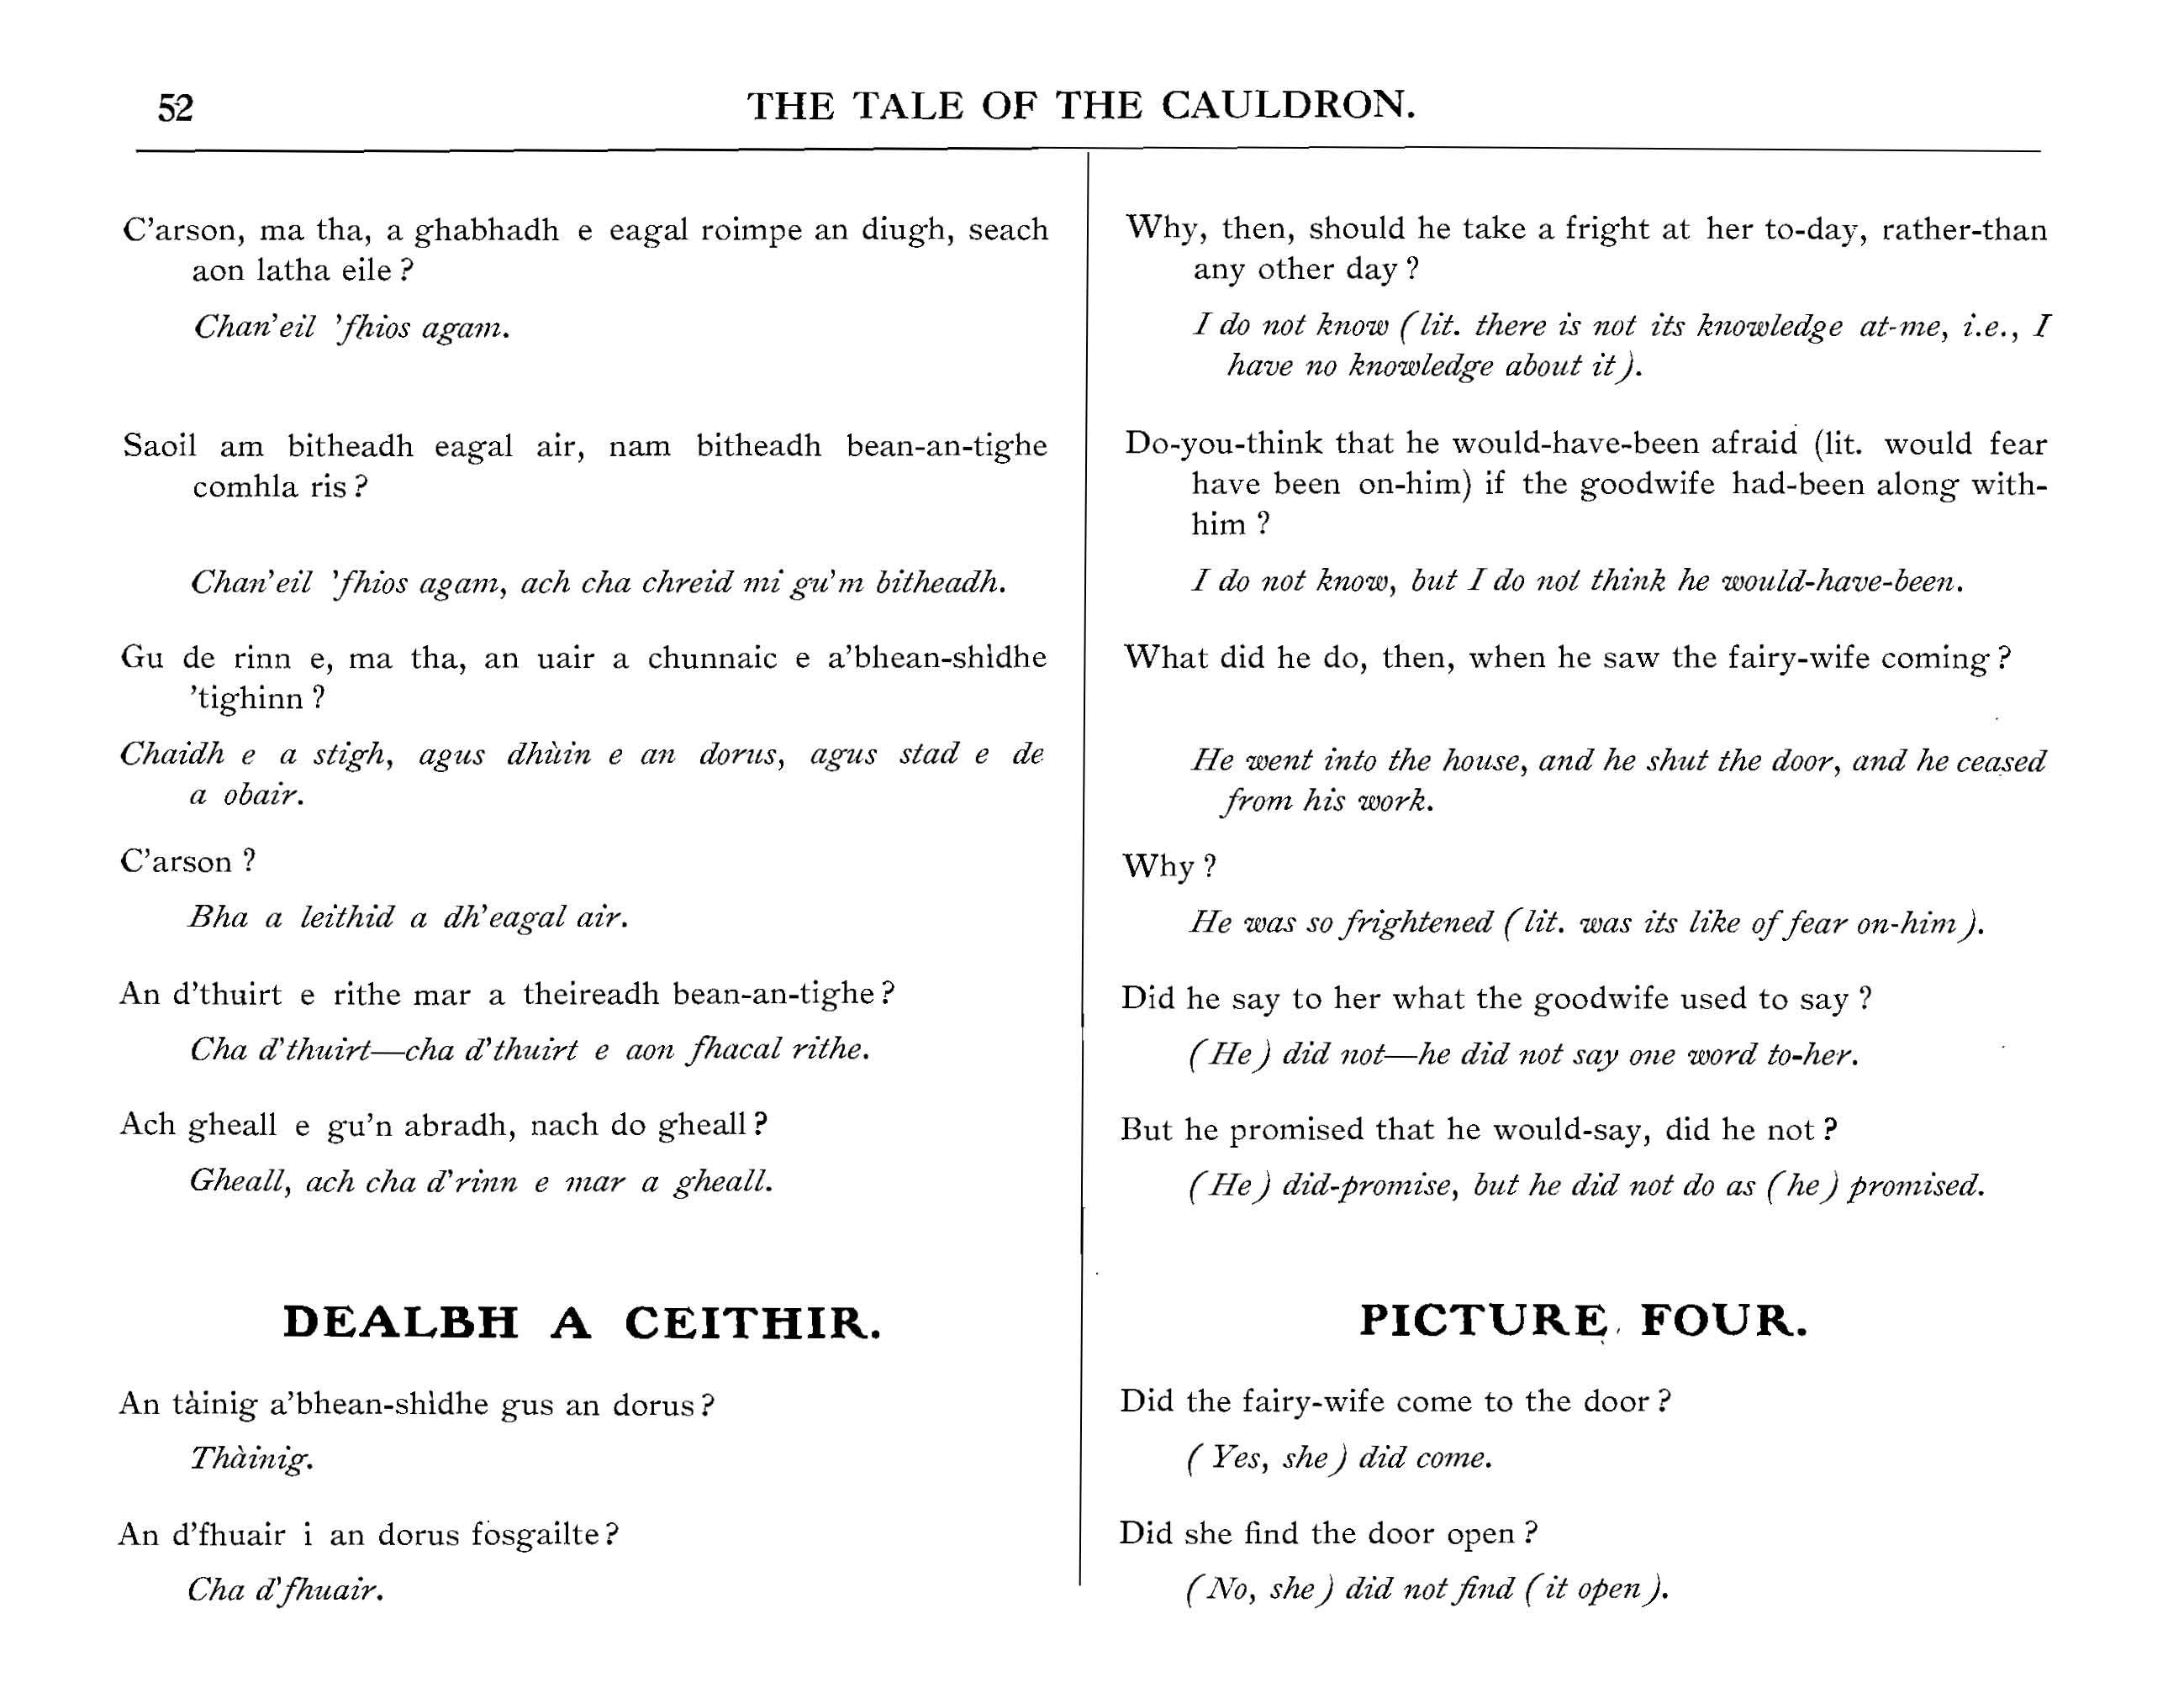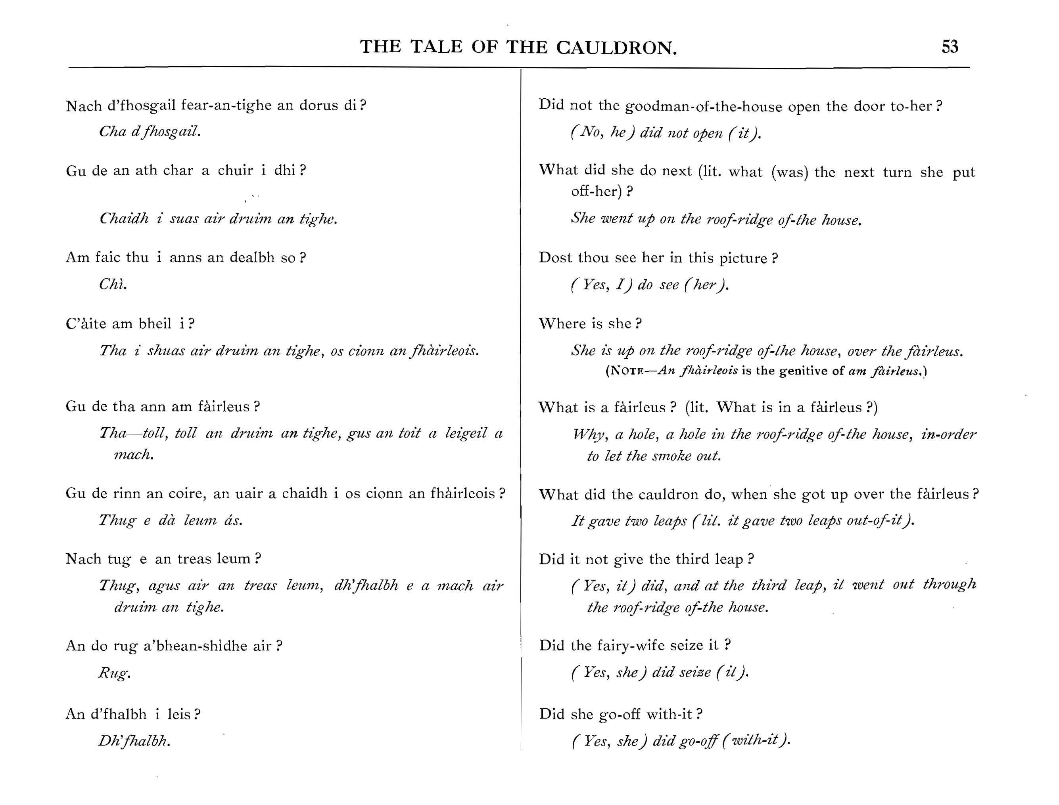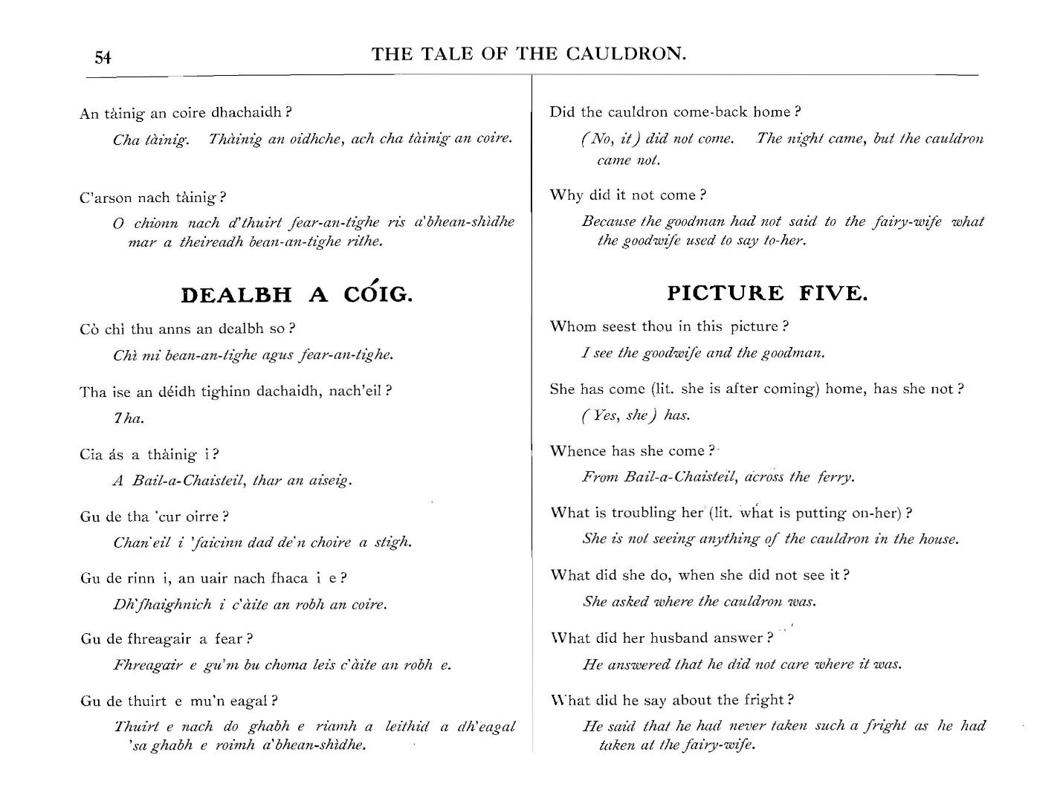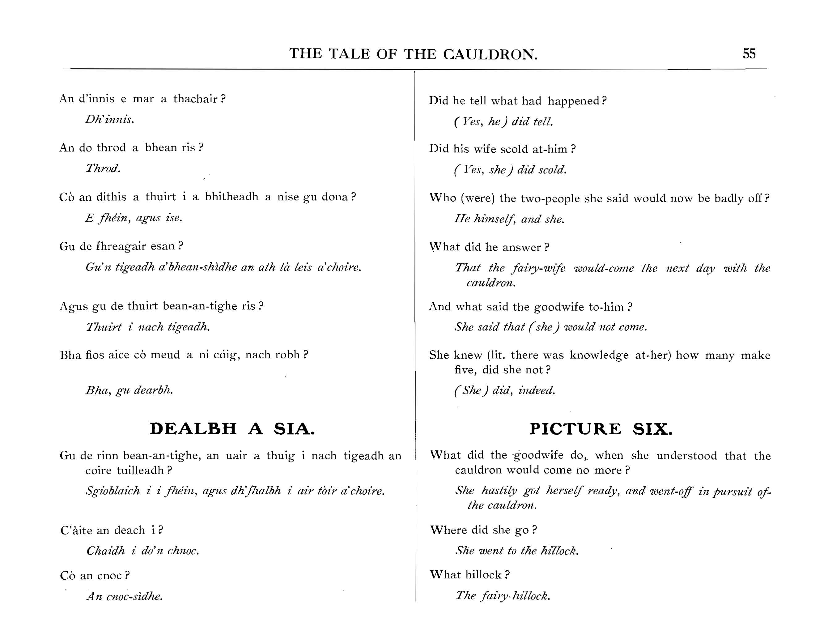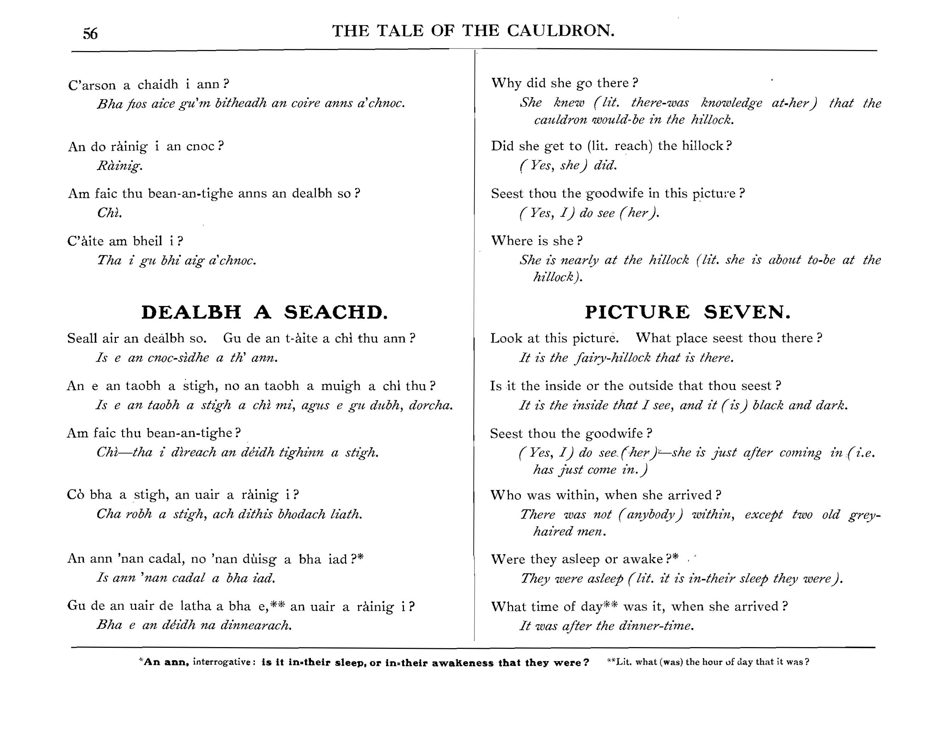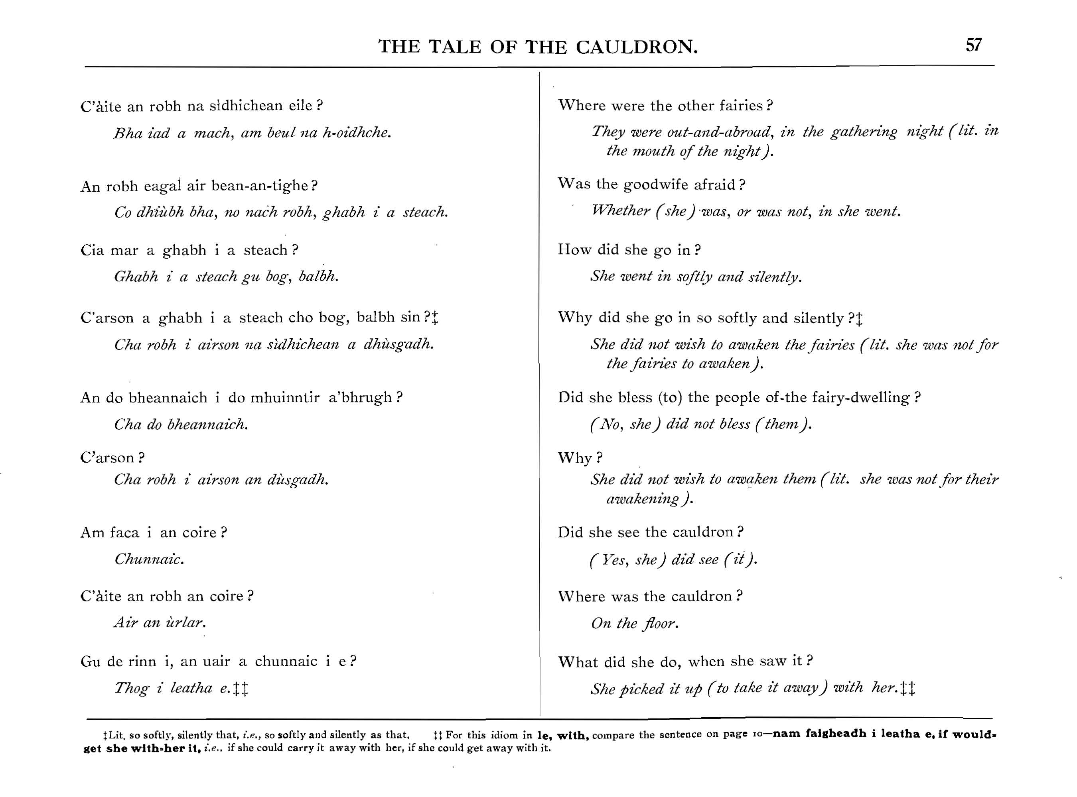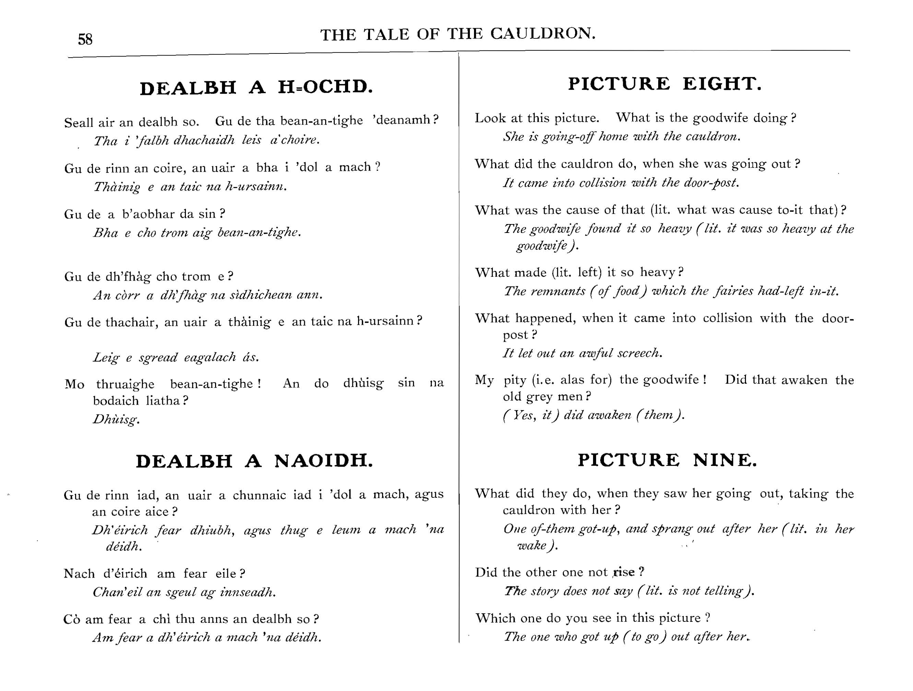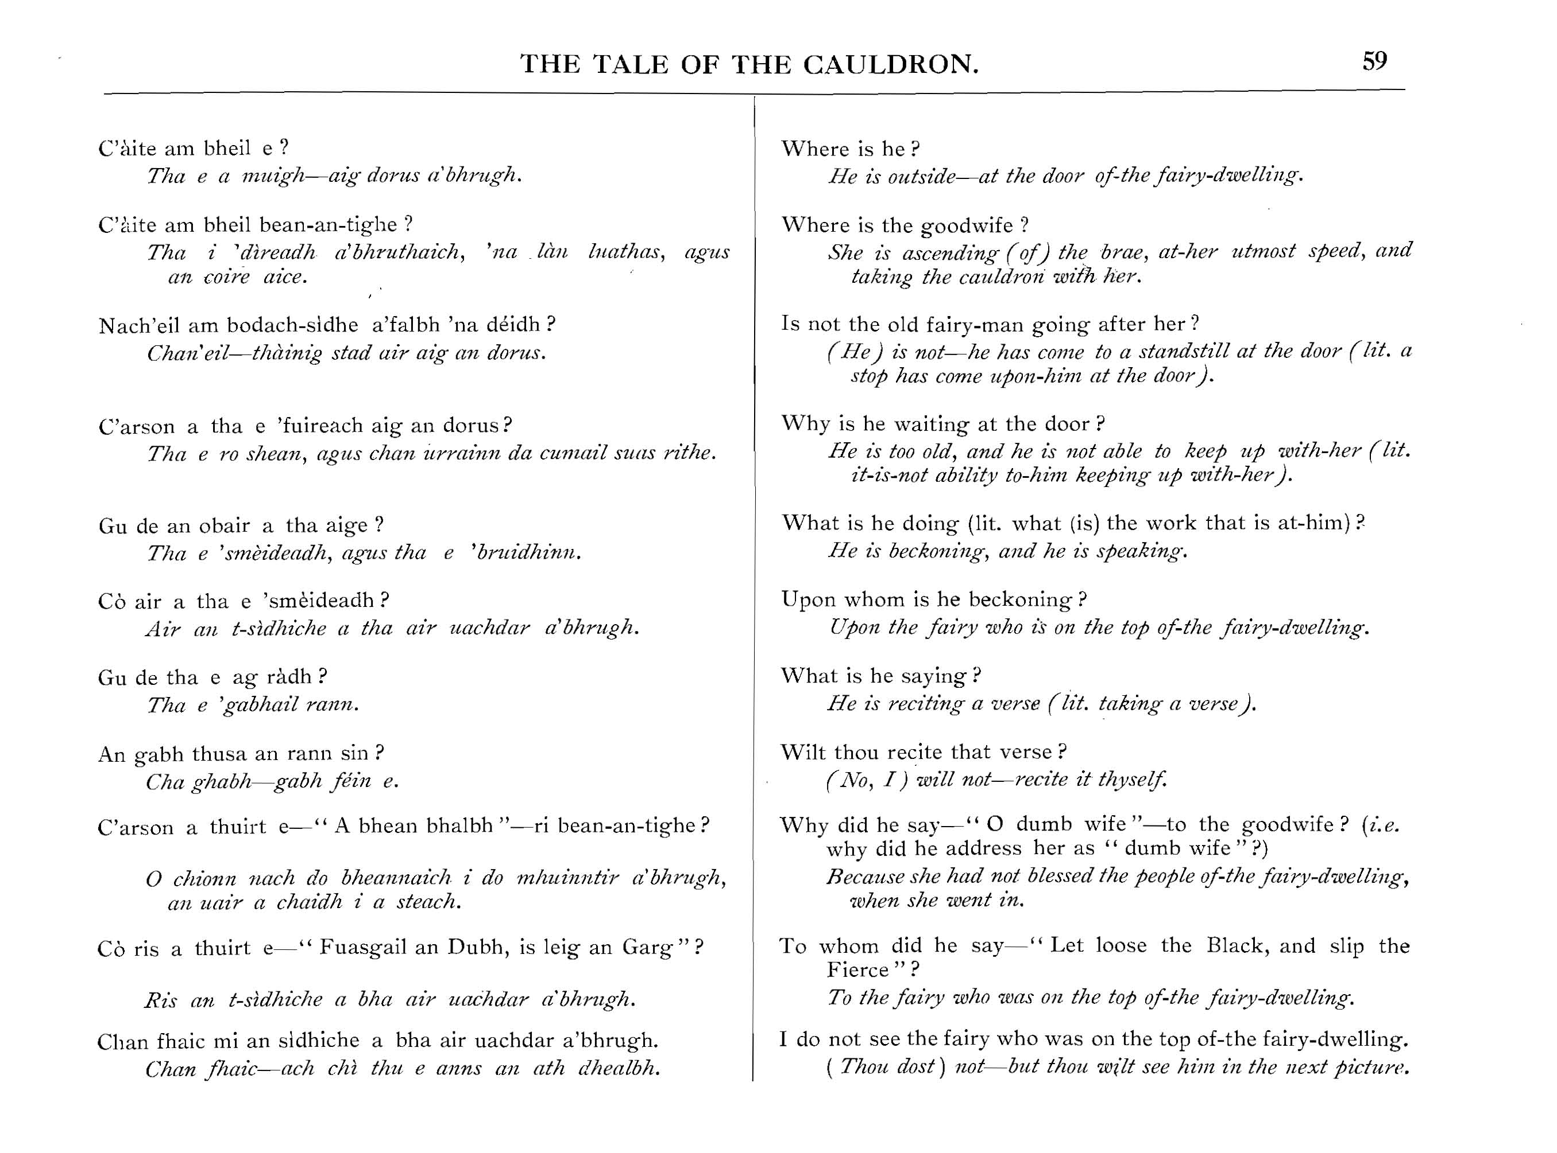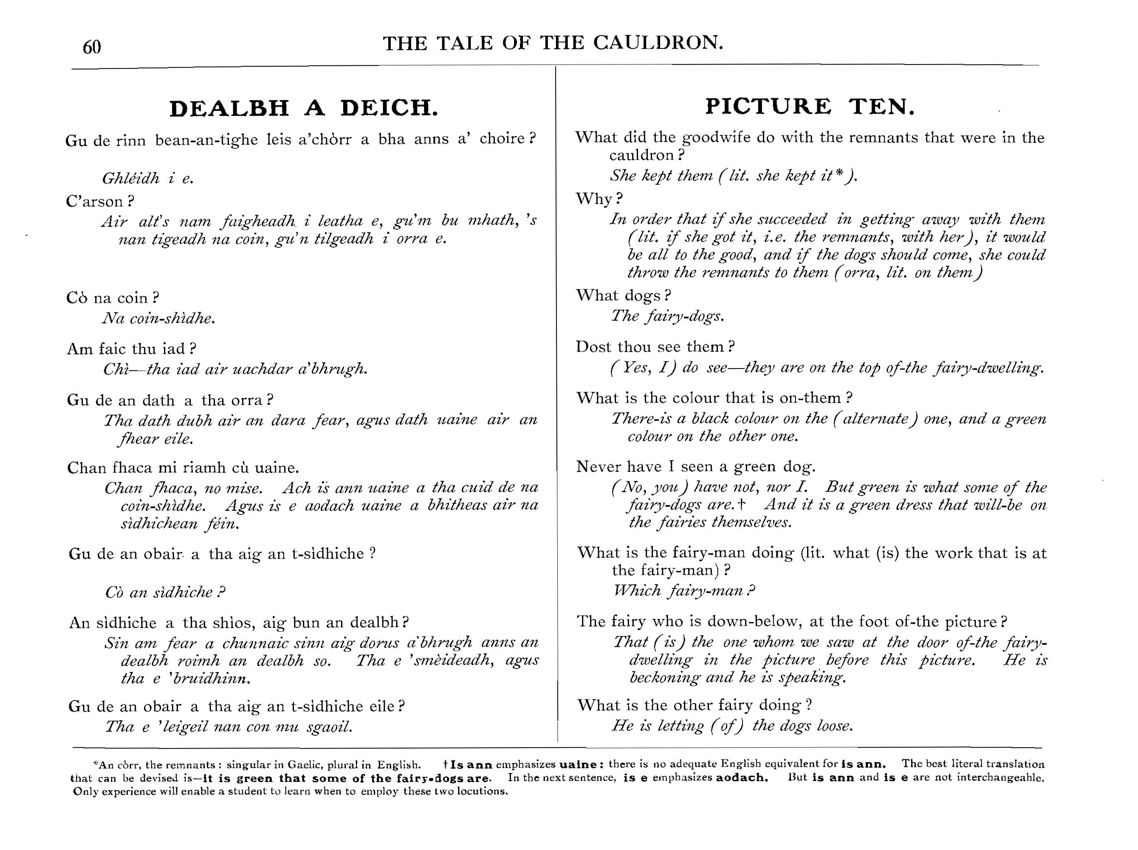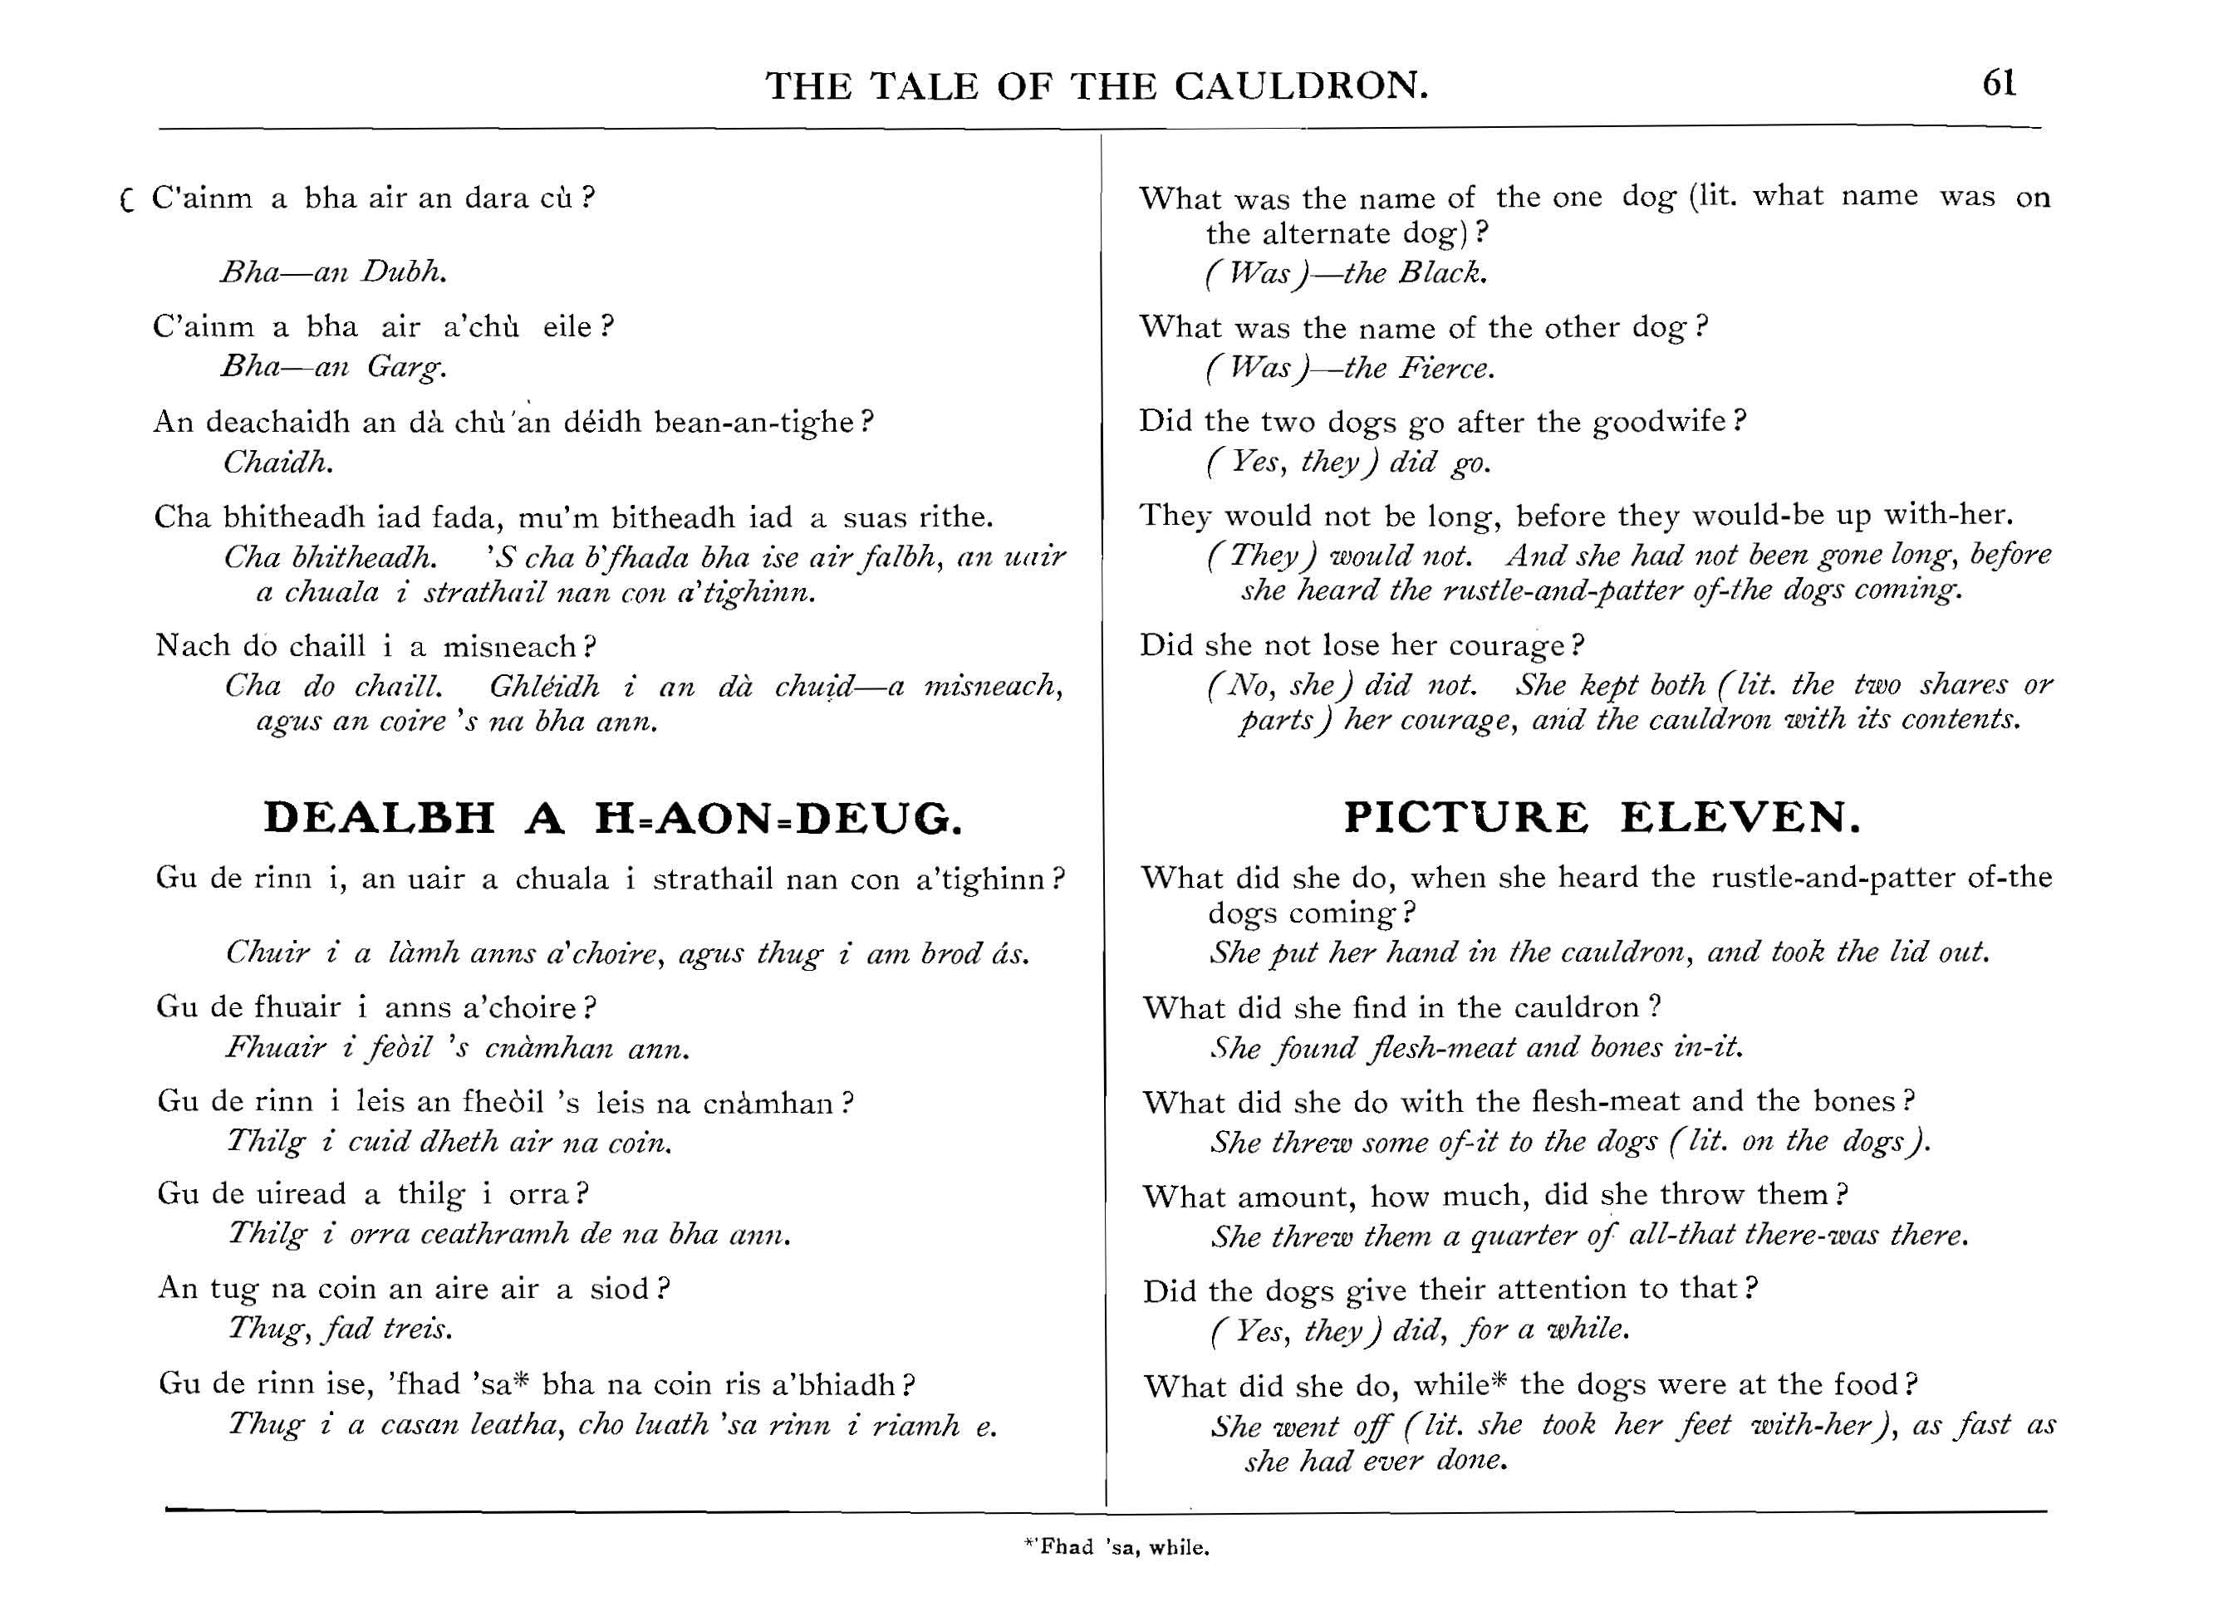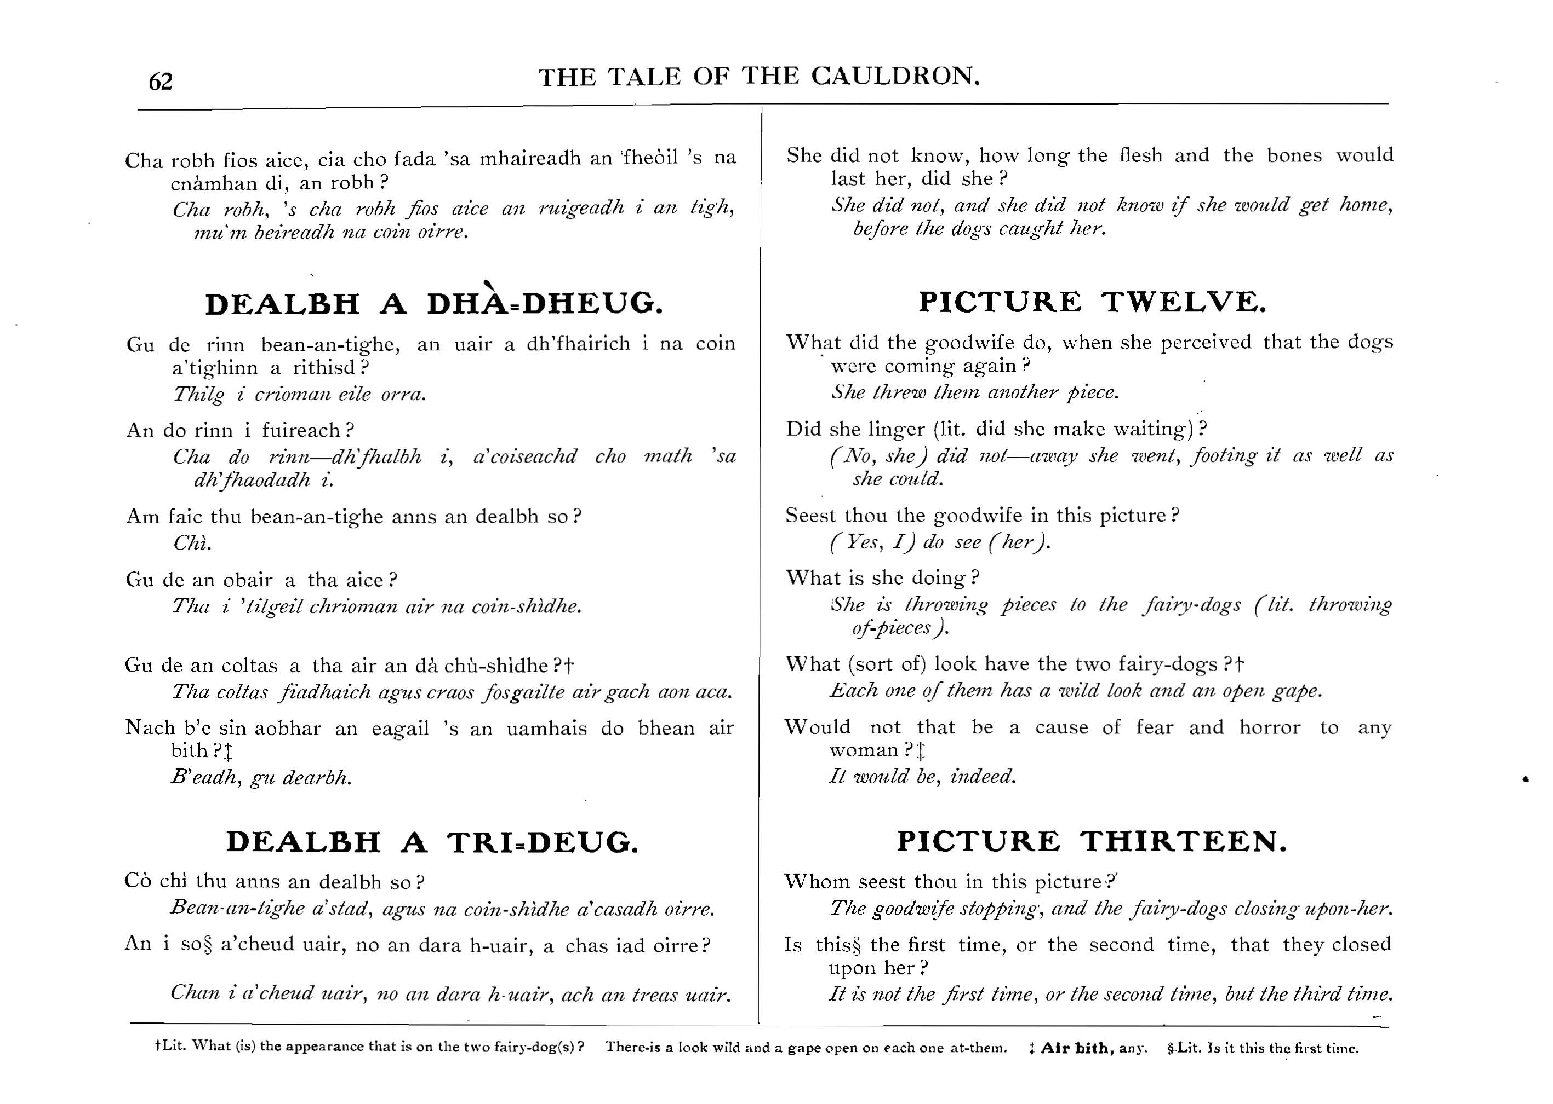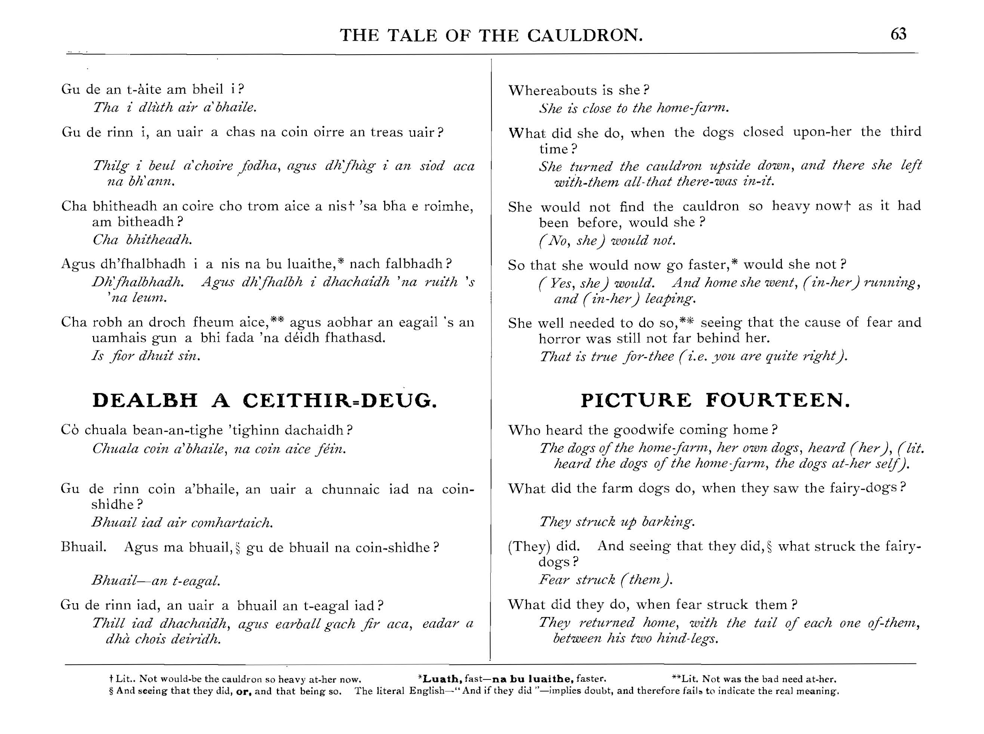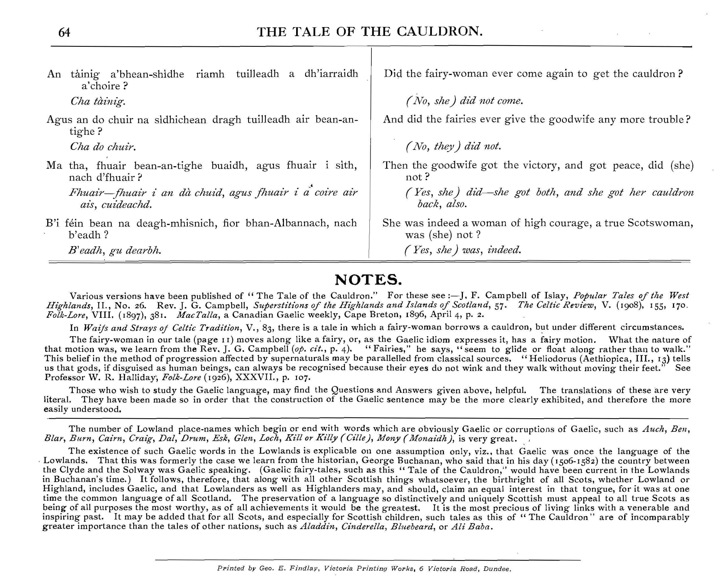

Òran na seachdaine

Mairead nan Cuiread

A song written about – or to – a “wily” rival who slanders a woman out of spite.

https://www.youtube.com/watch?v=zJolZxVvj-0&list=PLOC2Qr5lRyyy_KJw01fHR3B6SOKWSXrpY&index=7
Lyrics: | English Translation:
Tha mulad, tha mulad | Sadness, sadness
Tha lionn-dubh orm fhin | Deep melancholy is mine
Hì rì hoireann ò, Hì rì hoireann ò | Hì rì hoireann ò, Hì rì hoireann ò
Tha de mhingin air m'aire | There's much despair in me
Nì nach aidich mo bheul | That my mouth can't confess it
Hì rì hoireann ò, Hì rì hoireann ò | Hì rì hoireann ò, Hì rì hoireann ò
Mun òganach gasda ùr | About the fine youth
Mharcach nan steud | Young rider of the steeds
Hì rì hoireann ò, Hì rì hoireann ò | Hì rì hoireann ò, Hì rì hoireann ò
Mun taca seo 'n uiridh | Around this time last year
Bu thoil leat m' fhuran ro cheud | You liked my banter above hundreds
Hì rì hoireann ò, Hì rì hoireann ò | Hì rì hoireann ò, Hì rì hoireann ò
Cha mhò ort mi'n bliadhna | You don’t like mi this year
Na eunlaith nan speur | As much as the birds of the air
Hì rì hoireann ò, Hì rì hoireann ò | Hì rì hoireann ò, Hì rì hoireann ò
Chan inns mi dha m' phiuthair | I wouldn't ever tell my sister
Meud mo chumh as do dhèidh | How much I mourn you
Hì rì hoireann ò, Hì rì hoireann ò | Hì rì hoireann ò, Hì rì hoireann ò
Na dha m' mhàthair a rug mi | Or the mother who bore me
Chuir mi cudthrom 'na ceum | I made her step heavy
Hì rì hoireann ò, Hì rì hoireann ò | Hì rì hoireann ò, Hì rì hoireann ò
Tha sac trom air mo chridhe | There is a heavy load on my heart
Nach tog fìdheall nan teud | That no stringed fiddle will lift
Hì rì hoireann ò, Hì rì hoireann ò | Hì rì hoireann ò, Hì rì hoireann ò
Ach a Mhairead nan cuiread | But wily Margaret
'S dàn a chuir tha arm breug | Boldly you slandered me
Hì rì hoireann ò, Hì rì hoireann ò | Hì rì hoireann ò, Hì rì hoireann ò
Thilg thu arm-sa mar aileis | You cast up to me in slander
Nach b'uilear dhomh 'm brèid | That I needed a snood
Hì rì hoireann ò, Hì rì hoireann ò | Hì rì hoireann ò, Hì rì hoireann ò
Gu robh leanabh am pasgadh | That there was a child
Fo asna mo chliabh | Hidden behind my ribcage
Hì rì hoireann ò, Hì rì hoireann ò | Hì rì hoireann ò, Hì rì hoireann ò
Cuim nach innseadh tu'n fhìrinn | Why couldn't you tell the truth
Mar a dh'innsinn ort fhèin | As I would about you
Hì rì hoireann ò, Hì rì hoireann ò | Hì rì hoireann ò, Hì rì hoireann ò
Ann an làthair mo thighearn’ | In the presence of my Lord
Far am bithinn 's tu rèidh | Where you and I would be on equal terms
Hì rì hoireann ò, Hì rì hoireann ò | Hì rì hoireann ò, Hì rì hoireann ò
Thilg thu arm-sa mar dhearrais | You cast up to me, for spite
Gu robh m' athair an èis | That my father was poor
Hì rì hoireann ò, Hì rì hoireann ò | Hì rì hoireann ò, Hì rì hoireann ò
Cha b' ionnan dha m' athair | My father was different
'S dha d' athair-sa fhèin | From your father
Hì rì hoireann ò, Hì rì hoireann ò | Hì rì hoireann ò, Hì rì hoireann ò
Cha b' ionnan dhan taighean | And their houses were different
'N àm laighe do'n ghrèin | At the time of sun setting
Hì rì hoireann ò, Hì rì hoireann ò | Hì rì hoireann ò, Hì rì hoireann ò
'S ann a gheibhte 'n taigh d' athar-s' | In your father's house
Cinn is cnàmhan an èisg | Heads and bones of fish were to be found
Hì rì hoireann ò, Hì rì hoireann ò | Hì rì hoireann ò, Hì rì hoireann ò
'S ann a gheibhte 'n taigh m' athar-s' | In my father's house
Cinn is casan an fhèidh | Heads and feet of deer
Hì rì hoireann ò, Hì rì hoireann ò | Hì rì hoireann ò, Hì rì hoireann ò

