**Gael-Talk**

**Learning Gaelic**

**Year 2**

**Caibideil 2-6**

*Zoom link:*

<https://us02web.zoom.us/j/86793281836?pwd=WXUvQmJJdkxhRHdjaTV4YWxyYTVpQT09>

*Nas fheàrr a’ Ghàidhlig bhriste n’ a’ Bheurla chliste!*

Better Broken Gaelic than fluent English!

A little reminder –

We really should pay the piper

(*mòran taing* to those who have!)

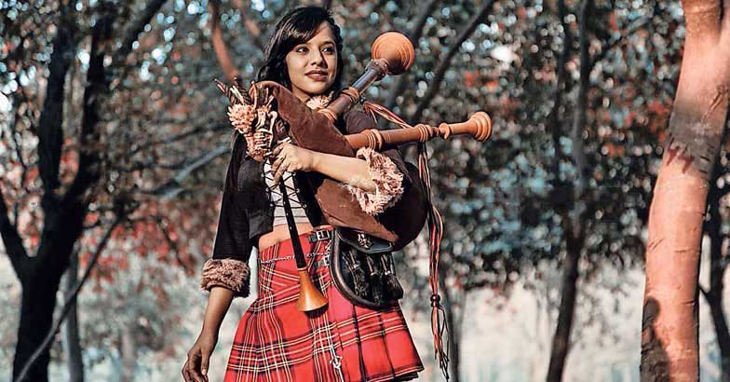

*Please send donations for the class to Paypal*:

[profmcintyre@yahoo.com](mailto:profmcintyre@yahoo.com)

the amount is up to you, but the suggested donation is $5

**Clàr na seachdain (schedule of the week)**

* Fàilte!
* Sean fhacal na seachdain – far …
* Òran na seachdain – far a bhios mi
* Gràmar na Seachdain
  + Còmhradh na Seachdain – far
* Cunntadh
* ***Sean fhacal na seachdain***

(bought to you by *far*)

**Far am bi a' mhuc, bidh fail.**

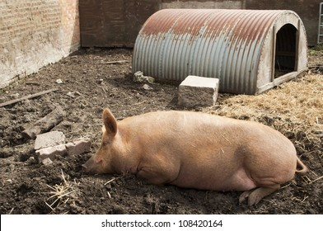

Where the sow is, that’s where a pig sty will be.

**Far am bi an t-iasg, 's ann a bhios na h-eòin.**



Where the fish is, the birds will be.

**Far am bi do chràdh bidh do làmh;**



**far am bi do ghràdh bidh do thathaich.**



Where your pain is your hand will be ;

where your love is that’s where you will hang out.

Alternative: Far am bi mo ghaol, bidh mo thathaich.

(tathaich means lit. ‘haunt’ or ‘haunting’ – but used in this sense to mean ‘hang out’ )

**Gràmar na Seachdain**

Review:

**Caite ’s Far** (where and where)

Review: As with the Gaelic words for “when,” Gaelic has two words for “*where*,” and it’s not that they are merely synonyms that can be used interchangeably, for they are used in quite different ways.

Simply put, ***càite (sometimes càit’)*** is used to ask a question:

**Càite a bheil thu a dol? Where are you going?**

**Càite a bheil na h-iuchairean agam? Where are my keys?**

We should be familiar with the other word for “when” from the song, “Nuair a bha mi òg”. This word for “when”on the other hand, is used as a *conjunctive* – that is, it *links* parts of a sentence when you want to build a more complicated structure than a simple sentence.

Two versions: Where I am, there will be my hopes.

Far am bi mi fhìn is ann a bhios mo dhòchas

Far am bi mi fhìn, bidh mo dhòchas ann

**far** rel pron where, wherein -- As with *càite / càit’* , ***far*** uses the dependent / question form of the verb:

* seo **far** an do dh’fhàg mi mo sporan -- this is where I left my purse
* sin **far** am bi sinn ag obair -- that’s where we work / will be working
* **far** an do shuidh an coitheanal a sheinn agus an do sheas iad a dhèanamh ùrnaigh -- where the congregation sat to sing and stood to pray (a custom in services in Presbyterian denominations). Note that, as in English, the word for ‘where’ need not be repeated

**Notes:** Remember – question sentences require some form of the ‘a’ or in the past tense, the ‘an’ or ‘an do’ construction, as in

Chunnaic mi e far an robh e ag obair – I saw him where he was working.

Lorg me na h-iuchairean agam far an do dh’fhàg mi iad. – I found my keys where I left them.

Further note:

Even though far is a conjunction, note that it can come at the beginning of a sentence, though it doesn’t form a question. So you could have

Fhuair mi ùbhlan far an robh na craobhan ùbhlan ann.

I got apples where the apple trees were.

Or

Far an robh na craobhan-ùbhlan ann, fhuair mi ùbhlan.

Where the apple trees were, I got apples.

* Note 2: Both *càite* (càit’ ) and *far* require the particle (or relative pronoun) ***a*** … and the dependent (question) form:

**Càit’ a** bheil thu a’ dol? Where are you going?

And of course, hearkening back to the poem by Robert Burns:

Càit’ a bheil do chridhe? – Where is your heart?

’S ann anns a’ Ghàidhealtachd **far a bheil** mo chridhe –

It is in the Highlands where my heart is.

* + - a *caìte* sentence is always punctuated by a question mark.*
    - A *far* clause is always a part of a larger sentence

Other examples of ’S ann form:

’S ann aig an doras a bha an duine.

’S ann air a’ bhòrd a bha na h-iuchairean agam.

**Eacarsaichean na seachdaine:**

**far**

**Eacarsaich 1**: Translate the following Gaelic sentences into English:

The first has been done for you to illustrate.

You will find constructions using *’S ann* … which introduces a preposition at the beginning of a sentence:

* + ’S ann anns a’ chidsin far an d’ rinn sinn dìnnear –
    - It was in the kitchen that / where we made dinner
  + ’S ann aig a’ phàirc far a chluich na balaich –
    - it was at the park were the boys played

|  |  |
| --- | --- |
| **Original Gaelic Statement** | **English translation** |
| 1. ’S ann anns an sgoil far an robh an clas 2. Chaidh sinn dhan taigh-bidh far an do cheannach sinn dìnnear. 3. Choisich sinn anns a’ phàirc far an robh an t-uisge ann. 4. Thuit iad nan cadal far an robh iad a’ coimhead air telebhisean. 5. Dh’ith an cù far an do dh’ith sinne. 6. Tha an oifis a’ phuist far an do thachair thu mi 7. Dhraibh iad a Canada far an d’ rugadh e 8. ’S ann air an drochaid far an robh an tubaist 9. ’S toil leam obair far a’ bheil e samhach 10. Cha robh fios aice far an robh i 11. Chunnaic mi an eaglais far an robh mi nam sheasamh 12. Lorg mi an sporan agam far an do ghabh sinn dìnnear 13. Pheant i dealbh far an robh e bòidheach 14. Dh’ith sinn an *cuirm-cnuic* againn far an robh an rathad *faisg air* an abhainn. 15. Cha do dh’innis mi dhi far an robh thu 16. Cha robh fios aca far am biodh iad a’ dol 17. ’S ann anns an taigh-dhealbh far an robh iad a’ coimhead air an fhilm. 18. Lorg mi e far an do chluich e 19. Sin far an do thogadh mi 20. Dh’innis mi do ’m (dom) poileas far an do dh’fhuirich iad | It was in the school where the class was |

Biodh = would … biodh a’ dol = would go

Biadh = good

Dhi = to her; dhomh = to me; dha = to him; dhut = to you

Chan eil fios agam > chan eil fhios ‘m

Ann an (a) sheasamh = na sheasamh = his standing; nam sheasamh = my standing

**Eacarsaich 2:** Translate the following English sentences into Gaelic, creating a far sentence:

The first one has been done for you to illustrate:

Remember, looking up in the dictionary is ‘fair’ (in fact, you might have to for some of the vocabulary)

|  |  |
| --- | --- |
| **English** | **Gàidhlig** |
| 1. I saw him where he was working 2. We went where we wanted to 3. It’s in the Highlands where my heart is 4. Here is a place where you will sleep 5. I am living where my friends live 6. He and his family went to where the grass is green 7. They know where you are all the time 8. I know where the river is 9. Where she goes, her brother goes too 10. They were walking in a glen where there were many sheep 11. They went to the hotel where the man was sitting with his friends 12. You see where this is going 13. We bought this in a little store where the road ended 14. Where I come from, we don’t steal 15. The forest is beautiful where 16. I like the beach where the view is beautiful 17. We went to the place where we saw many people 18. A kitchen was in the town hall where they did the cooking. 19. I have a little cottage in the forest where I am happy 20. We heard the music where they were singing | 1. Chunnaic mi e far an robh e ag obair. |

A bràthair = her brother

A bhràthair = his brother

A màthair = her mother

A mhàthair = his mother

Mamaidh, granaidh, dadaidh,

**Answer key**

|  |  |
| --- | --- |
| **English** | **Gàidhlig** |
| 1. I saw him where he was working 2. We went where we wanted to 3. It’s in the Highlands where my heart is 4. Here is a place where you play 5. I am living where my friends live 6. He and his family went to where the grass is green 7. They know where you are all the time 8. I know where the river is 9. Where she went, her brother went too 10. They were walking through a glen where there were many sheep 11. They went to the hotel where the man was speaking with his friends 12. You see where this is going 13. We bought this in a little store where the road ended 14. Where I live, we dance all night 15. The forest is beautiful where we ate 16. I like the beach where the view is beautiful 17. We went to the place where we saw many people 18. A kitchen was in the town hall where they cooked. 19. I have a little cottage in the forest where I am happy 20. We heard the music where they were singing | 1. Chunnaic mi e far a bha e ag obair 2. Chaidh sinn far a dh’iarr sinn / bha sinn ag iarraidh 3. ‘S ann anns a’ Ghàidhealtachd far a bheil mo chridhe 4. Seo àite far a tha thu a’ cluich. 5. Tha mi a’ fuireach far a’ bheil na càirdean agam a’ fuireach 6. Chaidh e agus a theaghlach far a bha am feur gorm (bha e a’ dol etc) 7. Tha fios aca far a bheil thu fad na ùine 8. Tha fios agam far a bheil an abhainn 9. Far an deach i, chaidh a bràthair cuideachd 10. Bha iad a’ coiseachd anns a’ ghleann far an robh iomadh caora 11. Chaidh iad dhan taigh-òsta far an robh an duine a’ bruidhinn ris na caraidean aige 12. Chi thu far a bheil seo a’ dol. 13. Cheannaich sinn seo ann an bùth bheag far a chrìochnaich an rathad 14. Far a bheil mi a’ fuireach, bidh sinn a’ dannsadh fad na h-oidhche 15. Tha a’ choille bòidheach far an do dh’ith sinn 16. ’S toil leam an tràigh far a bheil an sealladh bòidheach 17. Chaidh sinn dhan meadhan a’ bhaille far an do chunnaic sinn iomadh duine 18. Bha cidsin ann an talla a’ bhaile far an do chòcaireachd iad 19. Tha bothan beag agam anns a’ choille far a bheil mi toilichte 20. Chuala sinn an ceòl far an robh iad a’ seinn |

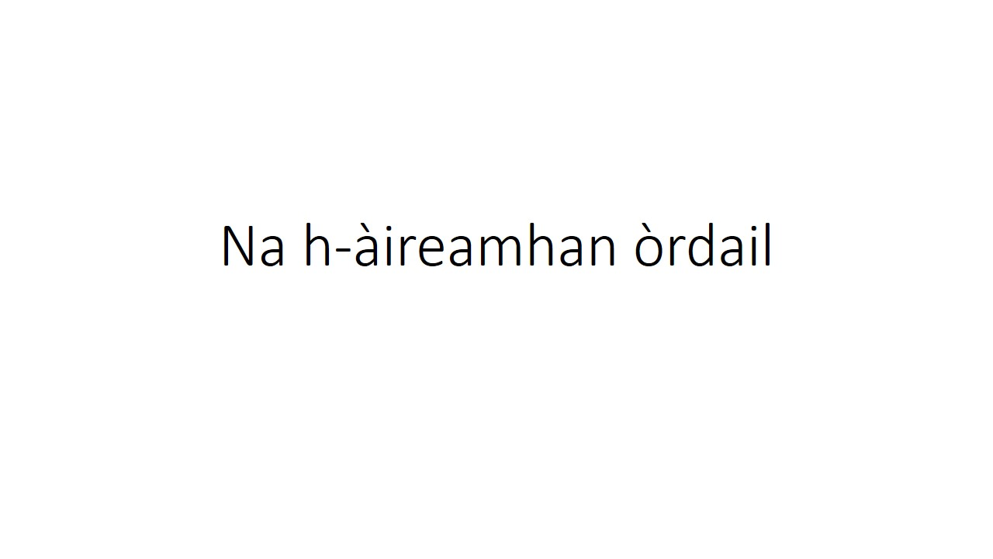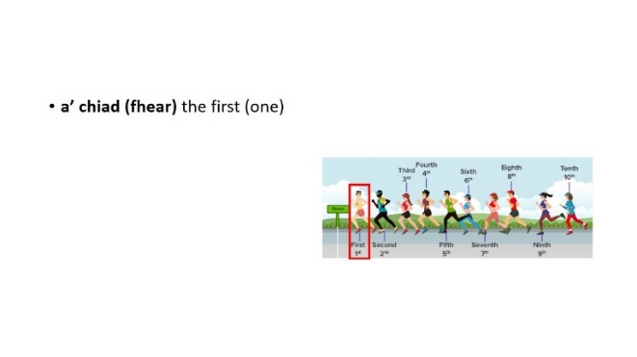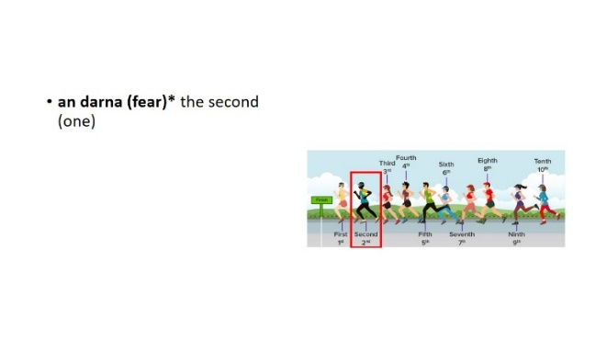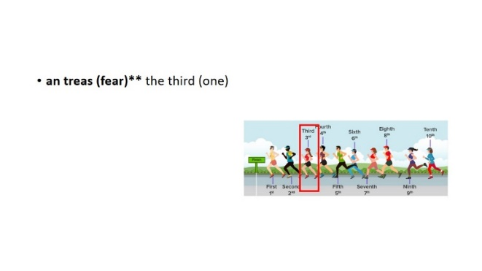 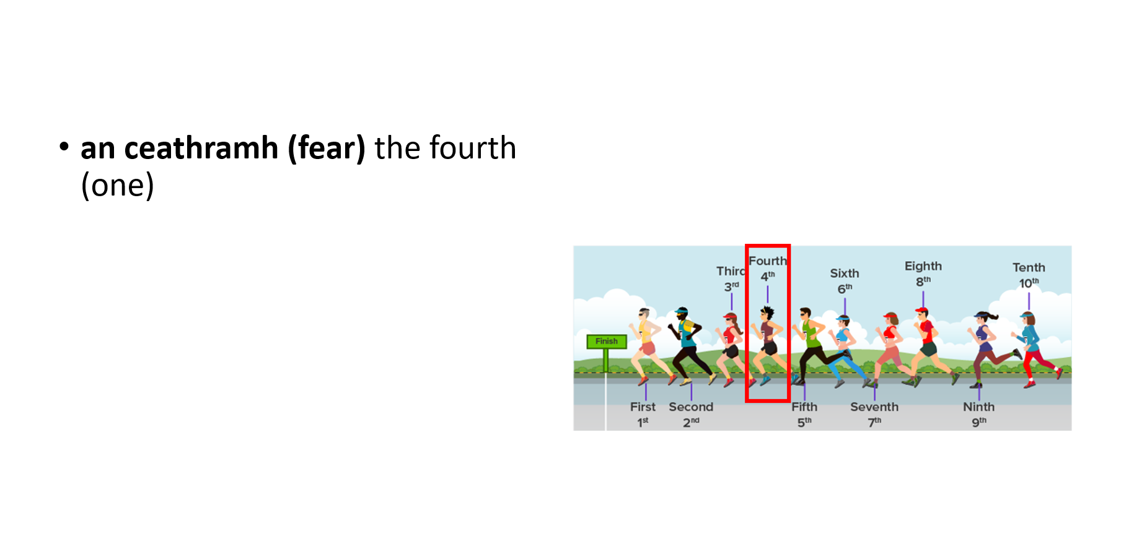 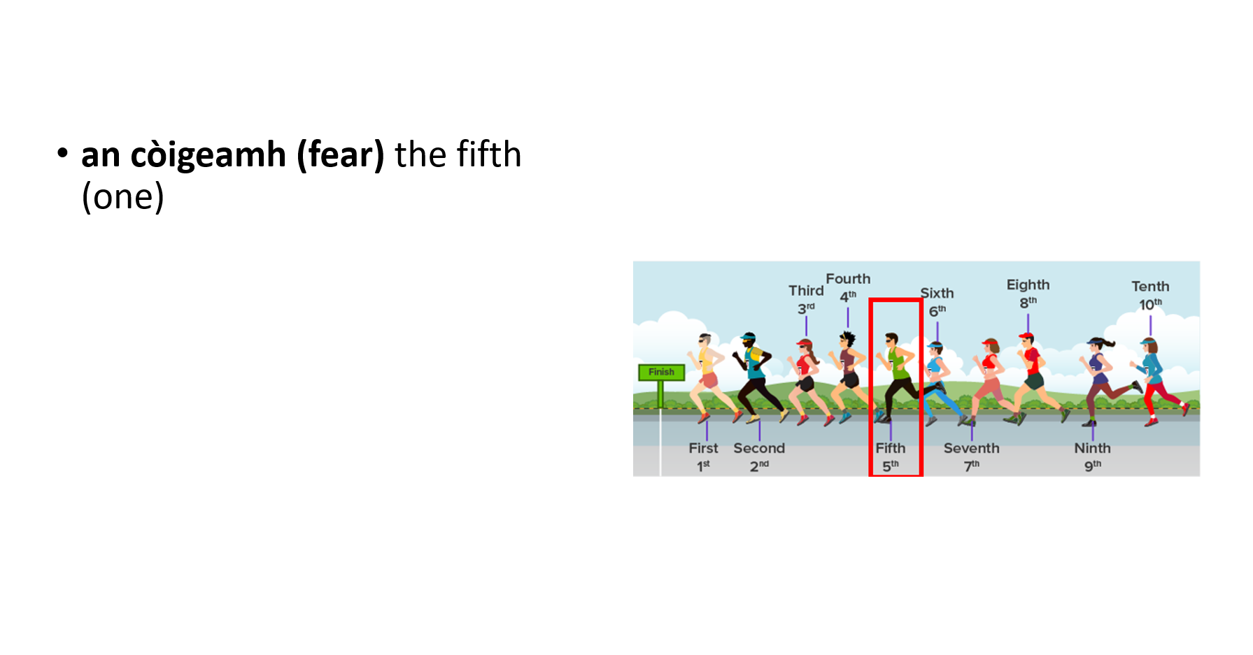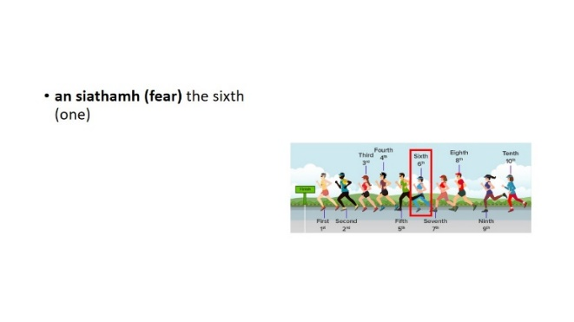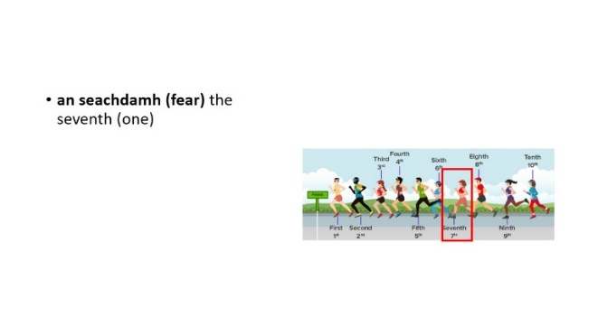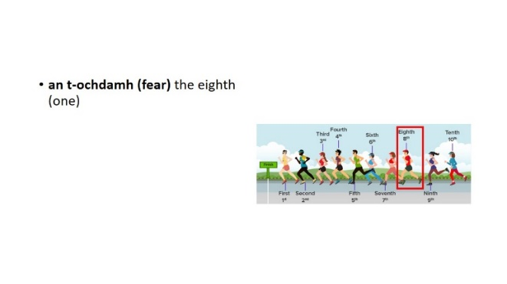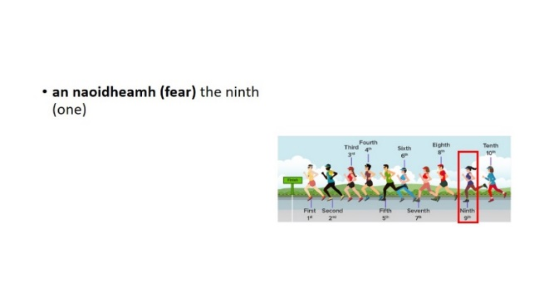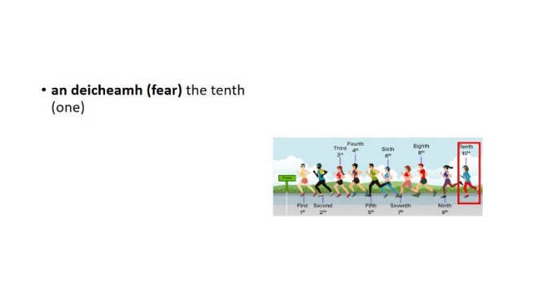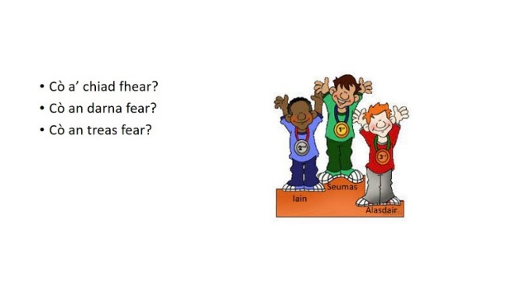

**Duanag nan aireamhan òrdail**

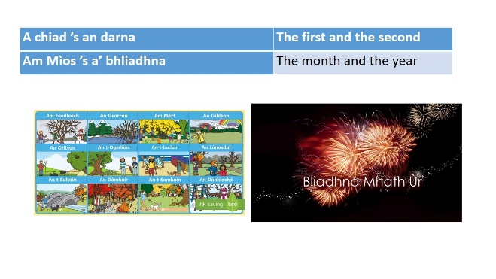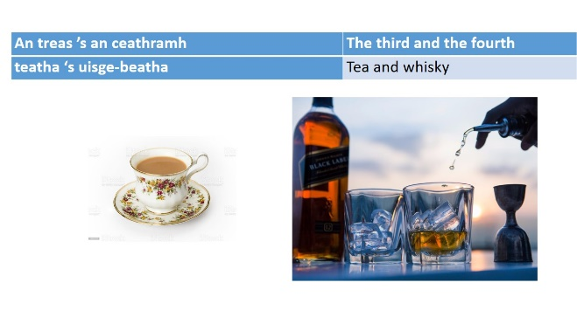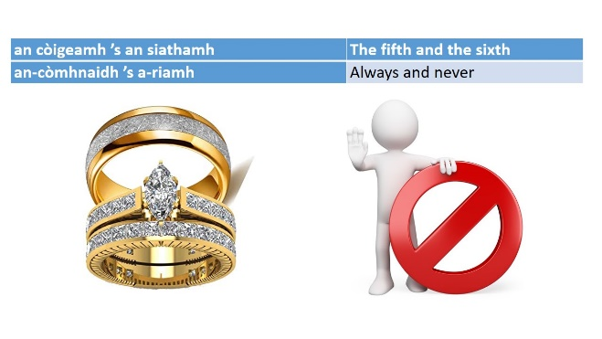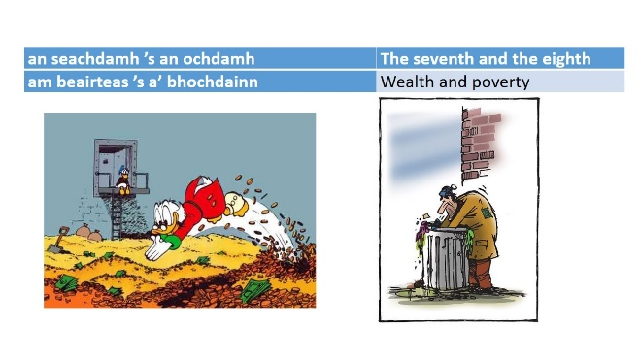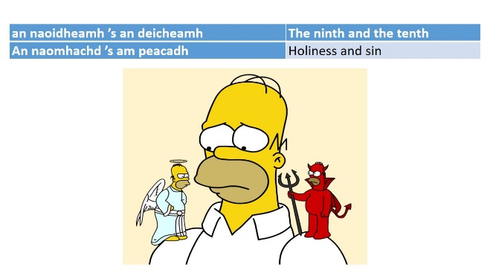

**Eacarsaich**: a’ feitheamh air a’ bhus

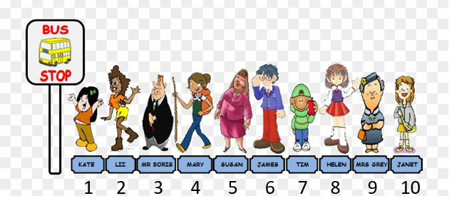

|  |  |
| --- | --- |
| 1. Dè àite a tha Liz ann? |  |
| 1. Dè àite a tha Mary ann? |  |
| 1. Dè àite a tha James ann? |  |
| 1. Dè àite a tha Janet ann? |  |
| 1. Dè àite a tha Kate ann? |  |
| 1. Dè àite a tha Mr. Boris ann? |  |
| 1. Dè àite a tha Susan ann? |  |
| 1. Dè àite a tha Tim ann? |  |
| 1. Dè àite a tha Mrs Grey ann? |  |
| 1. Dè àite a tha Helen ann? |  |

**Ecarsaich: na h-aireamhan òrdail**

Sgrìob an àite aca fo ghach bèist (a’ chiad, an darna … mar sin air adhart)

|  |  |  |  |  |  |
| --- | --- | --- | --- | --- | --- |
| Bèist  Ainm |  | | | | |
| Àite |  |  |  |  |  |

|  |  |  |  |  |  |
| --- | --- | --- | --- | --- | --- |
| Bèist | 46,543 Monkey Illustrations &amp; Clip Art - iStock | Pig - YouCubed | simple cartoon horse - Clipart World | Easy How to Draw a Dog Tutorial and Dog Drawing Coloring Page | Cartoon Deer Isolated on White Background Stock Vector - Illustration of  hooves, forest: 136771768 |
| Ainm | Am muncaidh | am muc | An t-each | An cù | Am fiadh |
| Àite |  |  |  |  |  |

**Lìon na seantansan**

1. Tha _______________  anns ________________ àite
2. Tha _______________  anns ________________ àite
3. Tha _______________  anns ________________ àite
4. Tha _______________ 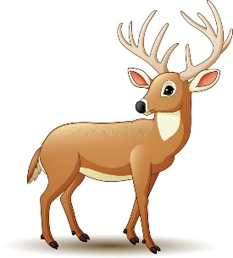 anns ________________ àite
5. Tha _______________  anns ________________ àite
6. Tha _______________ 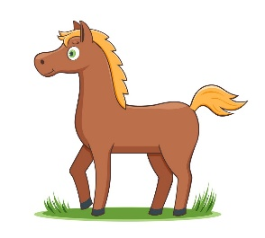 anns ________________ àite
7. Tha _______________  anns ________________ àite
8. Tha _______________ 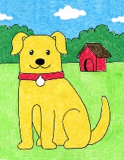 anns ________________ àite
9. Tha _______________  anns ________________ àite
10. Tha _______________  anns ________________ àite

**Òran na seachdain**

**The song this week brought to you by the word “*far*”**

***Far am bi mi fhìn***

<https://learngaelic.scot/littlebylittle/songs/farambi/index.jsp>

|  |  |
| --- | --- |
| Far am bi mi fhìn ’s ann a bhios mo dhòchas  Far am bi mi fhìn ‘s ann a bhios mo dhòchas  Far am bi mi fhìn ‘s ann a bhios mo dhòchas  Far am bi mi fhìn bidh mo dhòchas ann  Siubhal air na cladaichean 's a' coiseachd air a' ghainmhich  Siubhal air na cladaichean 's a' coiseachd air a' ghainmhich  Siubhal air na cladaichean 's a' coiseachd air a' ghainmhich  Far am bi mi fhìn bidh mo dhòchas ann  Far am bi mi fhìn ‘s ann a bhios mo dhòchas  Far am bi mi fhìn ‘s ann a bhios mo dhòchas  Far am bi mi fhìn ‘s ann a bhios mo dhòchas  Far am bi mi fhìn bidh mo dhòchas ann | Where I will be, there is my hope  Where I will be, there is my hope  Where I will be, there is my hope  Where I will be, my hope will be there  Travelling on the beaches and walking on the sand  Travelling on the beaches and walking on the sand  Travelling on the beaches and walking on the sand  Where I will be, my hope will be there  Where I will be, there is my hope  Where I will be, there is my hope  Where I will be, there is my hope  Where I will be, my hope will be there  Dòchas also = sweetheart |