

PARENT HANDBOOK

Address: 43 Gale St Concord NSW 2137
Phone: (02) 9743 3094
concord@adamslanechildcare.com.au

WELCOME-Our Family Handbook contains essential details for a successful start at Adams Lane ELC. Please read the information carefully, ask any questions for clarity, and sign and return the form at the end of the handbook to confirm you’re understanding.

Service Information
Our Service caters for children aged 6 weeks to 5 years. We are open from 7.30am to 6.00pm Monday to Friday, 50 weeks of the year]and closed on public holidays. Notice will be given on our app when these days occur.
We have 2 classrooms:
0-3-year-old room – Koala Room
3-5-year-old room – Joey/Kanga Room

Management Structure
Approved Provider: Henry Xiao
Nominated Supervisor: Philomena Chahine
Assistant Director: Filomena Thomas
Educational Leader: Suzy Boumelhem & Philomena Chahine

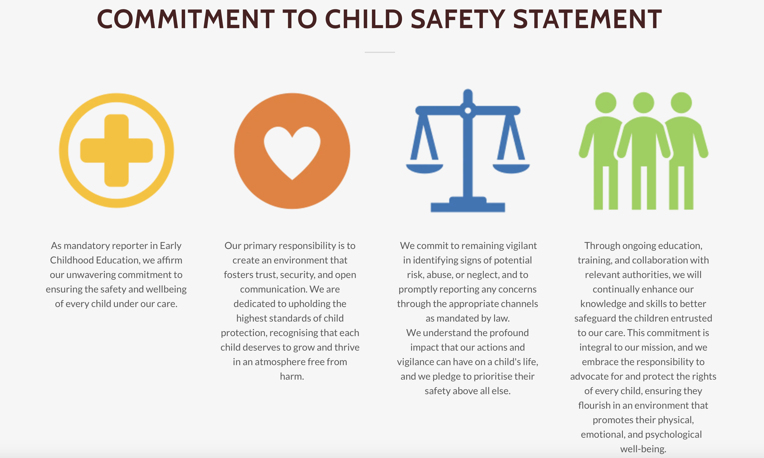

Code of Conduct
The Code of Conduct establishes the standards for all employees of our Service. Employees are committed to adhere to the ethical responsibilities of early childhood professionals outlined in the Early Childhood Australia’s Code of Ethics. The values that underpin our work ethic include equality, respect, integrity and responsibility.

National Quality Framework
National Quality Framework (NQF) ensures compliance with Australian regulations, standards, and assessments for quality early childhood education. Our curriculum aligns with the Australian Early Years Learning Framework (EYLF) and undergoes continuous improvement guided by our Quality Improvement Plan (QIP) based on the National Quality Standard. Your feedback is valued. Learn more at ACECQA/nqf/about.

Regulatory Authority
Our Service is regulated by the national body for early education and care – the Australian Children’s Education and Care Quality Authority (ACECQA) as well as the state licensing department in our State. To contact our Regulatory Authority, please refer to the contact details below:

NEW SOUTH WALES
Early Childhood Education Directorate
NSW Department of Education phone: 1800 619 113
Locked Bag 5107 PARRAMATTA NSW 2124
www.education.nsw.gov.au/ email: ececd@det.nsw.edu.au
Early Learning Goals
Educators document children's learning to create individual portfolios, incorporating profiles, goals, observations, work samples, and development objectives in various formats.

Documentation of Learning/ Portfolios
Educators create portfolios for children by documenting their learning with profiles, goals, observations, work samples, and development objectives in different formats.
The individual child’s portfolio is maintained and used as a direct tool for evaluation and future planning within the Service’s program. This makes the program reflect the value of individuality and is not be used as a means of comparison between peers or stereotypes. The portfolio will be used in parent/educator meetings throughout the year and is always available for you to review at your convenience.

Communication
We collaborate with families to communicate effectively regarding each child's needs and daily experiences. Communication preferences are respected, and meetings with educators can be scheduled at a convenient time. KinderM8 is used to provide instant updates on your child.

Family law and access
We adhere to Family Law obligations and require court orders for enrollment. Written permission from the custodial parent is needed for a child to leave.

Inclusion of all children
Please discuss your child's disability with our Supervisor before enrolling. We offer inclusive education and support for equitable access. If your child has an NDIS package, we may contact services for their learning plan. Additional support may be sought through the Inclusion Support Program.

Authorised Nominees
Please list authorised nominees on your child's enrolment form for pick up, medical consent, ambulance services, and excursions.
Authorisations
Enrolment form covers medical treatment, emergency transportation, sun cream, emergency medication, paracetamol, excursion permission, and transportation arrangements. Provide contact details for authorized person.

Photographs, social media, promotion
We will ask for your permission to take photos and videos of your child for sharing on social media, marketing and program purposes.

Medical conditions- Allergies, Asthma, Diabetes or Epilepsy
It is important to inform us of your child's medical conditions, allergies, and asthma on the enrolment form. Please provide a Medical Management Plan from your GP and prescribed medication for daily attendance. A Risk Minimisation and Communication Plan will be developed with you and the Nominated Supervisor.
To ensure the safety and wellbeing of your child, please update your child’s Medical Management Plan/ Action Plan every 12-18 months or whenever a change in their medication or treatment occurs. (Australasian Society of Clinical Immunology and Allergy) (ASCIA).

Fees, rebates and attendance
Our daily fee is: $178 per day before Child Care Subsidy (CCS) has been applied. Fees must always be paid 1 week in advance. .
.Parents/guardians are required to provide four weeks’ written notice before cancelling their child’s enrolment .Fees remain payable during the four-week notice period. The Child Care Subsidy (CCS) is applied to eligible families in accordance with Services Australia requirements.

Statement of fees in arrears/ Financial Support
Weekly statements will be emailed before your debit. Please verify details and contact the Nominated Supervisor immediately if there are discrepancies. A $178 late fee applies after two weeks of unpaid fees. If fees remain unpaid after three weeks, debt recovery begins with additional fees, and Adams Lane may suspend or withdraw your child’s enrolment. If facing financial hardship, contact the Nominated Supervisor or Director to discuss payment plans or Additional Child Care Subsidy (ACCS) before fees are overdue.

Payment methods
Parents/guardians are required to complete a Direct Debit form upon enrolment. Fees will be deducted weekly. Fees must be paid via Electronic Funds Transfer (EFT).
Please note that additional charges will apply for any failed transactions as a result of insufficient funds.

Complying Written Agreement (CWA)
A Complying Written Agreement (CWA) outlines childcare arrangements, including child's details, session information, fees, and must be approved on MyGov for Child Care Subsidy.

Absences
Please inform the Service promptly of your child's absence. Child Care Subsidy covers up to 42 days of absences per financial year. Fees are due for absences beyond this, but exceptions may be granted with Nominated Supervisor approval.

Withdrawal from care/Reducing Enrolment Days
To change enrollment days, give 4 weeks' notice with written form provided by Nominated Supervisor. CCS won't apply after the last attended day unless an exception is approved.

Service Closing Time and Late Collection Fees
Our program ends at 6:00 pm; children must be picked up by then. Late fee of $15 per child for every 15 mins past 6:00 pm. If no contact, authorities may be involved for child's safety.

Service Policies and Procedures
Please follow Service policies on KinderM8 for compliance with National Law. Exceptions need approval from Management. We value your input to improve our procedures.

Orientation-Preparing for your child’s first day
Orientation is an important start for your child and family to connect to our Service. We encourage each child to attend our Service in the company of a family member before they start their first day with us. We take a holistic approach and flexibility. A plan for your orientation is personalized according to you and your child’s needs.

Arrival and Departure
Please sign in/out your child every day. Only authorized individuals can pick up your child with written consent. Staff may request ID for verification.
What you need to bring
Backpack
For independence, we work towards all children being able to recognise and open their own bag. You can help by allowing them to be involved in selecting their bag and taking ownership of it. Please ensure it is large enough to hold all their belongings and is clearly labelled.

Spare Clothing
Every now and then, accidents occur, and it may be necessary for your child to get changed into a fresh set of clothes. Please include a complete change of clothes every day which can stay in your child’s bag...just in case!
Drink Bottle
A labelled drink bottle is required every day for water. Children can refill their drink bottle, when necessary, throughout the day. We always provide water and cups, but a drink bottle is a great start to school readiness.

Sun Hat
A protective sun hat (either broad brimmed or legionnaire hat) must be worn every day when playing outside for protection against the sun. Please make sure to include it in your child’s bag every day regardless of the weather conditions.

Clothing
Children should wear practical, easy-to-move-in clothes and appropriate shoes like joggers or sandals. Avoid items like thongs and long dresses. Choose hats with broad brims for sun safety. Dressing this way helps children learn and develop physically, mentally, and socially.

Rest and Sleep
We provide one portable cot per child from birth to 2 years of age and one floor mattress per child over 2 years of age.

Enroll children over 9 months of age. On Red Nose Recommendations, the safest place for baby to sleep is in their own safe space in the same room as their parents or adult caregivers for the first 6 months. 6 months is the recommend age to introduce solid food, get the health check and third scheduled vaccination. The enrolment’s age was extended for 3 more months from 6 months as children must strengthen their jaw to help with chewing food and talking, and are up to date with their vaccinations under the Public Health Act 2010. All babies develop at different rates. The enrolment’s age of over 9 months takes this into account.

For children over 9 months to 1 year of age:
- We create 1 to 2 daytime nap routines. Each nap is 2 to 4 hours.
- Children can be left to find their own preferred sleep or rest position once they have been observed to repeatedly roll from back to front and back again on their own.
- We help children sleep by playing soft music and recognising cues of sleep readiness (rubbing eyes, yawning, looking away, fussing etc).
- We teach children to fall asleep on their own by putting them to bed when they are drowsy.
- We comfort and reassure children when they wake up by patting and soothing. Repeat as needed.

For children over 1 year to 2 years of age:
- We create 1 daytime nap routine. Each nap is 1 to 2 hours.
- We help children sleep by playing soft music and recognising cues of sleep readiness (rubbing eyes, yawning, looking away, fussing etc).
- We teach children to fall asleep on their own by putting them to bed when they are drowsy.
- We comfort and reassure children when they wake up by patting and soothing. Repeat as needed.

For children over 2 years to 3 years of age:
- We create a consistent 1 daytime nap routine. Each nap is 1.5 to 2.5 hours.
- We move children out of a portable cot into a floor mattress.
- We do not put children to bed with bottles.

For children over 3 years to 5 years of age:
- We create 1 daytime nap or rest routine. Each nap or rest is 1 to 2 hours.
- We schedule an official rest time after lunch to encourage relaxation.
- We offer special calm activities (such as books, puzzles, drawing) reserved only for rest time.

To meet the individual health care needs of children:
- We dress children in lighter clothing, and use sleep sacks or wearable blankets if needed.
- We isolate children with colds and request parental pickup.
- We conduct more frequent physical bedside checks, at least every 5 minutes, on children with chronic lung disorders or other specific health care needs made through the Safe Sleep Record. Initiate first aid immediately if emergency symptoms present.
- We modify Red Nose Recommendations to the written advice from the child’s medical practitioner.

To meet the family requests and cultural preferences for sleep and rest of children:
- We phase out dummy use. According to current recommendations, dummies should be discontinued between 6 months and 12 months to reduce the risk of ear infections (otitis media) and dental issues (dental malocclusion).
- We align cultural preferences with Red Nose Recommendations.

Supervision and monitoring during sleep and rest periods:
- For children from birth to 2 years of age, the ratio of children to educators is 4 to 1.
- For children from over 2 to less than 3 years of age, the ratio of children to educators is 5 to 1.
- For children from 3 to 5 years of age, the ratio of children to educators is 10 to 1.
- We position educators within sight and hearing distance of sleeping and resting children.
- Educators will not be engaged in other duties (e.g., administrative duties) that will take their attention away from actively supervising sleeping and resting children.

We follow Red Nose Recommendations to reduce the risk of sudden infant death:
- Always place baby on their back to sleep.
- Keep baby’s face and head uncovered.
- Keep baby smoke free before and after birth.
- Safe sleeping environment night and day.
- Sleep baby in their own safe sleep space in the parent or caregiver’s room for the first 6 months.
- Breastfeed baby.

We follow Red Nose Recommendations for a safe sleeping environment:
- Mattresses are firm, flat, the right size and meet the Australian standard AS/NZS 8811.1:2013.
- Beddings are lightweight, firmly tucked in and only pulled up to the chest.
- Sleeping bags are well fitted across the neck and chest, with baby’s arms out, and with no hood.
- Continuous supervision where the educators are always in the sight and hearing of the sleeping infant or child. If continuous supervision is not possible, conduct regular physical bedside checks at least every 5 minutes on children from birth to 3 years of age and at least every 10 minutes on children from 3 to 5 years of age.

We follow Red Nose Recommendations to phase out:
- Any soft items in the sleep space due to the risk of suffocation and overheating. Soft items include:
- Doonas or loose blankets
- Pillows
- Cot bumpers
- Lambs wool
- Soft toys like a teddy
- Inclined sleep products or infant sleep products that swing or rock to reduce the risk of sudden infant death.
- Amber teething bracelets or necklaces to reduce the risk of choking.

Temperature of sleep and rest environments:
- Air condition and maintain the room temperature to ensure maximum comfort for the children. In winter, the ideal room temperature is 20˚C to 21˚C, while in summer, that temperature is 22˚C to 23˚C.
- We do not use wall mounted heaters.

Lighting of sleep and rest environments:
- We ensure that there is ample lighting in sleep areas to allow for supervision and physical bedside checks.

Ventilation of sleep and rest environments:
- We ensure a continuous flow of fresh air to sleep and rest areas.

Auditory stimulation of sleep and rest environments:
- We play soft and calming music during sleep times to create a peaceful ambiance.
- Educators may read stories to children before nap or sleep times to promote a soothing atmosphere for sleeping.
- These practices encourage a positive association with sleep.

Communication of the sleep and rest policies and procedures to you:
- We provide the sleep and rest policies and procedures to you as part of the Parent Handbook and notify you of any changes to policies.
- We provide you with regular updates on your child’s sleeping routines and patterns.
- We share information, at least every 6 months, with you about Safe Sleep practices that are sourced from Red Nose and educate them on the importance of adhering to these guidelines.

Health and Hygiene
Our Service has effective and systematic risk management systems in place to identify any possible risk of hazards to our learning environment and practices.
All staff diligently practice and model personal hygiene measures such as hand washing, cough and sneeze etiquette and disposal of tissues. We request that all children and visitors to our service wash their hands or use the alcohol-based hand sanitiser upon arrival.
Our educators teach and model correct hand washing techniques to children and regularly clean and disinfect high touch objects throughout the service to reduce the spread of infection.

When should I not send my child to the Service?
Please monitor your child’s health and do not bring your child to the Service if they are suffering from any illness or infectious disease.

We follow health guidelines to prevent the spread of illnesses. Children who become sick must be picked up promptly. Children should not attend if they have a fever, are on antibiotics, or have vomiting/diarrhea. A medical clearance may be required for certain illnesses before returning. Make-up days are only available if the absence is communicated on the day.

Infectious Diseases
The National Health and Medical Research Council have supplied the following information regarding minimum exclusion period for children from an early childhood education and care service. Please inform staff if your child has any of the following so that we can notify the Public Health Unit and other families of any infectious disease/illness. (Confidentiality is always maintained).

CONDITION | EXCLUSION
Hand, foot and mouth disease | Until all blisters have dried
HIB | Exclude until medical certificate of recovery is received
Hepatitis A | Exclude until a medical certificate of recovery is received, but not before 7 days after the onset of jaundice or illness
Herpes- Cold sores | Young children unable to comply with good hygiene practices should be excluded while the lesion is weeping. Lesions to be covered by dressing, where possible
Influenzas and flu-like illnesses | Exclude until well
Measles | Exclude for at least 4 days after onset of rash
Meningitis (Bacterial) | Exclude until well
Meningococcal Infection | Exclude until adequate carrier eradication therapy has been completed
Mumps | Exclude for 9 days or until swelling goes down (whichever is sooner)
Pertussis (Whooping Cough) | Exclude the child for 5 days after starting antibiotic treatment
Rubella (German measles) | Exclude until fully recovered or for at least 4 days after the onset of rash
Salmonella | Exclude until diarrhea ceases
Streptococcal Infection  (Including scarlet fever) | Exclude until the child has received antibiotic treatment for at least 24 hours and the child feels well
Tuberculosis | Exclude until a medical certificate from an appropriate health authority is received
Worms (intestinal) | Exclude if diarrhea present
If your child is unimmunised according to our records, then they will be excluded until the threat has passed and upon advice of the Public Health Unit

Immunisation
Families must provide proof of up-to-date vaccinations before enrolling their child. Notify us immediately if your family member has a contagious disease. We are mandated to report cases to the Health Unit. Check your enrolment pack for the immunisation schedule.

Medication
Complete the medication form to authorize educators to administer prescribed medication, which should be in original packaging and labelled with your child's name. Ensure all medication is in date and meets requirements. Essential medication like inhalers or EpiPens must be brought daily or kept stocked. Sign the form upon picking up your child.

Incidents, injury or trauma
Accidents may happen during play. We have trained staff and first aid kits onsite. Minor injuries will be treated, and you will be notified. For serious incidents requiring urgent medical attention, we will call an ambulance and parents will be contacted. Parents must acknowledge and sign incident reports. Our Service must also report serious incidents to the Regulatory Authority.

Emergency and evacuation procedures
As per Regulations 101 and 102 of the Education and Care Services National Regulations, we conduct regular emergency evacuation drills for various hazards, with procedures displayed in all rooms. Educators are trained in fire safety. In emergencies or drills, children will walk under supervision to our off-site evacuation point at St Patrick’s Primary School and The Parish Church Hall (approx. 240m), with 6-7 staff supervising ~25 children. A risk assessment, per Regulation 101, is available for review.

Drop off and pick up time
Parents, please be cautious in our busy carpark and hold your child's hand. Watch out for reversing cars and use the rear passenger door to get your child in and out of the car seat. Never leave children unattended in the car or leave the entry gate open. Always check around your vehicle before driving and prevent children from accessing staff-only areas.

Privacy and Confidentiality
We prioritize privacy, collecting info to plan programs, ensuring confidentiality. Your consent is essential for sharing personal data with others, except as required by law. We never request personal info from others without your consent. Access to your child's file is available upon request. Our privacy policy adheres to laws, promptly addressing complaints and securely maintaining records. See the Record Keeping Policy for details.

Our Philosophy

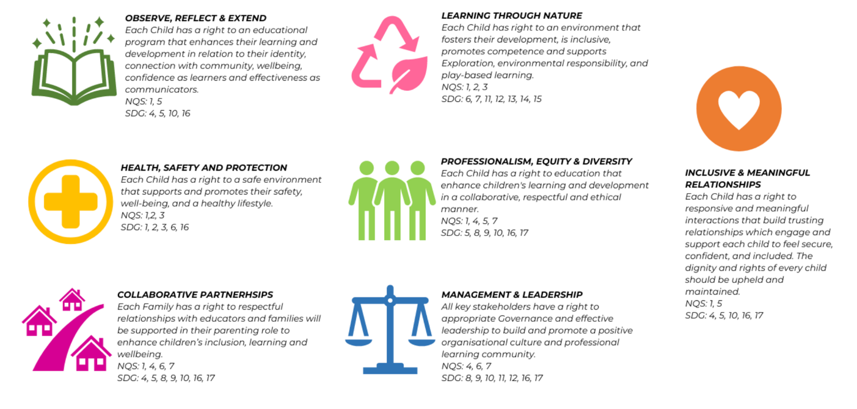

Parent Acknowledgement
I/we acknowledge the handbook, understand responsibilities, completed enrolment and provided necessary documents. Complying with policies, we pledge to notify any changes affecting child's care promptly.

Family Name |  | Date
First Name
Child/ren’s Name
Parent/Guardian Signature

