Partner Company Program
Expand Your Business
Increase your company’s value and recognition.

Creative Endeavors Consulting creates, protects, and expands the value of intellectual property (brands/trademarks) for our Partner Companies and their clients, as well as develops new intellectual properties on a client- or joint ventured-project basis. Our diversified skills, talents and resources support your organization’s business objectives to enter new markets and expand upon current markets.

Creative Endeavors Consulting contracts with Partner Companies to expand the value of each other’s interests. Partner Companies work within a brand, to provide value for licensed projects. Projects are initiated by either our Partner Company or Creative Endeavors Consulting. We participate with the Partner Company, utilizing our business experience and our marketing strategies to create a specific value for the partnership. These strategies include co-branding for advertising, product placement, product and technology development, providing the research and development through our team on a vested participation basis for a cost-effective advancement into a new market niche.

- We increase our Partner Company’s value through opportunity, diversity of income, and competitive cost advantages.
- Greater capabilities to market on an individualized basis for value added and cost-effective campaigns.
- Our creative campaigns align our resources on an ongoing basis, offering additional incentive for research and development to participate in new brands, products or services on a vested basis.
- Products and services can be reintroduced to the market within new projects and marketed within a cooperative advertising campaign.
- We can co-venture through co-marketing agreements or joint ventures to create or expand brand services or products.
- Cost-effective brand extension strategies attract subsequent licenses.

Become Part of Joint Venture Program

To Increase Licensing Value

Today, licensing has become a $132+ billion worldwide industry and is one of the most powerful forms of marketing and brand extension, being used in ever increasingly sophisticated ways. Creative Endeavors Consulting Partners’ joint endeavored partnerships bring together skills, talents and resources, which are then utilized by our structured licensing program for joint ventured brand extensions. The purpose of licensing joint ventures is to create stronger expansion opportunities for intellectual properties by creating tangible extensions (products) that create demand for the use of the brand (licensing value).
- Our strength is in knowing the cyclical nature of markets, to assist in the success of the joint ventures that we develop.
- Provides a higher degree of product development success due to built-in business from the partners’ current sales or through other joint venture participation.

We create recognition opportunities for licenses by co-brand marketing with other companies and licenses that inter-relate, through cost-effective regional, national or international campaigns that communicate the value of product or service brands to provide an increased awareness within specialized markets. We co-create and co-design collections that have not yet entered the market place, determined through the success of limited edition collections. We co-market with manufacturers, and co-promote using licensed images, non-profit and/or celebrity endorsements, with product placement to launch newly designed product lines to increase current product sales.

Joint ventures include licensing partners, trademark holders, designers (with or without name recognition), manufacturers or contractors, artistic talent, and business and multimedia partners (either individuals or companies). Management of each individual joint venture is determined by the intellectual property owners.

The direction of the joint ventures will be the targeted markets accessible through the strength of our teams. Product direction is determined by matching current markets with new products, or new markets with existing products, developed by the joint venture.

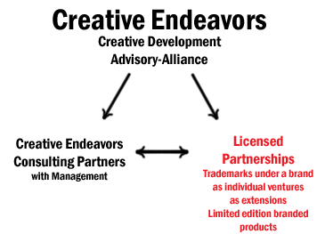
Licensed Partnerships
Co-Create Co-Design Co-Produce Co-Market
TRADEMARK

BRANDED PROJECTS
as brands for trademarking

Licensed Partnership
-Co-brand
-Campaign
-Merchandising
Licensed Partnership
-Co-create for licensing purposes
Licensed Partnership
-Licensed for branding products
Licensed Partnership
-Brand
-License
-Service

Owners with Capital Investors | 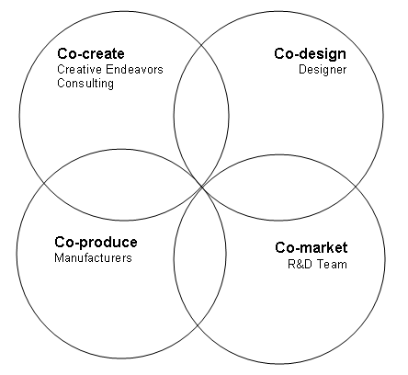 | Vested Participations
Brand royalties  Brand and Brand  New Brands  Trademarks  Copyrights  Domains  Tagline Licensing  Merchandising  Campaign |  | Individualized Strategies  Marketing Programs  Licensees with Licensors  Designers with Manufacturers  Merchandisers with Media  Technology and Sales  Media with Promotion  Public Relations  Product Placement

Licensed Partnership: AdviceAboutAnything
Brand: “.coms” Future option
Brand: Release
The
Spirit
Brand: Inspire Desire
Brand: Creative Endeavors

Licensed Partnership: CECP – will be offered position can earn
Licensed Partnership: Group License – owner of licensed product “jewelry” collection
Licensed Partnership: MyHealth
andWellness.tv – Percentage of product sales

BRAND
Projects under a brand

Licensed Partnership: Use of our IP’s to promote a partner’s product
Licensed Partnership: Tagline created for a marketing campaign
Licensed Partnership: Newly created division for a client trademark

Licensed Partnership: Other licenses we market

Our projects develop brands for licensing, including our domains and copyrights. Project details:

- Bring in production
- Percentage of others’ services/products for overseeing production (area of expertise)
- Percentage of extensions, option for returns other than production costs, for branded designs and trademarks
- Percentage of product sales, domain under the brand
- Vested – for specific services and/or product sales
- Percentage of all product sales

Owner Opportunities | Expand Your Brand Program | Approach | Income Strategy: New Collections using Brand
Owners  Capital & Vested Participations:  Advisors, partnerships, consultants | Shared R&D costs with our team  *If Affiliate wants to produce health & wellness collection* | Owners-Sponsors through Association Alliances  *Setup domain sales, produce goods and services for sales* | Management and vested participation for initial R&D
Licensed partners: Branded projects  “owners, client-partners, vested participations, project consultants: | Co-brand campaigns are licensed programs paid by:  *Affiliates and Sponsors* | Partners and their Affiliations  *Everyone can become a partner hard and soft (sweat equity) dollars* | Joint endeavor in a licensed venture  *Each venture provides a percentage* and costs / expenses
Consultants: Trade value  *For Service*  Business, marketing, technology, product development | Individual and co-marketed services  *Paid by co-branders (with Creative Endeavors)* | Clients  *our liaison includes referrals for activities that strengthen a message for intangibles and tangibles* | Joint venture implementation and fulfillment  With the licensors and ventured partners

