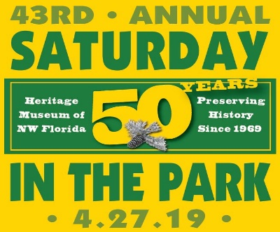
FOOD VENDOR APPLICATION
44th Saturday in the Park
Saturday, April 25, 2020 10 a.m. – 4 p.m.

WHERE: Heritage Museum of Northwest Florida at Perrine Park in Valparaiso, FL

FEE: Registration: $125 ($25 Fee for Returned Checks from Insufficient Funds)
SPACES: Space is available on a first come, first serve basis. Food vendors will not sell the same foods. Tent, booth, tables, extension cords, etc. must be provided by vendor.

RULES:
- Water and Soda may not be sold. Exclusive rights for these beverages belong to the Heritage Museum of Northwest Florida (HMNF) and selected community partners.
- Food Vendors MUST be set up & REMOVE VEHICLES from Perrine Park before 7:00 a.m. Please!
RULE #2 is enforced for safety of 5K Run/Walk at 8 a.m. (Parking is available on nearby streets.)
- On-site overnight camping or overnight hookups are not permitted.
- Concessionaires must stay the full eight hours of the festival.
- Silent auctions, drawings, raffles, etc. are not permitted by an exhibitors or concessionaires without pre-approval of the HMNF.
- Concessionaires must abide by these rules and regulations. The signature below indicates that you release and forever discharge the HMNWF, its employees and volunteers, the Heritage Museum Association, Inc., the City of Valparaiso, and the SITP 2019 Committee from any responsibility, personal liability, loss, claims or damages arising out of or in connection with this event.
- Concessionaires will be asked to remove from sale any food/drinks not pre-approved by the HMNWF.
- The SITP 2019 Committee reserves the right to refuse applications from exhibitors and concessionaires.
- Space fees are a donation to the HMNWF and are Non-refundable and Non-transferable.
- NO RAIN DATE

SPACE IS LIMITED – PLEASE RESPOND PROMPTLY!
Mail or deliver completed form with payment to: HMNWF - SITP 2019, 115 Westview Avenue, Valparaiso, FL 32580.
A confirmation will be returned to you by mail or email. You may fax this form to (850) 678-2615 and pay by phone with MC/VISA by calling (850) 678-2615 during museum hours: Tuesday – Saturday 10 a.m. to 4 p.m.

CONTACT NAME: BUSINESS NAME:
MAILING ADDRESS: ____________________________________ CITY: __________________________ STATE: ______ ZIP: ____________
TELEPHONE: _________________________________ CONTACT PERSON: _____________________________________________________
EMAIL: _________________________________________________________ TAX ID#: ___________________________________________
DESCRIPTION OF FOOD TO BE SOLD: (Please be specific) _____________________________________________________________________
______________________________________________________________________________________________________________________

Please FILL IN INFORMATION RELATED TO YOUR CONCESSION.

Specify length and width of trailer/booth (including tongue):

Space without electricity
______ Space with electricity Power needed (Volt/Amp) ______ Size (with tongue): ____________________________________
______ Need water Size (without tongue): __________________________________
I certify that proper insurance is in place to cover any liability that I/we may incur as a result of our attendance and participation in the Festival.
I understand that my business is subject to Florida sales tax (where applicable) and that food vendors must meet Health Department regulations.

Signature of Business Owner: x___________________________________________ Date: _________________

