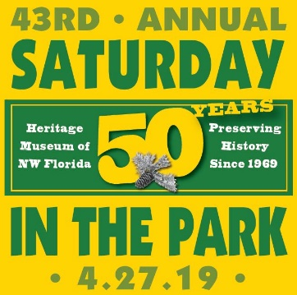
44th Saturday in the Park
Saturday, April 25, 2020 10 a.m. – 4 p.m.

VENDOR APPLICATION

Non-Profit, Government Agencies & Clubs

WHERE: Heritage Museum of Northwest Florida & Perrine Park in Valparaiso, FL

FEE: $15; free for Greater Okaloosa Museum Coalition, Inc. Members (Add $5 for electricity)
($25 Fee for Returned Checks from Insufficient Funds)
SPACES: 10’ x 10’ SPACE. NO BOOTH PROVIDED. Exhibitors furnish their own tents, tables, shelves, easels, chairs, display panels, etc. Tables must be covered and booths attractively decorated. Spaces are assigned in order of receipt of applications and fees. Upon acceptance, confirmation will be by phone or e-mail. A limited number of electrical hookups are available.
RULES:
- Vendors MUST REMOVE VEHICLES from Perrine Park before 7:00 a.m. PLEASE!
Rule #1 enforced for safety of 5K event at 8 a.m. (Parking is available on nearby streets. Ask attendants)
- This application is for Non-Profits, Government Agencies & Clubs ONLY.
- This application is not for political candidates. Please contact the Museum for sponsor package.
- Participants are encouraged to promote their mission and use Saturday in the Park venue for community informational purposes only. The sale of any items, (ie: crafts, food, toys, etc.) is Not Permitted.
- Cash raffles, silent auction or fundraising is Not Permitted. Giveaways Are Allowed.
- Space fees are a donation to the Museum and are non-refundable and non-transferable.
- There is No Rain Date.
- On-site overnight camping is not available; however you may set-up tent/tables day before.
- Exhibitors must agree to remain set-up at the festival site until 4:00 p.m.
- SITP 2019 Committee reserves the right to refuse applications.
- Exhibitors must abide by these rules and regulations. The signature below indicates that you release and forever discharge the Heritage Museum Assoc., Inc., the City of Valparaiso, and its employees and volunteers, from any responsibility, personal liability, loss, claims or damages arising out of or in connection with this event.

Space is limited – PLEASE RESPOND PROMPTLY!

Mail or deliver completed form & payment to: HMNF - SITP 2019, 115 Westview Ave., Valparaiso, FL 32580.
You will receive confirmation via telephone or email. You may fax this form to (850) 678-2615 and pay by MC/VISA by calling (850) 678-2615 during museum hours: Tuesday through Saturday, 10 a.m. to 4 p.m.

New Vendor: □ Repeat Vendor: □ Picture enclosed: □ Electricity: □ (addt’l $5) Museum Member: □ ($5 off total)
Type of group: Non-profit: □ Government Agency: □ Club: □ Other: □ ________________________________
Description of group, your mission & purpose:
Contact Name: ___________________________________ Group Name: ______________________________________________
Address: ____________________________________________ City: ___________________ State: ______ Zip: _______________
Email: __________________________________ Telephone: ______ ____________________
Signature of Vendor/Business Owner: X_____________________________________ Amount Enclosed: ____________________
For Staff Use Only: DATE: _______________AMOUNT PAID: ____________ Cash, Check # ____________, MC / VISA
NOTES: ____________________________________________________________________________________________________

