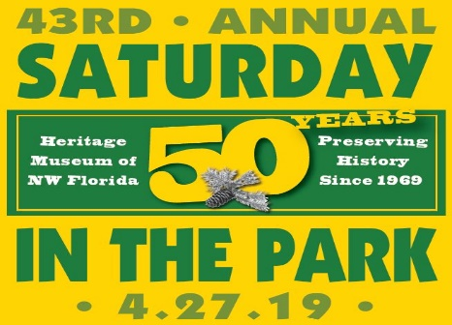
Craft Demonstrators & Re-enactors
VENDOR APPLICATION
44th Saturday in the Park
April 25, 2020 10 a.m. – 4 p.m.

WHERE: Heritage Museum of Northwest Florida at Perrine Park in Valparaiso, FL
FEE: No Fee

RULES:
1. Exhibitors MUST REMOVE VEHICLES from Perrine Park before 7:00 a.m. PLEASE!
Rule #1 enforced for safety of 5K Run/Walk at 8 a.m. (Parking is available on nearby streets.)
2. This form is for RE-ENACTORS & DEMONSTRATORS ONLY.
3. Participants are encouraged to promote their mission and use Saturday in the Park venue for community informational purposes only.
4. Cash raffles, silent auction, fundraising or the sale of any items (ie: crafts, food, toys, etc.) is Not Permitted.
5. Giveaways Are Allowed.
5. On-site overnight camping is not available; however you may set-up the day before.
6. Demonstrators must agree to remain set-up at the festival until 4:00 p.m.
7. There is No Rain Date.
8. Re-enactors & Demonstrators must abide by these rules and regulations. The signature below indicates that you release and forever discharge the Heritage Museum Association, Inc., the City of Valparaiso, and their employees, volunteers, sponsors, and the SITP 2019 Committee from any responsibility, personal liability, loss, claims or damages arising out of or in connection with this event.
9. SITP 2019 Committee reserves the right to refuse applicants if necessary.

Mail or deliver completed form to: HMNWF, 115 Westview Ave., Valparaiso, FL 32580.
You will receive confirmation via telephone or email. For questions call: (850) 678-2615 Museum hours of operation: Tuesday through Saturday, 10 a.m. to 4 p.m.

New Vendor: □ Repeat Vendor: □ Electricity needed?: □ Amount of Space needed
Type of group & description of your mission & purpose:

Contact Name: ___________________________________ Group Name: ______________________________________________
Address: ____________________________________________ City: ___________________ State: ______ Zip: _______________
Email: __________________________________ Telephone: ______ ____________________
Signature of Participant: X_____________________________________ Amount Enclosed: _______No Fee_____________
For Staff Use Only: DATE: _______________AMOUNT PAID: ____________ Cash, Check # ____________, MC / VISA
NOTES: ____________________________________________________________________________________________________

