Finishing the Japanese Oriental Box

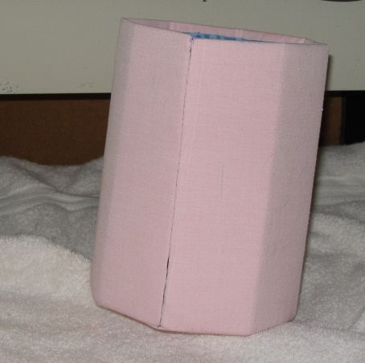
I purchased the finishing kit and instructions from Judy O'Dell and followed her instructions, with some changes which are noted below.

I was so nervous about cutting and gluing the finished needlework that I did a mock-up first, using pink fabric in place of my stitched work, blue cotton fabric for lining material and cardboard for the box. This gave me some ideas about changing the final box: I didn't use any glue on the good side of the false bottom and I didn't use construction paper.

The lining fabric is light blue hand-dyed silk. I couldn't find any cardboard that was heavy enough so I used mat board (from a picture framer's supply store). It is definitely heavy enough and acid free, but it doesn't bend easily. To make the folds for the box I used a sewing machine; instructions on this are below.
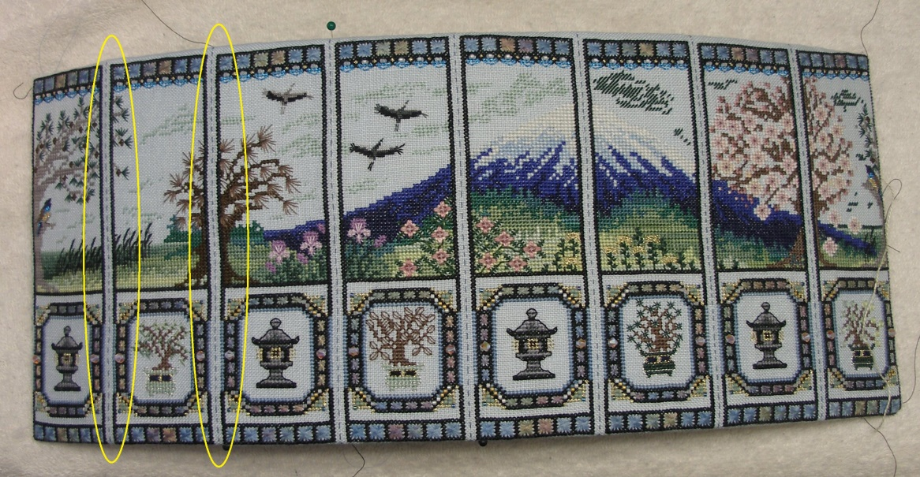
Before staring the box, I based between each of the panels from top to bottom; I also based a couple of threads in from where the ladder stitching would be on the top and bottom. This made it much easier to see where the box would be stitched together.

Next, I took a piece of mat board ¾" wide and as long as the circumference of the box (which I had cut for the inside ring under the false bottom) and bent it into a circle. Then I draped the stitched piece around the ring and marked the ring where the basting between the panels was. These marks were transferred from the ring onto the mat board for the box.
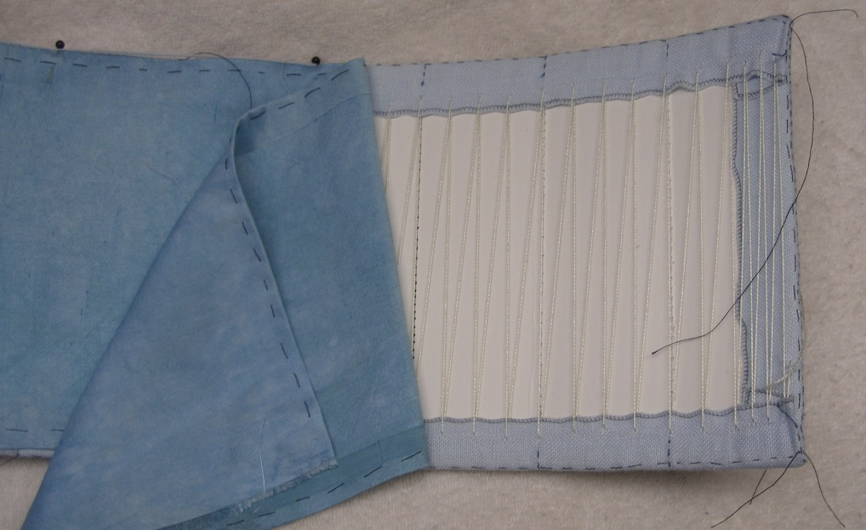
The stitched linen was laced over the mat board making sure the marks for the bends lined up with the basting lines between the stitched panels.

To fold the mat board, I used my sewing machine - without any thread and on the longest setting (6 stitches to the inch) and stitched with the box right-side up, from top to bottom, along the basting lines between each panel. This created straight lines of holes on the 'corners' of the box where the mat board folded easily. However, I had to be very careful not to stitch over or break any of the beads.
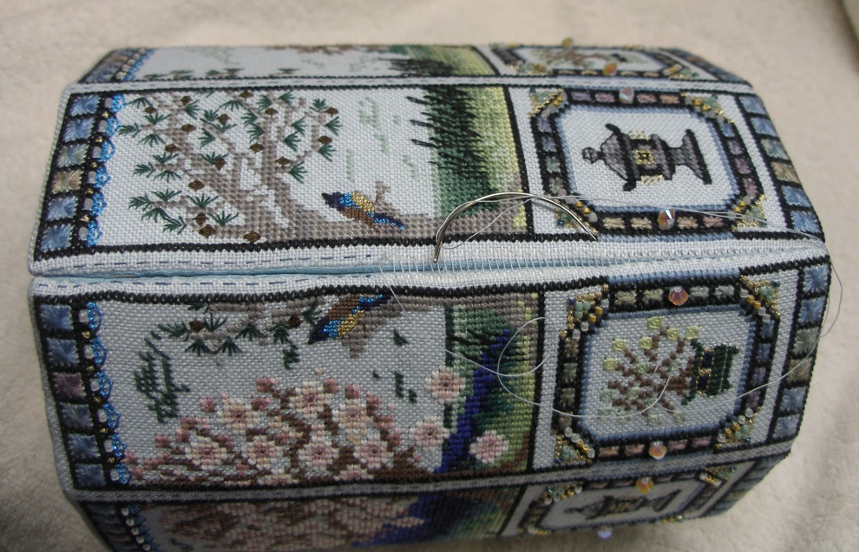

Next the lining was stitched in place. Then the edges were ladder stitched together

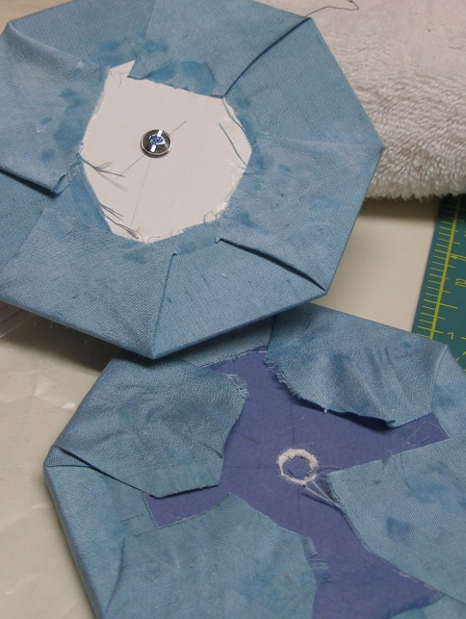
Before putting the top together, I marked the center on each piece of mat board for the top and made holes in each piece of board wide enough for the screw (for the knob) to go through. While stitching the top pieces together I stuck a large darning needle though the holes to keep the top pieces centered.

Next, the finishing instructions say to glue 3 octagons together for the inside top. I cut a hole in the center of the first layer of mat board large enough for the screw head to sit in. This also helped when stitching the pieces together.

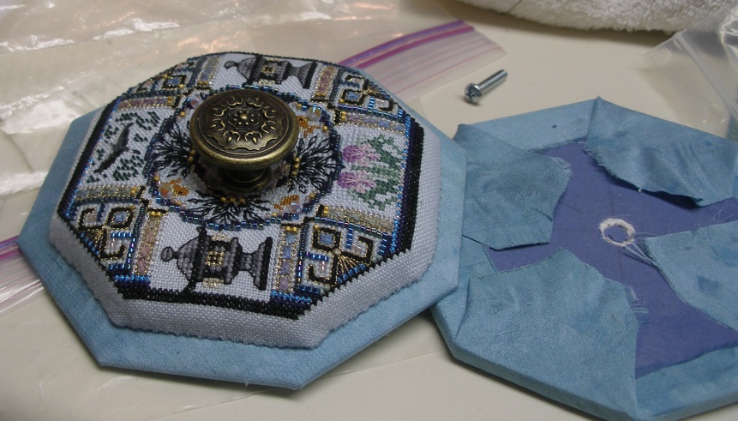

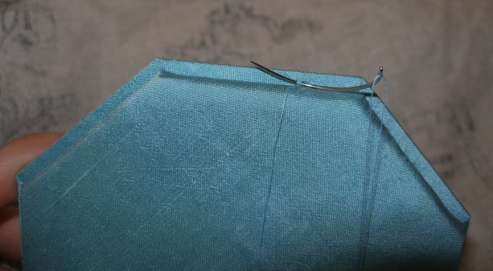

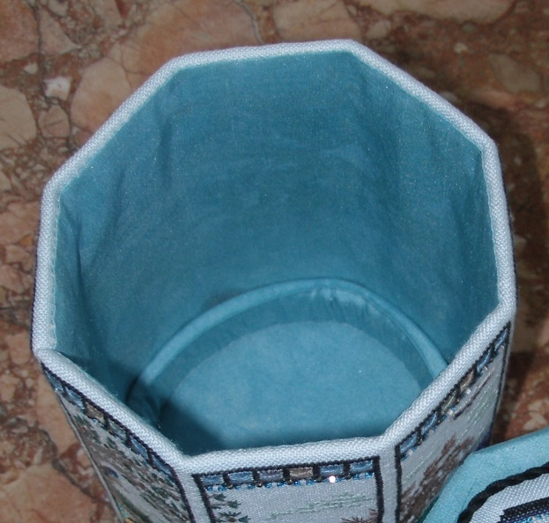
The finished box was a birthday present for my husband; so I stitched a dedication to him on one side of the false bottom and used the silk lining material on the other. Because of this I had to use two layers of mat board which I ladder stitched together along the edges.
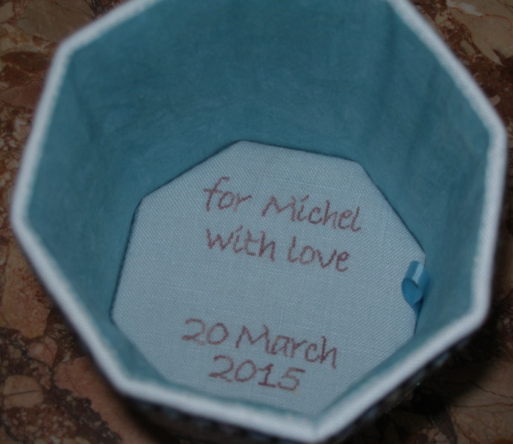

Finally, I made the cording to go around the top. I found some beautiful stone beads at my neighbourhood bead store which I used instead of tassels

