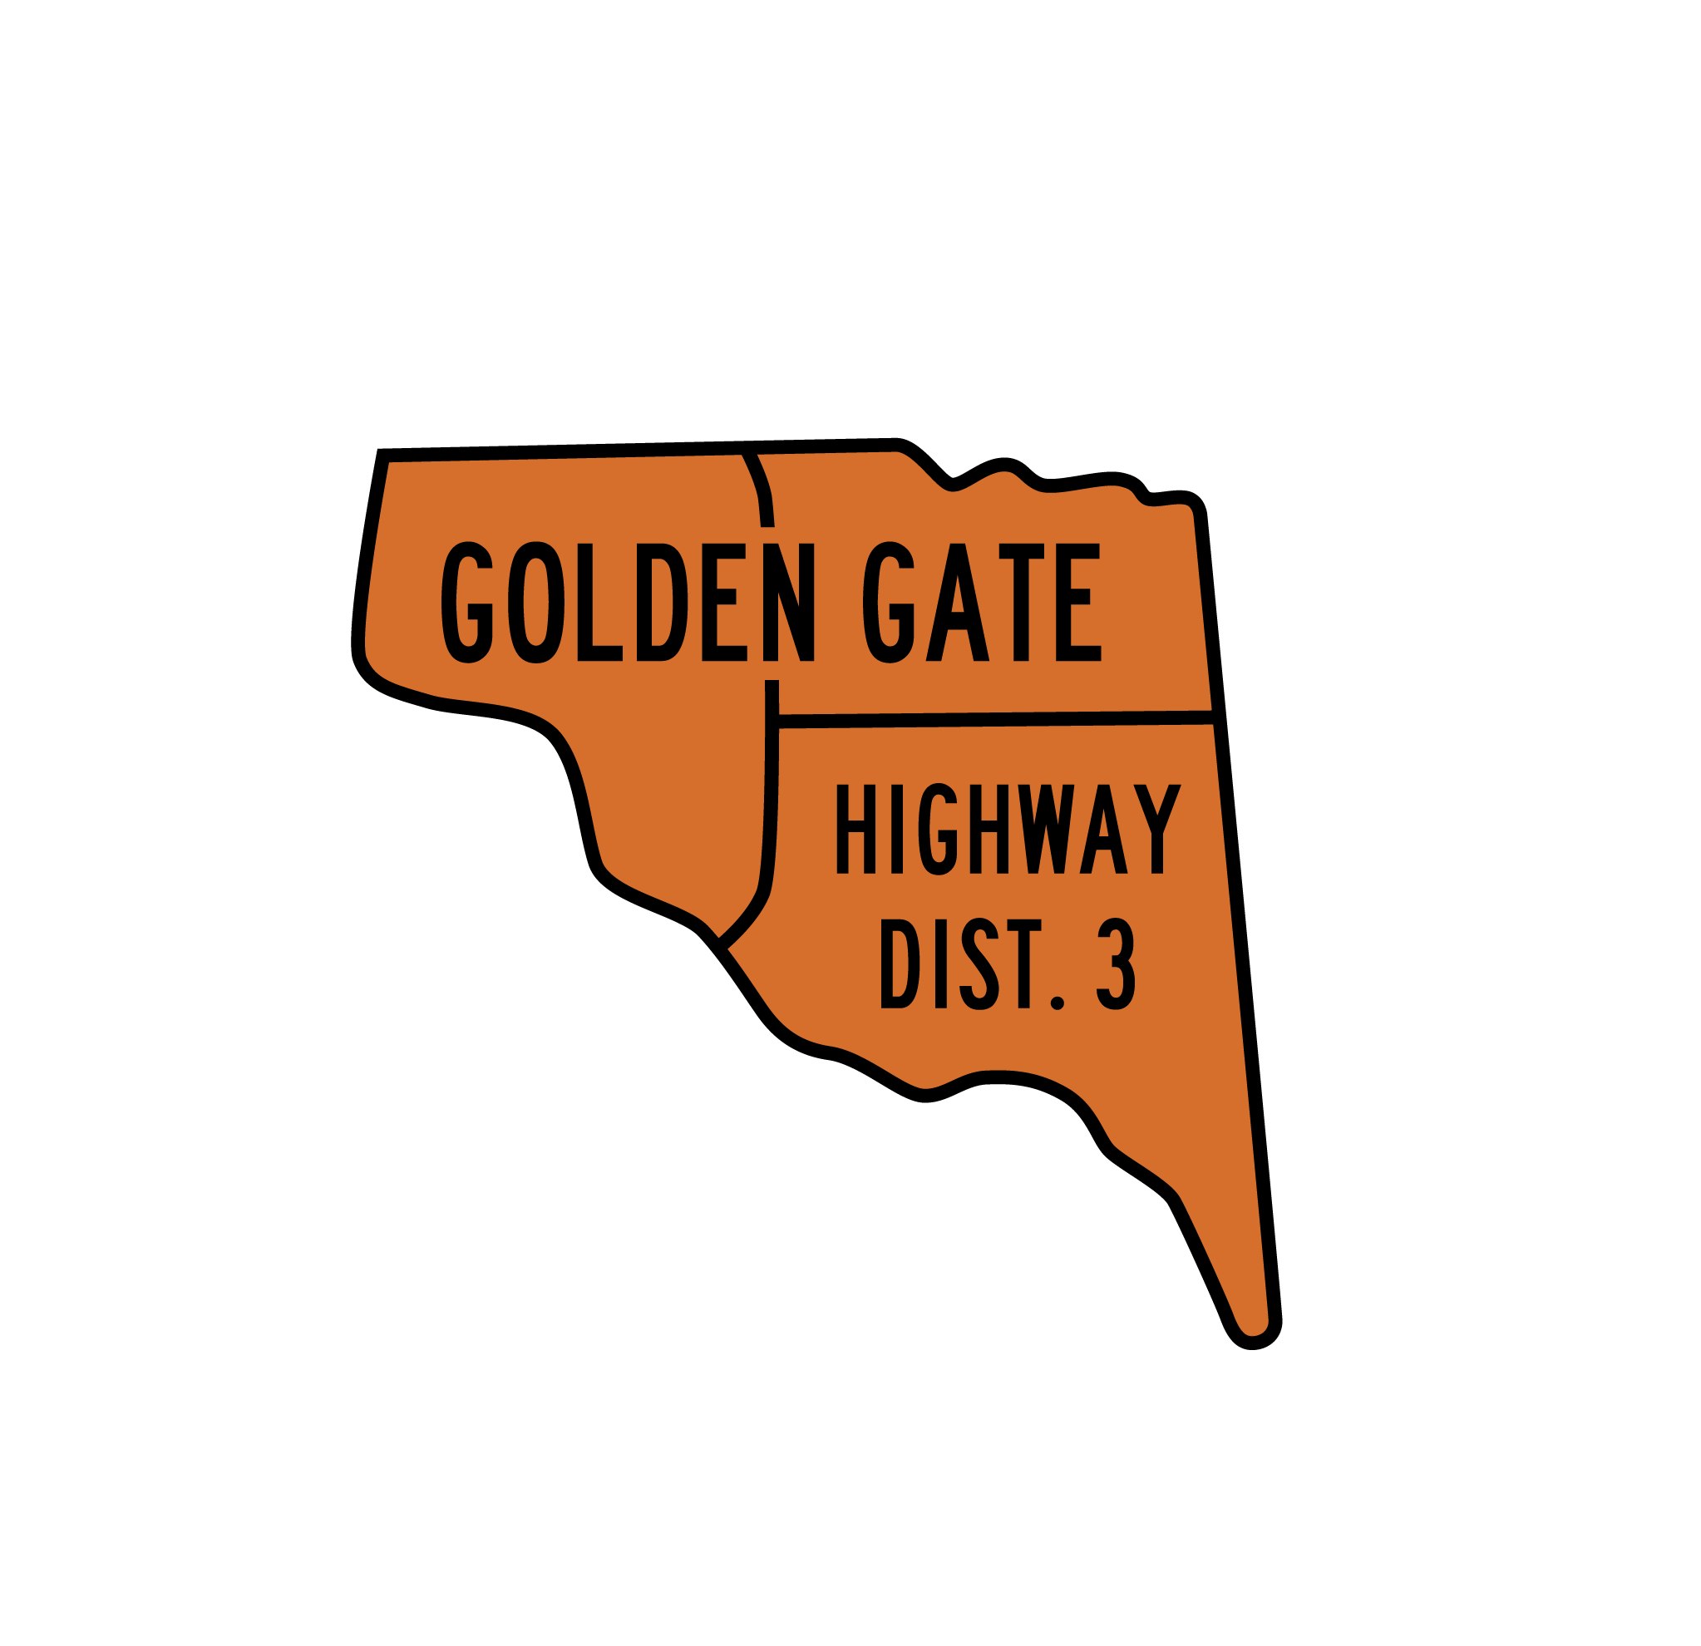
APPLICATION FOR:
DISTRICT MAINTENANCE WORKER
Golden Gate Highway District No. 3

Applications must be filed by April 27, 2023 at 5:00 p.m. Mountain Daylight Savings Time.

Street Address: 500 Golden Gate Avenue E, Wilder, Idaho 83676
E-mail: office@gghd3.org
For application assistance, phone (208) 482-6267

Golden Gate Highway District No. 3 is an equal opportunity employer and encourages applications from all individuals. Golden Gate Highway District No. 3 complies with all state and federal antidiscrimination laws prohibiting discrimination upon the basis of religion, sex (including pregnancy), age, national origin, disability, marital status or genetic information.

Name: _____________________________________________________ Date: ____________
Last First Middle

Address: ______________________________________________________________________
Street City State Zip

Phones: _______________________________________________________________________
Home Work Cell

Fax # ____________________________ E-mail: ___________________________________

Present Position: ____________________________ Employer: _________________________

Present Salary: _________________

A full job description of the District Maintenance Worker is attached to this Application.

Educational Record
Name & Location of  Institutions Attended | Years | Degree | Major | Minor

1. Do you hold any Certificates? Yes No

2. If so please identify each certificate and include only those which are currently active:
_______________________________________________________________________
_______________________________________________________________________
_______________________________________________________________________
_______________________________________________________________________

References
(Names of three persons who can discuss your experience and qualifications in detail)
Name | Official Position | Work Phone Number

Experience
(List in consecutive order beginning with the next most recent position following the position listed on page 1.)
From: | Position:  Employer:  Location: | Supervisor’s Name & Title:  Supervisor’s Work Phone:
To:
Reason for Leaving: (please be specific)

From: | Position:  Employer:  Location: | Supervisor’s Name & Title:  Supervisor’s Work Phone:
To:
Reason for Leaving: (please be specific)

From: | Position:  Employer:  Location: | Supervisor’s Name & Title:  Supervisor’s Business Phone:
To:
Reason for Leaving: (please be specific)

From: | Position:  Employer:  Location: | Supervisor’s Name & Title:  Supervisor’s Business Phone:
To:
Reason for Leaving: (please be specific)

From: | Position:  Employer:  Location: | Supervisor’s Name & Title:  Supervisor’s Business Phone:
To:
Reason for Leaving: (please be specific)

Background Information
Have you ever failed to be rehired? Yes No If so, where? ______________________

Have you ever resigned from a position in lieu of discharge or non-renewal of contract?
Yes No (If your answer is yes, provide an explanation on a separate sheet)

Have you ever had a license or certificate revoked in any state? Yes No
(If your answer is yes, provide an explanation on a separate sheet)

Have you ever been convicted of a crime? Yes No
(If your answer is yes, provide an explanation on a separate sheet)

The filed Application must also include a current resume and two letters of recommendation.

Application and Review Process

Applications and accompanying materials must be timely filed by 5:00 p.m. MST on April 27, 2023 with Anita Herman, Secretary, Golden Gate Highway District No. 3, 500 Golden Gate Avenue E, Wilder ID 83676 [office@gghd3.org]

- Except for e-mail filings, the Secretary will stamp receipt and provide notification to Applicant of timely or untimely filing of Application and will process Applications.

- Confidentiality: Applications and accompanying materials will be securely filed or retained and will be available either in hard copy or electronically only to the Director of Highways and the three commissioners of the Highway District. Review by the Commissioners will be conducted in Executive Session.

- Following the filing deadline for Applications, the Director of Highways and Road Foreman will commence the screening process, which will include a contact of references and interview of top tier applicants. Supplemental information may be requested by the Director of Highways at this time.

- Interviews of top tier applicants will be conducted by the Director of Highways and Road Foreman.

Applicant’s Statement and Acknowledgement

I certify that the information in this Application is true and complete to the best of my knowledge, and I understand, agree and acknowledge that an omission or falsification of any information in this application will be sufficient grounds for the Board of Commissioners of the Highway District to not hire or upon hiring to immediately discharge me from employment.

I understand that employment is contingent upon investigation of any or all statements contained in this application and authorize the release of any information from persons named in this application. In the event that I am employed by Golden Gate Highway District No. 3, I agree to abide by all its applicable policies, procedures, rules and regulations.

I authorize Golden Gate Highway District No. 3 to verify any prior employment and discuss any and all recommendations regarding such employment

__________________________ ___________________________________
Date Signature

Note: If you are sending your application electronically, you will be required
to sign this statement at the time of your interview if selected as a finalist.

Crime means a violation of any law in any state, province, federal or military court including pleas of guilty or nolo contendere and includes proceedings in which the sentence has been suspended, deferred or withheld but does not include convictions for traffic offenses unless alcohol or drug related.

