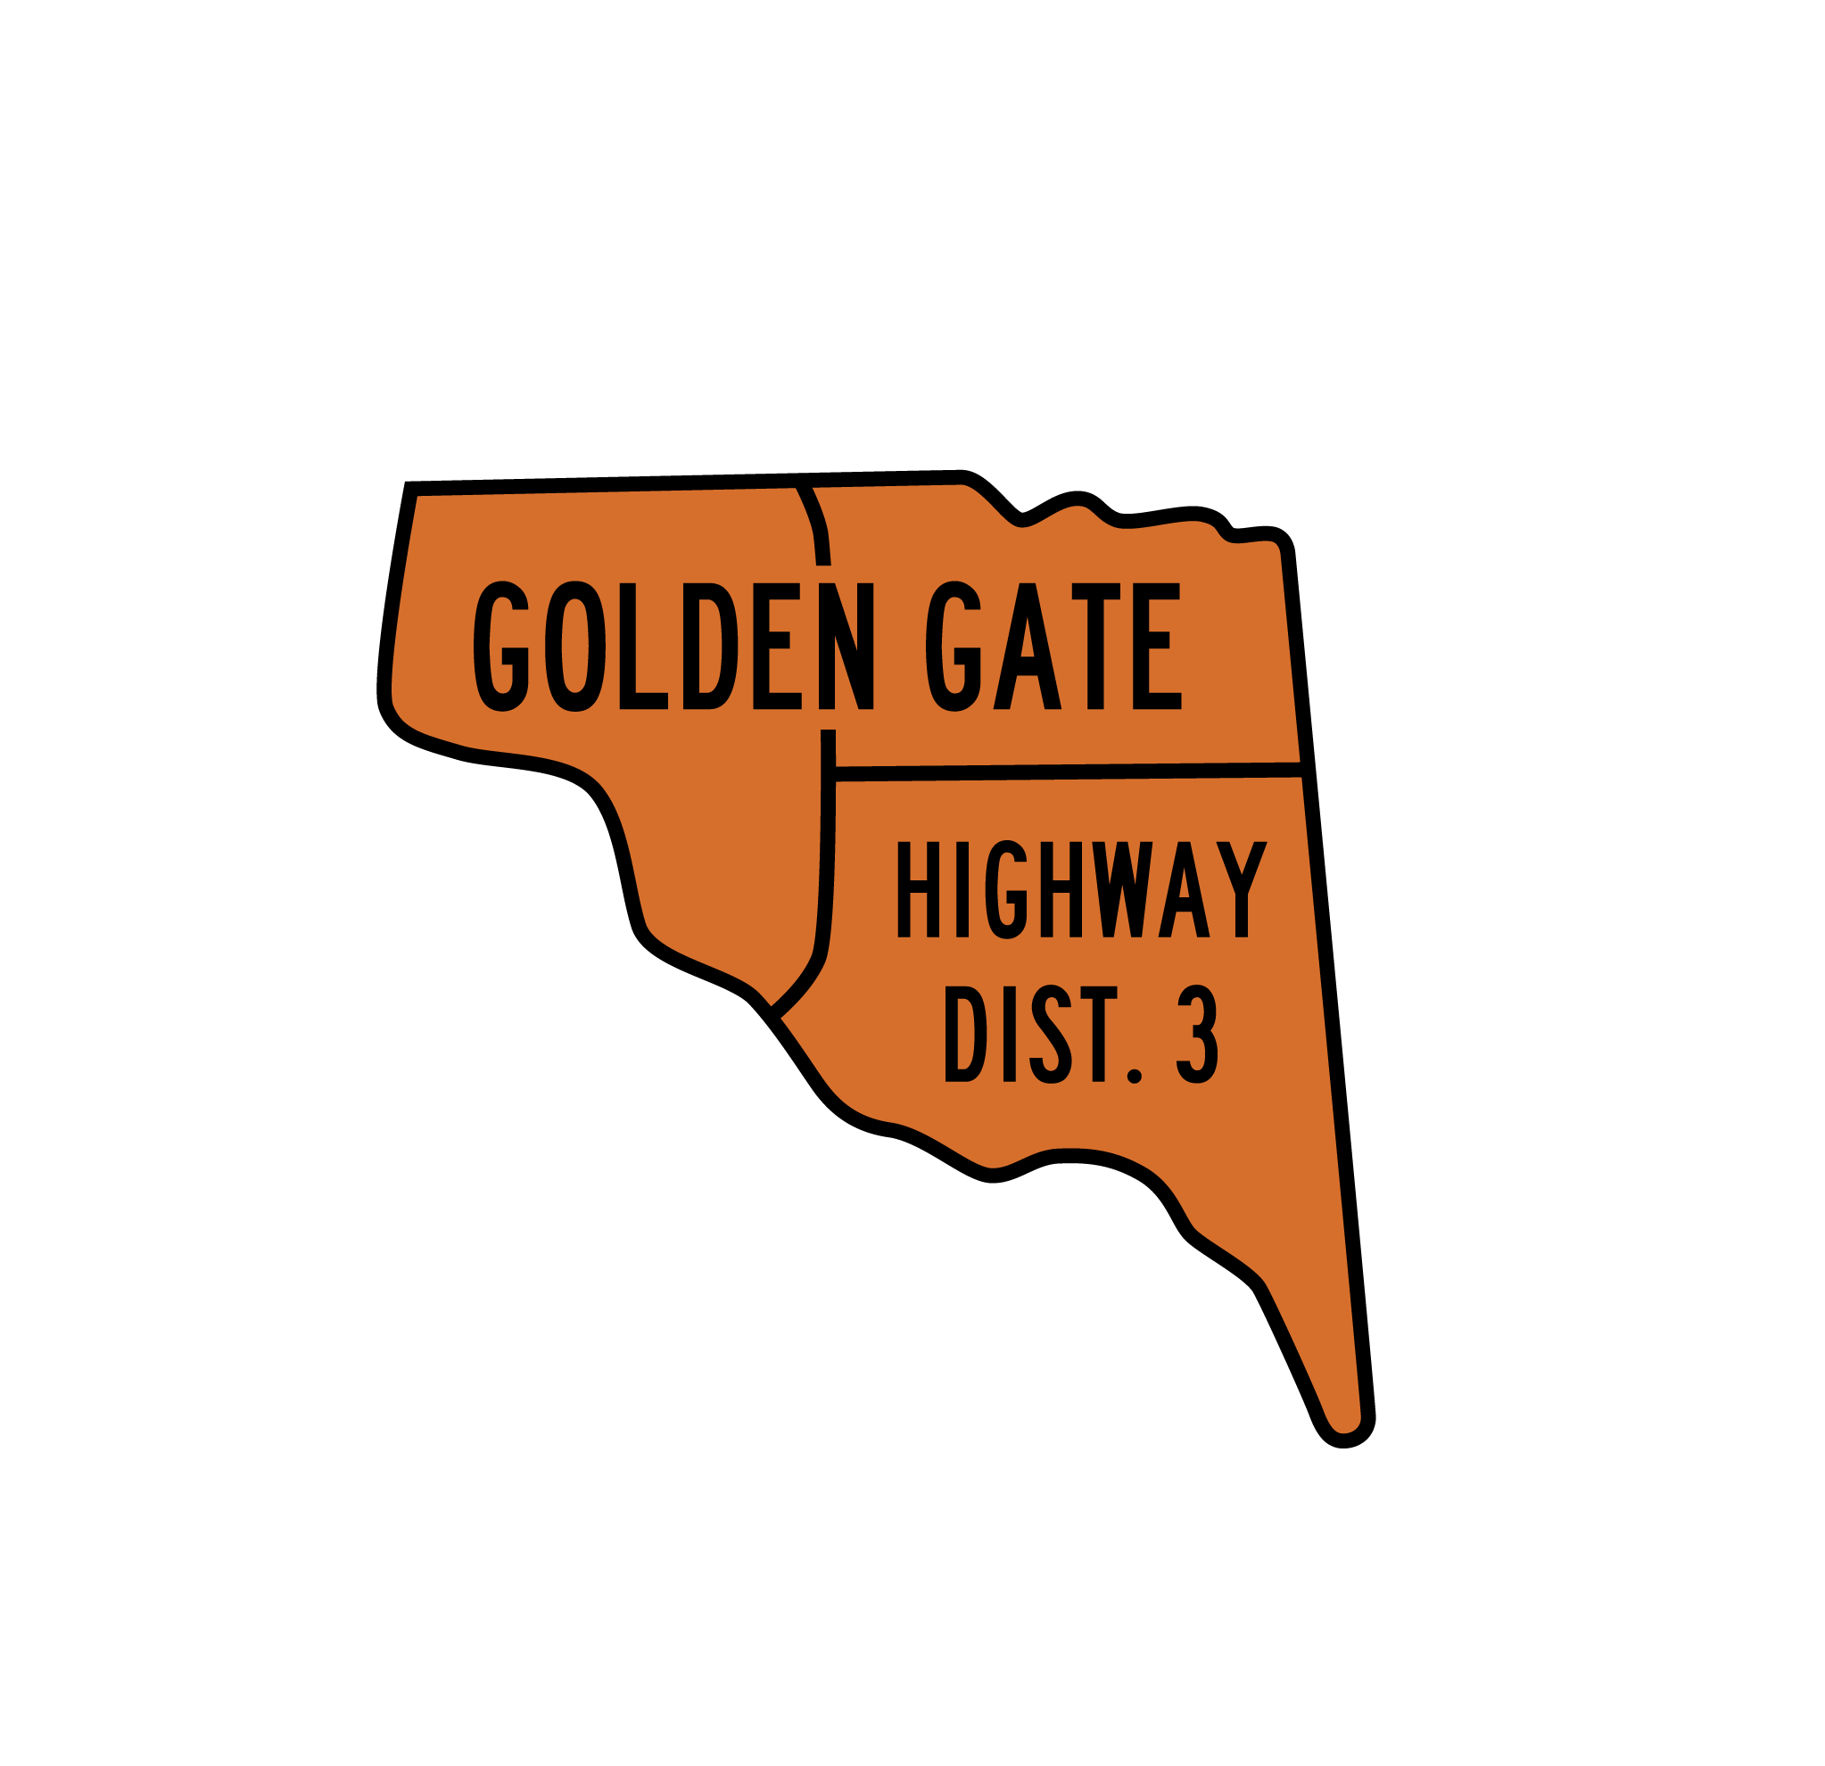

GOLDEN GATE HIGHWAY DISTRICT NO. 3

NOTICE OF POSITION OPENING
DISTRICT MAINTENANCE WORKER

DATE AND LOCATION UPON WHICH APPLICATIONS ARE FILED FOR THE DISTRICT MAINTENANCE WORKER POSITION:
All applications and accompanying materials are to be delivered in a sealed envelope marked “Application for District Maintenance Worker” by 5:00 p.m. Mountain Time on or before April 27, 2023. The application and supporting materials may be delivered in one of the following formats:

Mail:  Golden Gate Highway District No. 3  Attention: Secretary  500 Golden Gate Avenue  Wilder, ID 83676 | Hand Deliver:  Golden Gate Highway District No. 3  Administrative Office  500 Golden Gate Avenue E  Wilder, ID 83676 | E-Mail:  Golden Gate Highway District No. 3  Attention: Secretary  office@gghd3.org

POSITION DESCRIPTION:
See attached job description.

MINIMUM QUALIFICATIONS:
In order to be considered for the District Maintenance Worker, candidate must have valid Idaho Class A Commercial Driver’s License. Candidate must have good knowledge of road construction and maintenance activities; of tools and material used in the work, good knowledge of principles and practices of truck operations, good knowledge of traffic laws, ordinances and rules applicable to motor vehicles and construction equipment. Practices safety precautions and is aware of hazards that may be encountered. Able to detect needed repairs and make necessary simple adjustments in the field to keep equipment operating. Able to understand and carry out all oral and written instructions, able to work independently and perform manual labor for long periods under adverse conditions. Maintains a positive and good working relationship with other employees and supervisors at all times. Arrives at work on time and maintain a regular and reliable level of attendance.

Is available for duties other than described above for routine sign repair call-out and any other after hour emergencies that arise, and can respond to work within thirty (30) minutes of notification to respond to work for any duty that arises.

APPLICATION FORM:
The application form [which includes the job description] for this position is available from the Secretary of the Golden Gate Highway District No. 3, located at 500 Golden Gate Avenue E, Wilder ID 83676 [Phone 208-482-6267]. Applications must be signed by the applicant and submitted according to this Notice.

SALARY PACKAGE:

The salary range for the District Maintenance Worker position is $23.00 - $26.00 per hour.

REVIEW AND SELECTION PROCESS:
The applicant review and selection process is set forth in the official Application Form.

By: Anita Herman, Secretary, Golden Gate Highway District No. 3

