Congratulations on your new pup!
Here is a list of items that you may want to start getting to prepare for an easier transition when bringing home your new pup!! These are just what I use and some of my favorites!!
Dog food- TLC Dog Food – Whole Life Dog Food- that’s what puppy will go home on. You will receive an email from them with my code to order if you choose to. If you choose to change foods make sure to start slowing by mixing both foods together gradually increasing new food every few days. I also like their Dog Biscuits!!
https://tlcpetfood.com/nutrition/ChannysDoodles/179348
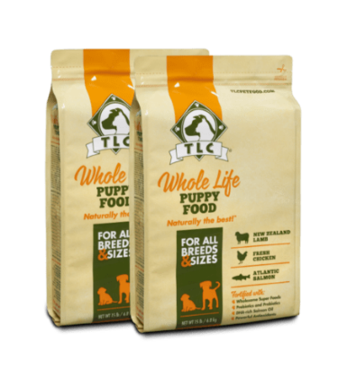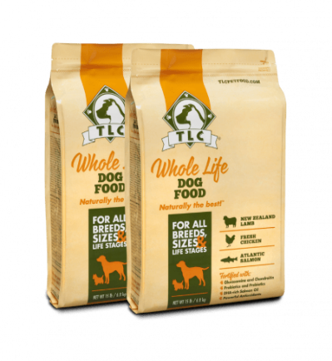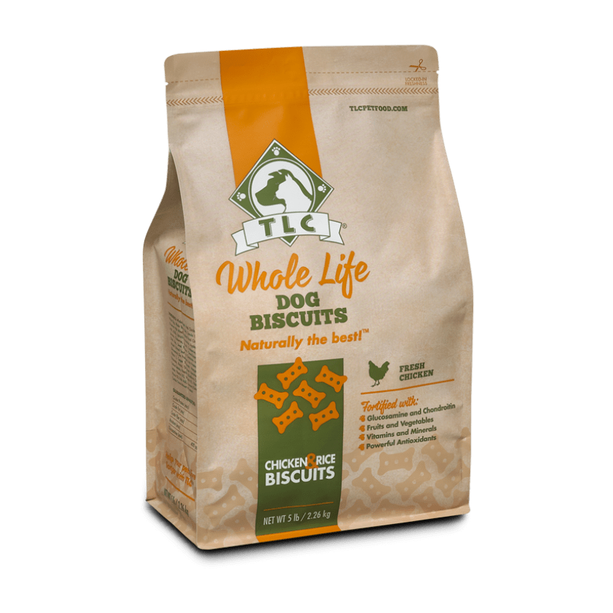

Dog kennel/crate- either 42in or 48in is fine, just make sure it comes with a divider, so as your puppy grows you don’t have to keep buying bigger kennels, just remove divider!
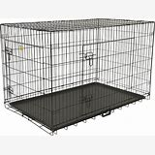

Food and water bowls- I like the ceramic ones!
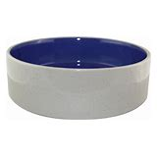
Training treats- I like Zukes! Or any freeze dried training treats!
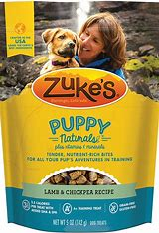

Puppy toys and chews- just some examples!!
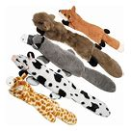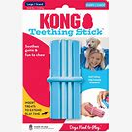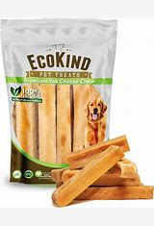

Snuggle puppy- It has a heartbeat, so it helps the puppy when they leave momma! Highly Recommend! I also have some in stock for purchase if you don’t order one.
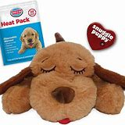

Leash and collar or harness-I like the Barkbay harness!
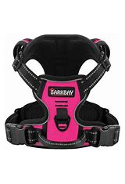
Pet bed/ blanket-
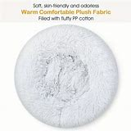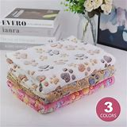

Puppy pads-
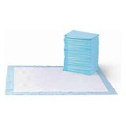
Slicker brush and comb-
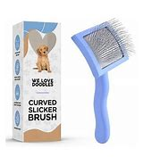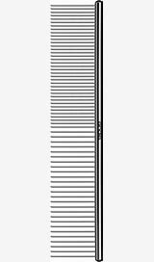

Puppy Shampoo and Dog Shampoo-
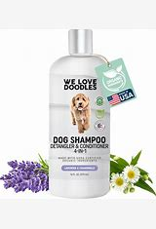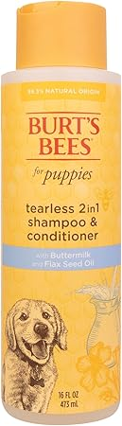

Little Wolves potty tray- This is what I use to start potty training the puppies, if interested in getting one.. www.littlewolves.com and use code “chantallorentz” to get a discount!! If your going to use a playpen and they will be in it for an extended period then I would highly recommend getting one to put in the area.
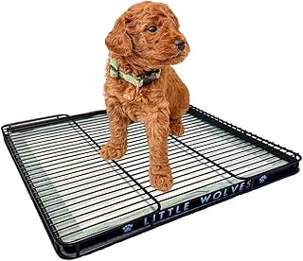

Puppy playpen- I like the FXW brand! They have all different kinds and sizes.
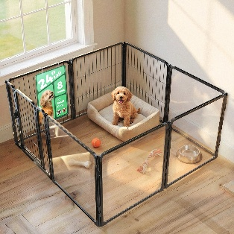

FurLife- I like to use the pendant as a 2nd form of protection, so I would still get your pet on a primary flea and tick preventive.
Here is my discount code to save you 15% off when you order! https://snwbl.io/furlife/CHANTAL32209
