Hardin Community School
011324

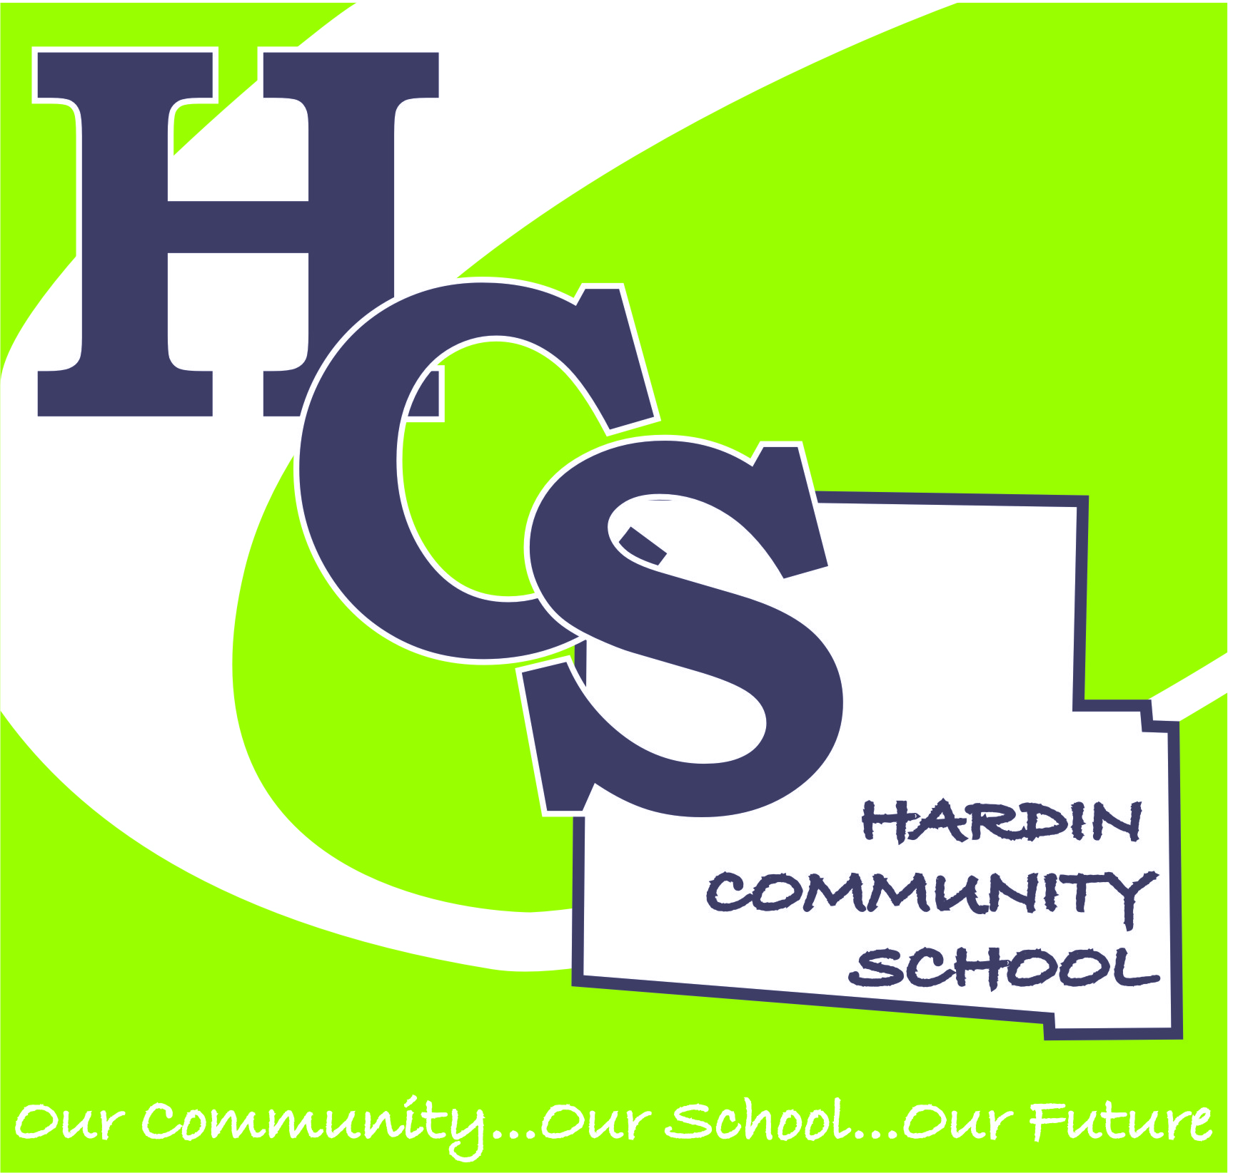

ANNUAL REPORT
2023-2024

Description of School
Hardin Community School is a drop-out recovery conversion school of Hardin County pursuant to Section 3314.03 of the Ohio Revised Code. HCS is a school designed especially for credit deficient "at-risk" students in grades 6-12, with the majority of students ages 16-21 as permitted under the Ohio Revised Code 3314-06. HCS meets the needs of students in an environment that allows the student to remediate, enrich and expand his or her educational experiences. HCS takes reasonable steps to ensure the compliance of all health and safety standards for its students within the control of HCS.

Vision
Hardin Community School will lead, shape, educate and transform youth into self-motivated, engaged, and successful citizens of the Hardin County community.

Mission
Hardin Community School exists to value, educate, empower, and transform the lives of our students and their families.

Demographic Data
Enrollment

Composition
Black 2.00 %
White 92.00 %
Multiracial 4.00 %
Hispanic 2.00 %

Economically Disadvantaged 82.00 %
Students with Disabilities 32 %

Hardin Community School exists to value, educate, empower, and transform the lives of our students and their families.

Education Program – Hardin Community School’s mission is to value, educate, empower, and transform the lives of our students and their families. The school strives to accomplish this mission by valuing each student. Many of our students have not found success in a traditional education setting provided by local school districts. Some students are credit deficient or “at-risk” of not graduating due to behavior issues, others enroll because of our smaller class sizes, and a few like the flexibility of the self-paced education programming offered at HCS. For all of these students HCS provides a meaningful educational alternative where they can find academic and social success. Regardless of individual needs, all students are provided a standards-based curriculum taught by highly qualified staff with the goal of transforming lives.

The unique purpose of HCS is to provide the environment and experiences to develop each individual's intellect and will to the maximum of the students' ability and interest. Given the environment and experiences, the individuals will progress in their ability to make judgments and arrive at conclusions based upon responsible inquiry and factual evidence. Given this framework, the HCS Board of Directors believes that:

1. Education should contribute to the continuous improvement of the democratic society and cultures in which it exists through the development of concerned, contributing, and patriotic citizens.
2. The dignity and worth of the individual should be respected and each individual should be given the opportunity to participate in our society to the best of his/her ability.
3. Basic knowledge, skills, understandings, and appreciation are necessary for full life functioning.
4. All students should be offered the opportunity for optimum development of their abilities and talents.
5. The development of self-appraisal skills, decision making techniques, and critical thinking skills by Hardin Community School’s students should help them in assuming the responsibility for setting realistic, immediate, and long-range academic and career goals. These skills should also assist them in making judgments and developing understanding for lifelong decision- making.

Academic Assessment & Accountability Performance- Student evaluation, in order to be effective, must rely on several methods of measuring student attainment of learning objectives. For that reason, Hardin Community School Assessed Curriculum plan is based on a cyclical system of pre-assessment, formative assessment, and summative assessment. Teachers will use both formal and informal assessment methods. Diagnostic assessments and screening tools will be used to determine each student's present level of performance and readiness for the learning experience. Ongoing, formative assessments are conducted during instruction to help teachers make necessary instructional adjustments such as intervention and enrichment. Depending on the information gained during these benchmarking assessments, teachers may decide to alter instructional methods and materials. Teachers will refer to the benchmarks and indicators in their written curriculum to help them design and implement these ongoing assessments, both formal and informal. Summative assessments will indicate student mastery of skills, and will also serve as pre-assessment information for future work. Summative assessments will be both formal and informal, will be varied, and will include the Ohio Department of Education End-of-Course Exams, ACT for juniors (student/family choice), and Renaissance STAR assessments. HCS will provide required information to allow for the acquisition and administering of all mandated statewide testing.
GOAL: All students will meet AYP by scoring “making progress” on Renaissance STAR (Math and ELA) assessments (students on an IEP will have assessments determined by the IEP team.). Data from the above mentioned tests will drive the interventions provided to students.

Reference testing and assessment data/last year or most recent Ohio Local Report Card information.

4-Year Graduation Rate: 69.2% (Not Rated)

5-Year Graduation Rate: NC (Not Rated)

6-Year Graduation Rate: 54.5% (Not Rated)

7-Year Graduation Rate: NC (Not Rated)

8-Year Graduation Rate: 57.9% (Not Rated)

Value Added Progress has not been rated.

Overall Graduation Rate: 64.8% (Not Rated)

NOTE: Hardin Community School is an at-risk grades 6-12 school providing credit and therapeutic recovery services to enrolled students. Part of the enrollment process is to meet criteria for acceptance. Students who enroll at Hardin Community School must have a history of Chronic behavior issues in another school and/or at least one grade level behind in middle school and/or at least 5 high school credits behind their on-time graduating class. Consequently it is difficult for students to achieve graduation on time.

The 4-year graduation rate applies to the Class of 2020 who graduated within four years, i.e. students who entered the 9th grade in 2016 and graduated by 2020.

The 5-year graduation rate applies to the Class of 2020 who graduated within five years, i.e. students who entered the 9th grade in 2015 and graduated by 2020.

Financial Plan & Performance- The financial plan complies with section 3314.03(A) 15 of the Ohio Revised Code, which requires an estimated school budget for each year of this Contract and a total estimated per pupil expenditure amount for each year. In accordance with these requirements, this plan specifies for each year the base formula amount that will be used for purposes of funding calculations under section 3314.08 of the Ohio Revised Code. This base formula amount for any year shall not exceed the formula amount defined under section 3317.02 of the Ohio Revised Code. The plan may also specify for any year a percentage figure to be used for reducing the per pupil amount of disadvantaged pupil impact aid calculated pursuant to section 3317.029 of the Ohio Revised Code.

If applicable, please address the following; Financial Data, Federal Title Funds allocated for targeting areas of greatest academic needs & how funds are used
Total Operating Revenues: $ 339,920.05
Total Expenditures: $ 306,036.52
Total Assets: $ 774,506.75
Organization & Operation- Hardin Community School’s local board is charged with the responsibility to establish and maintain a basic organizational structure for HCS, develop curriculum, meet federal and state mandates for HCS, appoint a Director and key members of the central office staff, adopt an annual budget, approve the 5-year forecast, and create a climate that promotes educational excellence. Consequently, HCS’s school board initiate educational policies at the local level and have a responsibility for implementing a variety of state and federal policies. This board provides important administrative oversight relative to the educational policies and programs they institute; play a central role in establishing systems and processes to ensure the school system's fiscal, programmatic, and outcome accountability; and undertake broad human resource functions that include making crucial decisions regarding the district's top-level leadership and key staff. Finally, the HCS’s school board provides leadership for HCS, adopting a unifying vision and mission, soliciting and balancing the participation and input of members of the community, and advocating on behalf of the educational needs of students at the local, state, and national levels.

Governance: – The Board of Directors is responsible for helping to create, approve, and monitor HCS’ annual budget, to develop policies to guide the operation of HCS, to secure funding for HCS, and maintain a commitment to the vision, mission, and belief statements of HCS and the students it serves. The Board of Directors makes such rules and regulations as are necessary for its governance and the governance of its employees and students, of its grounds or premises by adopting policies for the organization and operation of this Board of Directors and HCS. The Board of Directors may assume jurisdiction over any dispute or controversy arising within HCS and concerning any matter which authority has been vested in the Board of Directors by policy, contract, rule or law. The Board of Directors has experienced turnover in membership since the 2020-2021 school year as five of the seven Board members have resigned and been replaced. The current directors have diverse backgrounds who have brought a wealth of experience to the school, strengthening our core values and mission. Specifically, the current members include a local business owner, a current school superintendent, a financial institution manager, a person retired as a teacher and with chamber and business alliance credentials, a Job and Family Services director, a local pastor who is also employed at a county school, and an officer with the Hardin County Sheriff Department. One of the current directors has been with the board since the opening of HCS.

The Board of Directors is responsible for carrying out the provisions of the Contract.
The Board of Directors is the final governing authority of HCS.
Legal Compliance- As the designated legal agency responsible for public education in the District, the HCS Board of Directors derives its authority from the State. In reality the Board has only those powers conferred on it by statute--these powers are extensive and appear throughout the sections of the Ohio Revised Code and Constitution. At no time may the Board of Education by its own action augment or relinquish its power or authority.

The HCS Board is responsible to the State Board of Education, the school’s sponsor, North Central Ohio Educational Service Center (NCOESC), and Superintendent of Public Instruction for implementing statutory requirements. Within the extent of its legal powers, it also has responsibility for conducting the school system. Legal compliance includes: establishing policy for the management of the schools, selecting the school director, approving the annual budget and appropriation, considering and voting on the recommendations of the Director in all matters of policy, appointment or dismissal of employees, salary schedules or other personnel regulations, or other matters pertaining to the welfare of HCS, selecting the District Treasurer, and appraising the effectiveness with which HCS is achieving the educational purposes for which it is being operated and to the reports submitted by the Director regarding the conditions, efficiency, and needs of the HCS.

Sponsorship Agreement Performance- Hardin Community School complies with all rules and laws that govern community schools including making sure all board members have completed required annual board training.

Hardin Community School
Governing Board
2023-2024

- Mark Bishop
- Dennis Burns
- John Hohn, Chairman
- Melissa Humble
- Kirk Shepherd
- Chad Thrush
- Jodi Tudor

School Location:
400 Decatur Street, Kenton, Ohio 43326
www.hardincommunityschool.org

