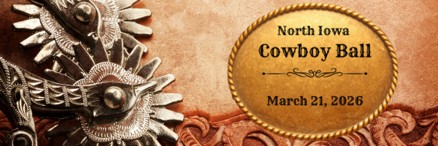
2026 NORTH IOWA COWBOY BALL
Sponsorship Levels

TITLE SPONSOR - $5,000
- “Presented by” billing on all marketing and other event materials.
- Brief time on stage to be introduced and welcome guests.
- Logo displayed in all digital and printed material for the event, including the program.
- Logo displayed on the Cowboy Ball website for one year.
- Recognition on North Iowa Events Center social media platforms (over 9K followers).
- 2 tables (seating 10 guests each) with premier placement at the event, includes dinner and 2 drink tickets per person.
- Banner placement at the entrance and exit of the North Iowa Fair.
- Logo recognition on the donor wall during the North Iowa Fair.
STETSON SPONSOR - $2,500
- Verbal recognition on stage
- Logo displayed in all digital and printed material for the event, including the program.
- Logo displayed on the Cowboy Ball website for one year.
- Recognition on North Iowa Events Center social media platforms (over 9K followers).
- 1 table (seating 10 guests) at the event, includes dinner and 2 drink tickets per person.
- Banner placement in a prime location during the North Iowa Fair.
- Logo recognition on the donor wall during the North Iowa Fair.
BRANDING IRON SPONSOR - $1,000
- Logo displayed in all digital and printed material for the event, including the program.
- Logo displayed on the Cowboy Ball website for one year.
- Recognition on North Iowa Events Center social media platforms (over 9K followers).
- 1 table (seating 10 guests) at the event, includes dinner and 2 drink tickets per person.
- Name recognition on the donor wall during the North Iowa Fair.
HORSESHOE SPONSOR - $500
- 1 table (seating 8 guests), includes dinner and 1 drink ticket per person.
- Name recognition in event program
- Name recognition on the donor wall during the North Iowa Fair.
2026 NORTH IOWA COWBOY BALL
Sponsor Commitment Form

SPONSOR INFORMATION

Business/Organization (If Applicable):___________________________________________________________

Contact Name:________________________________________________________________________________

Mailing Address:______________________________________________________________________________

City:___________________________________State:_____________________Zipe:_______________________

Phone:_________________________________Email:________________________________________________

SPONSORSHIP LEVEL IN-KIND DONATIONS

___Title Sponsor ($5,000) ___I/we would like to contribute the
___Stetson Sponsor ($2,500) following in-kind donation of goods and/or
___Branding Iron Sponsor ($1,000) services to be auctioned off:
___Horseshoe Sponsor ($500) ___________________________________________
___________________________________________
___________________________________________

The form and payment can be mailed to:
The North Iowa Events Center
3700 4th Street SW, Mason City, IA 50401

For more information, contact office@northiowafair.org or call (641)423-3811
www.northiowacowboyball.com

The North Iowa Fair Association is a designated 501(c)(3) nonprofit organization.

