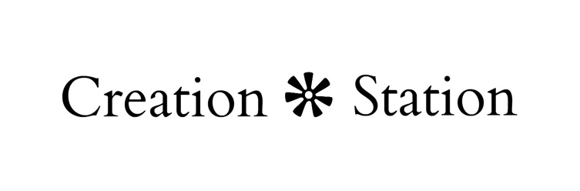
String Art Directions

Materials Needed:

- Hammer
- All other materials are included in craft kit

Instructions:

- Remove sticker stencil and place it on the center of the board.

- Starting at the top, hammer a nail half way into the board just around the outside of the stencil. Be sure to hammer in a straight downward motion so the nail goes into the board straight and even to prevent bending.

- Repeat step 2 around the outside of the entire stencil keeping each nail about an inch apart.

- Be sure to place a nail in any corners or indents around the stencil to help define the image when you fill it with string.

- Once the entire stencil is outlined with nails remove the stencil from the board.

- Take the string and make a loop. Tie a knot around one of the nails. Creating an “anchor” for you to start filling in the image keeping it in place. Cut off any loose ends.

- Begin weaving the string back and forth, up and down, going from nail to nail. You can go in any direction or way you like. There is really no wrong way to do this part! This is where you make it unique and your own!

- When you have finished filling in your image take the string and go around the outside of the image, outlining the image. This will make your image more defined and make it stand out.

- Lastly, take the string and tie a knot on a nail to secure your string in place. Cut off any loose ends.

