Asslamu-Aliykum Wa-Rahmatullahi- Wa- Barakatuh!

Dear parents/guardians;

#### We at Sunnah Academy, pray and hope that this message finds you in the best of I’maan and health. Please find the school dress code below for 2019-2020 school year.

**Sunnah Academy**

**School Dress Code**

**Boys: White Shirts & Navy Pants**

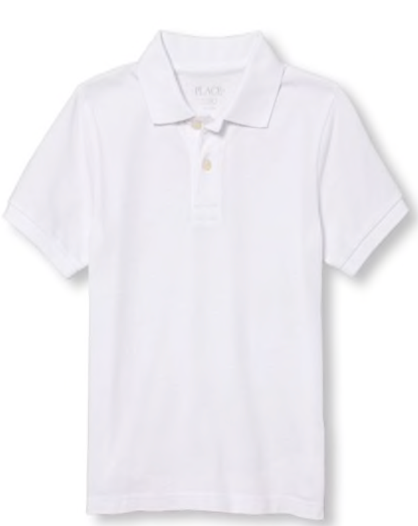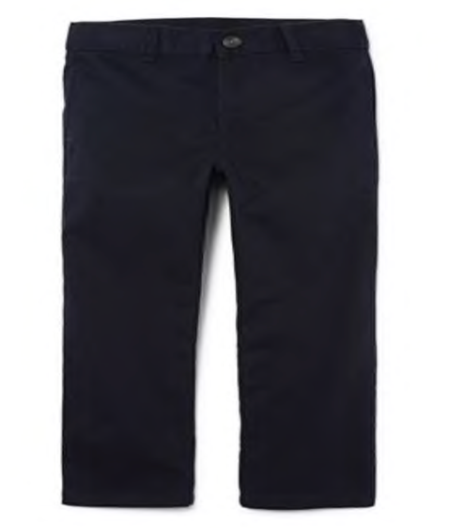

**Girls:**

**Option # 1) Long Sleeve Navy Polo dress with white pants &**

**white Head scarf.**

**Option # 2) Navy Blue Abaya**

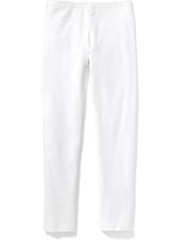

Jazaka-Allahu-Khair,

Sunnah Academy