Youth Compensation Legal Guide

**Written and Edited By:**

Katie Meyer Scott, Youth Homelessness Director

Jeremy Penn, Youth Homelessness Attorney

*National Homelessness Law Center*

Jacq Tate, Co-Owner

*TrueSelf LLC*

Siena Cornacchini, Associate

Jeff Hill, Senior Associate

*Alston & Bird*

**Additional Legal Research and Review by:**

Maritza Adonis, *MTA Visions LLC*

David Donald, *The Chinese University of Hong Kong*

Marilyn Harbur, *Co-Chair, Economic Justice Committee, American Bar Association Section of Civil Rights and Social Justice Section and Special Advisor, American Bar Association Commission on Homelessness and Poverty*

Francine Lipman, *Human Rights Editorial Board Chair, American Bar Association Section of Civil Rights and Social Justice*

Jim Pierson, *Co-Chair, Economic Justice Committee, American Bar Association Section of Civil Rights and Social Justice*

**Special thanks** to the [Youth Compensation Advocacy Workgroup](https://youthhomelessnessindex.org/youth-comp-workgroup/) for their feedback, ideas, and encouragement. **And extra special thanks** to the 20+ young people who contacted the Law Center and bravely shared their stories and experiences of doing youth engagement work over the past few years. Those conversations directly informed the content and framing of the guide.

For questions about the workgroup or this guide, contact Katie Scott at [kmeyerscott@homelesslaw.org](mailto:kmeyerscott@homelesslaw.org).

This work is licensed under Creative Commons license<https://creativecommons.org/licenses/by-nc-nd/4.0/> (CC BY-NC-ND 4.0). You may share or distribute this work for non-commercial purposes but must give appropriate credit to the author.

Suggested Citation: Jeremy Penn, Katie Scott, Jacq Tate et al., [*Youth Compensation Legal Guide*](https://docs.google.com/document/d/1iB2zBolH8u6EVksNDrTdNzwmfydOUfKY/edit?usp=sharing&ouid=115011792647741663827&rtpof=true&sd=true), Youth Compensation Advocacy Workgroup, 2025

Table of Contents

Introduction 3

CHAPTER 1. Understanding How Nonprofit Organizations Work 5

Articles of Incorporation, Bylaws, and Tax-Exempt Status 5

Board of Directors 6

Fiscal Sponsorship 7

The Role of the Executive Director and Other Operational Staff 7

Grant Funding 7

Programs and Program Staff 8

CHAPTER 2: Foundational Labor Law Issues - When is a “Contractor” Actually an Employee? 10

Best Practices for Organizations 11

Red Flags for Young People 12

CHAPTER 3: Contract Law Considerations 13

Contracting Best Practices 13

Potential Red Flags when Writing a Contract 14

Special Considerations for Accessibility, Accommodations, and Disability 15

Contracting Problems and Solutions - Based on Real Life Scenarios 15

Best Practices for Organizations 17

Quick Note on Non-Disclosure Agreements and Non-Competes 17

CHAPTER 4: Tax Implications 19

Form 1099 19

Filing Taxes as a Non-Employee: Who, What, Where, When, Why 20

Expenses and Recordkeeping Tips for Youth Contractors 21

Tax Information for other Types of Income 22

Resources for Tax Help 22

CHAPTER 5: Impact of Youth Compensation on Benefits 24

Best Practices for Young People 24

CHAPTER 6: Forming and Working With Microbusinesses 27

Benefit of Incorporating 27

Types of Businesses 28

Effect on Taxes/Tax Filing as a Business 29

State and Local Licensing Requirements 29

CHAPTER 7: Making and Receiving Payments – Harder Than You Think! 31

Policies 31

Types of Payments? 32

Paperwork Required? 32

Payment Options and Timelines 33

Be Ready with Resources for Youth 37

Plan Ahead for the Time and Costs 37

## Introduction

The past ten years has seen a growing effort in mainstream nonprofit and government entities to ensure that young people with lived experience of homelessness are given a voice in the programs and systems that are supposed to help them. The trend took off in earnest when the Department of Housing and Urban Development (HUD) began requiring that applicants establish Youth Action Boards (YABs) before they can apply for Youth Homelessness Demonstration Project (YHDP) funding.

Private foundations funding youth homelessness work followed suit and many grant applications request an explanation of how the organization is incorporating youth voices and leadership in their work. As young people gained experience and made connections with nonprofit and governmental organizations through participation in boards and advisory councils, some have moved on to work with these organizations as consultants on specific projects and as employees.

Of course, there is a rich history of youth-led movements and organizing outside of the government and nonprofit world. Wherever there is injustice, there are young people organizing against it. On the other hand, nonprofit organizations, private foundations, and government agencies are very different entities than youth-led movements and the effort to center youth with lived experience in that work has been rocky, at best, and has caused harm to youth, at worst. Many nonprofit organizations don’t have sufficient human resources and operational staff to keep up with basic legal and administrative compliance, let alone engage in consistent, trauma-informed labor practices. There is also the issue that this approach has blurred the line between organizations’ relationships with young people as service providers and as employers/contractors. Many young people and even organizations do not understand all of the legal implications of paying youth for their expertise.

*“I want to do the work. When I have complaints about the payment amount or terms, it isn’t because I just care about the money. I am passionate about this work - I want to do it, but sometimes my entire life can get messed up when a payment comes late or if I can’t access a payment as promised or if I can’t predict what I will be paid from one month to the next. So yes, I need to be paid but I also don’t just want to be paid - I want to do the work.”* Jacq Tate

To create successful programs, nonprofit organizations and government agencies need the insight, perspective and leadership of young people who have experienced these systems firsthand - who know how far the gulf can be between shiny websites and annual reports to how it all works on the ground. It is a gift when young people who have experienced homelessness are willing to work with youth homelessness organizations and systems - the pay is low, secondary trauma is almost guaranteed, and the work is bureaucratic and slow, while the issues and needs are painfully urgent. But youth compensation is not a “solution” to youth homelessness. Instead, it is about properly valuing young people’s labor in the labor & employment context. The ultimate goal is not to have more young people working with youth homelessness organizations - the goal is for young people to have what they need to thrive and to make the need for these organizations obsolete.

It is crucial that an organization takes steps to get their legal and administrative houses in order before engaging with young people as participants, contractors, or employees. Devote ample thought and planning time to the framing described above before engaging young people in the nonprofit industrial complex.[1] They should also consider additional structures to meaningfully shift power to young people. This includes opportunities for collective organizing and co-operative Youth Action Board (YAB) structures with funding streams and decision-making processes that are independent of the organization(s) the YAB is associated with.

Since this guide focuses on the legal and administrative issues around youth compensation, it doesn’t cover how to effectively[2] engage young people with lived experience in other ways, including preventing and rectifying tokenism[3], adultism[4], and secondary trauma[5]. This Guide currently covers *only* the legal and administrative parts of youth compensation in the context of contracting or other forms of participation that are not employment. We will expand the guide to cover more employment related issues in the coming months.

NOTE: The images you see in this document are from the *Youth & Young Adult Compensation Survey*, 2023, an effort to gather data around the different ways youth homelessness organizations are compensating youth and young adults with lived experience of homelessness and housing instability. A full summary of the results can be found [here](https://drive.google.com/file/d/151B2comVqR5Pi4XmyH5qK8WebR4cBibb/view?usp=sharing).

## CHAPTER 1. Understanding How Nonprofit Organizations Work

One of the most common sources of conflict and confusion regarding youth compensation is a lack of understanding of or reckoning with the constraints of grant-funded, nonprofit organizations and a lack of transparency and communication by leaders in those organizations about those constraints - to young people and to the program staff that work most closely with young people. This lack of communication and understanding is a huge source of conflict and breakdown in trust between organizations and young people. It is important that young people (and program staff) are empowered with information about how nonprofit organizations work, in general - as well as the quirks and processes of the organization they are working with, in particular.

### Articles of Incorporation, Bylaws, and Tax-Exempt Status

Most nonprofit organizations are corporations - a legal entity organized under and governed by state law that is organized for some purpose other than generating a profit. The Articles of Incorporation is the formation document of a nonprofit. It is usually very broad and contains just the information required by state law (usually the name and mission of the organization; whether the organization will have members, i.e., people or organizations that pay dues and may receive additional benefits or services for the organization; and what happens if the organization dissolves). An organization's bylaws get into the details of how the organization is governed (usually focused on the makeup and operation of the board of directors). For employees of the organization, a personnel manual or organizational policies are usually what govern their day to day operations.

Many nonprofit organizations seek out tax exempt status from the federal government - meaning they will not be responsible for paying taxes on any revenue (usually grant funding or donations) they receive or sales tax on purchases or services. Individuals, companies, and foundations that donate to organizations with tax exempt status also receive the opportunity for a tax deduction (benefit) on their own personal or business taxes.

Many nonprofit organizations are exempt under Internal Revenue Code Section 501(c)(3)[6] or 501(c)(4)[7]. The difference between a 501(c)(3) and a 501(c)(4) is that 501(c)(3)s are prohibited from supporting or opposing candidates for elected public office and must only engage in nonpartisan advocacy. On the other hand, 501(c)(4)s may engage in some partisan activity, but partisan political activity cannot be the primary purpose of the organization.

### Board of Directors

Nonprofit organizations are usually governed by a board of directors. The board of directors focuses on the high-level strategy, oversight, and accountability of the organization (whereas the staff oversees the day-to-day operations). The board of directors has what is called a “fiduciary duty” to act in the best interest of the organization. Specifically, the board has a:

* Duty of Care: Ensure the organization is sustainable by adopting ethical and legal governance and financial management policies and ensuring that the organization has adequate resources to advance its mission;
* Duty of Loyalty: Recognize and disclose conflicts of interest and make decisions that are in the best interest of the organization (and not the director);
* Duty of Obedience: Ensure that the organization obeys applicable laws and regulations, follows its own bylaws, and adheres to its stated mission.

Boards are also usually responsible for hiring and setting the compensation of the CEO or executive director of the organization and for providing supervision and evaluation of that person. However, in practice, how much and how well board members execute these duties and responsibilities varies widely[8]. Nonprofit board members are (usually) volunteers and may fall into the trap of being hands off and overly deferential to the executive director - acting as a rubber stamp, rather than providing independent oversight and accountability to the organization.

Can youth under 18 serve on nonprofit boards?

It depends. A few states do not allow young people to serve on boards, and many states have laws prohibiting minors to sign binding contracts. Organizations should verify whether their state has an age limit for board members[9]. Even if state law prohibits minors from serving as full members of the board, youth could serve as nonvoting members or on an advisory council.

### Fiscal Sponsorship

Some nonprofit organizations are “fiscally sponsored” meaning they are not their own independent tax-exempt non-profit corporation but are managed by another organization that does have that status. Fiscal sponsorship is governed by an agreement between the sponsor and sponsored organization but usually, the sponsor receives donations on behalf of the organization (so that donors can receive a tax benefit) and manages the finances of the organization. On the one hand, if there is a transparent and trusting relationship between the sponsor and sponsored organization, the sponsored organization might benefit from being able to focus fully on their programmatic and substantive work without worrying about financial management and administration. On the other hand, this arrangement can severely limit the ability of an organization to manage, change, or even understand the sponsor’s financial practices and policies as it relates to youth compensation. It may add an additional layer of confusion or delay regarding when and how payments can be made and leave staff unable to answer questions that youth might have regarding payments.

### The Role of the Executive Director and Other Operational Staff

For an organization that is not fiscally sponsored, the executive director (sometimes called a chief executive officer or CEO) is ultimately responsible for the day to day operations of a nonprofit organization, including financial management. But there are usually other staff that are responsible for the administration of finances - sometimes called an operations or financial director. Even if not fiscally sponsored, some organizations don’t do this work in house - they contract with a payroll company or outside bookkeeper or accountant. There is usually someone in charge of human resources (managing the organization's employer-employee relationships, including hiring) though in many small nonprofit organizations, the person in charge of human resources might wear other hats, as well. There is usually a development director or someone else in charge of fundraising for the organization. Sometimes there are communication staff, responsible for social media, newsletters, press releases, and other ways of communicating with external stakeholders about the work an organization is doing.

### Grant Funding

Most nonprofit organizations are funded primarily by grants from a government entity (like HUD) and/or from private foundations. A private foundations is a nonprofit organizations that is established by an individual, family or corporation to support causes they care about. Sometimes, these foundations accept applications from any nonprofit organization that think they meet the criteria of the foundation; other foundations only accept applications from organizations they’ve specifically invited to apply.

Government grants almost always have very strict deliverables (what the organization must accomplish with the money), rules (including what the money can and can’t be used for) and reporting requirements (letting the government know how the money was used at different points during the grant period and how to prove it). This requires a lot of record keeping and documentation and some organizations actually hire someone specifically to manage the administration of these grants.

There is a trend in private foundations to move away from very strict requirements that require a lot of administrative time - they want organizations to focus on the work of the mission and not on completing extensive reports and paperwork. This is generally a welcome trend for nonprofit staff. But switching to a relationship based mostly on trust removes a potential avenue for accountability when organizations are telling foundations they are doing one thing - but youth receiving services or participating in action boards or otherwise working with an organization are experiencing something else.

Nonprofit program structure is largely dictated by the grants they receive. There are very few foundations or government programs that provide unrestricted funds to nonprofits (funds that can be used for whatever is most needed, including operational staff, rent, office supplies, etc.). Most restricted grants limit use of their funds for these “indirect” costs to 15%, which means that it can be very difficult for nonprofit organizations to adequately fund their operational staff. Some nonprofit boards and leaders prioritize fundraising staff (including the executive director) over human resources and financial administration - with the hope that putting more effort into fundraising will enable them to hire more staff. But because it is easier to get grants for new programs, rather than for operations and administration, these organizations can sometimes expand at a rate that is unsustainable for the size of the human resources or finance department - growing new programs and taking on new projects without the support staff to ensure an efficient, predictable, and healthy work environment. These issues inevitably spill out into youth engagement and compensation efforts.

### Programs and Program Staff

Program staff are often not privy to the operational and financial inner workings of the organization, and sometimes don’t even know much about the funders that support their work or the actual budget for their program and projects. Nor are many aware of how unstable the funding for their job may be. Many grants are for one year - meaning that fundraising staff (and the executive director and/or the board, in some organizations) need to continually seek out new funding, which often has slightly different priorities or requirements. This can make it difficult for program staff to run a program from year to year - they might be faced with adding new initiatives on a regular basis or making changes based on what a funder wants or to attract a new funder, rather than what is actually needed or sustainable. In recognition of this problem, some foundations and government entities provide multi year grants and prioritize long-term relationships with their grantees. But even that has its pitfalls - if an organization builds up a program with large multi year grants but doesn’t have a contingency plan for if/when that multi year funding ends or is reduced, entire programs or organizations can disappear in an instant.

Young people on YABs or who are working as consultants are almost always engaging with program staff and rarely with operational staff or those in charge of funding or financial decisions. Program staff may make promises they can’t keep in regard to payments and payment timing. To avoid this, program staff and financial staff should get on the same page and ideally create written policies and procedures before engaging young people. Young people should also be empowered to ask detailed questions about payment procedures and program operations.

Youth Compensation Advocacy Workgroup, *Youth & Young Adult Compensation Survey*, 2023.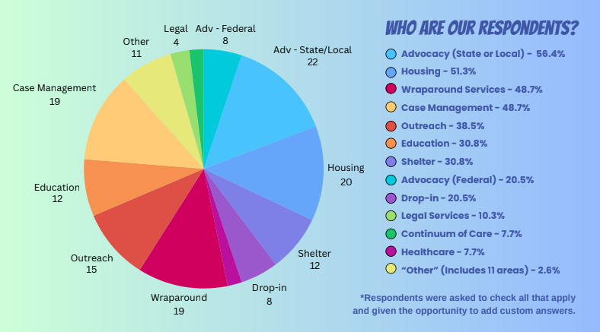

## CHAPTER 2: Foundational Labor Law Issues - When is a “Contractor” Actually an Employee?

A small organization began a new project and hired several youth with lived expertise of homelessness as consultants to provide advice and complete some deliverables for the project. The youth hadn’t worked as consultants before and the organization didn’t provide any information about potential legal or tax obligations, except informing them that they would receive a 1099 form if they earned over $600 per year.

When tax time came around, the youth were surprised to learn they owed taxes on the income they earned and were unprepared to pay them. The youth reached out to the state Attorney General office for help, which resulted in the organization receiving notice that it was inappropriately classifying employees as independent contractors. Because the youth **had supervision, were not completely directing their own work, were carrying out the work of the organization’s mission, and did not run their own business as consultants**, they could not be considered consultants under state law.

The first legal consideration in engaging and paying young people is to determine whether the organization is engaging a young person as an employee, independent contractor, or participant. **Each state has a test to determine whether someone is considered an employee, an independent contractor, or neither** (some states defer to the federal test, which is partially in flux due to lack of a final rule). An overview of the federal test and the test for all 50 states and the District of Columbia can be found [**here**](https://docs.google.com/spreadsheets/d/1gOKq5YdPmCLrNzIoA84pUlhUKERVNykH/edit?usp=drive_link&ouid=115011792647741663827&rtpof=true&sd=true).

Here are some general questions an organization should ask before engaging a contractor:

1. What amount of control will staff have over when and how the young person does the work?
2. Does the work require special skills? Is it outside the usual course of business at the organization?
3. Does the young person have the opportunity for profit or loss? Can they negotiate their rate? Do they contract with other organizations?
4. How permanent is the working relationship between the young person and your organization?

Generally, if an organization offers a stipend, gift card, or incentive to attend a meeting, focus group, or training, it is unlikely that this would create an employee relationship nor would that young person likely be considered an independent contractor (unless, for instance, they are in the “business” of attending focus groups). In this case, a young person is mostly likely a participant and it is unlikely that labor laws are implicated. **However, any income (or item that has cash value, including gift cards) that a young person receives from an organization is potentially subject to income tax**. See CHAPTER 4 below.

If an organization is engaging a young person on an ongoing basis, it is imperative that there is clarity around the questions described above. **If the young person cannot complete the project without supervision from staff, if staff are dictating when and how the young person completes the work, if the young person is doing work that you otherwise engage employees to do – these are all signs that the relationship might be employee, rather than contractor.**

Special considerations for working with minors[10]

Normally, young people under the age of majority (usually 18) can’t enter into binding contracts. But some jurisdictions allow a minor to contract for housing and necessities when a minor is living independently or allow certain minors above a certain age to contract. If you are planning to contract with a minor, check the law in your state **here**.

One final note is that there are several different words people use to refer to people working as non-employees: contractor, consultant, freelancer, gig-worker (to name a few!). They all basically mean the same thing and are subject to the same laws and rules.

### Best Practices for Organizations

So, what does this mean for organizations committed to working with young people in an ethical, trauma-informed, and supportive way? It means that it is very difficult to do this in a contracting relationship. Contractors are supposed to be able to work independently, bringing a specialized skill that is not already a core function of the organization. If this is not the relationship that your organization or the young person is envisioning - contracting is not the right path. Organizations should consider temporary employment for longer term engagements (with clear plans for training, mentoring, and professional development) ororganizations could create paid opportunities for young people to engage in as a participant - these could include training and mentoring on particular skills, as well as opportunities for organizations to gather feedback and survey young people about their experiences. For tax treatment of participant stipends, see CHAPTER 4 below.

Organizations that are going to engage in contracting with young people or with businesses started by young people must first [get familiar with the labor laws in the state](https://docs.google.com/spreadsheets/d/1gOKq5YdPmCLrNzIoA84pUlhUKERVNykH/edit?usp=drive_link&ouid=115011792647741663827&rtpof=true&sd=true) where the organization is incorporated and the state where the young person resides. Ensure that the work you are planning is actually appropriate for contract work. Make sure that all levels of staff who may be working with young people as contractors understand the parameters and limitations of the law. And then, check out the best practices in CHAPTER 3 to ensure that the organization’s processes around contracting and contract negotiations are fair, transparent, and equitable.

### Red Flags for Young People

* If the organization is looking to contract with you but is promising mentorship, training, and other kinds of supports (especially ones that aren’t specified in the contract) - the organization may be incorrectly classifying you as a contractor.
* If you are being asked to complete or lead a project and you cannot lead or complete it independently, you may not be considered a contractor under the law.

*Protections that Apply to Employees and Contractors*

“The employer is automatically liable for harassment by a supervisor that results in a negative employment action such as termination, failure to promote or hire, and loss of wages. If the supervisor's harassment results in a hostile work environment, the employer can avoid liability only if it can prove that: 1) it reasonably tried to prevent and promptly correct the harassing behavior; and 2) the employee unreasonably failed to take advantage of any preventive or corrective opportunities provided by the employer.

The employer will be liable for harassment by non-supervisory employees or **non-employees over whom it has control (e.g., independent contractors or customers on the premises)**, if it knew, or should have known about the harassment and failed to take prompt and appropriate corrective action.” (emphasis added)

<https://www.eeoc.gov/harassment#:~:text=The%20employer%20will%20be%20liable,case%2Dby%2Dcase%20basis>.

## CHAPTER 3: Contract Law Considerations

A contract is a legal document that represents an agreement between the people (or “parties”) signing it. To make a legal contract, both parties must give or promise something to the other, such as money or work, and both parties must freely agree to the terms without being tricked or forced. If someone signs a contract but then doesn't do what it says, they might have to pay money to the other party or be required by court order to do what was agreed to in the contract.

For organizations engaging young people as independent contractors, if the young person doesn’t already have a contract that they usually use, having a [plain language](https://nlchp.sharepoint.com/:b:/g/EVQR0HiFgpNJjY1AOYs3opAB4S1AlYkJplnnyFOkmsSlqw?e=WvHUvb) contract template available is a helpful resource. Plain language contracts are the opposite of complicated contracts full of legal jargon. Here are some elements of a plain language contract:

* Short sentences and common words with common everyday meanings.
* Able to be independently understood and implemented by the people who are responsible for doing the work under the contract.
* What each person promises to do is clear - no provisions are vague or subject to guessing.
* No legal boilerplate - each section uses as few words as possible to explain what it means.

One of the potential downsides to a plain language contract is that it might not be able to address as many potential future situations as a complicated contract. Contracts dealing with very complicated topics may need to be long. But when the topic is not very complex, negotiating parties can try to make their contracts shorter, more clear, and less complex. The people negotiating a contract will need to consider the advantages and disadvantages of plain language contracting when negotiating a contract.

### Contracting Best Practices

* Clearly lay out the expectations of the parties, especially regarding the work to be accomplished and the timeline. Setting clear standards of performance can help avoid conflicts and miscommunication.
* Provide detailed payment terms, including:
  + Amount and schedule of payment(s)
  + If there will be expenses, who will cover them? Who will be responsible for fronting the money?
  + Method and mechanics of payment
* Include conflict resolution terms, particularly if the parties want to agree to set a dispute mechanism (such as mediation).
* Make the duration of the contract clear and address when and how the contract can be terminated or extended.
* If there are strict deadlines around the performance of services under the contract, it can be helpful to add language to address what happens if something goes wrong or something unexpected happens.
* Contracts should address what the rights of the parties are in the event the contract is violated.
* When contracting for written work or other forms of intellectual property, a contract should make it clear who owns the rights to the intellectual property.

### Potential Red Flags when Writing a Contract

* It’s not always clear who or what is covered by each sentence - language should be drafted so that it is clear which parties have rights or obligations.
* Important words aren’t defined in the contract - if this is the case, sections of the contracts using undefined terms can create ambiguity and confusion.
* There is nothing in the contract that says how long it will last or how it can be ended or changed, if needed.
* There isn’t enough detail to provide clear instructions on what is expected of one of the parties.
* Some parts of the contract are conflicting or say different things (e.g. one paragraph says 30 hours a week, but another says 40 hours a week).
* The contract is not well-written or has errors.
* The penalties or fees for not following (or “breaching”) the contract are harsh, unfair, or uneven in a way that departs from the agreement of the parties.
* The contract is written in a way that makes it hard for one or more of the parties to understand it.
* Before entering into a formal contract negotiation the parties generally have an informal deal on the table - this deal should be reflected and fleshed out in the contract, the contract should not revise the deal without the mutual agreement of the parties.

*Potential Red Flags when Signing a Contract*

* You don’t understand what the contract says or means. Before signing a contract, think about whether you need a lawyer to advise you.
* You notice that the details of the contract don’t make sense, or don’t look like what you previously agreed to. (Often, contracts contain language that the agreement on paper replaces any verbal contract previously made so be careful to read the contract carefully to make sure you agree with the terms.)
* Someone is pressuring or forcing you to sign the contract or agree to certain terms.
* You or someone else is sick, under the influence, or otherwise not able to think clearly when signing the contract.
* You think the contract might be unfair.
* If one of the parties does not want to sign the agreement or does not agree to the terms of the contract, they should not enter into the contract but instead voice their concerns and see if the other party is willing to negotiate. Sometimes, not having a deal is better than having a deal that you don’t want.

### Special Considerations for Accessibility, Accommodations, and Disability

The Americans with Disabilities Act (ADA) prohibits discrimination against individuals with disabilities in many areas of life, including in the workplace. The ADA requires employers to provide “reasonable accommodations” for employees or job applicants with disabilities, including accommodations that allow you to do your job as easily as other people or ones that allow you to enjoy the work environment as much as other people (unless providing the accommodations would be unreasonably difficult).

However, the ADA does not apply in all situations - including independent contractors. If you require accommodations due to disability or other mental or physical impairment, you should put these accommodations or conditions into the wording of the contract itself. However, just because something is not included in a contract, does not mean that your employer is not required to provide it. If you have questions about whether something might be covered or required under the ADA, you can visit one of these websites:

* [ADA National Network | Information, Guidance and Training on the Americans with Disabilities Act](https://adata.org/)
* [JAN - Job Accommodation Network](https://askjan.org/)
* [Home | U.S. Equal Employment Opportunity Commission](https://www.eeoc.gov/)

### Contracting Problems and Solutions - Based on Real Life Scenarios

By Jacq Tate

**Problem 1:**

An organization is looking to hire a young person with lived experience as independent contractors for a project. The job listing states: “You will be working on a project with 1-3 hours minimum a month for up to 12 months. Payments will be made monthly once hours have been received. Email us to be considered.”

This may sound vague to an established organization, however this is an example of what youth are provided when inquiring about a position. Specifics about the terms of the project, the hours listed, and how payments will be made are not discussed until after the young person has agreed to the position. This creates too much leverage for the organization over a youth contractor, leading to confusion, resentment, and lack of trust.

**Solution 1:**

Clearly state during the interview and on the potential contract, start date of the project and the end date. If there are specific requirements regarding what is classified as work related to the project, this must be detailed as well. It’s important that the organization is clear in what they expect from the independent contractor, especially when working with youth who may be new to this type of work and don’t know what questions to ask.

Diving deeper into the job listing, what does 1-3 hours minimum of work look like? If you only expect 1 hour a month but are stating 3 hours minimum, youth will expect to be paid the 3 hours and will budget this into their finances. Every dollar, every hour, can make the difference between someone being able to afford their rent, food, or medication so it is necessary to be transparent when searching for youth with lived experience to partner with.

Finally, when creating a call for youth contractors to join a project, explain exactly what you are wanting to receive in the email to be considered for the position. If there are no requirements such as a resume, letter of recommendation, or examples of previous work, then state that in the listing. However, if your organization is deliberately being vague and is wanting to see how youth respond to judge accordingly, then this can create unnecessary confusion or lack of engagement from youth in the future.

**Problem 2:**

A young person and a staff member of an organization meet to discuss a potential project. They discuss payment terms during the meeting but then the contract provided does not reflect what was discussed during the conversation because the staff person did not have the authority to offer those payment terms. There is no room to negotiate and there is no option for the young person to discuss payment with the correct person (ex: HR or team lead or financial team). It’s either accept the offer or don’t do the work.

**Solution 2:**

When searching for youth with lived experience for a project, it is important to be as transparent as possible while providing an opportunity for the contractor to ask questions until they are certain of the requirements for payment for a project. If this is a grant-funded project with rules regarding payment structure or payment type, this must be expressed before signing a contract because this may be a potential barrier for youth who cannot access certain payment types such as direct deposit, mailed checks, or payment apps. If promises were made during a spoken conversation that are not reflected in the contract, have an open discussion about why changes were made and allow an opportunity for the youth contractor to negotiate terms.

### Best Practices for Organizations

* Use a plain language contract avoiding the red flags described above.
* Be open to negotiation - if your contract is take it or leave it, you are not truly engaging a young person as an independent contractor.
* Make sure the contractor has a copy of the fully executed (signed) contract.

### Quick Note on Non-Disclosure Agreements and Non-Competes

Non-Disclosure Agreements (NDAs) and Non-Competes are two ways that employers might attempt to limit an employee or contractor’s ability to talk about certain things or do certain jobs.

**Non-Disclosure Agreements (NDAs)[11]** are agreements where the person signing agrees not to talk about something for a limited amount of time. NDAs can be different in scope and term, so if you’re signing an NDA, it’s important to read it carefully and understand what is or is not allowed under the NDA. For example, an NDA may only last until a secret project has been disclosed to the public, or it could go on for many years. It might forbid you from talking to anybody about a certain topic, or it may allow you to talk to some people but not others. In order to avoid accidental disclosure or breach of the agreement, the NDA should be very clear about:

* What “Confidential Information” or topic of potential discussion is covered
* Who cannot disclose the information, who cannot receive the information (if someone specific), and which methods cannot be used to communicate (if applicable)
* How long the NDA lasts
* What happens if you accidentally disclose something that was covered by the NDA

**Non-Compete Agreements or Provisions (Non-Competes)[12]** are agreements or provisions/clauses where the person signing agrees not to work in a certain industry or area for a certain amount of time either (i) after the signing of the agreement or (ii) after you stop working somewhere.

Non-Competes often cover both working for possible competitors in the same industry as your original employer AND starting your own business in that industry. For example, if you are hired to work at CVS and your contract includes a non-compete, you might not be allowed to work at Walgreens, Duane Reade, or Rite Aid OR start your own pharmacy within a certain amount of time after you leave CVS.

If a contract you’re signing has a Non-Compete, you should think carefully about whether this might negatively impact future opportunities for you and whether there might be a way out of the Non-Compete. You should also make sure that the contract is clear about what jobs you might not be able to take and how long the Non-Compete would last.

Non-Competes might look different from each other, so it is important to read carefully, but below are a few examples of wording that might be used: *“[Employee] agrees that for a period of [twelve months] following [the date of this Agreement] / [the conclusion of Employee’s employment with the Company], Employee shall not in any manner:*

* *engage with any business competitive with the Company*
* *compete with the Company or the business of the Company*
* *participate in any business engaged in the provision of services that are the same as the Company”*

## CHAPTER 4: Tax Implications

[2025 Tax Resources and Q&A](https://docs.google.com/document/d/1A-GHKh-_BPoVLBpm1reuQ4z-nxJ4P8vlyitP3eBibhg/edit?usp=sharing)

NOTE: This chapter covers the tax implications for young people earning money as non-employees of nonprofit and governmental organizations.

For young people serving on youth action boards or engaged in other types of non-employee work, receiving a 1099 form is the start of the sometimes nerve-wracking experience of filing and paying federal and state taxes.[13] Young people might assume that they aren’t earning enough money to owe taxes or that the organization they are working with is withholding taxes. After all, an employer is obligated to withhold income tax and Social Security and Medicare taxes from their employees’ paychecks (and to pay a matching amount of Social Security and Medicare taxes for their employees).

**But contractors and non-employees (people who are “self-employed”) are responsible for keeping track of and paying their own federal and state income tax and self-employment taxes** (i.e., Social Security and Medicare taxes). (For more information about whether someone is an employee or a contractor, see Chapter 2). The current rate of Social Security and Medicare self-employment taxes is 15.3% and must be paid on net earnings (the amount of income left after you deduct all allowable expenses) of $400 or more.[14]

Another issue for contractors and non-employees is that **the U.S. tax system is pay-as-you-go**. This means that workers should have paid the majority of their tax liability by the time their tax return is due or face a penalty. Employers usually satisfy this requirement through paycheck withholding. But gig workers and contractors may need to make quarterly estimated tax payments during the year to cover this obligation.

In this chapter, we will cover common tax issues and forms young people may encounter, as well as the reporting obligations of organizations engaging youth.

### 

### Form 1099

The 1099 form is a common IRS form covering several potentially taxable income situations. Organizations are typically required to issue a 1099 form to a taxpayer who has received at least $600 or more in non-employment income during the tax year.

There are several types of 1099s that a young person may receive:

* **1099 K** is a report of payments from selling goods or providing services during the year from credit, debit, “stored value cards” such as gift cards, payment apps (such as Venmo, Paypal, Cash App) or online marketplaces (such as Etsy)[15]. For more information, see:
  + <https://www.irs.gov/businesses/what-to-do-with-form-1099-k>
  + <https://www.irs.gov/businesses/understanding-your-form-1099-k>
* **1099 NEC** is used to report nonemployee compensation. If an organization only pays contractors via direct deposit or check, it is likely to be reported on a 1099 NEC.
  + <https://www.irs.gov/forms-pubs/about-form-1099-nec>
* **1099 Misc** is a catch-all for “other income payments”
  + <https://www.irs.gov/forms-pubs/about-form-1099-misc>

**Even if an organization doesn't provide a Form 1099, the taxpayer is required to report all income, unless excluded by law**. This means young people may need to track and self-report their income and expenses.

### Filing Taxes as a Non-Employee: Who, What, Where, When, Why

**WHO:** If you earn income, meaning you receive money or something of monetary value, like a gift card, in exchange for something (work, participation, survey completion, etc.), it is VERY likely that you will need to file taxes unless the total amount you earned minus any expenses you incurred to earn that income is under $400. If your net earnings from self-employment were less than $400, you may still have to file if you meet any other filing requirements for Form 1040 (such as income from a regular job).

**WHAT!?:** Yes, even if the “income” you receive is a bunch of gift cards or called a stipend or an incentive and even if you don’t have a contract with the organization that provided them to you - you are still considered self-employed for tax purposes. See more about why below.

**WHERE:** The annual income and expenses should be reported on [Schedule C](https://www.irs.gov/pub/irs-pdf/f1040sc.pdf). Before you can determine if you’re subject to self-employment tax and income tax, you must calculate your net earnings/profit by subtracting your business expenses from your business income for the year. If your expenses are less than your income, the difference is net profit and is reported on [Form 1040](https://www.irs.gov/pub/irs-pdf/f1040.pdf). If your expenses are more than your income, the difference is a net loss. You may be able to deduct your loss from gross income on Form 1040. But in some situations your loss is limited. See [Pub. 334, Tax Guide for Small Business](https://www.irs.gov/forms-pubs/about-publication-334) for more information on business income, expenses, and when a loss is deductible.

**WHEN:** Individual income tax returns are typically due April 15, unless the date falls on a weekend or holiday (then the deadline is the next business day. However, since the tax system is pay as you go, some self-employed youth may need to make [estimated tax payments](https://www.irs.gov/businesses/small-businesses-self-employed/estimated-taxes) throughout the year. Estimated tax payments for your federal and state income taxes and any self-employment taxes are generally due on April 15, June 15, Sept. 15 (of the current year) and Jan. 15 of the following year (unless these dates fall on a Saturday, Sunday, or federal holiday, then the due date is the next business day). You can use [Form 1040-ES, Estimated Tax for Individuals](https://www.irs.gov/pub/irs-pdf/f1040es.pdf) to calculate and report the amount of these payments. The fastest and easiest way to make estimated tax payments is electronically, using [IRS Direct Pay](https://www.irs.gov/payments/direct-pay-with-bank-account) or the [Treasury Department’s Electronic Federal Tax Payment System (EFTPS)](https://www.eftps.gov/eftps/). A [Paycheck Checkup](https://www.irs.gov/paycheck-checkup) using the IRS Withholding Estimator can help you see if you should make additional tax payments to avoid an unexpected tax bill or underpayment penalty when you file your tax return.

**WHYYYY?[16]:** It is undoubtedly an injustice that young people earning such small amounts of income as non-employees are responsible for paying taxes on it. By contrast, employees earning under $14,600 (in 2024) usually do not need to file taxes and will likely not owe any taxes on that income. The reason self-employed people need to file and pay taxes on even small amounts of income is to track earnings for and pay into Social Security and Medicare (something an employer does automatically for their employees). [Social Security](https://www.usa.gov/what-is-social-security) is a retirement program but also a life insurance ([Survivor Benefits](https://www.ssa.gov/survivor)) and disability insurance ([SSDI](https://www.ssa.gov/disability)) program[17]. Social Security retirement benefit amounts are based on your earnings that you pay Social Security taxes on[18]. If you don’t pay in, you won’t be able to access or use this benefit later on. Similarly, [Medicare](https://www.medicare.gov/basics/get-started-with-medicare) is a federal health insurance program for people age 65 or older (and people younger than age 65 with certain disabilities). If you pay into Medicare through these taxes, you are able to then access some of the benefits for free when you retire.

### Expenses and Recordkeeping Tips for Youth Contractors

The IRS has some good tips on [recordkeeping](https://www.irs.gov/businesses/small-businesses-self-employed/what-kind-of-records-should-i-keep). In order to deduct expenses from your self-employment income, you will need to track them and keep receipts or proof of the expense (or photos of the receipts/proof). It is best to keep your documentation in one place - using a spreadsheet or folder for that tax year. Experts recommend saving these receipts and proof of expenses anywhere from three to seven years[19].

Example of Deductible Expenses:

* Equipment, such as computers, phones, furniture that you use for work (and not for personal use);
* Operating Expenses, such as phone or internet bills, postage, software, or the cost of transportation to get to meetings - anything (not including personal expenses) that you have to spend to complete the job;
* Education, such as trainings, webinars or conferences to maintain or improve your skills or are required for the tasks you need to complete; and
* Travel for work, including public transportation.

It can be helpful to connect with a tax professional who is experienced in working with small businesses to ensure you are maximizing all possible expenses.

Note on Undocumented Tax Filers

If you do not have a social security number, you can still meet your legal obligation to file taxes using an ITIN (Individual Taxpayer Identification Number). See [this page from the IRS](https://www.irs.gov/tin/taxpayer-identification-numbers-tin#itin) for more information.

### Tax Information for other Types of Income

The information above is for youth working as independent contractors, consultants, or who participate in focus groups or other programs that offer a financial incentive or stipend. But some young people may have income from other sources and some of it may also require tax filing:

1. Employment Income
2. Unemployment Income
3. Scholarships or Fellowship Income
4. Social Security/SSDI Income

### Resources for Tax Help

Help with tax filing, including state taxes: <https://www.irs.gov/individuals/free-tax-return-preparation-for-qualifying-taxpayers>

Link to state tax information: <https://www.usa.gov/state-taxes>

Information/help if state taxes are owed: <https://publicintegrity.org/inequality-poverty-opportunity/taxes/unequal-burden/behind-on-state-income-taxes-heres-what-you-need-to-know/>

## Youth Compensation Advocacy Workgroup, *Youth & Young Adult Compensation Survey*, 2023.

## CHAPTER 5: Impact of Youth Compensation on Benefits

“People face a benefits cliff (also known as the “cliff effect”) when they receive public benefits from the government, earn a raise, and then discover that they make too much money to receive the benefits. But they are not making enough money to sustain themselves and their household.” <https://www.benefitscliff.com/what-is-a-benefits-cliff>

Almost all government benefits are connected to income. As people receive more income (or in some cases, as they save more money or put money away for retirement), the amount of their benefits usually decreases, sometimes to zero. And it doesn’t need to be a lot of income or saved income to mean the difference between qualifying and not qualifying for food assistance, medical assistance, TANF, and other general assistance programs. **It is extremely important that organizations seeking to engage young people understand and account for these potential impacts by letting young people know that even small amounts of income may be reportable and may impact their public benefits**.

For young people working as contractors, hourly rates should take into account the potential loss of benefits. For young people hired as employees, wages and benefit packages should be designed so that a young person does not face a benefits cliff without the ability to sustain themselves and their household on their earned income.

For young people with disabilities who receive SSI or SSDI, this is an even more complicated equation with much bigger risk – most disability benefits require that a person not be able to engage in “substantial gainful activity”, a fancy word for part-time work (which can even include “work-like” activities). There is also a very strict limit on the amount someone receiving SSI and SSDI can save. There are some exceptions and limited options and opportunities for young people with disabilities to earn and save but it requires detailed understanding of program rules. **It would benefit all organizations who engage youth to become familiar with these issues and to develop a list of referrals to legal or other advocates who can help and advise young people regarding benefit issues.**

### Best Practices for Young People

* Find out how much you are being paid and how often and ask for the information in writing.
* Keep a record of payments and any expenses related to your youth engagement work, including any taxes you may owe (see Chapter 4 for more information about taxes, including deductible work-related expenses)
* Review the income limit, asset limit[20], and reporting rules for the benefits you receive.
  + Your approval or renewal letter will have this information or the website for the state agency that issues the benefits.
  + For some benefits, you have to report anytime you earn additional income; for others, you only need to report if you earn or receive over a certain amount; and for others, you may only need to report changes in income the next time you reapply (sometimes called recertify or renew).
* If you still aren’t sure, [contact a lawyer](https://consumerattorneys.com) who does public benefits work – for a directory of lawyers in your state, visit <https://youthhomelessnessindex.org/legal-help/> or contact HYLN at 202-662-1695.
* Use extreme caution when speaking to benefits case workers – they work for the state and are not your advocate. Any information you give them can and will be used against you.

Note that many caseworkers will not necessarily understand what a Youth Action Board is nor will they be familiar with youth consulting work in general. As such, organizations engaging youth can help by providing an explanatory letter or other documentation explaining what the project is and how much, how often and under what conditions a young person will be paid. For youth working as consultants, it is important to have a written contract that covers all relevant details (see Chapter 3 for tips on contracting).

Depending on where a young person lives, they might receive benefits from local, state, or federal government agencies. Here is a list of many common public benefits:

* Supplemental Nutrition Assistance Program (SNAP or Food Stamps)
* Temporary Aid to Needy Families (TANF)
* Childcare Subsidy
* WIC
* General Assistance
* Housing and Urban Development (HUD) (Public Housing Authority Properties, Section 8 Vouchers, Supportive Housing Program)
* Medicaid
* Social Security (Supplemental Security Income (SSI), Social Security Disability Insurance (SSDI), Childhood Disability Benefits (CDB))
* Low Income Home Energy Assistance Program
* Emergency Rental Assistance
* Child Support
* College Student Financial Aid

## 

## CHAPTER 6: Forming and Working With Microbusinesses

*“Quite often youth who are learning about work that involves working on a project, event, or speaking engagement with an organization do not know how to leverage the current work they are doing. Youth are classified as a contractor for these tasks, however they do not understand the pros and cons nor how to utilize current connections to create more work opportunities and stability for the future. If gig-work is what you do and works better than a traditional 9-5 job, then it may be beneficial to start your own business. The benefit of starting your own business is that you can create a name for yourself in the area of youth homelessness so people can seek you out. If there are no arrangements between the current organization you are working for that prevent you from seeking out other projects, yet you don’t have your own business, this may hinder other organizations from contacting you thinking you are an employee or in a non-compete agreement.”* - Jacq Tate

### Benefit of Incorporating

One of the advantages of certain forms of business is that they offer a limitation of liability to the owners of the business, meaning that business is owned by a legal person (the company) and the physical person who owns the company is shielded from personal responsibility for their company’s debts and liabilities. Limitation of liability means that business owners risk only the funds they have invested in the business, not other assets they may own.

However, sole proprietorships (the default business structure if the business owner hasn’t filed/registered with the state) exposes the sole business owner to unlimited potential liability. Similarly, general partnerships create unlimited personal liability for all owners, including for the acts of other owners.

Business owners who are also operating the business should also be aware that limitation of liability may not protect them in all events, such as fraud or negligence.

Another benefit is the opportunity for undocumented young people to work legally in the U.S. by opening a business or consulting service. This [guide](https://immigrantsrising.org/wp-content/uploads/Immigrants-Rising_Working-for-Yourself-Guide.pdf) from Immigrants Rising provides a comprehensive overview of what to be aware of and best practices when starting a business or independent contracting as an undocumented person[21]. It also has great tips for small business owners in general. Note that while U.S. law does not bar undocumented immigrants from forming businesses, it also doesn’t explicitly allow it and it is illegal to hire (as an employee) an undocumented worker[22]. Consult an immigration attorney for more information.

### Types of Businesses

Growing a business is easier if you choose the appropriate business entity. Doing so can allow new people to join the business as owners and employees and gives owners the option of transferring or selling the ownership interest.

* **Sole Proprietor:** Sole proprietorships are essentially when a single person just does business alone. That is, the person does not incorporate a company or work with partners. Sole proprietorships arise without formal legal filings - it is the default business entity. A sole proprietor is fully liable for all debts incurred.
* **Partnership**: Partnerships are legal arrangements that allow multiple people to own and operate a business. A general partnership arises spontaneously when two or more people collaborate in a business sharing profit. Those partners do not benefit from limited liability. In fact, general partners are liable for the debts incurred by their partners for the business. A limited partnership requires filings with the state to be created, and someone who is labeled a limited partner in that partnership does benefit from limited liability but may not participate in the management of the business.
* **LLC:** Limited liability companies are the most popular form of company for small businesses and are seen to have many advantages. LLCs must be formed with a state by filing appropriate paperwork and fees. LLCs can have one or more owners who collaborate like partners. All owners of a limited liability company benefit from limitation of liability. Multi member LLCs can elect to be taxed as a corporation or a partnership - allowing the choice to be taxed at the entity level or at the owner level. That is, the income will be only taxed once. LLCs generally have fewer requirements under state law than corporations.
* **Corporations**: C Corporations are formed through filing appropriate paperwork with a state and paying relevant fees. C Corporations generally have more governance formalities than other forms of business entities. The owners or “shareholders” of a C Corporation benefit from limitation of liability against the debts of the corporation. C Corporations themselves are required to pay taxes at special corporate tax rates. If a business is formed as a corporation, the corporation will be taxed first and the shareholders will be taxed again from the profit they make on the business. This is a major reason why limited liability companies are a more popular choice for small businesses.

### Effect on Taxes/Tax Filing as a Business

Both businesses and the humans that own businesses may be taxed. Some forms of business entities are always taxed while other forms can be structured so as to pass through their tax burden to the individuals who own the businesses. Some business structures may lead to “double taxation” where the business is taxed and the funds distributed to owners of a business are taxed. People forming businesses should have a tax plan that addresses their specific circumstances before forming a business to avoid inefficiently placing themselves in highly taxed situations.

### State and Local Licensing Requirements

For practical purposes, any business entity you create will exist under and be governed by state law. Many larger businesses, from across the country choose to incorporate in the State of Delaware for its excellent courts and well-developed body of case law. About 35 other states use a “model law” for companies, so that their law is generally the same. The law governing LLCs is largely the same from state to state. **Businesses are governed by the law in the state where they were formed. However, when businesses enter into contracts, sign leases, or get into accidents, the law applied will usually be the law of the states in which they are operating.** For example, a business that is formed in Delaware and has an accident or signs a lease in New York will need to follow New York law for its operational activities, but the question of whether a company officer had power to sign the contract or breached a duty in doing so will be governed by Delaware law on governance. Often businesses that are formed in one state but operate in another will need to make filings in the second state before doing business.

Business entities generally need to make annual filings with a “Secretary of State” office to affirm their address and the officers of the company, as well as pay annual taxes and fees to the state. Some cities and towns also require businesses to apply for local licenses to operate. If you start a business, be sure to check the requirements in your state and the locality where you live or are planning to operate. All of these fees will generally be deductible as expenses on your taxes.

“*One thing that worked well for me regarding tax implications is that by having my own LLC, there are several things that I can write off each year which make my taxes lower or even non-existent since I don’t make as much as people who may work 40+ hours a week. I am able to write off part of my rent for my office space, as well as my phone, internet, and times where I travel and pay for food and lodging. Having an LLC specifically has also provided me with more power when negotiating contracts, because I am not just a sole proprietor, I have another business partner who helps walk me through contracts and decisions so I don’t just sign things I may not understand. Other benefits of having a business have meant I can make a paystub for my work, which is very helpful when needing to prove income for renting or benefits”* - Jacq Tate

Filing taxes as a business entity is beyond the scope of this guide, but the IRS has helpful information here: <https://www.irs.gov/businesses/small-businesses-self-employed>

## CHAPTER 7: Making and Receiving Payments – Harder Than You Think!

Organizations can have the best intentions to create youth-friendly payment practices and still mess up, cause harm, and damage trust. Often the program staff working directly with youth don’t fully understand the ins and outs of how their organization pays contractors or manages their finances. Operational staff who aren’t working directly with youth can sometimes be frustrated by the recommendations or complaints coming from program staff and youth. They may feel they are being asked to do things in a way that is different from current organizational policy or that is different from the industry standards they were taught. Operational staff in nonprofit organizations are often wearing many hats - finance, human resources, compliance, etc. - and may not have capacity to think deeply about the effect of organizational financial policy and practices on youth contractors and participants. Program staff, on the other hand, may feel disempowered and stuck - unable to set up payment systems that are responsive to youth with lived expertise, while at the same time telling the world that the organization values the input and leadership of youth. This chapter is a living one and will be improved and edited as we collectively find better ways and smoother systems to actually pay youth.

### 

### Policies

After reading this guide, organizations should gather everyone who has any responsibility in managing or making payments to young people and co-develop a clear, written policy about what types of payments are available, what paperwork is required from young people and staff and when, who is responsible for which part of the payment process, payment options and timelines, any resources or information (about taxes or other issues) the organization can provide and how to ensure equity in payment options for youth with special circumstances (for example, undocumented youth or youth receiving benefits with strict income guidelines).

### Types of Payments?

Under what circumstances will your organization pay young people?

* One time events?
* On-going projects?
* Advisory or action boards?
* For participation in trainings?
* For surveys or focus groups?

For each circumstance, evaluate whether the young person should be classified as an employee, independent contractor, or participant. Get legal advice if you aren’t sure.

### Paperwork Required?

* Will you require the young person to sign a participation agreement or a contract? If so, provide an approved template to program staff. If you are going to contract with a young person, a draft plain language contract is a good starting point, but remember that the terms and rates must be negotiable based on skill, expertise, and project complexity.
* Under what circumstances will you require young people to provide a [W-9 form](https://www.irs.gov/pub/irs-pdf/fw9.pdf) (Request for Taxpayer Identification)? What other contact or personal information do you need to collect? Think carefully about your data collection practices and minimize where you can.
* Will young people have to provide timesheets before they can get paid? Do program staff need to sign them? Do you require an invoice before providing payment? Do you have a sample invoice you can share for youth who are new to contracting?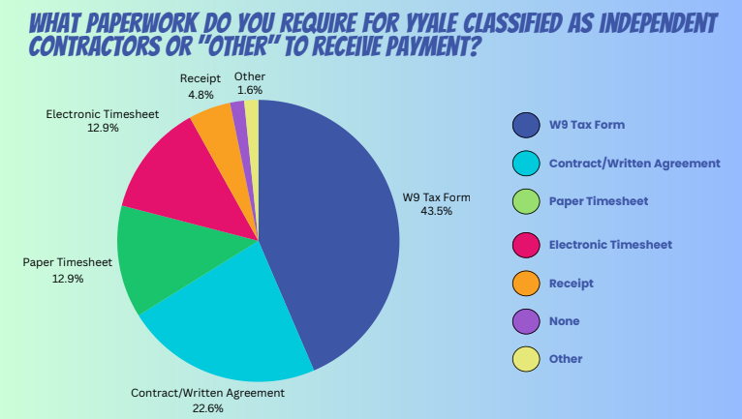

### Payment Options and Timelines

Youth Compensation Advocacy Workgroup, *Youth & Young Adult Compensation Survey*, 2023.

Despite many more direct payment options available, some organizations are still set up to prefer checks and gift cards to other more modern forms of payment. When surveyed, youth tend to overwhelmingly prefer cash, payment apps, or direct deposit, with gift cards being least favored. All of these payment types present unique challenges for both organizations and youth. Ideally, there should be several options for youth to choose from and those options shouldn’t require program staff to front the money and wait for reimbursement. 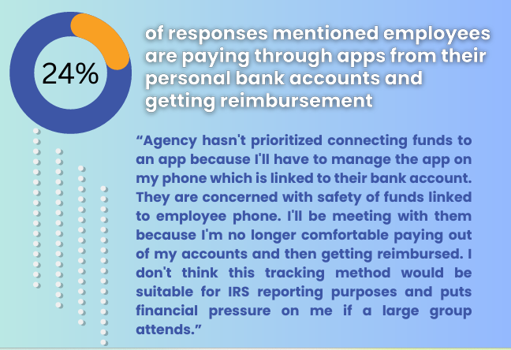

Payment by check can be problematic for some youth who don’t have a bank account or easy access to a bank or online banking with mobile deposit. For youth that have a bank account, direct deposit is fast, secure, and usually avoids fees for the young person (the organization may incur costs setting up or expanding its direct deposit system to include payments to contractors/non-employees).

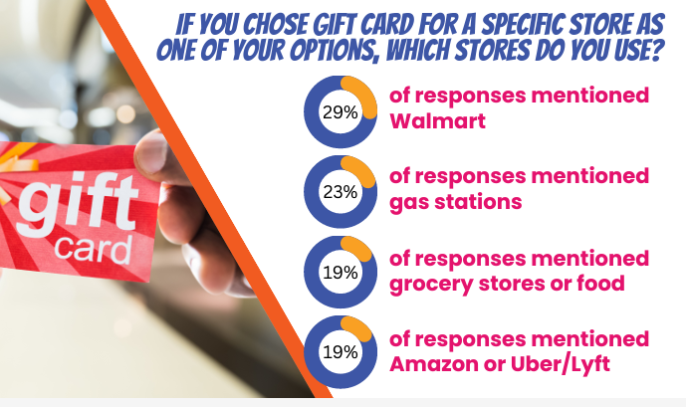

Many organizations utilize gift cards, as it is easy to purchase them in bulk and provide to program staff for distribution. While cash/Visa gift cards are preferred over store specific, gift cards in general present a few unique challenges. For young people, it is rare that they can access the full value of the card - purchases might come in just under the full value, leaving a few dollars on the card that can’t be used for something else. Gift card fraud is very common and organizations and young people may be left scrambling when it becomes apparent that the gift card is empty or doesn’t have the full value promised.

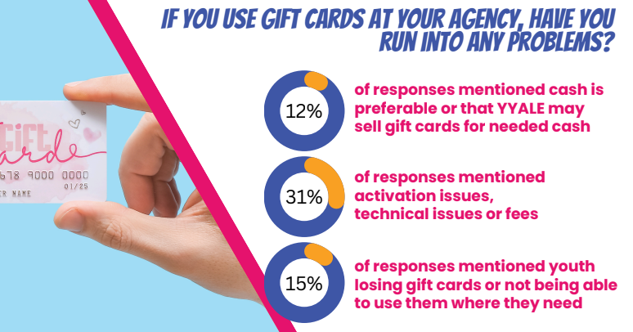

Payment apps such as Venmo are a promising alternative - generally accessible to young people (as the apps can usually be used to store balances and pay for things even if not linked to a bank account) and fairly easy to set up as an organization. Still, it is really important to understand how the apps work, the fees involved, and to assess any security concerns that financial staff may have regarding these products. Organizations should always plan to cover these fees and ensure that young people get the full value of the compensation promised.

| **App** | **What is it?** | **Fees** | **Pros** | **Cons** |
| --- | --- | --- | --- | --- |
| Cash App | A digital wallet and financial services platform that allows users to send, receive, and save money. It also offers banking services. | Offers standard transfers to a bank account for free (but it takes 1-3 business days).  Instant transfers to a debit card are subject to a 0.5% -1.75% fee (with a minimum fee of $0.25).  2.75% processing fee to a business account. | Can be used without a bank account. | Limited customer service if something goes wrong |
| PayPal | An online payment system that allows people to send and receive money to their PayPal accounts. Credit cards, debit cards, or bank accounts can be linked to this account or money can be stored via a PayPal Balance account. | [So many](https://www.paypal.com/us/webapps/mpp/paypal-fees). There is a 1.75% fee to transfer money to a bank account immediately rather than waiting 1-3 days and 2.99% fee for goods and services transactions, which most orgs will be required to use. | Can be used without a bank account. You have to provide a payment method to send money or make payments. | The fee structure is complex and can be unpredictable. |
| Venmo | A mobile payment app that allows users to send and receive money from friends, family, and businesses. It's similar to PayPal, but Venmo also has social features that let users share and like payments. | No fees to send or receive money. 2.99% fee on “goods and services” transactions. 1.75% fee for instant transfer from Venmo account to bank account. Standard transfer (1-3 days) is free. More info [here](https://venmo.com/resources/our-fees/). | Can be used without a bank account but you do have to link a credit or debit card. | Info about payments is public by default (can change this in settings) |
| Zelle | An online payment system to send money from bank account to bank account (but no account numbers needed) | [No fees to send or receive money](https://www.zellepay.com/faq/are-there-any-fees-send-money-using-zelle) - but some banks may still charge a fee to use it. Some banks include it as a benefit. | Zelle is bank account based so requires both parties to have a bank account. | Requires a bank account |

Figuring out a predictable, reasonable, and transparent timeline for payments is an extremely important responsibility for organizations developing their processes and policies around youth compensation. 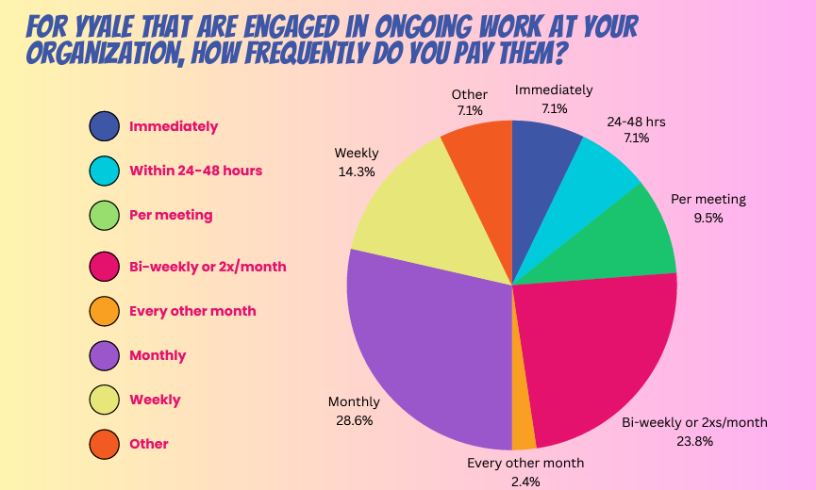

If you say you are going to pay a certain amount of money to a young person on a specific day, it is imperative that the payment is made as promised. This guide is not going to include the dozens of stories we heard from youth who are in situations where a late $50 payment can make or break them - and how it gets exponentially worse if the amount in question is larger. But almost every young person we spoke to had a story about that.

It is ok if you have a limited budget, it is ok if you are a small organization and it takes two weeks to process payments, it is ok if your payment options are limited as long as you are transparent and communicative about these limitations before engaging a young person. As an organization, you need to figure out what you can consistently deliver as far as payment amounts and timeline and meet or exceed expectations every time.

Another consideration around timing, especially for longer term projects, is paying contractors upfront rather than on a deliverable or reimbursement basis. For a young person, the stability offered by an upfront payment may be a prerequisite to actually completing the deliverables in a timely and competent manner.

Finally, young people often need a way to provide proof of the income they are earning, which looks much more official on your organization’s letterhead. Create a way for young people to access proof of their earnings even when it isn’t tax time.

### Be Ready with Resources for Youth

You do not need to be a tax expert or hire one in-house - but you do need to make sure you know where to refer the youth you compensate to ask questions about taxes, finances, benefits, and other issues that might arise due to this new source of income. Offer these resources, connections to experts, and training opportunities often.

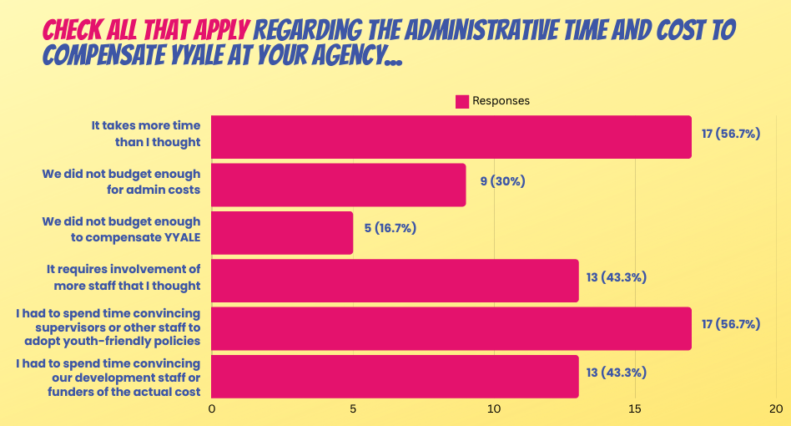

### Plan Ahead for the Time and Costs

There is no way around it - creating youth-friendly youth compensation policies and procedures that comply with the law requires dedicated time and resources. More than you might think! But starting off on solid legal footing, with clear policies, and predictable procedures will reduce unnecessary harm to young people and to your program staff. With this foundation, you can more easily tackle the myriad other issues in ensuring effective youth engagement.

1. <https://www.teenvogue.com/story/non-profit-industrial-complex-what-is>
2. <https://www.brookings.edu/articles/how-housing-insecure-youth-are-redefining-policy-planning-and-engagement-to-address-homelessness-in-ithaca-new-york/>
3. <https://c4innovates.com/wp-content/uploads/2020/01/CDLWR-3476__YESS_Tokenism-TipSheet_v4.pdf>; <https://adamfletcher.net/2012/10/31/are-you-tokenizing-youth/>; <https://peertac.org/2024/09/05/navigating-tokenism-in-family-and-youth-peer-advocacy-a-guide-for-genuine-inclusion/>
4. <https://nationalguild.org/files/resources/public/adultism-and-its-impact-on-youth-and-adult-spaces.pdf>
5. <https://www.nctsn.org/trauma-informed-care/secondary-traumatic-stress>; <https://www.actsproject.com/resource/workforce-development/secondary-traumatic-stress>
6. Organizations whose purpose is “charitable, religious, educational, scientific, literary, testing for public safety, fostering national or international amateur sports competition, and preventing cruelty to children or animals”. <https://www.irs.gov/charities-non-profits/charitable-organizations/exempt-purposes-internal-revenue-code-section-501c3>
7. A “social welfare organization”. See <https://www.irs.gov/charities-non-profits/other-non-profits/social-welfare-organizations>.
8. <https://creatingthefuture.org/the-problem-with-nonprofit-boards-is/>
9. See <https://www.harborcompliance.com/nonprofit-governance-by-state> (last updated Sept. 2020)
10. Under federal law, minors under age 14 may not be employed if employment is covered by the child labor laws and there is no specific exemption. *29 C.F.R. § 570.119*. Minors between ages 14 and 16 may be employed in occupations other than manufacturing if the employment is confined to periods which will not interfere with their schooling and to conditions which will not interfere with their health and well-being. Some states have different rules, which are summarized here. Whenever an applicable state or local law or regulation is different from the applicable federal law or regulation, that regulation most favorable to the employee must be followed. *See, e.g. 29 U.S.C.§ 218, 29 C.F.R. §570.25*.
11. An example of an NDA can be found here: [Basic Non-Disclosure Agreement](https://nondisclosureagreement.com/wp-content/uploads/2020/11/Basic-Non-Disclosure-Agreement.pdf)
12. Example templates can be found here: [Free Non-Compete Agreement Template - PDF | Word – eForms](https://eforms.com/non-compete/)
13. Nine states do not have an income tax.
14. <https://www.ssa.gov/pubs/EN-05-10022.pdf>
15. Also called "third party settlement organizations" or TPSOs.
16. Another benefit of filing could be the Earned Income Tax Credit (EITC), a refundable tax credit for low-income workers (including self-employed workers), but it currently is [not available to young people under 25 (unless you have a child)](https://www.irs.gov/credits-deductions/individuals/earned-income-tax-credit/who-qualifies-for-the-earned-income-tax-credit-eitc).
17. <https://www.cbpp.org/research/social-security/top-ten-facts-about-social-security>
18. See here for Social Security benefit calculators: <https://www.ssa.gov/OACT/anypia/index.html>
19. <https://www.wolterskluwer.com/en/expert-insights/tax-planning-recordkeeping-for-small-businesses>
20. Examples of an asset include a savings account (or even money in your bank account that carries over month to month); a car; a house; a retirement account, etc.
21. There are also some excellent resources here: <https://www.thedream.us/current-scholars/career-success/entrepreneurship/>
22. 8 U.S. Code § 1324a