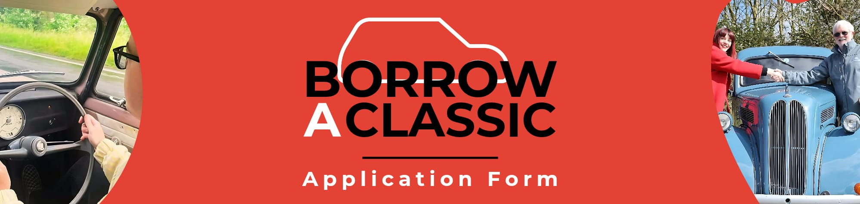
These details are given confidently and will be used only as background information to enable the car lender (owner) to select the most appropriate enthusiast. Please complete this application form, supplying as much information as possible to support your application. Remember, the more information you give, the better the idea we have about you, and it may help to get you shortlisted, so use more space if you need to.
This loan scheme is designed to get the younger generation interested in classic car ownership so that the pastime can go on into the future. Borrowers are usually aged 21-45 years old, although we consider all applications.
Your details will be shared with our insurer should your application be successful, no contact information will be released to any other third parties. If you no longer wish to be a part of Borrow A Classic, please advise us and your information will be removed and deleted per GDPR requirements.
Tell us about yourself:
Name:
Address:
Email Address:
Contact Number: |  |  |  | Date of Birth:
Field of Employment: |  |  |  | Full UK Driving Licence: |  |  | Yes ▢ No ▢
Type of license: |  | Manual ▢ Automatic ▢ |  | Years licence held:
Do you have any medical/physical conditions which may limit the use of the loan car? |  |  |  |  |  |  | Yes ▢ No ▢
If yes, please state:
Access to Everyday Car: |  | Yes ▢ No ▢ | Garage/Secure undercover parking: |  |  |  | Yes ▢ No ▢
If you have access to a garage, please tell us more:
e.g Location, relations garage or rented, a work warehouse or other facility
Please note that most of the older classic cars offered will require a garage or secure carport
Which classic car(s) or era of cars are you interested in and why?
See our website for a full list of available vehicles, the more selected the better your chance of success. Cars are changed often so please check for updates and advise us if a new car is of interest
Tell us what it is you like about the classic car world?
As a newcomer to the classic car world, what level of support (if any) do you have?
Family, friends, connections to any car clubs etc.
Have you or a close family member ever owned a classic car before? |  |  |  |  |  | Yes ▢ No ▢
If yes, please tell us more:
Are you or your support members of any classic car club? |  |  |  |  |  | Yes ▢ No ▢
If yes, please tell us which clubs:
What skills or experience, relevant to classic car ownership, do you consider yourself to have?
What sort of use do you intend for the car?
Use for trials etc. is prohibited unless specified
Is there any additional information you think the person loaning the car to you would like to know?
Please use another page if you need to
Where did you hear about the Classic Car Loan Project?
Do you agree to have the information provided kept on file by Borrow A Classic for up to two years whilst suitable vehicles become available? |  |  |  |  |  | Yes ▢ No ▢
Please understand that it can take some time to be put forward as cars are on loan for 12 months and there is a short turnaround period before handover to the new borrower. If shortlisted, you will get a phone call from the person responsible for the car.

Please check your junk mail if you have not heard from us and ensure that our email address is added to your safe senders list. Please keep us updated with any changes to your contact details.

Successful applicants are expected to engage fully in Borrow A Classic (BAC). This includes sharing stories of your exploits, and your use and maintenance of the car. You must keep in touch with the owner and clubs, your experience may be chosen to be shared with the classic car press as well as on the BAC website and social media.

You will be required to keep the car clean and presentable. You will keep the car well maintained with help and support from your mentor. At the end of the loan period, you will be expected to return to the owner washed and cleaned (externally and internally), just as you would hope your own car to be returned. An agreement will be in place before the vehicle is handed to the borrower and you will ensure that you fully understand it.

All cars loaned via Borrow A Classic must be insured by/with Peter James Insurance.
Please sign below to confirm that you agree to these terms and conditions:
Signed: |  |  |  |  | Date:
Please note that we are unable to discuss your application should it prove unsuccessful.
If unsuccessful on this occasion I wish to be considered for a future phase of the project? |  |  |  |  |  | Yes ▢ No ▢

Please return this form to Applications Coordinator via email: info@borrowaclassic.co.uk
