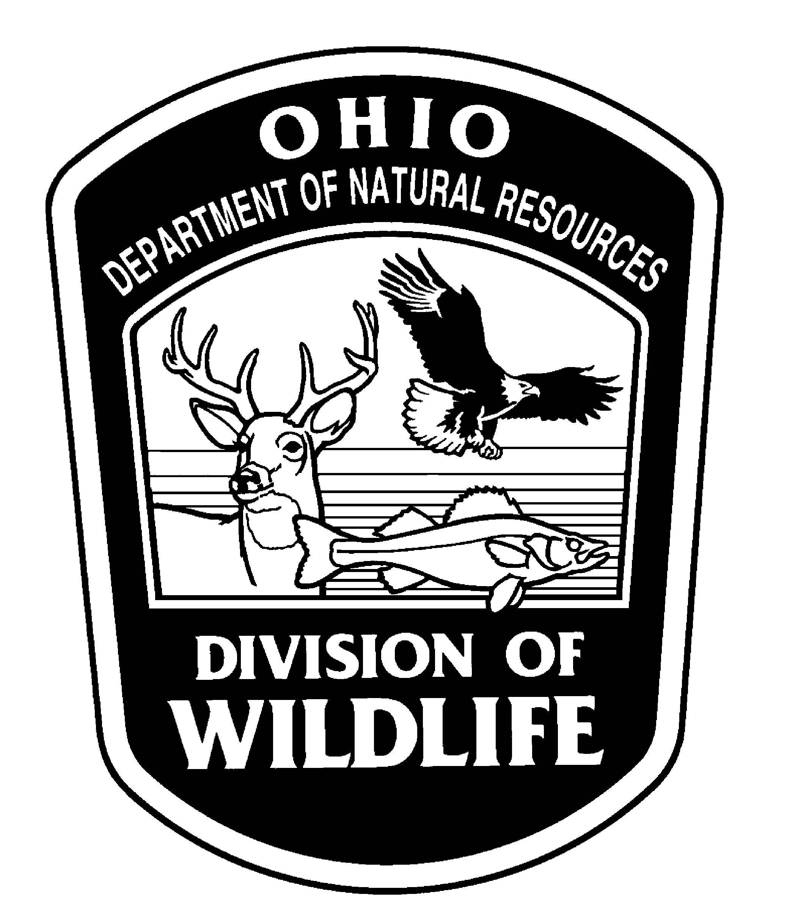

OHIO RECORD FISH
OFFICIAL APPLICATION FORM
OUTDOOR WRITERS OF OHIO, INC. (OWO)

Please print or type
Angler’s Name__________________________________________________ Age (optional)______________

Address____________________________________________Phone No._______________________________

City___________________________State________ Zip____________Email___________________________

Fish Species______________________________Date Caught_____________________Time______________

Weight_________________________________Length_______________________Girth__________________

Where Caught (be specific)_______________________________________ County______________________

Rod Type (spinning, casting, etc)_____________________Bait or Lure Used___________________________

Line Used (monofilament, braid, etc.)_______________________________Lb. Test______________________

Bowfishing_______________________Trotline, Bankline or Floatline_________________________________

WITNESS TO WEIGHING

Signature__________________________________Print Name______________________________________

Address______________________________________________Phone No,_____________________________

City______________________________________State_________________Zip________________________

Signature__________________________________Print Name______________________________________

Address______________________________________________Phone No,_____________________________

City______________________________________________State________________Zip_________________

Ohio record fish are determined on the basis of weight only
DECISIONS BY THE OWO RECORD FISH COMMITTEE AND OWO ARE FINAL

See reverse for instructions

Read These Rules:
- All record fish entries are to be examined by an Ohio Division of Wildlife Fisheries Biologist for species confirmation.
- Large fish intended for release may be examined photographically if the fisheries biologist is fully satisfied with species identification.
- Fish must be kept frozen or alive but intact until the species is confirmed by the Ohio Division of Wildlife to the satisfaction of the Record Fish Committee.
- Fish must be weighed on a county auditor-certified scale. Include a scale printout or a photo of the weight and a copy or photo of the county auditor’s certification sticker.
- Weighing of the fish must be witnessed by two persons.
- A close-up photo of the fish showing its characteristics must accompany the application.

- Total length is measured in a straight line from the tip of the snout to the farthest tip of the tail, laid flat with the mouth closed.
- Girth is measured at the deepest point of the body.
- Fish taken from pay lakes and streams are ineligible.
- All fish must be taken in a legal and sportsmanlike manner.
- Violation of any of these rules will lead to invalidation.

Send the application and photos within six months of the date of catch to:

Fred Snyder, Chairman
Record Fish Committee, OWO, Inc
754 Co. Rd. 126, Fremont, OH 43420
Phone: 419-307-1515
Email: fnsnyder@gmail.com

County auditor-certified scales can be found at any entity that sells products or services based upon weight. Examples would include grocery stores, delis, hardware stores, feed stores or even commercial shippers (FEDEX, UPS, etc.).

Ohio Division of Wildlife fisheries biologists can be contacted at offices listed on the inside front cover of the Division’s Ohio Fishing Regulations pamphlet.

The Ohio State Record Fish Program is administered by the Outdoor Writers of Ohio, Inc. (OWO), in cooperation with the Ohio Division of Wildlife. Record certification is conducted by OWO’s Ohio Record Fish Committee, consisting of a chairperson and four committee members from the OWO membership. The Ohio Division of Wildlife provides species confirmation and examinations by professional fisheries biologists and responds to calls for wildlife officers.

