The January 6, 2020, Board of Supervisors’ Meeting was called to order at 7:00 PM by it chair, Kurt Johnson. After calling the meeting to order, Kurt noted that all officers were present through the Roll Call:
Supervisors
- Kurt Johnson
- Jon Olson
- Mike Ruhland
Treasurer
- Peter Olson
Clerk/Deputy Clerk
- Kate Laine
- Sandra Lee Olson

Following the Pledge of Allegiance, Mike Ruhland made a motion, which was seconded by Jon Olson, to accept the Agenda as presented. The motion carried with a unanimous vote in favor of the motion.

The first order of business was the Reorganization of the Board. Mike Ruhland made a motion to continue with the current responsibilities and compensations. Jon Olson seconded the motion, which was accepted through a unanimous vote in favor of continuing the current responsibilities as follows:
- Positions/Responsibilities
  - Chair—Kurt Johnson/Vice Chair—Jon Olson
  - Supervisor Responsibilities
    - Town Hall—Mike Ruhland and Jon Olson
    - Cemetery—Kurt Johnson
    - Roads—Peter Olson
    - Joint Powers—Mike Ruhland
    - Noxious Weed Inspector—Mike Ruhland
    - St Louis County Association of Townships—All officers as available
- Compensation
  - Supervisors
    - Regular Meeting Rate $100
    - Extended Meeting Rate $150
    - Hourly Rate $25
  - Treasurer
    - Regular Meeting Rate $100
    - Extended Meeting Rate $150
    - Hourly Rate $25
    - Monthly Stipend $250
  - Clerk
    - Regular Meeting Rate $100
    - Extended Meeting Rate $150
  - Monthly Stipend $400
Deputy Clerk
    - Mtg Rate (attendance) $50
    - Meeting Rate (as Clerk) $100
    - Extended Meeting Rate $150
    - Monthly Stipend $200
  - Road Foreman
    - Hourly Rate $25
  - Mileage
    - Set by Federal Government Guidelines $0.575

Following the read of the minutes from the December 2, 2019, meeting, Jon Olson made a motion, which was seconded by Mike Ruhland, to accept the minutes as read. The Clerk had noted during the reading that the Clerk’s Report was not reproduced as part of the minutes. The motion carried with a unanimous vote in favor of the motion with the acknowledgment that the Clerk’s Report was not reproduced.

Treasurer Peter Olson read into the record his Treasurer’s Report for the month ending on December 31, 2019. His report was several pages in length and was filed with other documents from the meeting. Mike Ruhland made a motion to accept the Treasurer’s Report as presented. The motion was subsequently seconded by Jon Olson and accepted through a unanimous vote in favor of the motion. The first page is reproduced below:
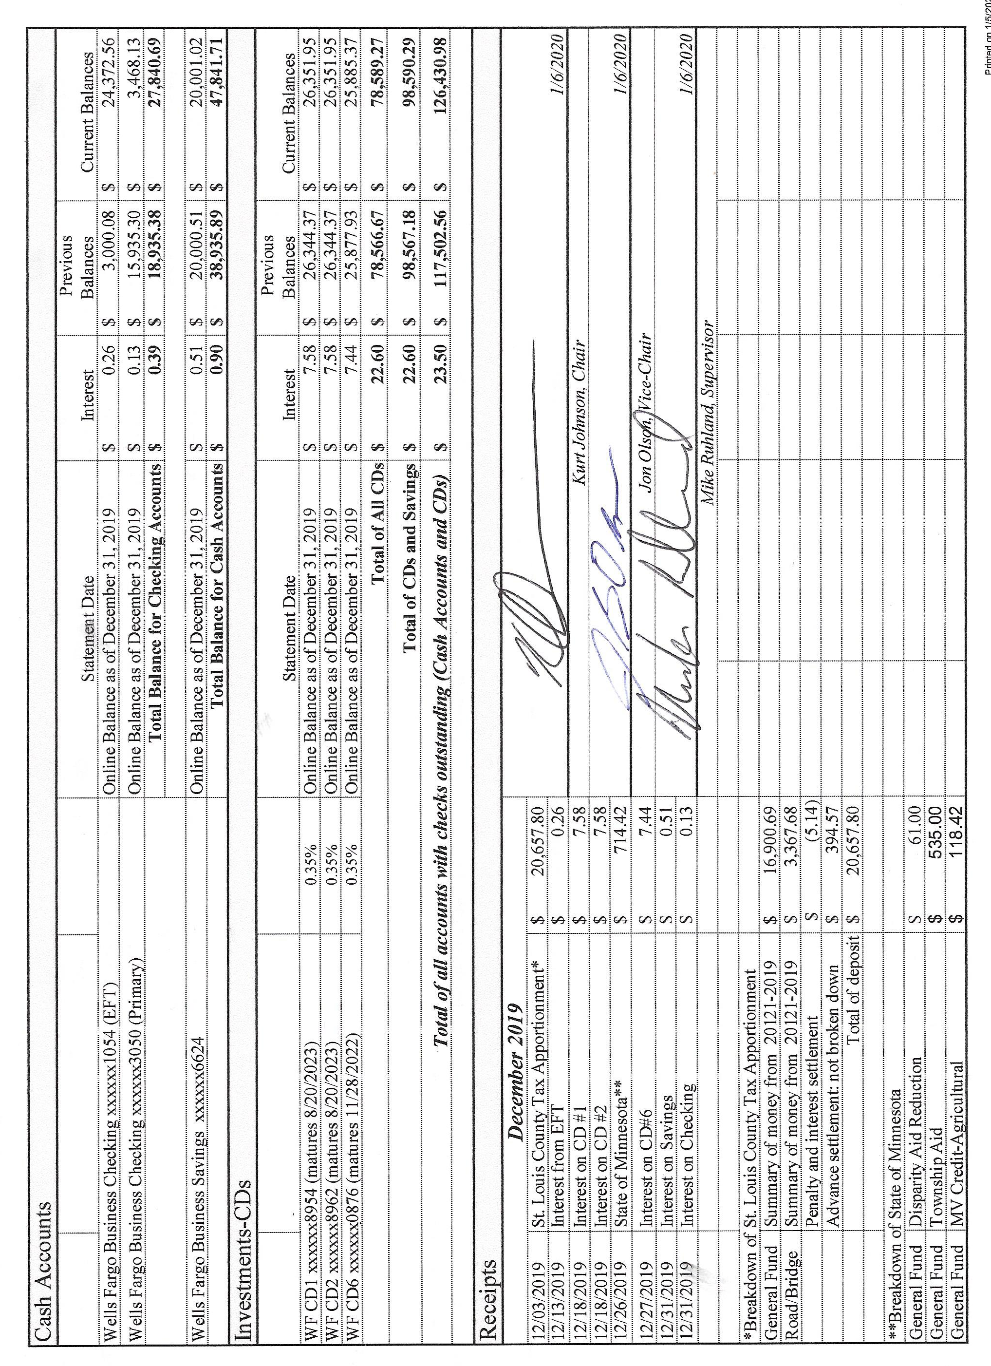

Sandra Lee Olson present the Clerk’s Report. Following the presentation of the report, Mike Ruhland made a motion to accept the report as presented. Jon Olson offered a seconded to the motion, which was accepted through a unanimous vote in favor of the motion. The first page of the Clerk’s Report is reproduced on the next page. The second portion of the Clerk’s Report was to address the Tax Apportionment Monies that were deposited in the EFT Account. Kurt Johnson made a motion to transfer $10,000 into the checking account and transfer $11,000 into the Savings Account. Following a second to the motion by Jon Olson, the motion was approved. The Clerk will transfer the money according to the motion.
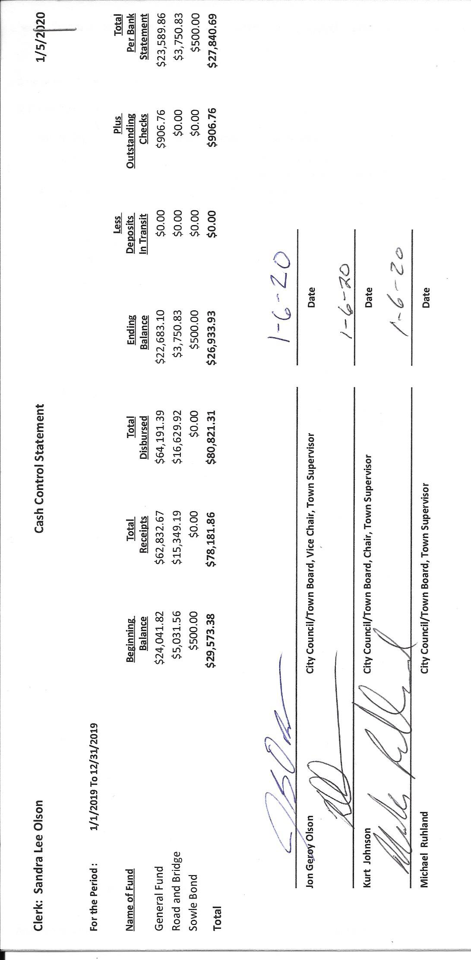

The following items of Incoming Correspondence were presented to the Board:
- Duluth Area Family YMCA…thank you note for those who helped with the YMCA project
- St. Louis County Fair…information regarding Minnesota Statute 38.12 that enables townships to donate to county fairs and a request for a donation in 2020
- Lake Country Power…notice of meeting to be held on January 29, from 5-7 PM at the Cotton Community Center
- St. Louis County Association of Townships…minutes from the October 23, 2019, meeting
- Lake Country Power…monthly statement showing a credit of $80.17 after capital credits of $55.87 were applied
- Federated Co-ops, Inc…. monthly statement showing no deliveries and unused prepaid credits of $1,316.88
- McRae Land Improvements LLC…holiday greetings
- Frontier Communications…monthly statement showing a balance due of 64.85
Emails
- Teresa Hirsch…possible strike by Teamsters, Local #320 Union
- Phil Chapman…article regarding Presidential Nominating Primary
- Jill Hoppe…requesting information about accessing property that adjoins New Independence
- Phil Chapman…grant for election equipment
- PERA…Annual Exclusion Report

The following Payroll claims were presented to the Board for approval and read into the record by Chair Kurt Johnson. Upon completion of the reading, Jon Olson made a motion to pay the payroll claims as submitted. Mike Ruhland offered a second to the motion, which was then accepted through a unanimous vote.
  - Payroll $93.55
  - Payroll $230.87
  - Payroll $116.94
  - Payroll $324.99
  - Payroll $46.17
  - Payroll $549.10
  - Payroll $116.94

The following Claims were read into the recorded. Jon Olson made a motion to accept and pay the claims. Mike Ruhland second the motion, which was accepted through a unanimous vote in favor of the motion. The following claims were submitted to the Treasurer for payment.
  - Michael Ruhland $26.69
  - Peter Olson $14.95
  - Sandra Lee Olson $218.88
  - Jon Olson 147.00
  - Frontier Communications $64.85
  - Public Employees Retirement Association $168.00
  - Lake Country Power $300.00

The following items of Unfinished Business were brought to the Board for discussion.
- Cemetery
  - Snowplowing at cemetery and town hall has been completed because Jay Tremblay’s plow is now working.
- Town Hall was shoveled since the last meeting.
- Township Roads
  - The road foreman, Peter Olson, stated that he drove the roads and felt they are in good shape for the winter.
  - The Board discussed the [lowing of township roads in the event of a strike by Teamsters, Local #320 Union. All supervisors felt that the Town of New Independence has a contract with St. Louis County and will stay with their services if the strike does go into effect. Other options were discussed, but Board members decided to stay with the County services.
- Presidential Nominating Primary (PNP)
  - SLCAT Meeting on January 22, 2020, at Cotton will be attended by Sandra Lee Olson in anticipation of Phil Chapman’s presentation about the upcoming PNP
  - Training in Duluth on December 13, 2019 was held for clerks. Sandra Lee Olson did attend the training and will train election judges for the township.

The following items of New Business were presented to the Board.
- A request for access to landlocked parcel was received from Jill Hoppe. The Board looked at maps to determine the access to which she might be addressing. The Board felt that addition information would be needed before discussing the matter in greater detail. Kurt Johnson offered to call Jill Hoppe and get more information.
- The Grant Application for Voting Equipment was discussed by the Board. General consensus was that the voting equipment is too expensive for a township of our size. No application will be submitted.
- Presidential Nominating Primary
  - Notifying residents of the PNP and requirements to vote will be addressed at the next meeting.
- Training
  - There is a new clerk training on Thursday, January 9, St. Michael, from 10:00 AM – 3:30 PM and another training clerk/treasurer training on Thursday, January 23 or January 30, St. Michael, from 10:00 AM – 3:30 PM. Mike Ruhland made a motion to allow Kate Laine to attend the meeting on January 9 in St. Michael. She will receive the extended meeting rate and mileage. The township will pay for the registration. Jon Olson seconded the motion, which was accepted through a unanimous vote.
- Benchmark Engineering information will be saved for future township needs. At the present time, New Independence does not have a need for the services offered.

Officer Reports
SLCAT—Sandra Lee Olson
Election Training for Clerks—Sandra Lee Olson

Having no additional business to be discussed at this time, Kurt Johnson asked for a motion for adjournment. The motion was offered by Mike Ruhland; a second was given by Jon Olson; and a unanimous vote in favor of the motion followed. Kurt adjourned the meeting at 8:23 PM

Minutes submitted for approval on ___________________February 3, 2020_______________

Clerk’s Signature______________________________________________________________

Chair of the Board of Supervisors’ Signature_________________________________________

UPCOMING MEETINGS

Board of Supervisors’ Meetings for 2020
January 6, 2020
February 3, 2020
March 2, 2020
April 6, 2020
May 4, 2020
June 1, 2020
July 6, 2020
August 3, 2020
September 14, 2020
October 5, 2020
November 2, 2020
December 7, 2020

2019-2020 SLCAT Calendar (meetings convene at 6:30 pm) and Related Meetings
JAN. 22, 2020 COTTON COMMUNITY CENTER 6:30 PM
- POSSIBLY THE ELECTION DEPT. FOR ST. LOUIS COUNTY TO BE SURE WE HAVE ALL OUR INFORMATION, ETC. FOR THE PRESIDENTIAL NOMINATION PRIMARY
FEB. 26, 2020 COTTON COMMUNITY CENTER 6:30 PM
MAR. 25, 2020 COTTON COMMUNITY CENTER 6:30 PM
APR. 22, 2020 NEED A TOWNSHIP TO VOLUNTEER TO HOST THE APRIL MEETING.
CALL CATHY AT 290-4970
MAY 27, 2020 COTTON COMMUNITY CENTER 5:30 P.M.
- ANNUAL SLCAT ELECTION AND MEETING;

