Oath of Office was administered to Mike Ruhland before the meeting convened. Sandra Lee Olson took the Oath of Office with Mandy Ellefson prior to the meeting.

At 7:01 PM, the monthly Board of Supervisors’ Meeting was called to order by its chair, Kurt Johnson. Roll Call indicated that the following officers were present:
Supervisors
- Kurt Johnson
- Jon Olson
- Mike Ruhland
Treasurer
- Peter Olson
Clerk
- Sandra Lee Olson

Following the Pledge of Allegiance, Mike Ruhland made a motion to accept the Agenda. Jon Olson offered a second to the motion, which was then passed through a unanimous voice vote.

Because this was the first meeting in January after an election, the first item of business was the Reorganization of the Board, which includes assignment of supervisor positions and responsibilities and setting the compensation rate for all officers
- Supervisor Positions
  - Chair/Vice Chair
    - Jon Olson made a motion to have Kurt Johnson continue as the Chair. Mike Ruhland seconded the motion, which was passed with a unanimous vote.
    - Mike Ruhland made a motion to have Jon Olson continue as the Vice Chair. Kurt Johnson seconded the motion, which was passed through a unanimous vote.
  - Supervisor Responsibilities
    - Kurt Johnson made a motion, which was seconded by Mike Ruhland, to assign supervisors and others to the following responsibilities. The motion carried through a unanimous voice vote.
      - Town Hall—Mike Ruhland and Jon Olson
      - Cemetery—Kurt Johnson
      - Roads—Peter Olson
      - Joint Powers—Mike Ruhland
      - Noxious Weed Inspector—Mike Ruhland
      - St Louis County Association of Townships—all officers as available
      - Other positions—no other positions were added or discussed.
- Compensations
  - Supervisors
    - Mike Ruhland made a motion to continue with the same pay rates as 2018. Jon Olson seconded the motion, which was accepted through a unanimous voice vote. Compensations for Supervisors will continue at the following rates:
      - Regular Meeting Rate $100
      - Extended Meeting Rate (more than four hours) $150
      - Hourly Rate $25
  - Treasurer
    - Kurt Johnson made a motion to continue with the same meeting rates as 2018 and increase the monthly stipend paid to the Treasurer. Mike Ruhland seconded the motion, which was accepted through a unanimous voice vote. Compensations for the Treasurer will be paid at the following rates:
      - Regular Meeting Rate $100
      - Extended Meeting Rate $150
      - Hourly Rate $25
      - Monthly Stipend $250
  - Clerk
    - Kurt Johnson made a motion to continue with the same rates as previously paid during 2018 for the Clerk. Mike Ruhland seconded the motion, which was accepted through a unanimous voice vote. Compensations for the Clerk will be paid at the following rates:
      - Regular Meeting Rate $100
      - Extended Meeting Rate $150
      - Monthly Stipend $400
      - Hourly Rate for tasks done outside of clerk duties $25
  - Mileage
    - New Independence follows the Federal Government Guidelines for mileage, which is set for $0.58/mile for 2019. If more is paid than the recommended amount, the recipient must pay taxes on the amount above $0.58/mile.

Following the reading of the minutes for the December 2018 meeting, Mike Ruhland made a motion to accept the minutes as read. Jon Olson offered a second to the motion, which was accepted through a unanimous vote. The minutes were placed on file with other documents from the meeting.

Peter Olson read the Treasurer’s Report into the record. It contained the Treasurer’s Report form developed by the Treasurer, Cash Control Statement (CTAS), Outstanding Checks and Deposits in Transit Report (CTAS), and Schedule B (CTAS). The first page of his report is shown at the top of the next page. The entire report was placed on file with other documents from the meeting after it was accepted by the Board through a motion by Mike Ruhland, a second from Jon Olson, and a unanimous vote in favor of acceptance.
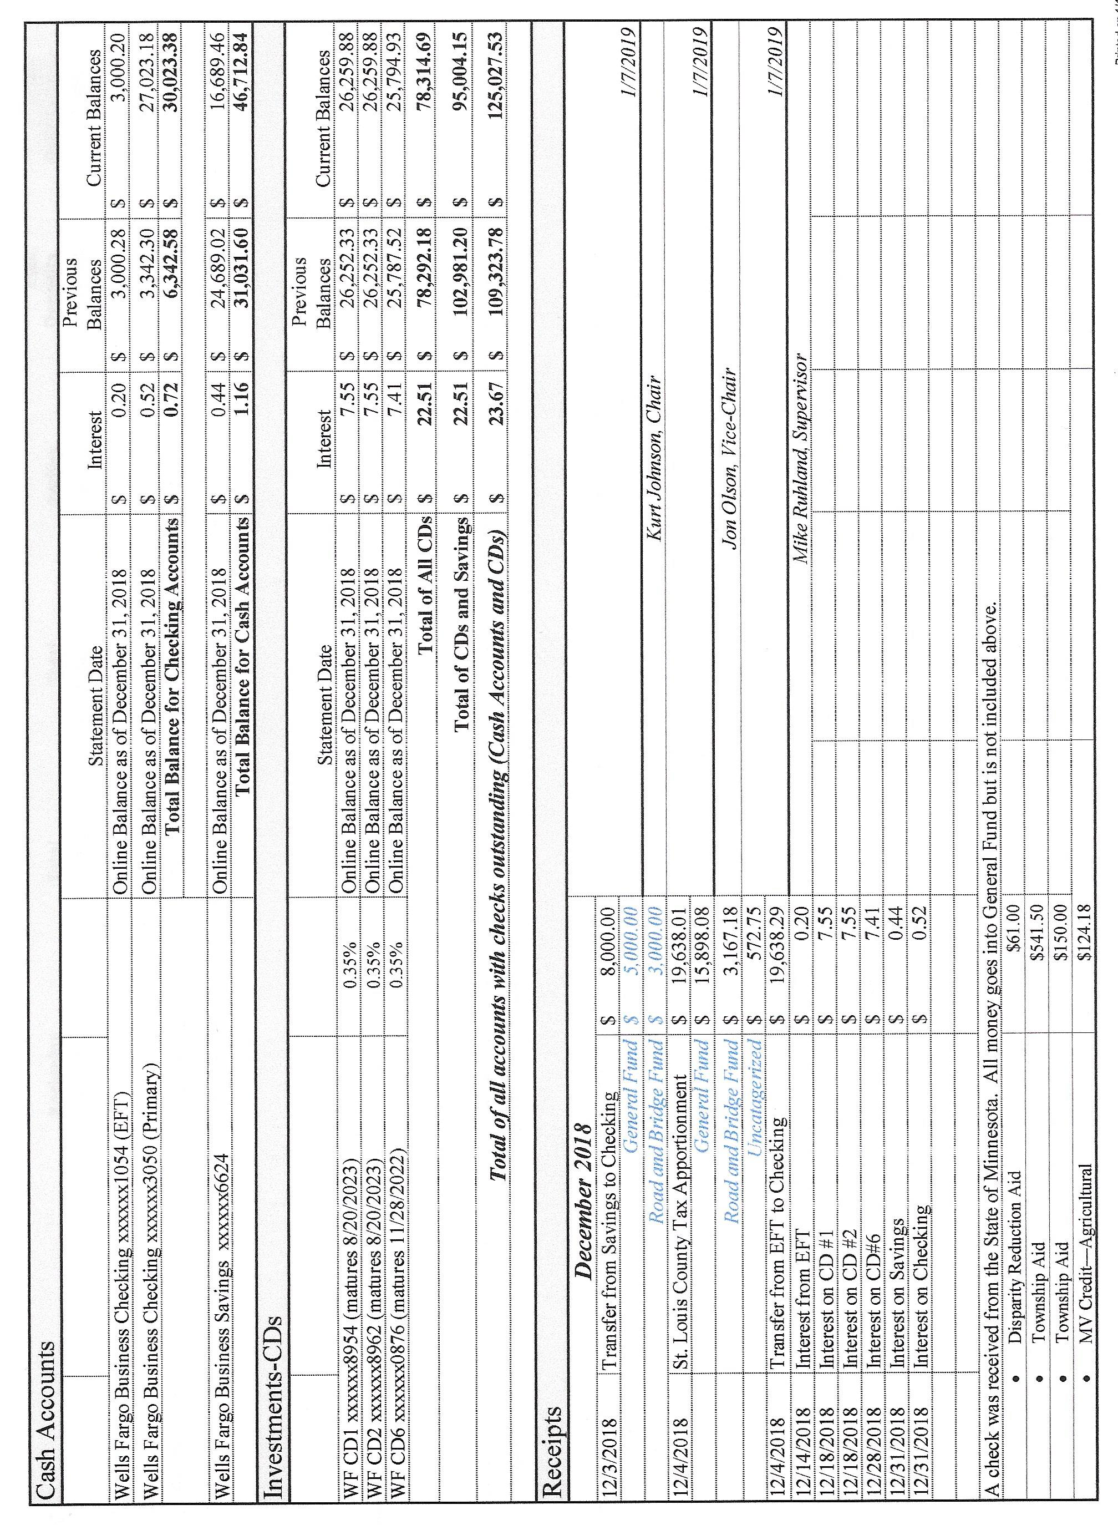

Clerk’s Report
- The Clerk’s Financial Report was presented by Clerk Sandra Lee Olson and contained the Cash Control Statement (CTAS), Outstanding Checks and Deposits in Transit Report, Cash Balance Statement (CTAS), Schedule 8—Investment Activity (CTAS), and a Cash Balance Statement (CTAS) that shows the balances after checks from the January 7 meeting clear. The report was accepted by the Board through a motion by Kurt Johnson, a second by Mike Ruhland, and a unanimous vote in favor of acceptance. The first page of the report is reproduced below. The entire report was placed on file with other documents from the meeting.
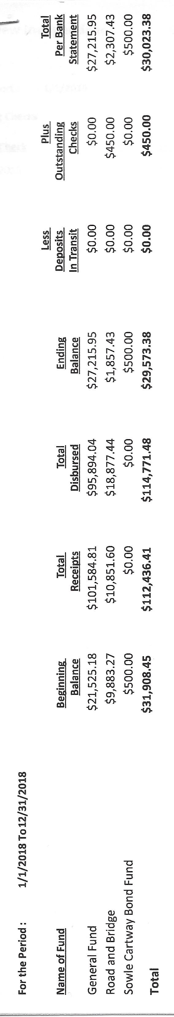

- Transfer of funds from Savings to Checking was completed on December 3, 2018 as approved by the Board at its December meeting
  - General Fund $5,000.00
  - Road and Bridge $3,000.00

Incoming Correspondence
- MAT…magazine, Minnesota Township Insider
- Minnesota Department of Revenue…notice that New Independence can file annually vs quarterly (note: application had to be made by December 26, 2018)
- State of Minnesota payment
  - Disparity Reduction Aid $61.00
  - Township Aid $541.50
  - Township Aid $150.00
  - MV Credit—Agricultural $124.18
- St. Louis County (SLC)…request for officer information
- Lake Country Power…monthly invoice showing a credit ($70.61)
- Public Employees Retirement Association (PERA)…monthly reporting form
- Brent Septic…invoice for pumping ($185.00)—already paid
- Federated Co-ops…statement showing a credit of $1,200 for pre-buy program
- McRae Land Improvements…Christmas card and business card
- Arrowhead Regional Development Commission (ARDC)…ballot for SLC Township Representative (needed to be filed by December 17, 2018
- SLC Association…minutes of the October 24, 2018 meeting
- Frontier Communications…monthly phone and internet ($66.12)

Payroll and Claims were read into the record by Chair Kurt Johnson.
Following the reading of the Payroll claims, Jon Olson made a motion to pay the following payroll. Mike Ruhland offered the second to the motion, which was unanimously accepted and claims submitted to the Treasurer for payment.
  - Payroll $187.10
  - Payroll $93.55
  - Payroll $187.10
  - Payroll $46.17
  - Payroll $399.86
  - Payroll $93.55

Following the reading of the Claims into the record by Kurt Johnson, Mike Ruhland made a motion to pay the claims as presented. Jon Olson offered the second to the motion, which was accepted and claims were forwarded to the Treasurer for payment.
  - Void
  - Frontier $56.12
  - Sandra Lee Olson $66.12
  - Lake Country Power $300.00
  - Peter Olson 29.25

Unfinished Business
- Cemetery
  - Kurt had nothing to report for the cemetery
- Town Hall
  - Water was picked up for the Town Hall
- Roads
  - Road Foreman’s Report
    - Peter Olson reported that he inspected the roads and found them to be in good condition at this point.
- Supplies for Accounting Records were picked up by the Clerk as approved last month by the Board. She also purchases two stamps for notarizing documents as required.
- Keys for the safe have not been picked up. Sandra Lee Olson said she would have them for the next meeting. It is likely that she will have to go to a store that specializes in keys—perhaps a locksmith. Other retail stores don’t carry the necessary blanks that are needed.

New Business
- Resolution for poll location for 2019
  - The Board of Supervisors passed a resolution setting the Town Hall as the polling place for 2019. A copy will be sent to the County Election Office.
- Notices will be sent to voters after the February meeting to inform them about the mail-in ballot option. That will give voters enough time to put it on calendars but not too much time that the meeting will be forgotten.

Officer Reports
Joint Powers…Kurt Johnson

Mike Ruhland made a motion for adjournment, which was seconded by Kurt Johnson, and accepted. Kurt declared the meeting to be adjourned at 8:00 PM.

Minutes submitted for approval on ___________February 11, 2019________________________

Clerk’s Signature______________________________________________________________

Chair of the Board of Supervisors’ Signature_________________________________________

UPCOMING MEETINGS

Board of Supervisors’ Meetings for 2019
Feb. 4, 2019
Mar. 4, 2019
Apr. 1, 2019
May 6, 2019
June 3, 2019
July 8, 2019
Aug. 5, 2019
Sept. 3, 2019
Oct. 7, 2019
Nov.4, 2019
Dec. 2, 2019

2019 SLCAT Calendar (meetings convene at 6:30 pm) and Related Meetings
Jan. 23, 2019 Cotton Townhall 6:30 pm Speaker Arrangements Philip Lobb
Feb.20-21, 2019 MAT L & R St. Paul Best Western
L & R Winter –
Let Cathy know BY 1/15/19 who is going.
Feb. 27, 2019 Cotton Townhall 6:30 pm Speaker Arrangements Cindy Moe & Jim Aird
March 27, 2019 Cotton Townhall 6:30 pm Speaker Arrangements Megan Julin
April 18, 2019 MAT Otsego, MN Town Law Review – Rockwoods Conf. Center
April 24, 2019 Host Township 6:30 pm Midway Township Speaker Enbridge
5 pm Directors/Officers & Audit Committee
May 22, 2019 Cotton Townhall 5 pm ChitChat/5:30 Mtg/6pm Dinner/6:45 Speaker

