The monthly Board of Supervisors’ Meeting was called to order by its chair, Kurt Johnson, at 7:00 PM. Roll call was taken and recorded to indicate the following members were present:

Supervisors

* Kurt Johnson
* Jon Olson
* Mike RuhlandTreasurer
* Peter OlsonClerk
* Sandra Lee Olson

Following the Pledge of Allegiance, Mike Ruhland made a motion to accept the Agenda as printed. Jon Olson seconded the motion, which was passed by a unanimous vote.

Clerk Sandra Lee Olson read the minutes from the January 7, 2019, Board of Supervisors’ Meeting. Upon completion of the reading, Mike Ruhland made a motion, which was seconded by Jon Olson, to accept the minutes as read. The motion was accepted through a unanimous vote and placed on file with other documents from the January meeting.

Peter Olson read the Treasurer’s Report for the period ending on February 28, 2019. His report included the customized Treasurer’s Report Cover Page, the Cash Control Statement (CTAS), Outstanding Checks and Deposits in Transit Report (CTAS), and Current Investments with Accrued Interest (CTAS). While the cover page is reproduced below, the entire report was placed on file with other documents from the February meeting. Mike Ruhland made a motion, which was seconded by Jon Olson, to accept the Treasurer’s Report—subject to audit. The motion was accepted through a unanimous vote and placed on file with other documents from the February meeting.

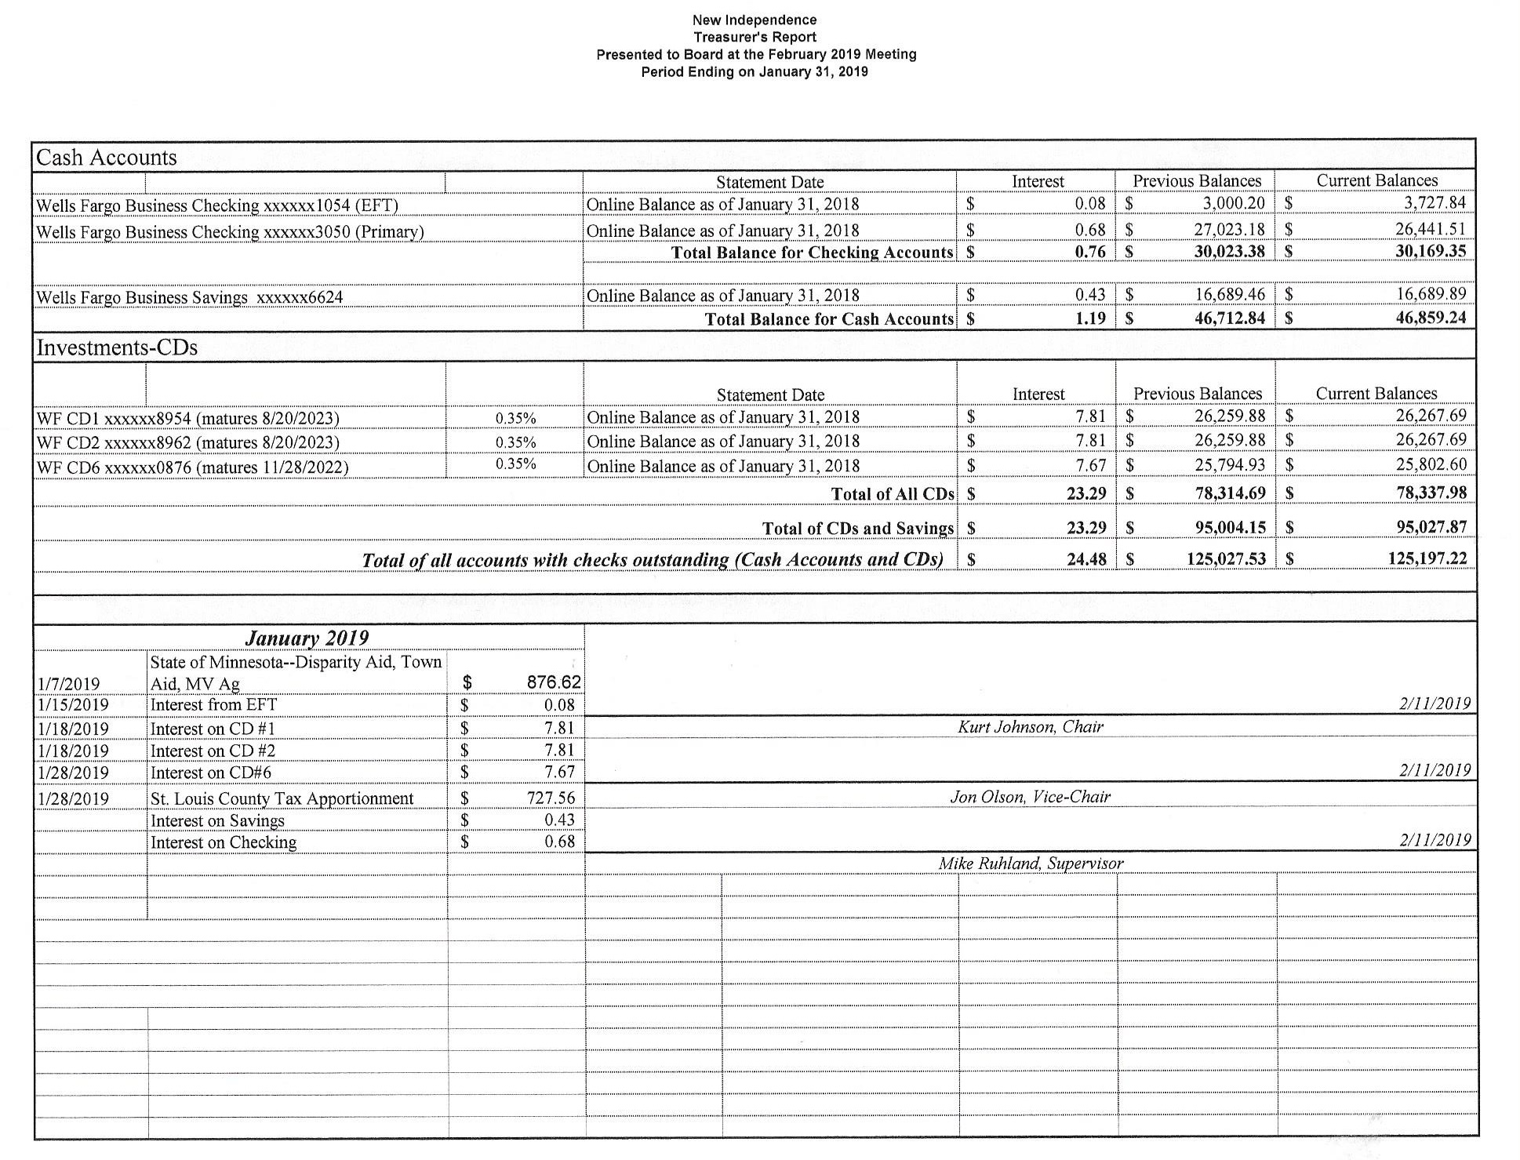

The Clerk’s Report was a two-part report for the activity and finances since the last meeting.

The Clerk’s Financial Report was comprised on reports for the period January 1 through January 31, 2019, which included the Cash Control Statement (CTAS),Outstanding Checks and Deposits in Transit Report (CTAS), Cash Balance Statement (CTAS), and Current Investments (CTAS). After the clerk presented the financial component of her report, Mike Ruhland made a motion to accept the report subject to audit. The motion was then seconded by Jon Olson and passed by a unanimous vote.

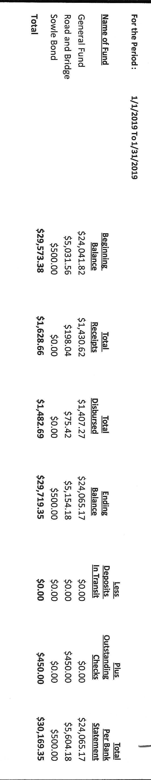

The second portion of the Clerk’s Report included a summary of tasks that were completed since the last meeting which included:

* + - W2 and 1099 completed filing and mailing to Federal IRS, Minnesota Department of Revenue, and recipients
    - 2019 Budget Worksheet
    - Workmen’s Comp Audit
    - List of Voters from Phil Chapman
    - Notice of Annual Meeting and Board of Audit sent to Voyageur

Incoming Correspondence

1. Frontier Communications…monthly phone and internet ($71.81)
2. Lake Country Power…monthly statement showing a balance due of $55.71
3. Federated Co-ops…monthly invoice showing a credit of $818.95 in unused prepaid credits
4. Public Employees Retirement Association
   * Monthly reporting form
   * Annual Exclusion Report to be completed and returned by February 28, 2019
5. Wells Fargo…1098 for interest received in 2018 $0.51
6. Minnesota Benefit Association…information on group term life insurance
7. Lake Country Power…newsletter, *Strictly Business*
8. United States Postal System…rental form for PO Box 232 ($56.00)
9. Western Lake Superior Sanitary District…application for biosolids on field for James Zywicki
10. South Ridge All-Night Grad Party…request for donation
11. St. Louis County Association of Townships
    * Annual Dues
      + SLCAT $179.20
      + MAT $612.64
    * Pocket calendars
    * Minutes of December 5, 2018 meeting
    * Lobby Day information
12. Alborn Fire Department...minutes for November and December

Payroll and Claims

Chair Kurt Johnson read the following Payroll into the record. When he was completed, Mike Ruhland made a motion to pay the Payroll for the period ending on February 11, 2019. The motion was seconded by Kurt Johnson and passed with a unanimous vote.

* 1. Payroll $187.10
  2. Payroll $280.65
  3. Payroll $318.75
  4. Payroll $46.17
  5. Payroll $471.36
  6. Payroll $93.55

The Claims were read into the record for the period ending on February 11, 2019. After Kurt had finished reading the claims, Mike Ruhland made a motion to pay the following claims. Jon Olson seconded the motion, which passed with a unanimous vote. All payroll and claims were submitted to the Treasurer for payment

* 1. Misprinted $
  2. Peter Olson $15.08
  3. Town of Alborn $1,200.00
  4. Jon Olson $20.88
  5. St. Louis County Auditor $83.63
  6. Frontier Communications $71.81
  7. Public Employees Retirement Assoc. $179.00
  8. St. Louis County Association of Townships $612.64
  9. United State Postal System $56.00
  10. Sandra Lee Olson $815.85

The following items of Unfinished Business were discussed by the Board

1. Cemetery
   * There was nothing to report since the last meeting
2. Town Hall
   * There was nothing to report since the last meeting.
3. Roads
   * Peter Olson checked all the township roads and reported that they were in good winter condition.
4. Clerk Sandra Lee Olson report that she picked up binders and dividers for 2019 Claims, 2019 Minutes, and Board of Audit Reports. She submitted a claim for the supplies.
5. The Board reviewed the letter notifying voters of the option for using Mail-in Ballots. The only change made was to include all officers as sending the letter.
6. Keys for the posting board and safe were picked up for officers. In addition, new combination laminated cards were given out.

New Business

1. 2019 Budget
   * Jon Olson made a motion, which was seconded by Mike Ruhland, to rollover the 2018 Budget with changes to reflect the contract
   * value for the Fire Department and increase in the Treasurer’s wages. Mike Ruhland seconded the motion, which was approved through a unanimous vote.
2. 2019 Annual Meeting Tentative Agenda
   * The Tentative Agenda for the 2019 Annual Meeting was presented to the Board. A suggestion was to include election costs so the numbers are available for the discussion to proceed or not proceed with the mail-in ballot option and resolution.
3. The Board was reminded that Board of Audit next month will be held next month.
4. Kurt Johnson made a motion to purchase Microsoft Office for the Treasurer’s computer. It is necessary if the customized report is to be used. Jon Olson seconded the motion, which was accepted through a unanimous vote.
5. The Clerk checked with Lake Country Power because the $300 prepayment did not appear on the current bill. Lake Country Power billing reported that the payment was received the day after monthly statements were sent out. The payment will appear on the March billing.
6. Notice was received from WLSSD that biosolids will be applied to Zywicki fields within the township. Biosolids have been applied in the past, so there was no objection to the application.
7. The request from the South Ridge All-Night Grad Party will be referred to the Annual Meeting so residents can offer input.
8. Kurt Johnson made a motion authorizing reoccurring purchases of ink as needed for the Treasurer’s printer. Mike Ruhland second the motion, which was accepted through a unanimous vote/
9. The Lobby Day Trip on February 20, 2019, was discussed. No officers from New Independence are able to attend the activity.
10. The life insurance benefit was presented to the Board. Kurt Johnson made a motion not to purchase the benefit for officers at this time. Mike Ruhland seconded the motion, which was accepted though a unanimous vote.
11. Kurt Johnson and Jon Olson completed the on-line training for the Local Board of Appeal and Equalization (LBAE) meeting. New Independence will have three officers trained for the upcoming meeting; one officer is required to be trained. By having all officers trained, New Independence is prepared should an officer cannot attend.
12. Kurt Johnson made a motion to purchase cookies for the Annual Meeting. Jon Olson seconded the motion, which was approved through a unanimous vote. Sandra Lee Olson will pick them up.

Officer Reports

St. Louis County Association of Townships: Jon Olson and Sandra Lee Olson

Following a motion made by Mike Ruhland, seconded by Jon Olson, and accepted through a unanimous vote to adjourn the monthly meeting. Kurt Johnson declared the meeting closed at 8:40 PM.

Minutes submitted for approval on _______________March 4, 2019_______________

Clerk’s Signature______________________________________________________________

Chair of the Board of Supervisors’ Signature________________________________________

**UPCOMING MEETINGS**

***Board of Supervisors’ Meetings for 2019***

March 4, 2019

April 1, 2019

May 6, 2019

June 3, 2019

July 8, 2019

August 5, 2019

September 3, 2019

October 7, 2019

November 4, 2019

December 2, 2019

**2019 SLCAT Calendar (meetings convene at 6:30 pm) and Related Meetings**

Feb.20-21, 2019 MAT L & R St. Paul Best Western

L & R Winter –

Let Cathy know BY 1/15/19 who is going.

Feb. 27, 2019 Cotton Townhall 6:30 pm Speaker Arrangements Cindy Moe & Jim Aird

March 27, 2019 Cotton Townhall 6:30 pm Speaker Arrangements Megan Julin

April 18, 2019 MAT Otsego, MN Town Law Review – Rockwoods Conf. Center

April 24, 2019 Host Township 6:30 pm Midway Township Speaker Enbridge

5 pm Directors/Officers & Audit Committee

May 22, 2019 Cotton Townhall 5 pm ChitChat/5:30 Mtg/6pm Dinner/6:45 Speaker