Chairman Kurt Johnson called the meeting to order at 7:02 PM. Kurt noted that all officers were present:

Supervisors
- Kurt Johnson
- Jon Olson
- Mike Ruhland
Treasurer
- Peter Olson
Clerk/Deputy Clerk
- Kate Laine
- Sandra Lee Olson

Following the Pledge of Allegiance, Mike Ruhland made a motion to accept the agenda as printed. Jon Olson seconded the motion, which was accepted through a unanimous vote.

The first item of business was the Clerk’s reading of the minutes from January 6, 2020, meeting. During the reading of the minutes, Sandra Lee Olson made a verbal correction and changed the first sentence on page two to read as follows:
Following the reading of the minutes from the December 2, 209, meeting, Jon …
Mike Ruhland made a motion to accept the minutes as corrected. Jon Olson seconded the motion, which was subsequently accepted through a unanimous vote.

Peter Olson read the Treasurer’s Report into the record. His report included the customized first page, Cash Control Statement (CTAS), Outstanding Checks and Deposits in Transit Report (CTAS), Schedule B—Investment Activity with Accrued Interest. The customized first page of his report is reproduced below. Following the completion of his report, Mike Ruhland made a motion to accept the report, subject to audit. A second by Jon Olson and a unanimous vote in favor of accepting the motion followed. The report was placed on file with other documents from the meeting.

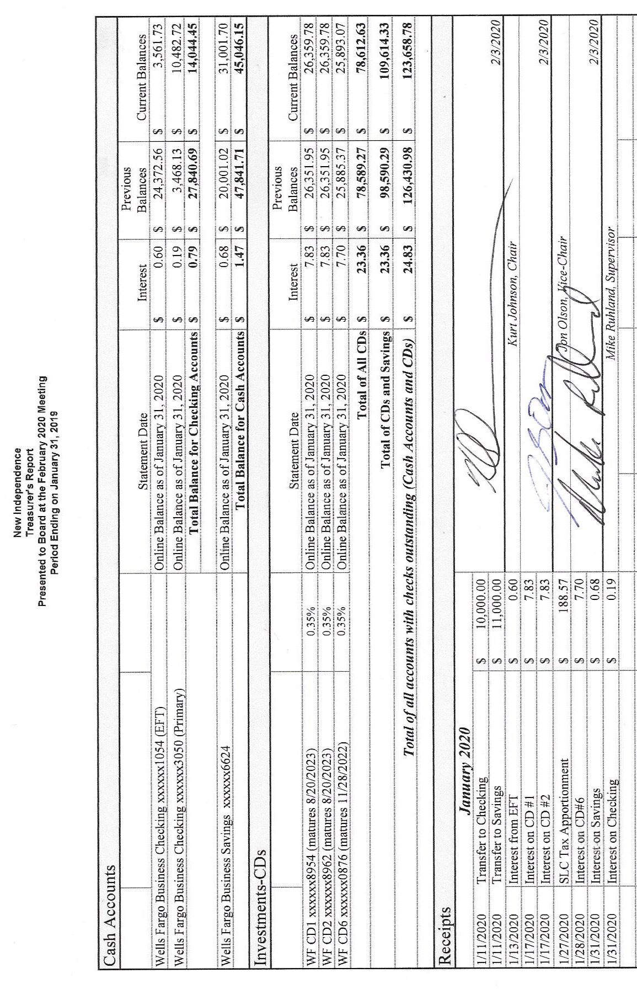

Sandra Lee Olson presented the Clerk’s Report and noted that the value of CD 2 was mis-entered and will be corrected. Kurt Johnson made a motion to accept the report with the correction error being noted. Jon Olson offered a second to the motion, and a unanimous vote in favor of acceptance followed. The Clerk’s Report included Cash Control (CTAS), Outstanding Checks and Deposits in Transit Report (CTAS), Cash Balance Statement (CTAS), and Current Investments with Accrued Interest (CTAS). While the entire report was placed on file with other documents from the meeting, the first page of her report is shown on the next page:

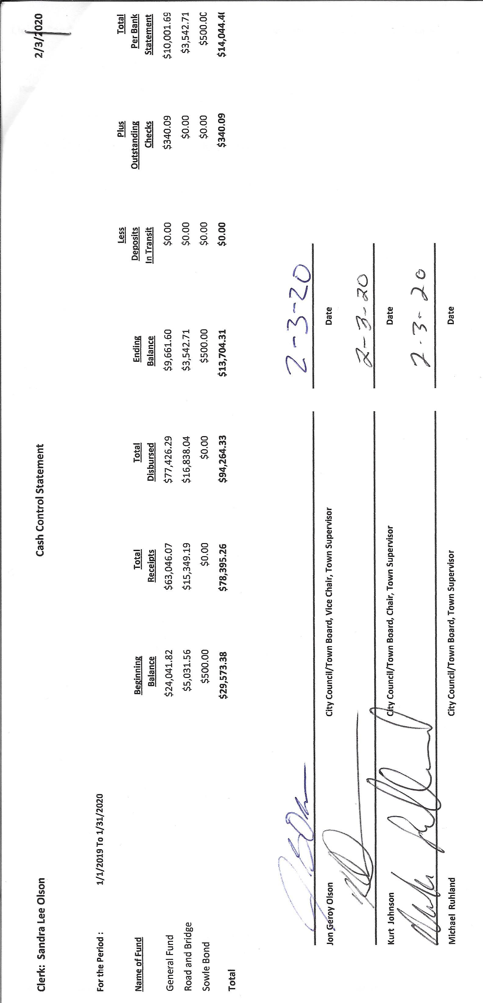

The following items of Incoming Correspondence were presented to the Board:
- Arrowhead Water...delivery of salt ($38.85)
- St. Louis County Association of Townships (SLCAT)…calendars, minutes of the December 4, 2019 meeting, and dues statement (SLCAT--$178.80 & MAT--$432.16: Total $610.96)
- Minnesota Benefits Association….information on insurances available for township officers
- Carlson Duluth Company/Randall…bill for work on furnace ($565.00)
- Randall’s Heating and Cooling…duplicate bill for the work listed in #4
- Minnesota Association of Townships…invoice for training for Kate ($40.00)
- Federated Co-ops, Inc…invoice showing a credit of $1316.88
- St. Louis County/Public Works Department…information regarding the strike by Teamsters.
- Lake Country Power…Strictly Business newsletter
- Lake Country Power…monthly statement showing a credit of $255.19

Emails
- Kristin Fogard…2020 Noxious Weed List Updates
- Yvonne McCauley…Annual Report of Outstanding Indebtedness
- Jonathan Blevins…PNP Judge Training Materials
- Lora Skarman, St. Louis County Information Specialist III…tentative LBAE meeting dates. New Independence is scheduled for April 21 at 2-3 pm
- Joshua Ripley, Wells Fargo…request for resolution

The Payroll was read into the record by Kurt Johnson. Once he completed the list of payroll claims, Mike Ruhland made a motion to pay the payroll as presented. Jon Olson offered a second, and a unanimous vote in favor of acceptance followed. The payroll was submitted to the Treasurer for payment.
  - Payroll $140.32
  - Payroll $356.61
  - Payroll $163.71
  - Payroll $324.99
  - Payroll $46.17
  - Payroll $477.60
  - Payroll $280.65

The following Claims were read into the record by Kurt Johnson. Following the reading, Mike Ruhland made a motion to pay the claims as presented. Jon Olson offered a second to the motion, which was accepted through a unanimous vote. All claims were submitted to the Treasurer for payment .
  - Peter Olson $14.95
  - Kate Laine $151.80
  - Sandra Lee Olson $150.26
  - Frontier Communications $90.00
  - Arrowhead Water Conditioning $38.85
  - St Louis County Association of Townships $610.96
  - Carlson Duluth Company/Randall $565.00
  - Minnesota Association of Townships $40.00
  - Public Employees Retirement Association $181.50
  - US Postal System $56.00

Unfinished Business
- Cemetery
Kurt reported that he has been working on the cemetery books. No requests have been recently received.
- Town Hall
The salt for the water softener is very low. Jon Olson said he would contact Arrowhead Water.
- Township Roads
Road Foreman, Peter Olson, reported the roads are in good share at this point. He did receive one call about the road sign on South Schelin.
- Presidential Nominating Primary (PNP)
  - SLCAT Meeting on January 22, 2020, at Cotton
  - Approval of Election Judges.
Mike Ruhland made a motion to accept the election judges for the upcoming PNP. Regular two-hour training will be needed for two of the judges. All three judges will need an additional one-hour of training for the PNP.
- Request for access to landlocked parcel from Jill Hoppe
Kurt Johnson talked with Jill Hoppe and discussed option the family might want to consider in accessing their parcel of land. Given the options available, Jill told Kurt that the family might opt to sell the property.

New Business
- Resolution for Wells Fargo
Wells Fargo needs additional paperwork from the township for its governmental accounts. One of the items needed is a resolution stating who is authorized to open/close accounts. The Clerk drew up a resolution that addressed the topics that Wells Fargo needed to have addressed. Kurt Johnson made a motion to adopt the resolution; Mike Ruhland seconded the motion; and a unanimous vote in favor of acceptance was cast.
- LBAE request for evening board of review
New Independence received a notice about the 2020 Local Board of Appeal and Equalization meetings. Last year was the first year the New Independence had an afternoon meeting. Supervisors at the time noted that they would prefer a meeting after business hours. More residents are likely to attend and Board members do not have to take time off from work. Because it was tentatively scheduled for an afternoon meeting, Sandra Lee Olson requested an evening meeting. The final schedule has not been received.
- Sandra Lee Olson noted that an external hard drive was purchased for the Clerk’s computer. She was concerned that the computer would crash and documents would be lost.
- Budget and Audit Meetings
A motion was made by Jon Olson and seconded by Mike Ruhland to set both meeting for February 26, 2020, at 6:00 PM. The motion was accepted through a unanimous vote.
- The Census 2020 map was reviewed, and paperwork was completed. The clerk will mail the paperwork back to Census 2020.

Officer Reports
Joint Powers—Mike Ruhland
SLCAT—Sandra Lee Olson
Election Training for Clerks—Kate Laine

Having no additional business to bring to the Board, Kurt Johnson made a motion for adjournment, which was seconded by Jon Olson. Following the unanimous vote in favor of the motion, Kurt adjourned the meeting at 8:00 PM

Minutes submitted for approval on ____________March 22, 2020_______________________

Clerk’s Signature______________________________________________________________

Chair of the Board of Supervisors’ Signature________________________________________

UPCOMING MEETINGS

Board of Supervisors’ Meetings for 2020
March 2, 2020
April 6, 2020
May 4, 2020
June 1, 2020
July 6, 2020
August 3, 2020
September 14, 2020
October 5, 2020
November 2, 2020
December 7, 2020

2019-2020 SLCAT Calendar (meetings convene at 6:30 pm) and Related Meetings
FEB. 26, 2020 COTTON COMMUNITY CENTER 6:30 PM
MAR. 25, 2020 COTTON COMMUNITY CENTER 6:30 PM
APR. 22, 2020 NEED A TOWNSHIP TO VOLUNTEER TO HOST THE APRIL MEETING.
CALL CATHY AT 290-4970
MAY 27, 2020 COTTON COMMUNITY CENTER 5:30 P.M.
- ANNUAL SLCAT ELECTION AND MEETING;

