The March meeting was called to order at 7:03 PM by its chair, Kurt Johnson. Kurt noted that all officers were present:

Supervisors

* Kurt Johnson
* Jon Olson
* Mike RuhlandTreasurer
* Peter OlsonClerk
* Sandra Lee Olson

Following the Pledge of Allegiance, Mike Ruhland made a motion to accept the Agenda with the addition allowing Stacy Kleiner to address the Board after the reading of the minutes. Jon Olson seconded the motion, which was accepted through a unanimous vote.

Clerk Sandra Lee Olson read the minutes of the February Board of Supervisors’ Meeting. Jon Olson made a motion to accept the minutes as corrected as read.

Stacy Kleiner informed the Board that there will be another Pancake Breakfast on Saturday, March 9, 2019. A sign has been put in the front yard of the New Independence Town Hall so residents would be aware of the community activity. The breakfast will run from 8-11 AM at the Alborn Town Hall. Stacy also told the Board that Jay Tremblay and Joe Hoerta will be retiring from the Alborn Fire Department this year. The last item brought to the Board was the agreement with Culver Township to participate in a box alarm for a part of Culver Township.

Peter Olson presented the Treasurer’s Report for the period ending February 28, 2019. His report consisted of the Customized Treasurer’s Report, Cash Control Statement, Outstanding Checks and Deposits in Transit Report, and Schedule B—Investment Activity. Following his reading of the report, Mike Ruhland made a motion to accept the Treasurer’s Report with a change in the date from 2018 to 2019. Kurt Johnson seconded the motion, which was accepted through a vote to accept the report. The Cash Control Statement is reproduced below:

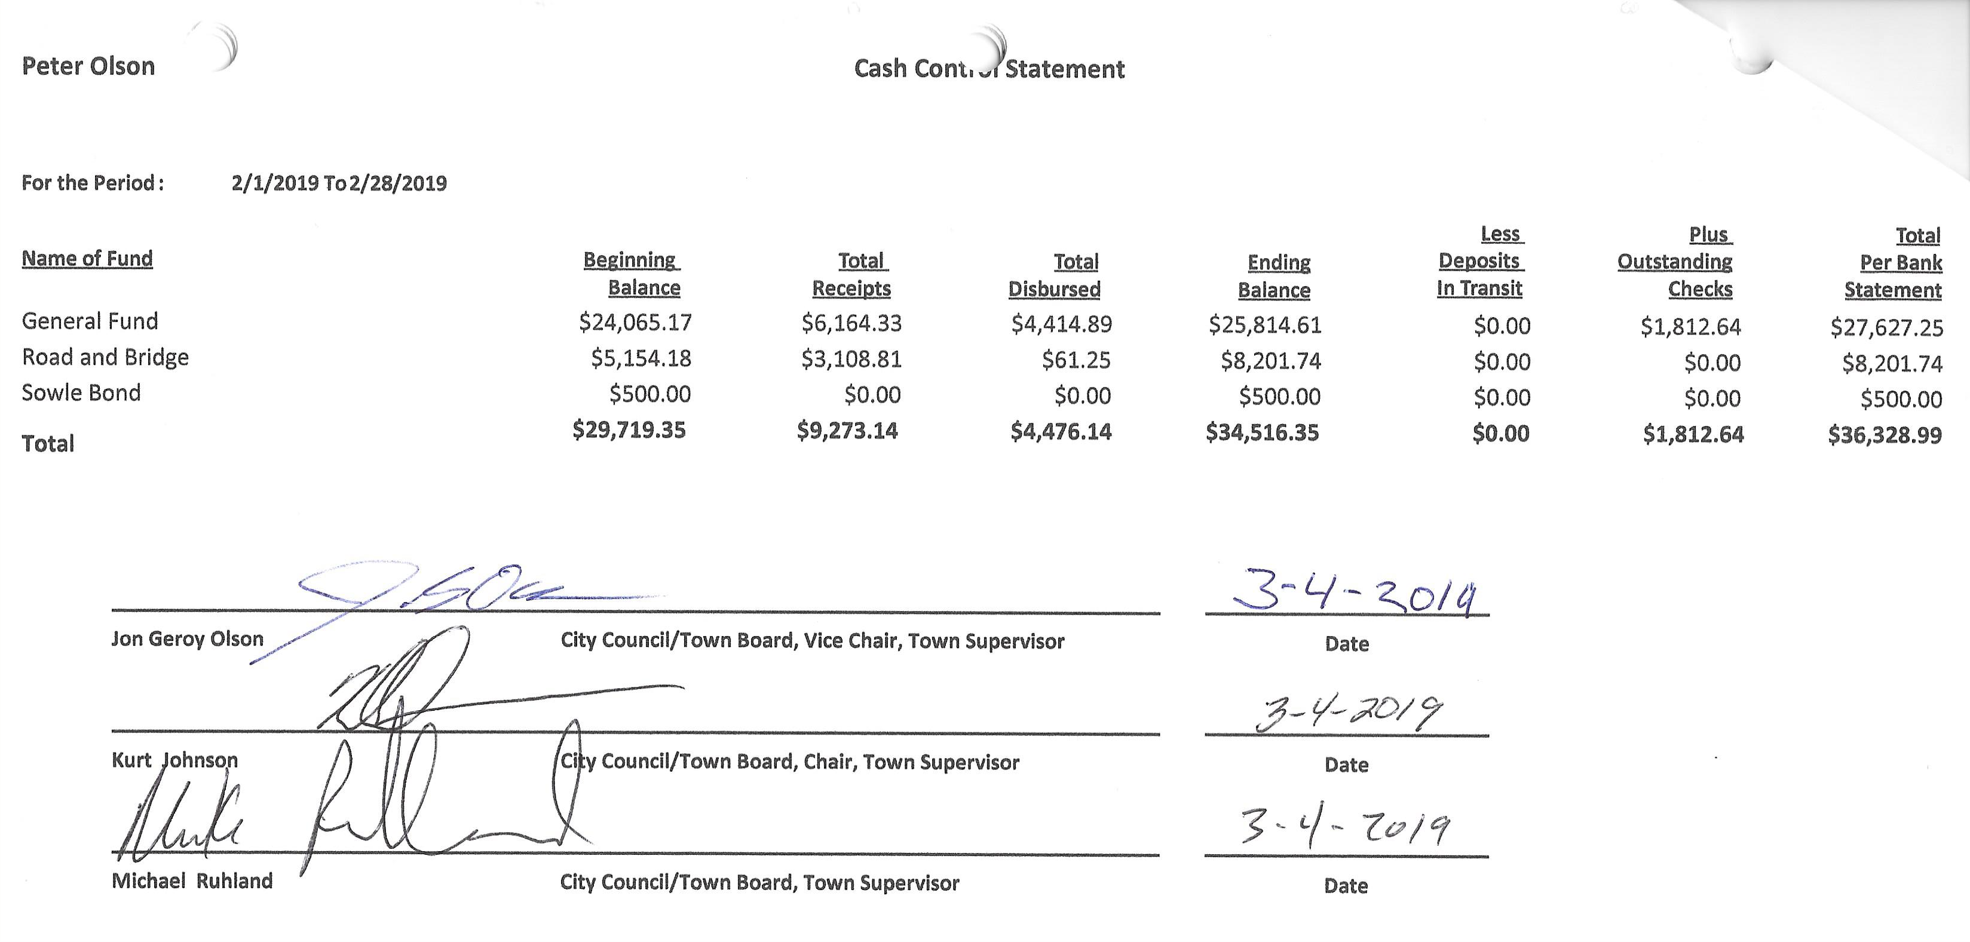

Sandra Lee Olson presented the Clerk’s Report for the period ending on February 28, 2019. Her entire report included the Cash Control Statement (shown below), Cash Balance Statement, Outstanding Checks and Deposits in Transit Report, and Current Investments. The entire report was put on file with other documents from the meeting. After completing the report, Mike Ruhland made a motion to accept the report. Jon Olson offered a second to the motion, which was unanimously accepted.

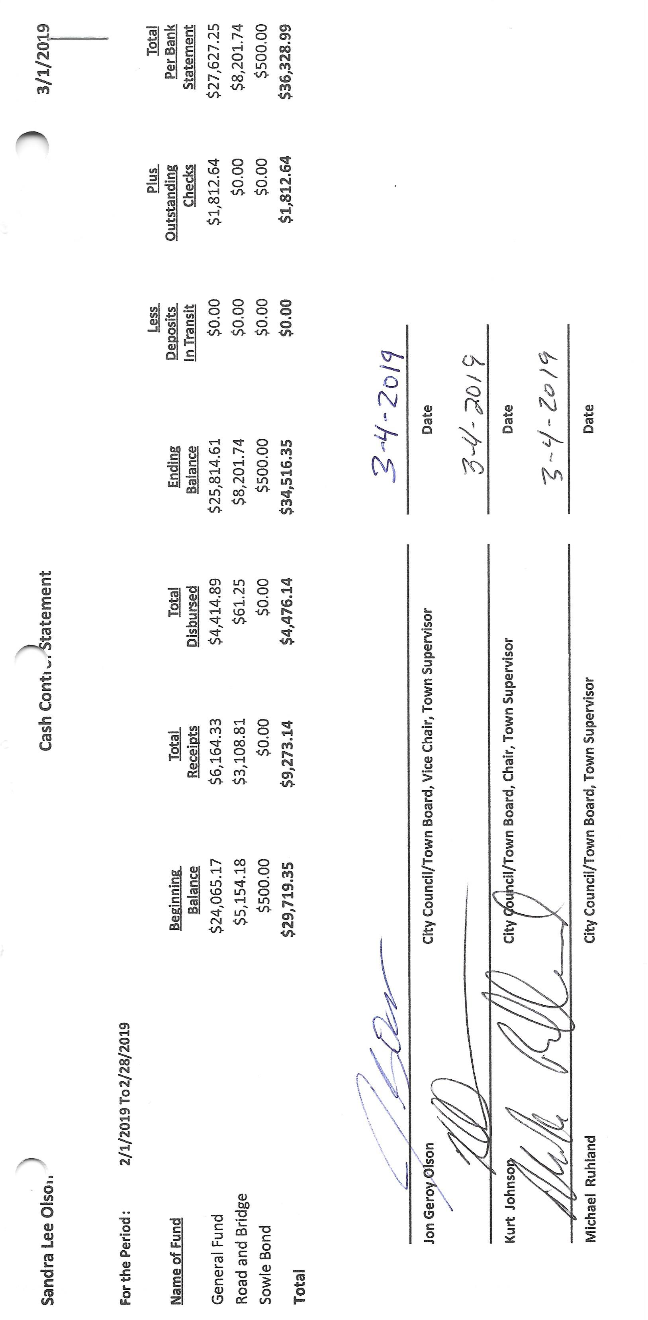

The following items of Incoming Correspondence were presented to the Board:

1. Frontier Communication…monthly internet and phone service ($71.17)
2. United States Postal Service…receipt for box rental
3. St Louis County Association of Townships (SLCAT)…minutes of the January 23, 2019, meeting
4. Minnesota Association of Townships…mailing for 2019 Spring Short Courses
   * April 4 in Grand Rapids—on-site registration only
   * April 5 in Duluth at the DECC—on-site registration only
   * Registration at 8:00 am, Sessions begin at 9:00 am, Sessions adjourn at 3:00 pm
5. Lake Country Power…billing showing a credit of $70.33
6. Voyageur Press…billing for Annual Meeting and Board of Audit ($79.20)
7. PERA…*PERANews*
8. St. Louis County/Planning and Development Department…permits issued in the second half of 2018
9. Northeast Service Cooperative…Broadband Renewal
10. Local Board of Review and Equalization…make-up session
11. Alborn Fire Department…minutes for the January 30, 2019, fire department meeting

Payroll and Claims

Kurt Johnson read the Payroll into the record. Mike Ruhland made a motion to pay the payroll claims as read. Jon Olson seconded the motion, which was accepted through a unanimous vote. The payroll was submitted to the treasurer for payment.

* 1. Payroll $93.55
  2. Payroll $93.55
  3. Payroll 318.75
  4. Payroll $57.71
  5. Payroll $399.86
  6. Payroll $187.10

Kurt Johnson read the Claims into the record. Mike Ruhland made a motion to pay the payroll claims as read. Jon Olson seconded the motion, which was accepted through a unanimous vote. The Claims were submitted to the treasurer for payment.

* 1. Misprinted void
  2. Minnesota Revenue $62.11
  3. Public Employees Retirement Assoc. $145.00
  4. Frontier Communications $71.81
  5. Sandra Lee Olson $124.06
  6. Peter Olson $19.14
  7. Lake Country Power $300.00
  8. Voyageur Press $79.20
  9. US Treasury $394.11

The following items of Unfinished Business were discussed by the Board:

1. Cemetery
   * Kurt reported that the cemetery has been plowed and is accessible.
2. Town Hall
   * The members of the Board discussed the snow load on the Town Hall and porch. Kurt Johnson made a motion to remove the snow off the roofs if a board member has time in the next few weeks. The porch is more of a concern than the Town Hall. Mike Ruhland seconded the motion, which was accepted through a unanimous vote.
3. Roads
   * Road Foreman’s Report
     + Peter Olson checked the road on Sunday and felt they were in fine condition at this time. He did say that brushing and gravel will be necessary this year.
     + Jon Olson had a call from Gary Fredrikson during the recent storm. Jon did explain that New Independence contracts with St. Louis County Highway Department for snowplowing and that an individual plowing the road would not be covered by insurance. Jon also explain the hierarchy order that is used in snowplowing—County roads, secondary roads, and finally, township roads. Jon did contact the County to check on snowplowing and was told that all plows had been pulled and return to the roads the next day at 4:00 AM.
4. Mail-in Ballots Returned Ballots
   * The clerk reported that letters for the upcoming Annual Meeting were sent out encouraging voters to attend and discuss the mail-in ballot option. Of the 239 letters sent, only two were returned (Mark Ligon and Timothy Greer).
5. Microsoft Office
   * Microsoft Office 2016 version was purchased for the treasurer’s computer. That version was purchased because the cost of the 2019 version would have been almost $300 while the 2016 version was under $90. The treasurer and clerk agreed that the 2016 version was adequate to complete the reports for the treasurer. Reimbursement was made for the purchase
6. Deputy Clerk
   * A discussion was held on the deputy clerk position. The clerk has approached several New Independence residents about serving in the position. She does have one suggestion but has not asked the individual. No one has expressed an interest. Kurt Johnson suggested that the position be put on the agenda for the Annual Meeting.
   * If the position will be discussed at the Annual Meeting, Sandra Lee Olson felt the discussion needed to include compensation amounts for the deputy clerk position. Kurt Johnson made a motion, which was seconded by Mike Ruhland, to pay a monthly stipend of $200, a meeting rate of $50 for attending meetings, and a meeting rate of $100 for acting as the clerk at a meeting. The motion was unanimously accepted.

The following items of New Business were presented to the Board.

1. SLC 2nd Half 2018 Permits Issued
   * The clerk reported that a letter from the County indicated that the following permits were issued in the last half of 2018.

|  |  |  |  |  |
| --- | --- | --- | --- | --- |
| **PERMIT #** | **PERMIT TYPE** | **DATE ISSUED** | **PARCEL ID #** | **STRUCTURE TYPE** |
| LU-001848 | Land Use Permit | 10/01/2018 | 475-0010-05841 | Accessory Structure |
| LU-001591 | Land Use Permit | 07/03/2018 | 475-0010-03223 | Dwelling |
| LU-001673 | Land Use Permit | 07/26/2018 | 475-0010-05500 | Addition(s) to Dwelling |

1. LBAE
   * The Local Board of Appeal and Equalization will be held on April 23, 2019, 3-4 PM, at the Town Hall. All three supervisors have been trained. A quorum will be needed for the meeting.
2. Broadband Resolution
   * Mike Ruhland made a motion to sign the Broadband Resolution received from SLCAT. Kurt Johnson seconded the motion, which was accepted through a unanimous vote.
3. Broadband Renewal
   * An email was received from NESC regarding renewal of the broadband service. Before the board makes a decision about renewing the service, the clerk will contact Frontier and NESC about the internet services and prices. The board will make a decision after the information is presented.
4. Annual Meeting
   * The Annual Meeting will be held on March 12, 2019, at 7:00 PM. Cookies and water will be available at the meeting.

The Board of Audit was conducted by Mike Ruhland and Kurt Johnson. Jon Olson left because he will ill. Mike and Kurt audited the books and found the treasurer and clerk financial records to be in agreement. The reports were signed and placed on file. They will be available for residents to view from 6:30 PM at the Town Hall and at the Annual Meeting.

Officer Reports

Mike Ruhland—Joint Powers Meeting

Kurt asked for a motion to adjourn because there was no additional business to be brought before the Board. He adjourned the meeting at 9:30 PM after a motion from Mike Ruhland, a second by Kurt Johnson, and a unanimous vote in favor of adjournment.

Minutes submitted for approval on ______________**April 1, 2019**________________________

Clerk’s Signature______________________________________________________________

Chair of the Board of Supervisors’ Signature_________________________________________

**UPCOMING MEETINGS**

***Board of Supervisors’ Meetings for 2019***

April 1, 2019

April 23, 2019, LBAE 3-4 PM

May 6, 2019

June 3, 2019

July 8, 2019

August 5, 2019

September 3, 2019

October 7, 2019

November 4, 2019

December 2, 2019

**2019 SLCAT Calendar (meetings convene at 6:30 pm) and Related Meetings**

March 27, 2019 Cotton Townhall 6:30 pm Speaker Arrangements Megan Julin

April 18, 2019 MAT Otsego, MN Town Law Review – Rockwoods Conf. Center

April 24, 2019 Host Township 6:30 pm Midway Township Speaker Enbridge

5 pm Directors/Officers & Audit Committee

May 22, 2019 Cotton Townhall 5 pm Chitchat/5:30 Mtg/6pm Dinner/6:45 Speaker