Chair Kurt Johnson called the meeting to order at 7:05 PM. After taking a visual count of the officers present, he declared that all officers were present:

Roll Call:

**Supervisors**

* Kurt Johnson
* Jon Olson
* Mike Ruhland**Treasurer**
* Peter Olson**Clerk/Deputy Clerk**
* Kate Laine
* Sandra Lee Olson

Following the recitation of the Pledge of Allegiance, Mike Ruhland made a motion to accept the agenda as printed. Jon Olson offered a second to the motion, which was accepted through a unanimous vote.

Clerk Sandra Lee Olson read the minutes from the Board of Supervisors’ Meeting held on February 3, 2020. Following the reading of the minutes, Jon Olson made a motion to accept the minutes as read. Mike Ruhland seconded the motion, which was accepted through a unanimous vote. The Board of Audit was held on February 26, 2020. The clerk read those minutes to the Board. Kurt Johnson made a motion to accept the minutes as read; Mike Ruhland second the motion, which was accepted through a unanimous vote in favor of acceptance. The minutes for February 3 and 26 were placed on file with other documents from the meeting.

Peter Olson read the Treasurer’s Report into the record. Upon completion, Mike Ruhland made a motion to accept the report—subject to audit. Jon Olson seconded the motion, which was accepted through a unanimous vote in favor of the motion. Peter’s report consisted of a specialized first page, Cash Control Statement (CTAS), Outstanding Checks and Deposits in Transit Report (CTAS), and Schedule B—Investment Activity (CTAS). The customized first page is reproduced on the next page:

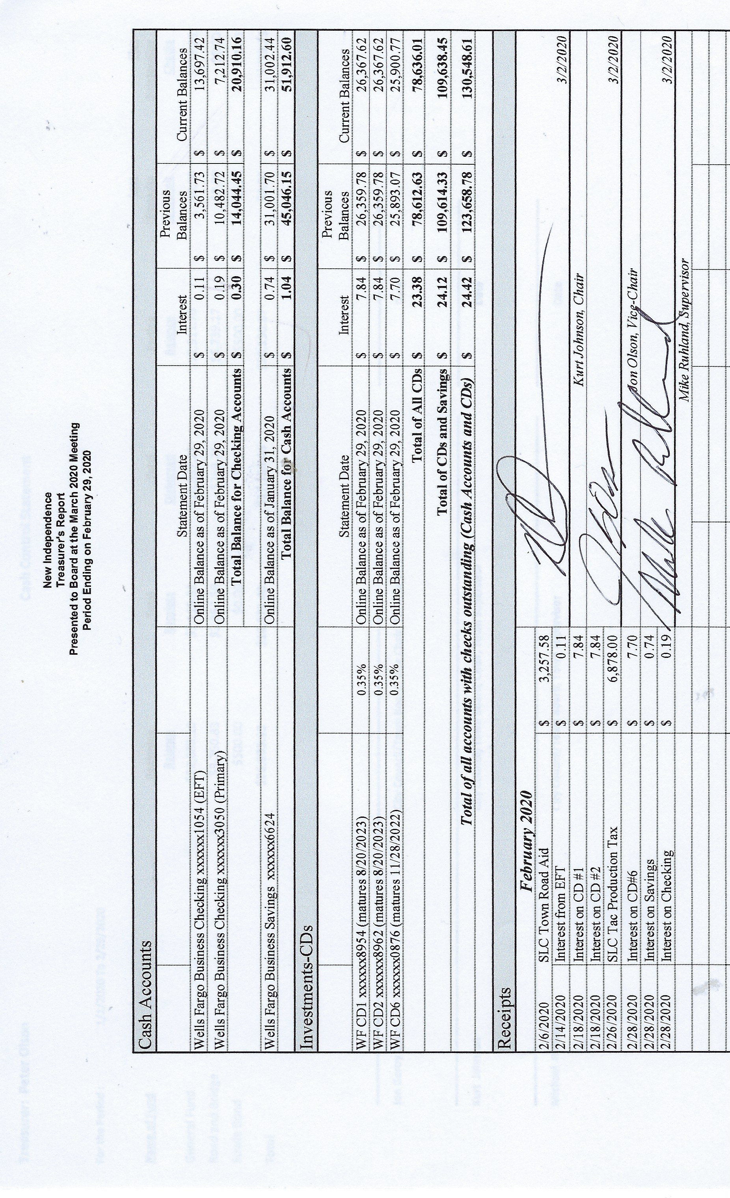

The Board discussed the money received during February (Taconite Production Tax and Town Road Aid). Kurt Johnson made a motion to transfer the Town Road Aid to Road & Bridge Fund in checking and the Taconite Production Tax to General Fund in checking. Jon Olson seconded the motion, which was accepted through a unanimous vote in favor of the motion.

Sandra Lee Olson read the Clerk’s Report and noted that it agreed with the Treasurer’s Report. Her report consisted on the Cash Control Statement (CTAS), Outstanding Checks and Deposits in Transit Report (CTAS), and Current Investments (CTAS). Mike Ruhland made a motion to accept the Clerk’s Report as read—subject to audit. Jon Olson seconded the motion. A unanimous vote was cast in favor of acceptance, and the report was placed on file with other documents from the meeting.

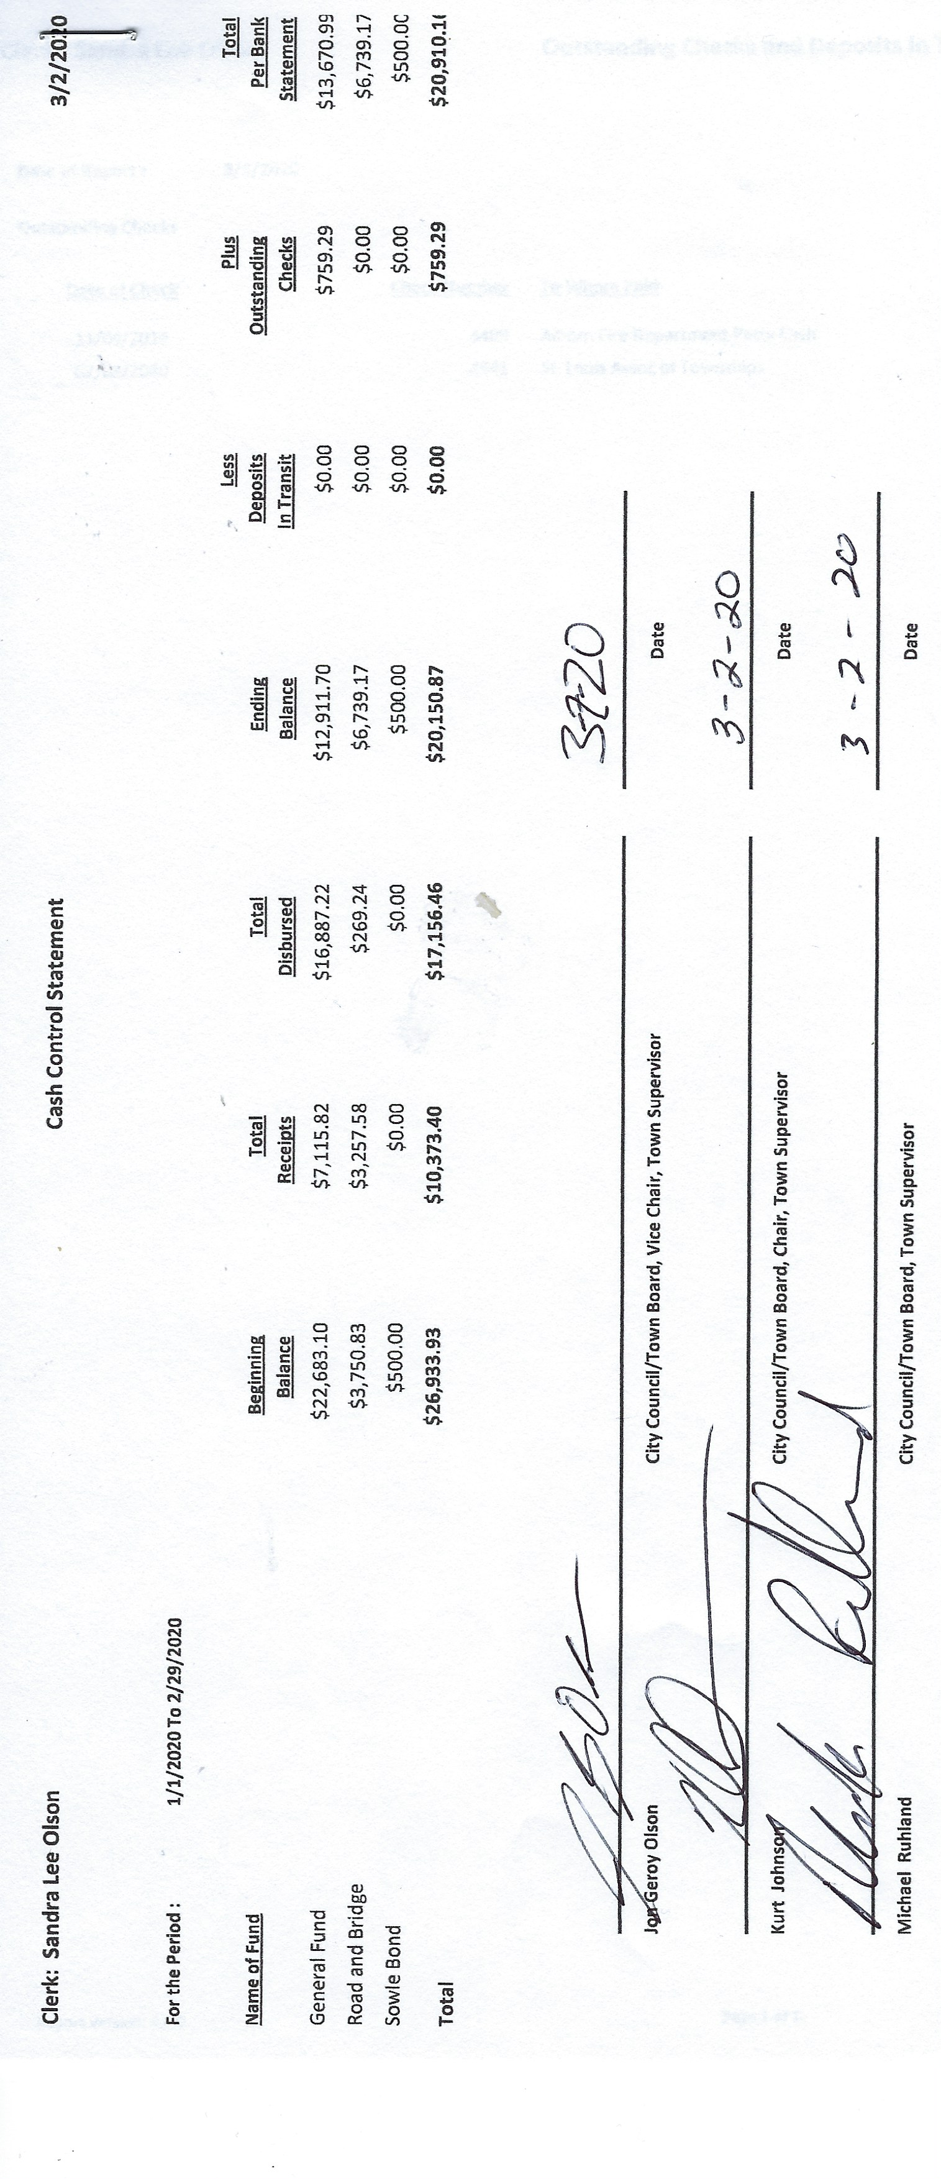Incoming Correspondence

1. St, Louis County…. election roster
2. St. Louis County…. invoice for Proposed Tax Notice preparation and delivery
3. Federated Co-ops….propane delivery ($377.62)
4. St. Louis county Auditor,,,,PNP Summary Statement
5. American Legion Auxiliary….request for fireworks donation
6. Minnesota Association of Townships….information on 20202 Spring Short Coursed
7. USPS…. receipt for post office payment
8. Lake Country Power…. credit of $131.80
9. Central Applicators, Inc. …. Advertisement for services

Emails

1. St, Louis County Elections Department….multiple emails regarding the PNP

The Payroll was read into the record by Kurt Johnson. After all the payroll claims had been read, Jon Olson made a motion to pay the payroll. Mike Ruhland seconded the motion, which was accepted through a unanimous vote. All payroll claims were submitted to the Treasurer for payment.

* 1. Payroll $187.10
  2. Payroll $230.87
  3. Payroll $187.10
  4. Payroll $601.38
  5. Payroll $46.17
  6. Payroll $477.60
  7. Payroll $187.10
  8. Payroll $517.16
  9. Payroll $230.87

Kurt Johnson read the Claims into the record. Upon completion, Jon Olson made a motion to pay the claims. Mike Ruhland offered a second, and a unanimous vote followed.

* 1. Frontier Communications $90.00
  2. Peter Olson $14.95
  3. Lake Country Power $300.00
  4. Alborn Fire Department $1,200.00
  5. Public Employees Retirement Association $214.00
  6. Sandra Lee Olson $110.95
  7. Shirley Tremblay $30.00
  8. Heather Bosiacki $60.00
  9. R. James Syria $60.00
  10. St. Louis County $84.74

Unfinished Business

1. Cemetery—Kurt had nothing new to report about the cemetery.
2. Town Hall—Jon Olson checked at the Town Hall before calling Arrowhead Water about salt delivery. Because salt had been delivered, he did not call.
3. Township Roads—Peter Olson reported that all the township roads are in good condition at this point. As spring break up comes, the condition is likely to change. The sign on South Schelin is in need of attention. Peter said he will talk with the County and find out if the County or New Independence is responsible.
4. Presidential Nominating Primary
   * Training was completed for all election judges. Jjm Syria and Heather Bosiacki both received general election judge training (2 hours). Jim, Heather, and Shirley Tremblay all received training for the Presidential Primary (PNP) for two hours and assisted with the AutoMark Public Testing.
   * AutoMark Tested was completed on February 26, 2020.
   1. The 2020 Budget was developed at the February 26, 2020, Special Meeting. The Clerk did not have the completed report for the meeting.
   2. Local Board of Appeal and Equalization (LBAE) final schedule has not been received.

New Business

1. Annual Meeting Agenda—the Clerk presented the agenda from the 2019 Annual Meeting and asked for additional items that Board members wanted to be included. There were no suggestions at the meeting, so Board members were encouraged to notify the Clerk if a topic needed to be included.

The Board decided not to include a Levy recommendation for the Annual Meeting.

1. The MAT Short Course will be offered in April. Jon Olson made a motion to authorized officers interested in attending the Short receive registration, mileage, long meeting rate, and parking fee. Mike Ruhland seconded the motion, which was accepted through a unanimous vote. Officers do not have to pre-register as on-site registration is the only option available this year.

Officer Reports--none

Having no additional items to bring to the Board, Kurt asked for a motion for adjournment. Mike Ruhland made the motion; Jon Olson offered the second; and the motion was accepted through a unanimous vote.

Minutes submitted for approval on ____________April 6, 2020________________________

Clerk’s Signature______________________________________________________________

Chair of the Board of Supervisors’ Signature_________________________________________

**UPCOMING MEETINGS**

***Board of Supervisors’ Meetings for 2020***

April 6, 2020

May 4, 2020

June 1, 2020

July 6, 2020

August 3, 2020

September 14, 2020

October 5, 2020

November 2, 2020

December 7, 2020

**2019-2020 SLCAT Calendar (meetings convene at 6:30 pm) and Related Meetings**

MAR. 25, 2020 COTTON COMMUNITY CENTER 6:30 PM

APR.  22, 2020 NEED A TOWNSHIP TO VOLUNTEER TO HOST THE APRIL MEETING.

CALL CATHY AT 290-4970

MAY 27, 2020 COTTON COMMUNITY CENTER 5:30 P.M.

* ANNUAL SLCAT ELECTION AND MEETING;