Chairman Kurt Johnson called the April Board of Supervisors’ Meeting to order at 7:01 PM with the following officers present:

Supervisors
- Kurt Johnson
- Mike Ruhland
Treasurer
- Peter Olson
Clerk/Deputy Clerk
- Kate Laine
- Sandra Lee Olson
Supervisor Jon Olson was not at the meeting.

Mike Ruhland made a motion to accept the Agenda as printed. Following a second by Kurt Johnson and a unanimous acceptance of the motion, Kurt proceeded with the meeting as outlined in the Agenda.

Clerk Sandra Lee Olson read the minutes from March 2, 2020, Board of Supervisors’ Meeting into the record. Mike made a motion, which was seconded by Kurt Johnson, to accept the minutes as read. A unanimous vote was cast in favor of the motion, and the minutes were placed on file with other documents from the meeting.

Following the reading of the Treasurer’s Report by Treasurer Peter Olson, Kurt Johnson made a motion to accept the report—subject to audit. Mike Ruhland seconded the motion, which was approved through a unanimous vote, and the report was placed on file with other documents from the meeting. The Treasurer’s Report for March included the customized front page, Cash Control Statement (CTAS), Outstanding Checks and Deposits in Transit Report (CTAS), and Schedule 8 – Investment Activity with Accrued Interest (CTAS). The first page is reproduced below:
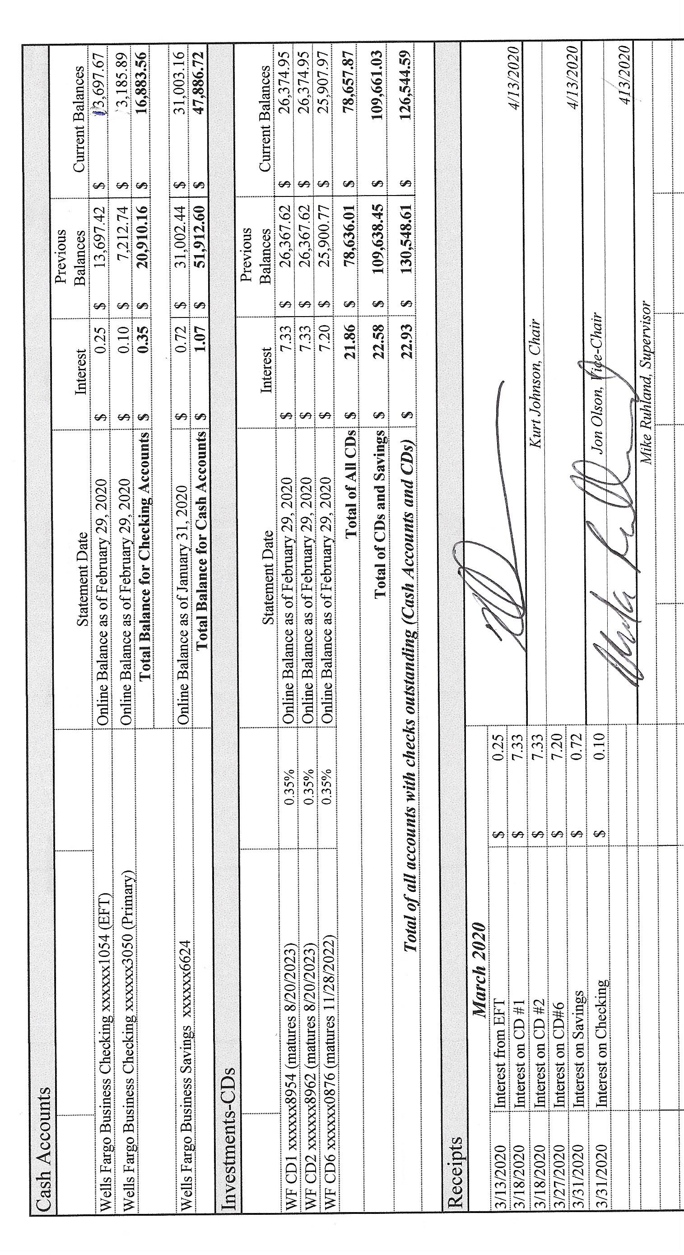
As part of the Clerk’s Report, Sandra Lee Olson noted that she had transferred $10,000 from the EFT account to the Regular Checking. The transfer was done because a motion was made at the March meeting. The transfer, however, did not happen until after the first of April and was not included in the numbers presented on the current report. The Clerk stated that the Treasurer’s Report and the Clerk’s Report reconciled with each other and no discrepancies were found. The first page of the Clerk’s Report is shown below. The entire report included the Cash Control Statement (CTAS), Cash Balance Statement, Outstanding Checks and Deposits in Transit Report, Statement of Receipts, Disbursements and Balances (Schedule 1-CTAS), and Current Investments with Accrued Interest. Following her report, Kurt Johnson made a motion to accept the report—subject to audit. A second was offered by Mike Ruhland and subsequently accepted through a unanimous vote. The entire report was placed on file with other documents from the meeting.
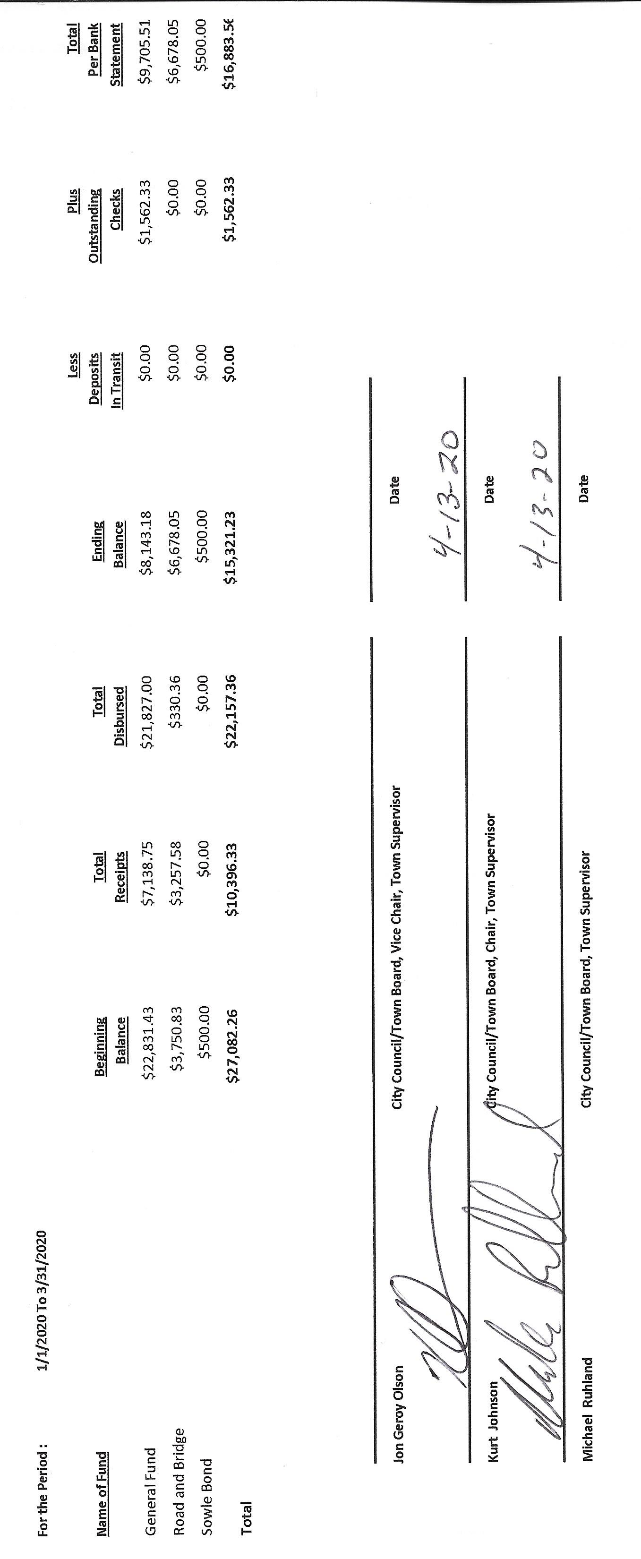

Incoming Correspondence
- Frontier Communications…monthly internet and phone service billing (39.87)
- St. Louis County Public Works Department…2019-2020 2nd Half of Snowplowing ($2,203.52)
- Federated Coops…fuel delivery slip for March 30, 2020 ($417.76)
- Federated Coops…invoices for February and March (call was made for credit to the account due to a service charge)
- St. Louis County Auditor…yearly tax statement for Waste Assessment ($70)
- Lake Country Power…monthly statement showing a credit ($319.43)
- Voyageur Press…legal ad for Annual Meeting ($81.60)
- Wayside Liquor…application to renew liquor license

Emails
- Minnesota Association…notice that Short Courses were cancelled due to Covid19
- Phil Chapman…reimbursement for Presidential Nominating Primary
- SLCAT…notice that meetings for April and May have been cancelled

The following Payroll claims were submitted by officers and employees and read into the record by Chair Kurt Johnson. Mike Ruhland made a motion to pay the claims as presented. Kurt Johnson seconded the motion, and a unanimous vote followed. The claims were submitted to the Treasurer for payment.
  - Payroll $257.26
  - Payroll $318.11
  - Payroll $187.10
  - Payroll $403.96
  - Payroll $46.17
  - Payroll $477.6
  - Payroll $187.10

The following Claims were read into the record by Chairman Kurt Johnson. When completed reading the claims shown below, Mike Ruhland made a motion to pay the claims as presented. Kurt Johnson offered a second, and a unanimous vote in favor of the motion followed. The claims were submitted to the Treasurer for payment.
  - Heather Bosiacki $210.00
  - Shirley Tremblay $210.00
  - R. James Syria $210.00
  - Southgate Family $34.26
  - Sandra Lee Olson $28.75
  - Voyageur Press $81.60
  - St. Louis County Auditor $70.00
  - St. Louis County Public Works Department $2,203.52
  - Frontier Communications $39.87
  - Peter Olson $14.95
  - US Treasury $790.52
  - Minnesota Revenue $69.01
  - Public Employees Retirement Association $196.50
  - Sandra Lee Olson $263.20

Unfinished Business
- Cemetery—Kurt noted that he has been cleaning the cemetery area. A discussion was held about the mowing of the cemetery and town hall. The clerk will post and also notify Jim Witkowski that the posting is being made.
- Town Hall—There was nothing to report related to the Town Hall
- Township Roads—Road Foreman Peter Olson noted that the roads need to be graded but are in good condition. He will contact Rodda about the grading.
- Presidential Nominating Primary—New Independence needs to complete a form sent out by Phil Chapman in order to obtain reimbursement for expenses related to the Presidential Nominating Primary. The Clerk will see that it is sent to the St. Louis County Election Office.
  - LBAE—Officers were reminded that the Local Board of Appeal and Equalization will be held on April 21 from 2-3 PM. Due to the COVID-19 pandemic, New Independence will hold a phone conference with the County Assessor. Mike said he is scheduled to work, so it will be imperative that both Kurt Johnson and Jon Olson be at the meeting. If a quorum is not met, New Independence will lose its LBAE meeting for two years. Jon did say he would be there, but Sandra Lee Olson will remind him, since he was not at the meeting.

New Business
- Annual Meeting
- Concern was expressed about the report from the Fire Department this year. In the past, New Independence has always received a very complete presentation from Jay Trembly. Since his retirement, the completeness that Jay offered was lacking.
- No recommendations for donations from the Annual Meeting were presented at the meeting since most of the donations go for school functions, which have been switched to distance learning until further notice from Governor Walz. Donations will be discussed at the May meeting so the Board is able to keep the meeting as short as possible during the current situation.
- Wayside Liquor—Kurt Johnson made a motion, which was seconded by Mike Ruhland and passed, to continue the liquor license for off-sale liquor for Wayside. The Clerk will complete the form and return it to Wayside.

There were no Officer Reports.

Being there was no additional business to be brought to the Board, Mike Ruhland made a motion for adjournment. Following a second by Kurt Johnson and a unanimous vote in favor of adjournment, Kurt declare the meeting to be adjourned at 7:40 PM

Minutes submitted for approval on _____________May 4, 2020__________________________
=

Clerk’s Signature______________________________________________________________

Chair of the Board of Supervisors’ Signature_________________________________________

UPCOMING MEETINGS

Board of Supervisors’ Meetings for 2020
May 4, 2020
June 1, 2020
July 6, 2020
August 3, 2020
September 14, 2020
October 5, 2020
November 2, 2020
December 7, 2020

2019-2020 SLCAT Calendar (meetings convene at 6:30 pm) and Related Meetings

