Chair Kurt Johnson called the monthly Board of Supervisors’ Meeting to order at 7:00 PM. Kurt took roll call and noted that all officers were present:

Roll Call:

**Supervisors**

* Kurt Johnson
* Jon Olson
* Mike Ruhland**Treasurer**
* Peter Olson**Clerk/Deputy Clerk**
* Kate Laine
* Sandra Lee Olson

Following the Pledge of Allegiance, Mike Ruhland made a motion to accept the Agenda. Jon Olson offered a second to the motion, which was accepted through a unanimous vote of the Board.

Clerk Sandra Lee Olson read the minutes from the April 13, 2020, Board of Supervisors’ Meeting. Upon completion, Mike Ruhland made a motion to accept the minutes as read. A second to the motion was offered by Jon Olson, a unanimous vote in favor of the motion was cast, and the minutes were placed on file with other documents from the meeting.

Following the reading of the Treasurer’s Report by Treasurer Peter Olson, Mike Ruhland made a motion to accept the report—subject to audit. Jon Olson seconded the motion, which was approved through a unanimous vote, and the report was placed on file with other documents from the meeting. The Treasurer’s Report for March included the customized front page, Cash Control Statement (CTAS), Outstanding Checks and Deposits in Transit Report (CTAS), and Schedule 8 – Investment Activity with Accrued Interest (CTAS). The first page is reproduced on the next page:

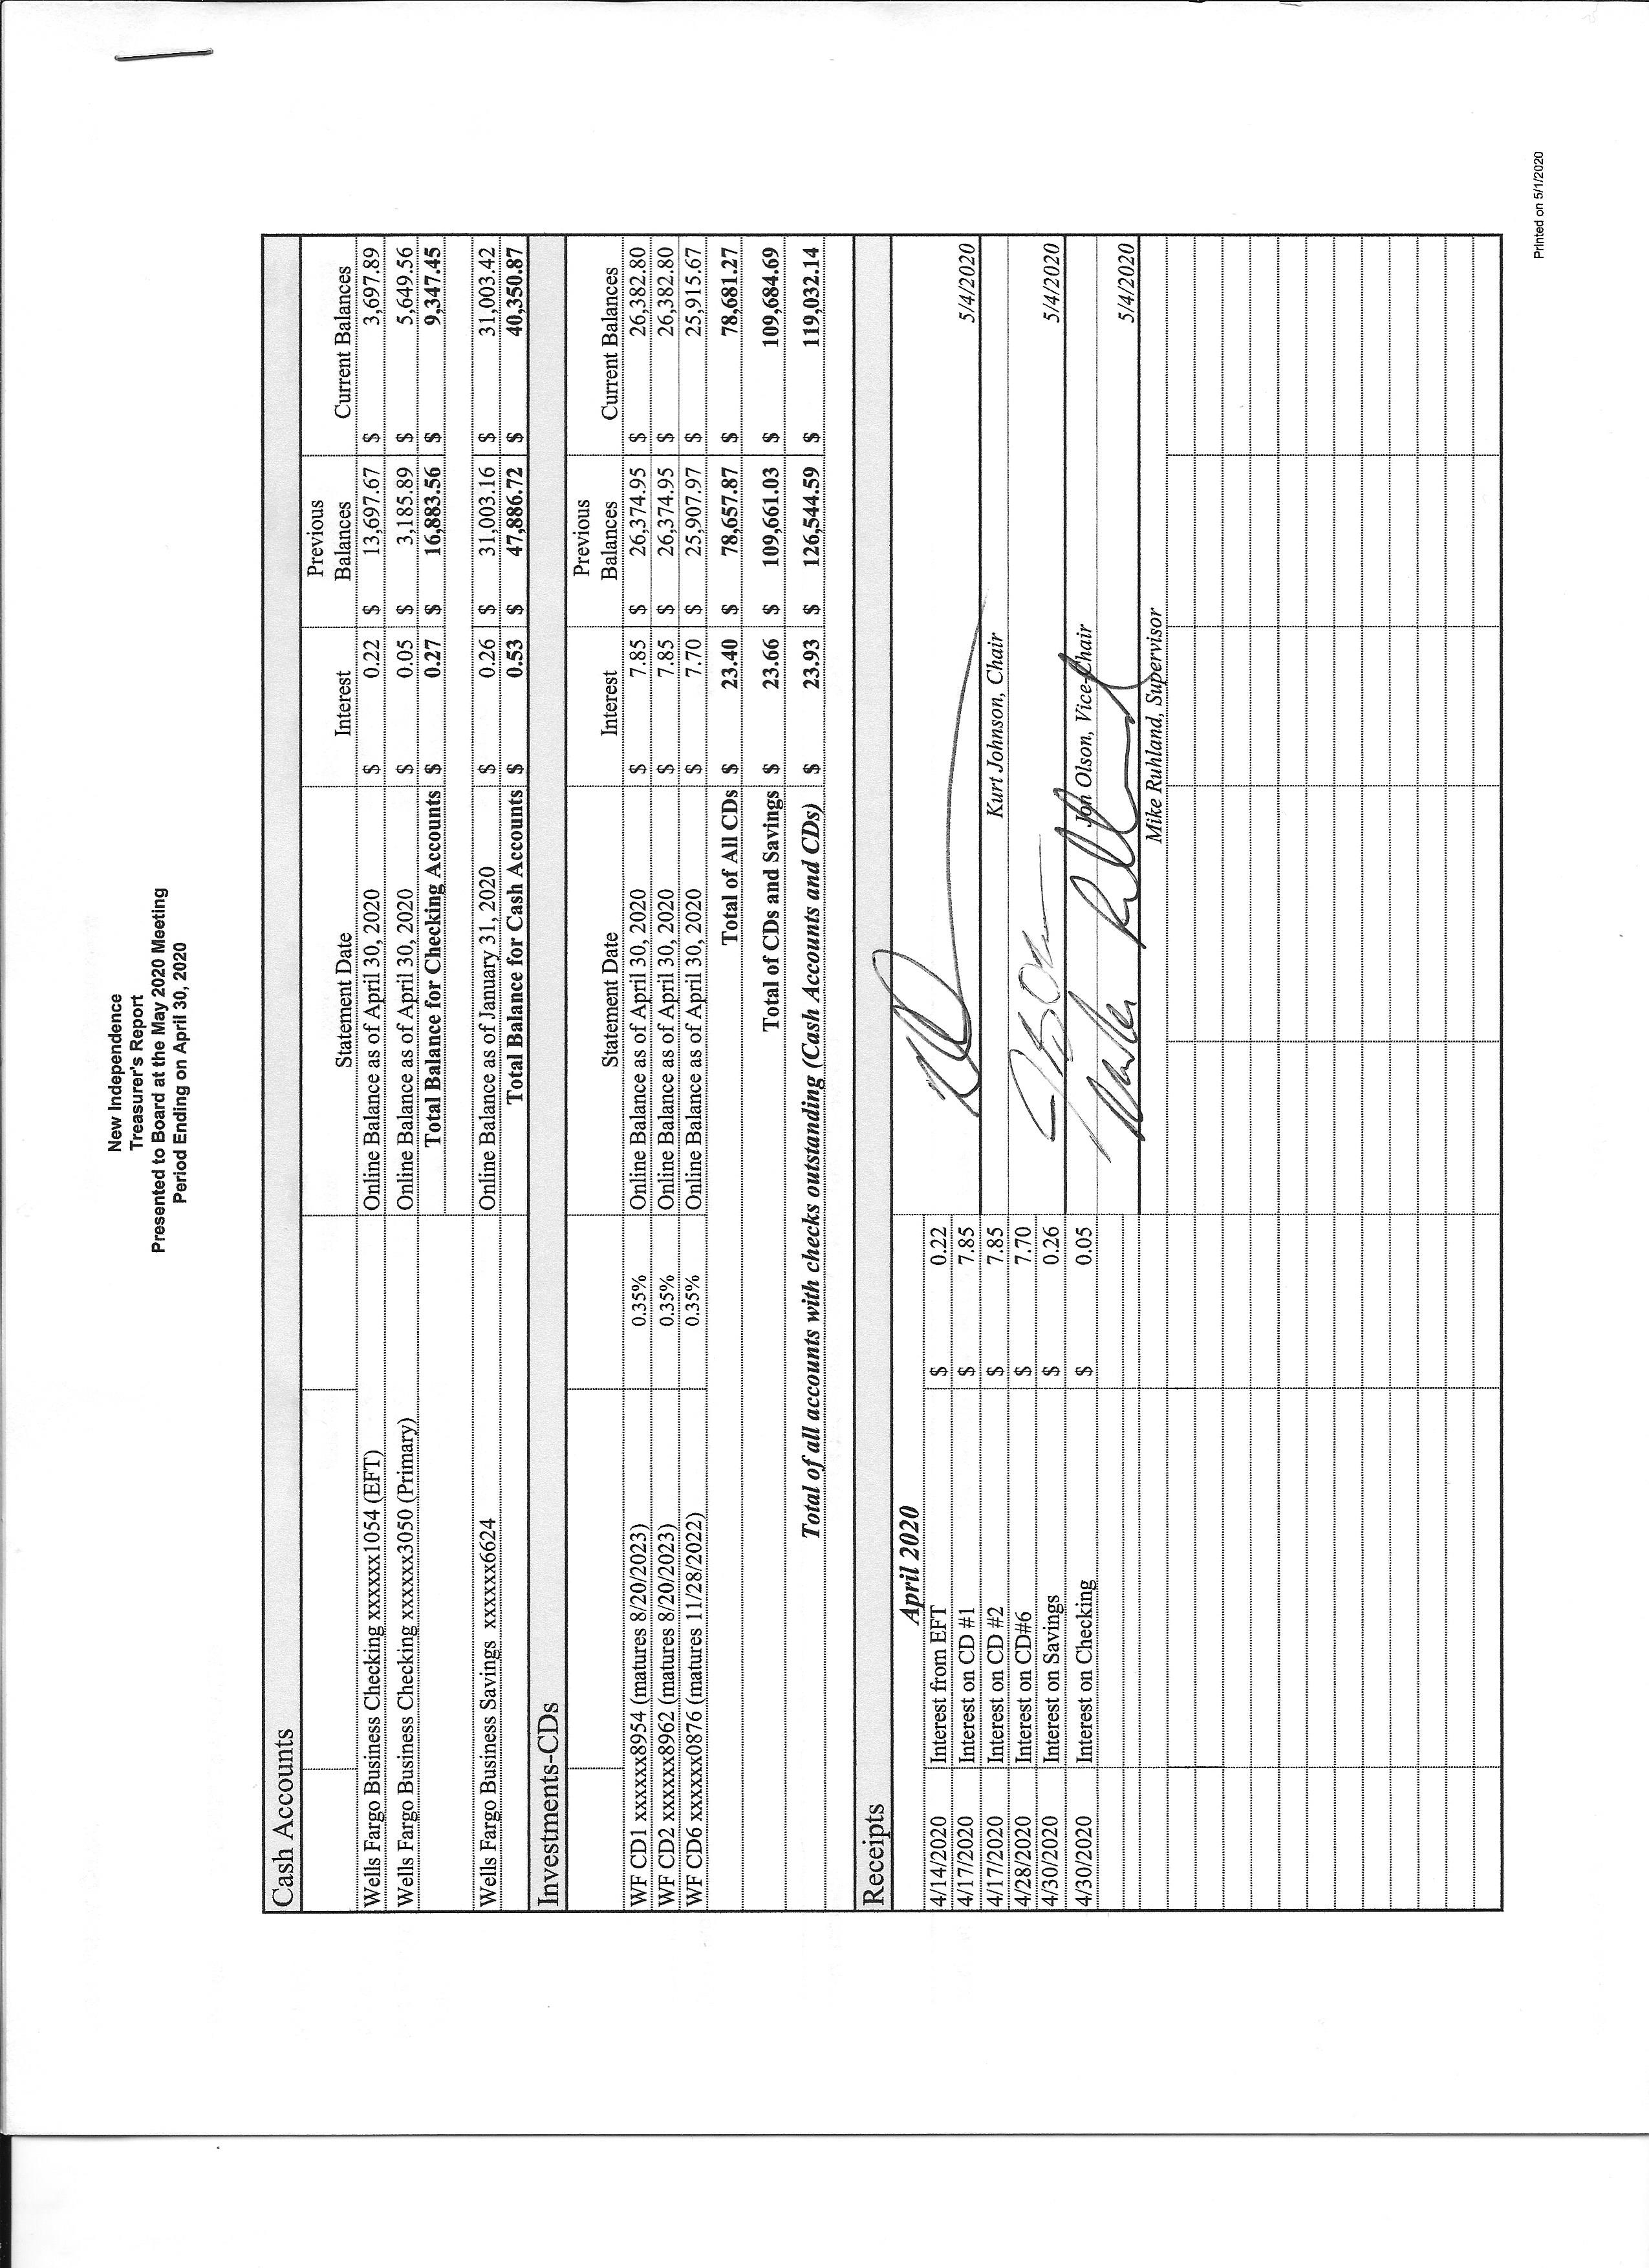

The Clerk stated that the Treasurer’s Report and the Clerk’s Report reconciled with each other and no discrepancies were found. The first page of the Clerk’s Report is shown below. The entire report included the Cash Control Statement (CTAS), Cash Balance Statement, Outstanding Checks and Deposits in Transit Report, Statement of Receipts, Disbursements and Balances (Schedule 1-CTAS), and Current Investments with Accrued Interest. Following her report, Jon Olson made a motion to accept the report—subject to audit. A second was offered by Mike Ruhland and subsequently accepted through a unanimous vote. The entire report was placed on file with other documents from the meeting.

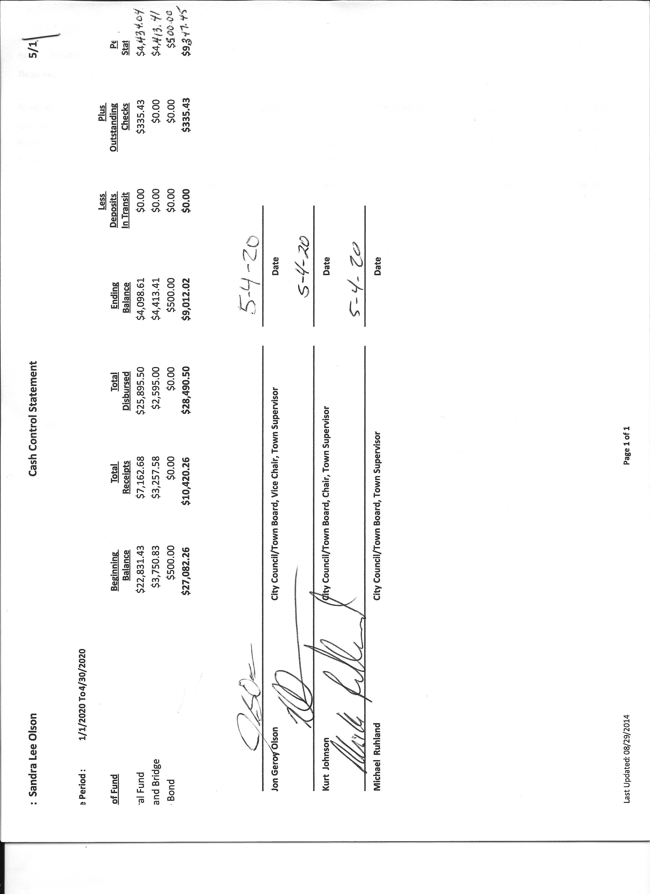

Incoming Correspondence

1. Frontier Communications…monthly internet and phone service billing ($72.57)
2. RGM (Road Groom Manufacturing) …advertising for services
3. Duluth Area Family YMCA…request for donation
4. Frontier Communications…claim for past events
5. Lake Country Power…change of billing date
6. Rodda Grading and Excavating…2020 price list
7. Lake Country Power…monthly bill (credit of $217.69)
8. Rodda Grading & Excavating…invoice for grading on April 4, 2020 ($546.25)
9. Voyageur Press…legal ad for LBAE ($96.00)
10. Jim Witkowski…quote for mowing the town hall and cemetery for 2020

Emails

1. Ben Crosby (Edward’s Oil Company)…dust control services ($0.865/gallon)
2. Joshua Gorham (SLC) … COVID – 19 update
3. Sarah M. Priest (Census 2020)…request to get residents to complete Census
4. Karen Kubiak (SLC) ,,, 60-day comment period is open for comments about the St. Louis River Watershed Comprehensive Management Plan
5. Lisa (SLC Election Office)…request for officers up for election in 2020 and questions that will be on the ballot
6. MAT and flu situation…letter from Jim Fisher to MAT (forwarded to board members)

Payroll

* 1. Payroll $187.10
  2. Payroll $93.55
  3. Payroll $46.17
  4. Payroll $477.60
  5. Payroll $93.55

Claims

xxxx Public Employees Retirement Association $10.00

* 1. Public Employees Retirement Association $124.00
  2. Sandra Lee Olson $55.00
  3. Michael Ruhland $50.46
  4. Rodda Grading & Excavating $546.25
  5. Voyageur Press $96.00
  6. Peter Olson $14.95
  7. Frontier Communication $72.57

Unfinished Business

1. Cemetery: Kurt Johnson reported that the cemetery is in good condition and there are no issues at this point.
2. Town Hall: Mike Ruhland purchased a new flag for the front of the Town Hall, and it has been installed. A discussion was held about the sign that is currently on the front of the building. The consensus what that the sign should be lowered so it is visible from the road.
3. Township Roads: Road Foreman Peter Olson stated that there are a few concerns related to the roads. Township Road 5743 has a hole that needs to be addressed. Salo corduroy is coming up after the winter. Finally, North and South Johnson Road needs gravel.
   1. LBAE: The Local Board of Appeal and Equalization was held on April 21. There were no appeals brought before the Board.
   2. Mowing Contract for Cemetery & Town Hall: The posting was made for mowing at the Town Hall and cemetery. The only quote was offered by Jim Witkowski. Jim has offered to mow both of them for the same rates as 2019. Mike Ruhland made a motion to offer the contract to Jim Witkowski for 2020. Sandra Lee Olson noted that the final certificate needs to be obtained. She will let Jim know about the 2020 contract and a reminder about the certificate.
   3. Presidential Nominating Primary: Clerk Sandra Lee Olson noted that the report for reimbursement was made on behalf of New Independence. It is uncertain when the money will be received.

New Business

1. Annual Meeting Donations. Requests were received from the following organizations. The COVID-19 has impacted many activities. As a result, Jon Olson made a motion to contribute only to the Brookston Fourth of July celebration. Mike Ruhland offered a second, and the motion was accepted through a unanimous vote.

* Tester Niemi
* St. Louis County Fair
* School related donations

1. Computer for Clerk: Sandra Lee Olson told the Board that the Clerk’s computer might have to be replaced in the near future. Files are being backed up to ensure data is not lost.
2. YMCA request for donation: Jon Olson made a motion that no donation be given. Mike Ruhland offered a second to the motion, which was accepted through a unanimous vote.
3. Town Hall Blacktop: A discussion was held about resealing the blacktop at the Town Hall and cemetery. Jon Olson will check on prices.
4. Weed Control: Mike Ruhland asked for time to assess weeds within the township. Kurt Johnson made a motion to Mike to assess the weed situation within the township. Jon Olson seconded the motion, which was passed with a vote in favor of the motion by Kurt and Jon and with Mike Ruhland abstaining.

There were no Officer Reports to be presented.

Kurt asks for a motion for adjournment, which was offered by Mike Ruhland, seconded by Jon Olson, and accepted through a unanimous vote in favor of the motion. Kurt then adjourns the meeting at 7:53 PM,

=

Minutes submitted for approval on ________________________________________________

Clerk’s Signature______________________________________________________________

Chair of the Board of Supervisors’ Signature_________________________________________

**UPCOMING MEETINGS**

***Board of Supervisors’ Meetings for 2020***

June 1, 2020

July 6, 2020

August 3, 2020

September 14, 2020

October 5, 2020

November 2, 2020

December 7, 2020

**2019-2020 SLCAT Calendar (meetings convene at 6:30 pm) and Related Meetings**